UNITED STATES

SECURITIES AND EXCHANGE COMMISSION

Washington, D.C. 20549

FORM 10-Q

- QUARTERLY REPORT PURSUANT TO SECTION 13 OR 15(d) OF THE SECURITIES EXCHANGE ACT OF 1934 For the Quarterly Period Ended June 30, 2025
- TRANSITION REPORT PURSUANT TO SECTION 13 OR 15(d) OF THE SECURITIES EXCHANGE ACT OF 1934 Commission File Number 1-7107

LOUISIANA-PACIFIC CORPORATION

(Exact name of registrant as specified in its charter)

 | Delaware |  |  |  |  |  | 93-0609074
 | (State or other jurisdiction of |  |  |  |  |  | (IRS Employer
 | incorporation or organization) |  |  |  |  |  | Identification No.)
 |  |  | 1610 West End Avenue, Suite 200, Nashville, TN 37203
 |  |  |  | (Address of principal executive offices) (Zip Code)
 |  | Registrant’s telephone number, including area code: (615) 986 - 5600
Securities registered pursuant to Section 12(b) of the Act:
 | Title of each class |  |  | Trading Symbol |  |  | Name of each exchange on which registered
 | Common Stock, $1 par value |  |  | LPX |  |  | New York Stock Exchange

Indicate by check mark whether the registrant (1) has filed all reports required to be filed by Section 13 or 15(d) of the Securities Exchange Act of 1934 during the preceding 12 months (or for such shorter period that the registrant was required to file such reports), and (2) has been subject to such filing requirements for the past 90 days. Yes x No o

Indicate by check mark whether the registrant has submitted electronically every Interactive Data File required to be submitted pursuant to Rule 405 of Regulation S-T (§ 232.405 of this chapter) during the preceding 12 months (or for such shorter period that the registrant was required to submit such files). Yes x No o

Indicate by check mark whether the registrant is a large accelerated filer, an accelerated filer, a non-accelerated filer, a smaller reporting company, or an emerging growth company. See the definitions of “large accelerated filer,” “accelerated filer,” “smaller reporting company,” and “emerging growth company” in Rule 12b-2 of the Exchange Act.
Large accelerated filer | x | Accelerated filer | o
Non-accelerated filer | o | Smaller reporting company | ☐
Emerging growth company | ☐

If an emerging growth company, indicate by check mark if the registrant has elected not to use the extended transition period for complying with any new or revised financial accounting standards provided pursuant to Section 13(a) of the Exchange Act. o

Indicate by check mark whether the registrant is a shell company (as defined in Rule 12b-2 of the Exchange Act). Yes ☐ No ☒

Indicate the number of shares outstanding of each of the issuer’s classes of common stock, as of the latest practicable date: 69,640,961 shares of common stock, $1 par value per share, outstanding as of August 4, 2025.
Except as otherwise specified and unless the context otherwise requires, references to "LP," the “Company,” “we,” “us,” and “our” refer to Louisiana-Pacific Corporation and its consolidated subsidiaries.

CAUTIONARY STATEMENT REGARDING FORWARD-LOOKING STATEMENTS

Section 27A of the Securities Act of 1933, as amended, and Section 21E of the Securities Exchange Act of 1934, as amended (the Exchange Act), provide a “safe harbor” for forward-looking statements to encourage companies to provide prospective information about their businesses and other matters as long as those statements are identified as forward-looking and are accompanied by meaningful cautionary statements identifying important factors that could cause actual results to differ materially from those discussed in such forward-looking statements. This quarterly report on Form 10-Q contains, and other reports and documents we file with, or furnish to, the Securities and Exchange Commission (SEC) may contain, forward-looking statements. These statements are based upon the beliefs and assumptions of, and on information currently available to, our management.

The following statements are or may constitute forward-looking statements: statements preceded by, followed by or that include words like “may,” “will,” “could,” “should,” “believe,” “expect,” “anticipate,” “assume,” “intend,” “plan,” “estimate,” “project,” “target,” “potential,” “continue,” “likely,” or “future,” as well as similar expressions, or the negative or other variations thereof. Forward-looking statements include other statements regarding matters that are not historical facts, including without limitation, plans for product development, forecasts of future costs and expenditures, possible outcomes of legal proceedings, capacity expansion and other growth initiatives, the adequacy of reserves for loss contingencies, and any statements regarding the Company's financial outlook.

Factors that could cause actual results to differ materially from those expressed or implied by forward-looking statements include, but are not limited to, the following:

- changes in governmental fiscal, trade, and monetary policies, including the imposition of higher or new tariffs, trade barriers, and levels of employment;

- changes in general and global economic conditions, including impacts from rising inflation, supply chain disruptions, new, ongoing, or escalated geopolitical or military conflicts or tensions including the conflict between Russia and Ukraine, the conflicts in the Middle East, tensions between the United States and China, and tensions between China and Taiwan;
- the commodity nature of a segment of our products and the prices for those products, which are determined in significant part by external factors such as total industry capacity and wider industry cycles affecting supply and demand trends;
- changes in the cost and availability of capital;

- changes in the cost and availability of financing for home mortgages;

- changes in the level of home construction and repair and remodel activity, including as a result of labor shortages;

- changes in competitive conditions and prices for our products;

- changes in the relationship between supply of and demand for building products;

- changes in the financial or business conditions of third-party wholesale distributors and dealers of building products;

- changes in prices and the relationship between the supply of and demand for raw materials, including wood fiber and resins, used in manufacturing our products;

- changes in the cost and availability of energy, primarily natural gas, electricity, and diesel fuel;

- changes in the cost and availability of transportation, including transportation services provided by third parties;

- our dependence on third-party vendors and suppliers for certain goods and services critical to our business;

- operational and financial impacts from manufacturing our products internationally;

- difficulties in the development, launch or production ramp-up of new products;

- our ability to attract and retain qualified executives, management and other key employees;

- the need to formulate and implement effective succession plans from time to time for key members of our management team;

- impacts from public health issues (including global pandemics) on the economy, demand for our products or our operations, including the actions and recommendations of governmental authorities to contain such public health issues;
- our ability to identify and successfully complete and integrate acquisitions, divestitures, joint ventures, capital investments and other corporate strategic transactions;

2

- unplanned interruptions to our manufacturing operations, such as explosions, fires, inclement weather, natural disasters, accidents, equipment failures, labor shortages or disruptions, transportation interruptions, supply interruptions, public health issues (including pandemics and quarantines), riots, civil insurrection or social unrest, looting, protests, strikes, and street demonstrations;
- changes in global or regional climate conditions, the impacts of climate change, and potential government policies adopted in response to such conditions;

- changes in other significant operating expenses;

- changes in currency values and exchange rates between the U.S. dollar and other currencies, particularly the Canadian dollar, Brazilian real, Chilean peso, and Argentine peso;

- changes in, and compliance with, general and industry-specific laws and regulations, including environmental and health and safety laws and regulations, the U.S. Foreign Corrupt Practices Act and anti-bribery laws, laws related to our international business operations, and changes in building codes and standards;
- changes in tax laws and interpretations thereof;

- changes in circumstances giving rise to environmental liabilities or expenditures;

- warranty costs exceeding our warranty reserves;

- challenges to or exploitation of our intellectual property or other proprietary information by our competitors or other third parties;

- the resolution of existing and future product-related litigation, environmental proceedings and remediation efforts, and other legal or environmental proceedings or matters;

- the effect of covenants and events of default contained in our debt instruments;

- the amount and timing of any repurchases of our common stock and the payment of dividends on our common stock, which will depend on market and business conditions and other considerations;
- cybersecurity events affecting our information technology systems or those of our third-party providers and the related costs and impact of any disruption on our business; and

- acts of public authorities, war, political or civil unrest, natural disasters, fire, floods, earthquakes, inclement weather, and other matters beyond our control.

In addition to the foregoing and any risks and uncertainties specifically identified in the text surrounding forward-looking statements, any statements in the reports and other documents filed by us with, or furnished by us to, the SEC that warn of risks or uncertainties associated with future results, events, or circumstances identify important factors that could cause actual results, events, and circumstances to differ materially from those reflected in the forward-looking statements.

The forward-looking statements that we make, or that are made by others on our behalf, are based on our knowledge of our business and our operating environment and assumptions that we believe to be, or will believe to be, reasonable when such forward-looking statements are or will be made. As a consequence of the factors described above, the other risks, uncertainties, and factors we disclose below and in the reports and other documents filed by us with the SEC, other risks not known to us at this time, changes in facts, assumptions not being realized or other circumstances, our actual results may differ materially from those discussed in or implied or contemplated by our forward-looking statements. Consequently, this cautionary statement qualifies all forward-looking statements we make, or that are made on our behalf, including those made herein and incorporated by reference herein. We cannot assure you that the results or developments expected or anticipated by us will be realized or, even if substantially realized, that those results or developments will result in the expected consequences for us or affect us, our business, our operations or our operating results in the manner or to the extent we expect. We caution readers not to place undue reliance on such forward-looking statements, which speak only as of their dates and are inherently uncertain. We undertake no obligation to revise or update any of the forward-looking statements to reflect subsequent events or circumstances except to the extent required by applicable law.

ABOUT THIRD-PARTY INFORMATION

In this quarterly report on Form 10-Q, we rely on and refer to information regarding industry data obtained from market research, publicly available information, industry publications, U.S. government sources, and other third parties. Although we believe the information is reliable, we cannot guarantee the accuracy or completeness of the information and have not independently verified it.

3

 |  | PART I - FINANCIAL INFORMATION
ITEM 1. | FINANCIAL STATEMENTS
 |  | Condensed Consolidated Statements of Income
 |  | Amounts in millions, except per share amounts
 |  | (Unaudited)
 |  |  |  | Three Months Ended June 30, |  |  |  |  |  | Six Months Ended June 30,
 |  |  |  | 2025 |  |  | 2024 |  |  | 2025 |  |  | 2024
Net sales |  |  | $ | 755 |  | $ | 814 |  | $ | 1,478 |  | $ | 1,539
Cost of sales |  |  |  | (577) |  |  | (551) |  |  | (1,103) |  |  | (1,062)
Gross profit |  |  |  | 178 |  |  | 263 |  |  | 375 |  |  | 477
Selling, general, and administrative expenses |  |  |  | (79) |  |  | (71) |  |  | (154) |  |  | (140)
Loss on impairment |  |  |  | (17) |  |  | — |  |  | (17) |  |  | —
Other operating credits and charges, net |  |  |  | (2) |  |  | 2 |  |  | (4) |  |  | 3
Income from operations |  |  |  | 80 |  |  | 194 |  |  | 200 |  |  | 339
Interest expense |  |  |  | (4) |  |  | (4) |  |  | (7) |  |  | (8)
Investment income |  |  |  | 4 |  |  | 6 |  |  | 8 |  |  | 11
Other non-operating income (expense) |  |  |  | (7) |  |  | 5 |  |  | (12) |  |  | 6
Income before income taxes |  |  |  | 73 |  |  | 201 |  |  | 189 |  |  | 349
Provision for income taxes |  |  |  | (19) |  |  | (53) |  |  | (45) |  |  | (94)
Equity in unconsolidated affiliate |  |  |  | — |  |  | 12 |  |  | 1 |  |  | 12
Net income |  |  | $ | 54 |  | $ | 160 |  | $ | 145 |  | $ | 267
Net income per share of common stock:
Basic |  |  | $ | 0.77 |  | $ | 2.23 |  | $ | 2.08 |  | $ | 3.72
Diluted
Diluted |  |  | $ | 0.77 |  | $ | 2.23 |  | $ | 2.07 |  | $ | 3.71
Average shares of common stock used to compute net income per share:
Basic |  |  |  | 70 |  |  | 72 |  |  | 70 |  |  | 72
Diluted
Diluted |  |  |  | 70 |  |  | 72 |  |  | 70 |  |  | 72

The accompanying Notes are an integral part of these unaudited Condensed Consolidated Financial Statements.

4

Condensed Consolidated Statements of Comprehensive Income

Amounts in millions

(Unaudited)

 | Three Months Ended June 30, |  |  |  |  |  |  | Six Months Ended June 30,
 | 2025 |  |  | 2024 |  |  |  | 2025 |  |  | 2024
Net income | $ | 54 |  | $ | 160 |  | $ | 145 |  | $ | 267
Other comprehensive income (loss), net of tax
Foreign currency translation adjustments |  | 6 |  |  | (4) |  |  | 18 |  |  | (20)
Comprehensive income | $ | 60 |  | $ | 156 |  | $ | 163 |  | $ | 248

The accompanying Notes are an integral part of these unaudited Condensed Consolidated Financial Statements.

5

Condensed Consolidated Balance Sheets

Amounts in millions, except per share amounts

(Unaudited)

 |  | June 30, 2025 |  |  | December 31, 2024
ASSETS
Cash and cash equivalents | $ | 333 |  | $ | 340
Receivables, net of allowance for doubtful accounts of $1 as of June 30, 2025 and December 31, 2024 |  | 168 |  |  | 131
Inventories |  | 370 |  |  | 357
Prepaid expenses and other current assets |  | 24 |  |  | 27
Total current assets |  | 895 |  |  | 855
Property, plant, and equipment, net |  | 1,639 |  |  | 1,592
Timber and timberlands |  | 25 |  |  | 29
Operating lease assets, net |  | 23 |  |  | 25
Goodwill and other intangible assets |  | 25 |  |  | 26
Investments in and advances to affiliates |  | 18 |  |  | 17
Other assets |  | 23 |  |  | 20
Deferred tax asset |  | 7 |  |  | 4
Total assets | $ | 2,656 |  | $ | 2,569
LIABILITIES AND STOCKHOLDERS’ EQUITY
Accounts payable and accrued liabilities | $ | 290 |  | $ | 287
Income taxes payable |  | 25 |  |  | 11
Total current liabilities |  | 315 |  |  | 299
Long-term debt |  | 348 |  |  | 348
Deferred income taxes |  | 148 |  |  | 145
Non-current operating lease liabilities |  | 22 |  |  | 24
Contingency reserves, excluding current portion |  | 26 |  |  | 27
Other long-term liabilities |  | 55 |  |  | 57
Total liabilities | $ | 914 |  | $ | 899
Stockholders’ equity:
Common stock, $1 par value per share, 200 shares authorized; 85 shares issued and 70 shares issued and outstanding, respectively, as of June 30, |  | 85 |  |  | 86
2025; and 86 shares issued and 70 shares issued and outstanding, respectively, as of December 31, 2024 |  | 85 |  |  | 86
Additional paid-in capital |  | 488 |  |  | 478
Retained earnings |  | 1,659 |  |  | 1,615
Treasury stock, 15 shares and 16 shares at cost as of June 30, 2025 and December 31, 2024, respectively |  | (386) |  |  | (386)
Accumulated comprehensive loss |  | (104) |  |  | (122)
Total stockholders’ equity |  | 1,742 |  |  | 1,671
Total liabilities and stockholders’ equity | $ | 2,656 |  | $ | 2,569

The accompanying Notes are an integral part of these unaudited Condensed Consolidated Financial Statements.

6

Condensed Consolidated Statements of Cash Flows

Amounts in millions

(Unaudited)

 |  |  |  | Six Months Ended June 30,
 |  |  | 2025 |  |  |  | 2024
 | CASH FLOWS FROM OPERATING ACTIVITIES:
 | Net income |  | $ | 145 |  | $ | 267
 | Adjustments to net income:
 | Depreciation and amortization |  |  | 70 |  |  | 62
 | Loss on impairment |  |  | 17 |  |  | —
 | Stock-based compensation expense |  |  | 12 |  |  | 11
 | Deferred taxes |  |  | (4) |  |  | 4
 | Foreign currency remeasurement and transaction loss (gain) |  |  | 7 |  |  | (5)
 | Other adjustments, net |  |  | 2 |  |  | (16)
 | Changes in assets and liabilities (net of acquisitions and divestitures):
 | Receivables |  |  | (37) |  |  | (33)
 | Inventories |  |  | (18) |  |  | 1
 | Prepaid expenses and other current assets |  |  | 6 |  |  | (11)
 | Accounts payable and accrued liabilities |  |  | 4 |  |  | 16
 | Income taxes payable, net of receivables |  |  | 21 |  |  | 21
 | Net cash provided by operating activities |  |  | 226 |  |  | 317
 | CASH FLOWS FROM INVESTING ACTIVITIES:
 | Property, plant, and equipment additions |  |  | (132) |  |  | (77)
 | Other investing activities, net |  |  | — |  |  | 16
 | Net cash used in investing activities |  |  | (132) |  |  | (61)
 | CASH FLOWS FROM FINANCING ACTIVITIES:
 | Payment of cash dividends |  |  | (39) |  |  | (37)
 | Repurchase of common stock |  |  | (61) |  |  | (115)
 | Other financing activities |  |  | (4) |  |  | (5)
 | Net cash used in financing activities |  |  | (105) |  |  | (157)
 | EFFECT OF EXCHANGE RATE ON CASH, CASH EQUIVALENTS, AND RESTRICTED CASH |  |  | 3 |  |  | (3)
 | Net increase (decrease) in cash, cash equivalents, and restricted cash |  |  | (7) |  |  | 95
 | Cash, cash equivalents, and restricted cash at beginning of period |  |  | 340 |  |  | 222
 | Cash, cash equivalents, and restricted cash at end of period |  | $ | 333 |  | $ | 317
 | Supplemental cash flow information:
 | Cash paid for income taxes, net |  | $ | 28 |  | $ | 69
 | Cash paid for interest, net |  | $ | 7 |  | $ | 7
 | Unpaid capital expenditures |  | $ | 26 |  | $ | 10

The accompanying Notes are an integral part of these unaudited Condensed Consolidated Financial Statements.

7

Condensed Consolidated Statements of Stockholders’ Equity

Amounts in millions, except per share amounts

(Unaudited)

 | Common Stock |  |  |  |  | Treasury Stock |  |  |  |  | Additional Paid- |  |  |  | Retained |  |  | Accumulated |  |  | Total Stockholders’
 |  |  |  |  |  |  |  |  |  |  |  |  |  |  |  |  |  | Comprehensive (Loss) |  |  | Total Stockholders’
 |  |  |  |  |  |  |  |  |  |  |  | in Capital |  |  | Earnings |  |  |  |  |  | Equity
 | Shares |  |  | Amount |  | Shares |  |  | Amount |  |  |  |  |  |  |  |  |  |  |  | Equity
 |  |  |  |  |  |  |  |  |  |  |  |  |  |  |  |  |  | Income |  |  | Equity
Balance, December 31, 2024 | 86 |  | $ | 86 |  | 16 |  | $ | (386) |  | $ | 478 |  | $ | 1,615 |  | $ | (122) |  | $ | 1,671
Net Income | — |  |  | — |  | — |  |  | — |  |  | — |  |  | 91 |  |  | — |  |  | 91
Dividends paid ($0.28 per share) | — |  |  | — |  | — |  |  | — |  |  | — |  |  | (20) |  |  | — |  |  | (20)
Issuance of shares under stock plans | — |  |  | — |  | — |  |  | 3 |  |  | (3) |  |  | — |  |  | — |  |  | —
Taxes paid related to net settlement of stock-based | — |  |  | — |  | — |  |  | (5) |  |  | — |  |  | — |  |  | — |  |  | (5)
awards |  |  |  |  |  |  |  |  | (5) |  |  |  |  |  |  |  |  |  |  |  | (5)
Purchase of stock | (1) |  |  | (1) |  | — |  |  | — |  |  | — |  |  | (61) |  |  | — |  |  | (62)
Compensation expense associated with stock-based | — |  |  | — |  | — |  |  | — |  |  | 5 |  |  | — |  |  | — |  |  | 5
compensation |  |  |  |  |  |  |  |  |  |  |  | 5 |  |  |  |  |  |  |  |  | 5
Other comprehensive income | — |  |  | — |  | — |  |  | — |  |  | — |  |  | — |  |  | 12 |  |  | 12
Balance, March 31, 2025 | 85 |  | $ | 85 |  | 15 |  | $ | (388) |  | $ | 480 |  | $ | 1,625 |  | $ | (110) |  | $ | 1,692
Net Income | — |  |  | — |  | — |  |  | — |  |  | — |  |  | 54 |  |  | — |  |  | 54
Dividends paid ($0.28 per share) | — |  |  | — |  | — |  |  | — |  |  | — |  |  | (19) |  |  | — |  |  | (19)
Issuance of shares under stock plans | — |  |  | — |  | — |  |  | 2 |  |  | 1 |  |  | — |  |  | — |  |  | 3
Taxes paid related to net settlement of stock-based | — |  |  | — |  | — |  |  | (1) |  |  | — |  |  | — |  |  | — |  |  | (1)
awards |  |  |  |  |  |  |  |  | (1) |  |  |  |  |  |  |  |  |  |  |  | (1)
Purchase of stock | — |  |  | — |  | — |  |  | — |  |  | — |  |  | — |  |  | — |  |  | —
Compensation expense associated with stock-based | — |  |  | — |  | — |  |  | — |  |  | 7 |  |  | — |  |  | — |  |  | 7
compensation |  |  |  |  |  |  |  |  |  |  |  | 7 |  |  |  |  |  |  |  |  | 7
Other comprehensive income | — |  |  | — |  | — |  |  | — |  |  | — |  |  | — |  |  | 6 |  |  | 6
Balance, June 30, 2025 | 85 |  | $ | 85 |  | 15 |  | $ | (386) |  | $ | 488 |  | $ | 1,659 |  | $ | (104) |  | $ | 1,742

8

 | Common Stock |  |  |  |  | Treasury Stock |  |  |  |  | Additional Paid-in |  |  |  | Retained |  |  | Accumulated |  |  | Total Stockholders’
 |  |  |  |  |  |  |  |  |  |  |  |  |  |  |  |  |  | Comprehensive (Loss) |  |  | Total Stockholders’
 |  |  |  |  |  |  |  |  |  |  |  | Capital |  |  | Earnings |  |  |  |  |  | Equity
 | Shares |  |  | Amount |  | Shares |  |  | Amount |  |  |  |  |  |  |  |  |  |  |  | Equity
 |  |  |  |  |  |  |  |  |  |  |  |  |  |  |  |  |  | Income |  |  | Equity
Balance, December 31, 2023 | 88 |  | $ | 88 |  | 16 |  | $ | (386) |  | $ | 465 |  | $ | 1,479 |  | $ | (89) |  | $ | 1,557
Net Income | — |  |  | — |  | — |  |  | — |  |  | — |  |  | 108 |  |  | — |  |  | 108
Dividends paid ($0.26 per share) | — |  |  | — |  | — |  |  | — |  |  | — |  |  | (19) |  |  | — |  |  | (19)
Issuance of shares under stock plans | — |  |  | — |  | — |  |  | 6 |  |  | (6) |  |  | — |  |  | — |  |  | —
Taxes paid related to net settlement of stock-based | — |  |  | — |  | — |  |  | (6) |  |  | — |  |  | — |  |  | — |  |  | (6)
awards |  |  |  |  |  |  |  |  | (6) |  |  |  |  |  |  |  |  |  |  |  | (6)
Purchase of stock | — |  |  | — |  | — |  |  | — |  |  | — |  |  | (13) |  |  | — |  |  | (13)
Compensation expense associated with stock-based | — |  |  | — |  | — |  |  | — |  |  | 6 |  |  | — |  |  | — |  |  | 6
compensation |  |  |  |  |  |  |  |  |  |  |  | 6 |  |  |  |  |  |  |  |  | 6
Other comprehensive loss | — |  |  | — |  | — |  |  | — |  |  | — |  |  | — |  |  | (15) |  |  | (15)
Balance, March 31, 2024 | 88 |  | $ | 88 |  | 16 |  | $ | (386) |  | $ | 465 |  | $ | 1,555 |  | $ | (104) |  | $ | 1,617
Net Income | — |  |  | — |  | — |  |  | — |  |  | — |  |  | 160 |  |  | — |  |  | 160
Dividends paid ($0.26 per share) | — |  |  | — |  | — |  |  | — |  |  | — |  |  | (19) |  |  | — |  |  | (19)
Issuance of shares under stock plans | — |  |  | — |  | — |  |  | 1 |  |  | 1 |  |  | — |  |  | — |  |  | 3
Taxes paid related to net settlement of stock-based | — |  |  | — |  | — |  |  | — |  |  | — |  |  | — |  |  | — |  |  | —
awards |  |  |  |  |  |  |  |  |  |  |  |  |  |  |  |  |  |  |  |  | —
Purchase of stock | (1) |  |  | (1) |  | — |  |  | — |  |  | — |  |  | (101) |  |  | — |  |  | (103)
Compensation expense associated with stock-based | — |  |  | — |  | — |  |  | — |  |  | 4 |  |  | — |  |  | — |  |  | 4
compensation |  |  |  |  |  |  |  |  |  |  |  | 4 |  |  |  |  |  |  |  |  | 4
Other comprehensive loss | — |  |  | — |  | — |  |  | — |  |  | — |  |  | — |  |  | (4) |  |  | (4)
Balance, June 30, 2024 | 87 |  | $ | 87 |  | 16 |  | $ | (385) |  | $ | 471 |  | $ | 1,595 |  | $ | (109) |  | $ | 1,658

The accompanying Notes are an integral part of these unaudited Condensed Consolidated Financial Statements.

9

NOTES TO THE CONDENSED CONSOLIDATED FINANCIAL STATEMENTS

NOTE 1. NATURE OF OPERATIONS AND BASIS OF PRESENTATION

Nature of Operations

Louisiana-Pacific Corporation and our subsidiaries are a leading provider of high-performance building solutions that meet the demands of builders, remodelers, and homeowners worldwide. Serving the new home construction, repair and remodeling, and outdoor structures markets, we have leveraged our expertise to become an industry leader known for innovation, quality, reliability, and sustainability. The principal customers for our building solutions are retailers, wholesalers, and home building and industrial businesses in North America and South America, and we make limited sales to customers in Asia, Australia, and Europe. The Company operates over 20 manufacturing facilities across the U.S., Canada, Chile, and Brazil, in certain cases through foreign subsidiaries. References to "LP," the "Company," "we," "our," and "us" refer to Louisiana-Pacific Corporation and its consolidated subsidiaries as a whole.

See "Note 15. Selected Segment Data" below for further information regarding our products and segments.

Basis of Presentation

The unaudited Condensed Consolidated Financial Statements presented here have been prepared in accordance with accounting principles generally accepted in the United States of America (U.S. GAAP) for interim financial reporting. As such, they do not include all the information and footnotes required by U.S. GAAP for complete consolidated financial statements. Management believes that all necessary adjustments for a fair presentation have been included and are of a normal and recurring nature. These Condensed Consolidated Financial Statements and the accompanying Notes should be reviewed in conjunction with our annual report on Form 10-K for the fiscal year ended December 31, 2024, filed with the SEC on February 19, 2025 (2024 Annual Report on Form 10-K). The results of operations for interim periods are not necessarily indicative of the results that may be expected for the full fiscal year.

The Condensed Consolidated Financial Statements include the accounts of LP and our controlled subsidiaries. All intercompany transactions, profits, and balances have been eliminated.

NOTE 2. REVENUE

We disaggregate revenue from contracts with customers into major product lines. We have determined that disaggregating revenue into these categories depicts how the nature, amount, timing, and uncertainty of revenue and cash flows are affected by economic factors.

As noted in the segment reporting information in “Note 15. Selected Segment Data” below, our reportable segments are Siding, Oriented Strand Board (OSB), and LP South America (LPSA). The following tables present our reportable segment revenues, disaggregated by revenue source (dollar amounts in millions):

 |  |  |  |  |  |  |  | Three Months Ended June 30, 2025
By product type and family: |  |  |  |  | Siding |  |  | OSB |  |  | LPSA |  | Other |  |  |  | Total
Value-add
Siding Solutions |  |  |  | $ | 458 |  | $ | — |  | $ | 5 |  | $ | — |  | $ | 463
OSB - Structural Solutions |  |  |  |  | — |  |  | 143 |  |  | 37 |  |  | — |  |  | 180
 |  |  |  |  | 458 |  |  | 143 |  |  | 42 |  |  | — |  |  | 643
Commodity
OSB - commodity |  |  |  |  | — |  |  | 104 |  |  | — |  |  | — |  |  | 104
Other
Other products |  |  |  |  | 2 |  |  | 3 |  |  | 1 |  |  | 2 |  |  | 8
 |  |  |  | $ | 460 |  | $ | 250 |  | $ | 43 |  | $ | 2 |  | $ | 755

10

 |  |  |  |  |  |  |  | Three Months Ended June 30, 2024
By product type and family: |  |  |  |  | Siding |  |  | OSB |  |  | LPSA |  | Other |  |  |  | Total
Value-add
Siding Solutions |  |  |  | $ | 413 |  | $ | — |  | $ | 4 |  | $ | — |  | $ | 417
OSB - Structural Solutions |  |  |  |  | — |  |  | 197 |  |  | 41 |  |  | — |  |  | 238
 |  |  |  |  | 413 |  |  | 197 |  |  | 45 |  |  | — |  |  | 655
Commodity
OSB - commodity |  |  |  |  | — |  |  | 149 |  |  | — |  |  | — |  |  | 149
Other
Other products |  |  |  |  | 2 |  |  | 4 |  |  | 1 |  |  | 2 |  |  | 10
 |  |  |  | $ | 415 |  | $ | 351 |  | $ | 46 |  | $ | 2 |  | $ | 814

 |  |  |  |  |  |  |  | Six Months Ended June 30, 2025
By product type and family: |  |  |  |  | Siding |  |  | OSB |  |  | LPSA |  |  | Other |  |  | Total
Value-add
Siding Solutions |  |  |  | $ | 857 |  | $ | — |  | $ | 13 |  | $ | — |  | $ | 870
OSB - Structural Solutions |  |  |  |  | — |  |  | 286 |  |  | 81 |  |  | — |  |  | 367
 |  |  |  |  | 857 |  |  | 286 |  |  | 94 |  |  | — |  |  | 1,237
Commodity
OSB - commodity |  |  |  |  | — |  |  | 224 |  |  | — |  |  | — |  |  | 224
Other
Other products |  |  |  |  | 5 |  |  | 7 |  |  | 1 |  |  | 4 |  |  | 17
 |  |  |  | $ | 862 |  | $ | 517 |  | $ | 95 |  | $ | 4 |  | $ | 1,478

 |  |  |  |  |  |  |  | Six Months Ended June 30, 2024
By product type and family: |  |  |  |  | Siding |  |  | OSB |  |  | LPSA |  |  | Other |  |  | Total
Value-add
Siding Solutions |  |  |  | $ | 772 |  | $ | — |  | $ | 11 |  | $ | — |  | $ | 783
OSB - Structural Solutions |  |  |  |  | — |  |  | 371 |  |  | 79 |  |  | — |  |  | 451
 |  |  |  |  | 772 |  |  | 371 |  |  | 90 |  |  | — |  |  | 1,234
Commodity
OSB - commodity |  |  |  |  | — |  |  | 283 |  |  | — |  |  | — |  |  | 283
Other
Other products |  |  |  |  | 4 |  |  | 9 |  |  | 3 |  |  | 5 |  |  | 22
 |  |  |  | $ | 776 |  | $ | 664 |  | $ | 93 |  | $ | 5 |  | $ | 1,539

Revenue is recognized when obligations under the terms of contracts (e.g., purchase orders) with our customers are satisfied; generally, this occurs with the transfer of control of our products at a point in time. Revenue is measured as the amount of consideration we expect to receive in exchange for transferring goods. The shipping cost incurred by us to deliver products to our customers is recorded in cost of sales. The expected costs associated with our warranties continue to be recognized as an expense when the products are sold.

Our businesses routinely incur customer program costs to obtain favorable product placement, promote sales of products, and maintain competitive pricing. Customer program costs and incentives are accounted for as a reduction in net sales at the time the program is initiated and/or the revenue is recognized. The costs include, but are not

11

limited to, volume allowances and rebates, promotional allowances, and cooperative advertising programs. These costs are recorded at the later of (i) the time of sale or (ii) the implementation of the program based on management’s best estimates. Estimates are based on historical and projected experience for each type of program or customer. Volume allowances are accrued based on our estimates of customer volume achievement and other factors incorporated into customer agreements, such as new product purchases, store sell-through, merchandising support, and customer training. Management adjusts accruals when circumstances indicate (typically as a result of a change in volume expectations).

We ship some of our products to customers’ distribution centers on a consignment basis. We retain title to our products stored at the distribution centers. As our products are removed from the distribution centers by retailers and shipped to retailers’ stores, title passes from us to the retailers. At that time, we invoice the retailers and recognize revenue for these consignment transactions. We do not offer a right of return for products shipped to the retailers’ stores from the distribution centers.

NOTE 3. EARNINGS PER SHARE

Basic earnings per share is based on the weighted-average number of shares of common stock outstanding. Diluted earnings per share is based upon the weighted-average number of shares of common stock outstanding, plus all potentially dilutive securities that were assumed to be converted into common shares at the beginning of the period under the treasury stock method. This method requires that the effect of potentially dilutive common stock equivalents (stock options, stock-settled appreciation rights, restricted stock units, and performance stock units) be excluded from the calculation of diluted earnings per share for the periods in which losses are reported because the effect is anti-dilutive.

The following table sets forth the computation of basic and diluted earnings per share (dollar and share amounts in millions, except per share amounts):

 | Three Months Ended June 30, |  |  |  |  |  |  | Six Months Ended June 30,
 | 2025 |  |  | 2024 |  |  |  | 2025 |  |  | 2024
Net Income | $ | 54 |  | $ | 160 |  | $ | 145 |  | $ | 267
Weighted average common shares outstanding - basic |  | 70 |  |  | 72 |  |  | 70 |  |  | 72
Dilutive effect of employee stock plans |  | — |  |  | — |  |  | — |  |  | —
Shares used for diluted earnings per share |  | 70 |  |  | 72 |  |  | 70 |  |  | 72
Net income per share of common stock:
Basic | $ | 0.77 |  | $ | 2.23 |  | $ | 2.08 |  | $ | 3.72
Diluted | $ | 0.77 |  | $ | 2.23 |  | $ | 2.07 |  | $ | 3.71

NOTE 4. FAIR VALUE MEASUREMENTS

Fair value is defined as the exchange price that would be received for an asset or paid to transfer a liability (an exit price) in the principal or most advantageous market for the asset or liability in an orderly transaction between market participants on the measurement date. The fair value hierarchy requires an entity to maximize the use of observable inputs and minimize the use of unobservable inputs when measuring fair value. We are required to classify these financial assets and liabilities into two groups: (i) recurring—measured on a periodic basis, and (ii) non-recurring—measured on an as-needed basis.

There are three levels of inputs that may be used to measure fair value:

Level 1 Unadjusted quoted prices in active markets that are accessible at the measurement date for identical, unrestricted assets or liabilities.

12

Level 2 Quoted prices for similar assets or liabilities in active markets; quoted prices for identical or similar assets or liabilities in inactive markets; or valuations based on models where the significant inputs are observable or can be corroborated by observable market data.

Level 3 Valuations based on models where significant inputs are not observable. Unobservable inputs are used when little or no market data is available and reflect the Company’s own assumptions about the assumptions market participants would use.

The Company's financial instruments consist of cash and cash equivalents, short-term receivables, trade payables, debt instruments, and trading securities. Carrying amounts reported on the balance sheet for cash and cash equivalents, receivables, and accounts payable approximate fair value due to the short-term maturity of these instruments.

The net carrying value of the 3.625% Senior Notes due in 2029 (2029 Senior Notes) was $348 million as of June 30, 2025 and December 31, 2024. Based on market quotations, the fair value of the 2029 Senior Notes was estimated to be $333 million and $323 million as of June 30, 2025 and December 31, 2024, respectively. The 2029 Senior Notes and other long-term debt are categorized as Level 1 in the U.S. GAAP fair value hierarchy. Fair values are based on trading activity among the Company’s lenders and the average bid and ask price is determined using published rates.

In March 2025, LP entered into the First Amendment to Second Amended and Restated Credit Agreement (the First Amendment) with American AgCredit, PCA, as administrative agent, CoBank, ACB, as letter of credit issuer, and the lenders and voting participants party thereto, which amends that certain Second Amended and Restated Credit Agreement (the Credit Agreement) that was entered into in November 2022. The First Amendment amended the Credit Agreement to (1) increase the aggregate principal amount for the credit facility (the Amended Credit Facility) from $550 million to $750 million, (2) increase the sub-limit for letters of credit from $60 million to $75 million, (3) change the interest rate for revolving borrowing, (4) change the capitalization ratio limit, and (5) extend the maturity date to March 26, 2032. As of June 30, 2025, there were no outstanding borrowings pursuant to the Amended Credit Facility.

NOTE 5. RECEIVABLES

Receivables consisted of the following (dollar amounts in millions):

 | June 30, 2025 |  |  |  | December 31, 2024
Trade receivables | $ | 146 |  | $ | 100
Income tax receivable |  | 5 |  |  | 12
Other receivables |  | 18 |  |  | 21
Allowance for doubtful accounts |  | (1) |  |  | (1)
Total Receivables | $ | 168 |  | $ | 131

Trade receivables are primarily generated by sales of our products to our wholesale and retail customers. Other receivables as of June 30, 2025, and December 31, 2024, primarily consisted of sales tax receivables, vendor rebates, and other miscellaneous receivables.

13

NOTE 6. INVENTORIES

Inventories are valued at the lower of cost or net realizable value. Inventory cost includes materials, labor, and operating overhead. The first-in, first-out or average cost methods are used to value our inventories as of June 30, 2025. Inventory consisted of the following (dollar amounts in millions):

 | June 30, 2025 |  |  |  | December 31, 2024
Logs | $ | 56 |  | $ | 64
Other raw materials |  | 45 |  |  | 41
Semi-finished inventories |  | 31 |  |  | 33
Finished products |  | 238 |  |  | 220
Total Inventories | $ | 370 |  | $ | 357

NOTE 7. GOODWILL AND OTHER INTANGIBLE ASSETS

Goodwill and indefinite-lived intangible assets are not amortized and are subject to assessment for impairment by applying a fair value-based test on an annual basis, or more frequently if circumstances indicate a potential impairment. The Company’s annual assessment date is October 1.

Changes in goodwill and other intangible assets for the six months ended June 30, 2025 are provided in the following table (dollar amounts in millions):

 | Timber Licenses¹ |  |  |  | Goodwill |  |  | Developed Technology
Beginning balance December 31, 2024 | $ | 23 |  | $ | 19 |  | $ | 7
Amortization |  | (1) |  |  | — |  |  | (1)
Ending balance June 30, 2025 | $ | 22 |  | $ | 19 |  | $ | 6

- Timber licenses are included in timber and timberlands on the Condensed Consolidated Balance Sheets.

The Company regularly evaluates the estimated useful lives of its definite-lived intangible assets. During the quarter ended June 30, 2025, the Company revised its estimate of the useful lives of its developed technology to better reflect the period over which the asset is expected to be utilized. The developed technology previously had a remaining useful life of ten years and is now being amortized over a revised useful life of one year. This revision in estimate resulted in a quarterly increase of $2 million in amortization expense.

NOTE 8. ACCOUNTS PAYABLE AND ACCRUED LIABILITIES

Accounts payable and accrued liabilities were as follows (dollars amounts in millions):

 | June 30, 2025 |  |  |  | December 31, 2024
Trade accounts payable | $ | 156 |  | $ | 139
Salaries and wages payable |  | 57 |  |  | 80
Accrued customer incentives |  | 51 |  |  | 48
Taxes other than income taxes |  | 9 |  |  | 4
Current portion of operating lease liabilities |  | 8 |  |  | 8
Other accrued liabilities |  | 9 |  |  | 9
Total Accounts payable and accrued liabilities | $ | 290 |  | $ | 287

Other accrued liabilities at June 30, 2025, and December 31, 2024, primarily consisted of accrued interest, worker compensation liabilities, and warranty reserves. Additionally, trade accounts payable included $26 million and $32 million related to capital expenditures that had not yet been paid as of June 30, 2025, and December 31, 2024, respectively.

14

NOTE 9. INCOME TAXES

For interim periods, income tax expense is recognized by applying the estimated annual effective tax rate to year-to-date results, unless doing so does not yield a reliable estimate. Each period, the income tax accrual is updated based on the latest estimate, and any difference from the previously accrued year-to-date balance is recorded in the current quarter. Changes in profitability estimates across jurisdictions may affect quarterly effective tax rates.

The provision for income taxes for the six months ended June 30, 2025, and 2024, reflected estimated annual effective tax rates of 26% and 25%, respectively, excluding discrete items discussed below. The total tax provision for the three and six months ended June 30, 2025, was $19 million and $45 million, respectively, compared to $53 million and $94 million for the corresponding periods in 2024, respectively. The effective tax rate, including discrete items, for the three and six months ended June 30, 2025, was 26% and 24%, respectively, compared to 25% and 26% for the comparable periods in 2024.

During the six months ended June 30, 2025, a net discrete tax benefit of $4 million was recognized, compared to a net discrete tax expense of $4 million for the same period in 2024. The benefit in the current year was primarily attributable to inflationary and foreign currency exchange-related effects, as well as stock-based compensation. The prior year's expense was mainly driven by similar inflationary and foreign currency exchange-related impacts.

In 2021, the Organization for Economic Cooperation and Development (OECD) announced an Inclusive Framework on Base Erosion and Profit Shifting, including the Pillar Two Model Rules (Pillar Two), applicable to large multinational corporations. These rules establish a global per-country minimum tax of 15%. Although, the United States has not enacted legislation to adopt the Pillar Two framework, and future adoption remains uncertain, certain countries where operations are conducted have enacted such legislation.

Specifically, the Canadian government enacted legislation in 2024 implementing aspects of the OECD’s minimum tax rules under the Pillar Two framework, effective for the 2024 fiscal year, and proposed additional legislation to implement further aspects effective in the 2025 fiscal year. Additionally, in 2024, the Brazilian Congress approved legislation-effective in 2025-that is largely aligned with certain aspects of the OECD’s minimum tax rules under the Pillar Two framework. To date, no other jurisdictions in which LP operates have enacted Pillar Two legislation. At this time, Pillar Two legislation is not expected to have a material impact on the Company's effective tax rate, consolidated results of operations, financial position, or cash flows. The Company will continue to monitor future developments related to Pillar Two legislation to assess any potential impact in the relevant jurisdictions.

On July 4, 2025, H.R. 1, a bill to provide for reconciliation pursuant to title II of H. Con. Res. 14, informally known as the “One Big Beautiful Bill Act” (OBBBA) was enacted in the U.S. The OBBBA includes significant provisions, such as permanent extension of certain expiring elements of the Tax Cuts and Jobs Act of 2017, modifications to the international tax framework, and the restoration of favorable tax treatment for specific business provisions. Certain provisions are effective in 2025, while others will be implemented through 2027. Given that the legislation was signed into law after the close of the second quarter, its impacts are not included in the operating results for the six months ended June 30, 2025. The potential effects on the consolidated financial statements are currently under evaluation.

15

NOTE 10. OTHER OPERATING AND NON-OPERATING ITEMS

Other operating credits and charges, net

Other operating credits and charges, net, is comprised of the following components (dollar amounts in millions):

 | Three Months Ended June 30, |  |  |  |  |  |  | Six Months Ended June 30,
 | 2025 |  |  | 2024 |  |  |  | 2025 |  |  | 2024
Reorganization charges | $ | (3) |  | $ | (1) |  | $ | (5) |  | $ | (3)
Legal settlement |  | — |  |  | — |  |  | — |  |  | 3
Loss on asset disposal |  | — |  |  | — |  |  | (1) |  |  | —
Other |  | 2 |  |  | 3 |  |  | 2 |  |  | 3
Other operating credits and charges, net | $ | (2) |  | $ | 2 |  | $ | (4) |  | $ | 3

Other non-operating items

Other non-operating items is comprised of the following components (dollar amounts in millions):

 | Three Months Ended June 30, |  |  |  |  |  |  | Six Months Ended June 30,
 | 2025 |  |  | 2024 |  |  |  | 2025 |  |  | 2024
Foreign currency gain (loss) | $ | (7) |  | $ | 5 |  | $ | (12) |  | $ | 6
Other non-operating items | $ | (7) |  | $ | 5 |  | $ | (12) |  | $ | 6

NOTE 11. IMPAIRMENT OF LONG-LIVED ASSETS

The carrying values of our long-lived assets are reviewed for potential impairments, and adequate support is believed by management to exist for each asset's carrying value based on anticipated cash flows derived from estimates of future demand, pricing, and production costs, assuming certain levels of planned capital expenditures. However, if demand and pricing for our products decline significantly below cycle-average levels, if capital is allocated to alternative projects, or if changes occur in the wood supply for mills, future impairment charges may be required.

Potential asset dispositions are also periodically reviewed, taking into account current and anticipated economic and industry conditions, the strategic plan, and other relevant factors. A decision to dispose of specific assets may require assumptions regarding the transaction structure of the disposition to estimate the net sales proceeds, which could be lower than prior estimates of undiscounted future net cash flows. As a result, impairment charges may be necessary in connection with such dispositions.

During the second quarter of 2025, $17 million in non-cash, pre-tax impairment charges were recorded. These included $11 million related to acquired equipment that will not be utilized in future operations, $4 million related to property, plant, and equipment associated with a facility closure, and $2 million primarily related to an operating lease asset associated with a previously closed facility.

16

NOTE 12. COMMITMENTS AND CONTINGENCIES

Reserves for various contingent liabilities were as follows (dollar amounts in millions):

 | June 30, 2025 |  |  |  | December 31, 2024
Environmental reserves | $ | 27 |  | $ | 28
Total contingencies |  | 27 |  |  | 28
Current portion (included in Accounts payable and accrued liabilities) |  | (1) |  |  | (1)
Long-term portion | $ | 26 |  | $ | 27

Estimates of loss contingencies are based on various assumptions and judgments. Due to the numerous uncertainties and variables associated with these assumptions and judgments, both the precision and reliability of the resulting estimates are subject to substantial uncertainty. Estimated exposure to contingencies is regularly monitored, and as additional information becomes available, estimates may change significantly. Although no estimate of the range of any such change can be made at this time, the amount ultimately paid in connection with these matters could materially exceed, in either the near term or the longer term, the amounts accrued to date. Estimates of loss contingencies do not reflect potential future recoveries from insurance carriers, except to the extent that recovery is deemed probable based on an insurer’s agreement to payment terms.

Environmental Matters

A reserve is maintained for undiscounted estimated environmental loss contingencies. This reserve primarily covers estimated future costs for the remediation of hazardous or toxic substances at various sites currently or previously owned by the Company. Estimates of environmental loss contingencies are based on a range of assumptions and judgments, which vary depending on the specific facts and circumstances of each case. These estimates typically reflect management's assumptions regarding the probable nature, magnitude, and timing of required investigation, remediation, and/or monitoring activities, as well as the probable costs associated with those activities. In some cases, estimates also consider the obligation, willingness, or ability of third parties to bear a proportionate or allocated share of the costs.

Due to the numerous uncertainties and variables associated with these assumptions and judgments-as well as the potential effects of changes in governmental regulations and environmental technologies-the precision and reliability of the resulting estimates are subject to substantial uncertainty. Estimated exposure to environmental loss contingencies is regularly monitored, and estimates may be revised significantly as additional information becomes available.

Other Proceedings

From time to time, the Company and its subsidiaries are parties to certain legal proceedings arising in our ordinary course of business. Based on currently available information, management does not believe that the resolution of such proceedings could reasonably be expected to have a material adverse effect on the Company's financial position, results of operations, cash flows, or liquidity.

17

NOTE 13. PRODUCT WARRANTIES

Warranties are offered on the sale of most of our products, and an accrual is recorded for estimated future claims. These accruals are based upon historical experience and management’s estimate of future claim levels. The activity in the warranty reserves for the three and six months ended June 30, 2025, and 2024, is summarized in the following table (dollar amounts in millions):

 | Three Months Ended June 30, |  |  |  |  |  |  | Six Months Ended June 30,
 | 2025 |  |  | 2024 |  |  |  | 2025 |  |  | 2024
Beginning balance | $ | 6 |  | $ | 8 |  | $ | 6 |  | $ | 8
Change in warranty provision |  | — |  |  | 1 |  |  | — |  |  | 1
Payments made |  | — |  |  | — |  |  | (1) |  |  | (1)
Total warranty reserves |  | 6 |  |  | 8 |  |  | 6 |  |  | 8
Current portion of warranty reserves (included in accounts payable and accrued liabilities) |  | (2) |  |  | (2) |  |  | (2) |  |  | (2)
Long-term portion of warranty reserves (included in other long-term liabilities) | $ | 4 |  | $ | 6 |  | $ | 4 |  | $ | 6

Warranty and other product-related claims continue to be monitored by management, and as of June 30, 2025, the warranty reserve balances associated with these matters are considered adequate to cover future warranty payments. However, additional adjustments may be required in the future.

NOTE 14. ACCUMULATED COMPREHENSIVE LOSS

Accumulated comprehensive loss is provided in the following table for the three and six months ended June 30, 2025 and 2024 (dollar amounts in millions):

 | Three Months Ended June 30, |  |  |  |  |  |  | Six Months Ended June 30,
 | 2025 |  |  | 2024 |  |  |  | 2025 |  |  | 2024
Beginning Balance | $ | (110) |  | $ | (104) |  | $ | (122) |  | $ | (89)
Translation Adjustments |  | 6 |  |  | (4) |  |  | 18 |  |  | (20)
Ending Balance | $ | (104) |  | $ | (109) |  | $ | (104) |  | $ | (109)

NOTE 15. SELECTED SEGMENT DATA

The Company operates in three segments: Siding, OSB, and LPSA. Our business units have been aggregated into these three segments based upon the similarity of economic characteristics, customers, and distribution methods. The results of operations are summarized below for each of these segments separately, as well as for the “Other” category, which comprises other products that are not individually significant.

- The Siding segment serves diverse end markets with a broad product portfolio of engineered wood siding, trim, soffit, and fascia, including LP® SmartSide® Trim & Siding, LP® SmartSide® ExpertFinish® Trim & Siding, LP BuilderSeries® Lap Siding, and LP® Outdoor Building Solutions® (collectively referred to as Siding Solutions).
- The OSB segment manufactures and distributes OSB structural panel products, including the innovative value-added OSB product portfolio known as LP® Structural Solutions (which includes LP® TechShield® Radiant Barrier, LP WeatherLogic® Air & Water Barrier, LP Legacy® Premium Sub-Flooring, LP NovaCore® Thermal Insulated Sheathing, LP® FlameBlock® Fire-Rated Sheathing, LP® TopNotch® 350 Durable Sub-Flooring) and LP® Oriented Strand Board.

18

- The LPSA segment manufactures and distributes OSB structural panel and Siding Solutions products in South America and certain export markets. This segment also sells and distributes a variety of companion products to support the region’s transition to wood frame construction. The LPSA segment carries out manufacturing operations in Chile and Brazil and operates sales offices in Argentina, Brazil, Chile, Colombia, Mexico, Paraguay, and Peru.

Performance of our business segments is evaluated based on net sales and segment Adjusted EBITDA. Accordingly, our chief operating decision maker, the chief executive officer, evaluates performance and allocates resources based primarily on net sales and segment Adjusted EBITDA for each business segment. Segment Adjusted EBITDA is defined as income attributed to LP excluding interest expense, provision for income taxes, depreciation and amortization, stock-based compensation expense, loss on impairment attributed to LP, business exit credits and charges, product-line discontinuance charges, other operating credits and charges, net, loss on early debt extinguishment, investment income, pension settlement charges, other non-operating items, income from discontinued operations, net of income taxes, and net income attributed to noncontrolling interest.

Information regarding the Company's business segments is presented below (dollar amounts in millions):

19

 |  |  |  |  |  |  |  | Three Months Ended June 30, 2025
 | Siding |  |  |  | OSB |  |  | LPSA |  |  | Segment Total |  |  | Other |  |  | Consolidated
Net sales | $ | 460 |  | $ | 250 |  | $ | 43 |  | $ | 753 |  | $ | 2 |  | $ | 755
Cost of sales |  | (314) |  |  | (229) |  |  | (31) |  |  | (573) |  |  | (3) |  |  | (577)
Selling, general, and administrative expenses |  | (44) |  |  | (18) |  |  | (6) |  |  | (67) |  |  | (13) |  |  | (79)
Adjustments to Adjusted EBITDA:
Depreciation and amortization |  | 20 |  |  | 13 |  |  | 2 |  |  | 36 |  |  | — |  |  | 36
Other charges¹ |  | 2 |  |  | 2 |  |  | 1 |  |  | 4 |  |  | 4 |  |  | 8
Adjusted EBITDA | $ | 125 |  | $ | 19 |  | $ | 9 |  | $ | 153 |  | $ | (10) |  | $ | 142
 |  |  |  |  |  |  |  | Three Months Ended June 30, 2024
 | Siding |  |  |  | OSB |  |  | LPSA |  |  | Segment Total |  |  | Other |  |  | Consolidated
Net sales | $ | 415 |  | $ | 351 |  | $ | 46 |  | $ | 812 |  | $ | 2 |  | $ | 814
Cost of sales |  | (291) |  |  | (222) |  |  | (34) |  |  | (548) |  |  | (3) |  |  | (551)
Selling, general, and administrative expenses |  | (39) |  |  | (15) |  |  | (4) |  |  | (58) |  |  | (13) |  |  | (71)
Adjustments to Adjusted EBITDA:
Depreciation and amortization |  | 19 |  |  | 11 |  |  | 2 |  |  | 31 |  |  | — |  |  | 31
Other charges¹ |  | 1 |  |  | 1 |  |  | — |  |  | 2 |  |  | 3 |  |  | 5
Adjusted EBITDA | $ | 105 |  | $ | 125 |  | $ | 10 |  | $ | 240 |  | $ | (11) |  | $ | 229
 |  |  |  |  |  |  |  | Six Months Ended June 30, 2025
 | Siding |  |  |  | OSB |  |  | LPSA |  |  | Segment Total |  |  | Other |  |  | Consolidated
Net sales | $ | 862 |  | $ | 517 |  | $ | 95 |  | $ | 1,474 |  | $ | 4 |  | $ | 1,478
Cost of sales |  | (590) |  |  | (440) |  |  | (68) |  |  | (1,097) |  |  | (6) |  |  | (1,103)
Selling, general, and administrative expenses |  | (85) |  |  | (34) |  |  | (12) |  |  | (131) |  |  | (24) |  |  | (154)
Adjustments to Adjusted EBITDA:
Depreciation and amortization |  | 40 |  |  | 26 |  |  | 4 |  |  | 70 |  |  | — |  |  | 70
Other charges¹ |  | 3 |  |  | 3 |  |  | 1 |  |  | 7 |  |  | 6 |  |  | 13
Adjusted EBITDA | $ | 230 |  | $ | 73 |  | $ | 21 |  | $ | 324 |  | $ | (20) |  | $ | 304
 |  |  |  |  |  |  |  | Six Months Ended June 30, 2024
 | Siding |  |  |  | OSB |  |  | LPSA |  |  | Segment Total |  |  | Other |  |  | Consolidated
Net sales | $ | 776 |  | $ | 664 |  | $ | 93 |  | $ | 1,533 |  | $ | 5 |  | $ | 1,539
Cost of sales |  | (546) |  |  | (441) |  |  | (69) |  |  | (1,056) |  |  | (6) |  |  | (1,062)
Selling, general, and administrative expenses |  | (75) |  |  | (31) |  |  | (8) |  |  | (114) |  |  | (26) |  |  | (140)
Adjustments to Adjusted EBITDA:
Depreciation and amortization |  | 37 |  |  | 22 |  |  | 3 |  |  | 62 |  |  | — |  |  | 62
Other charges¹ |  | 3 |  |  | 1 |  |  | — |  |  | 4 |  |  | 8 |  |  | 12
Adjusted EBITDA | $ | 195 |  | $ | 215 |  | $ | 20 |  | $ | 429 |  | $ | (19) |  | $ | 411

- Other charges includes stock compensation and income from equity in unconsolidated affiliates.

20

 | Three Months Ended June 30, |  |  |  |  |  | Six Months Ended June 30,
 | 2025 |  |  | 2024 |  |  | 2025 |  |  | 2024
NET INCOME TO ADJUSTED EBITDA RECONCILIATION
Net income | $ | 54 |  | $ | 160 |  | $ | 145 |  | $ | 267
Add (deduct):
Provision for income taxes |  | 19 |  |  | 53 |  |  | 45 |  |  | 94
Depreciation and amortization |  | 36 |  |  | 31 |  |  | 70 |  |  | 62
Stock-based compensation expense |  | 7 |  |  | 4 |  |  | 12 |  |  | 11
Loss on impairment |  | 17 |  |  | — |  |  | 17 |  |  | —
Other operating credits and charges, net |  | 2 |  |  | 1 |  |  | 4 |  |  | 1
Business exit credits and charges |  | — |  |  | (14) |  |  | — |  |  | (15)
Interest expense |  | 4 |  |  | 4 |  |  | 7 |  |  | 8
Investment income |  | (4) |  |  | (6) |  |  | (8) |  |  | (11)
Other non-operating items |  | 7 |  |  | (5) |  |  | 12 |  |  | (6)
Adjusted EBITDA | $ | 142 |  | $ | 229 |  | $ | 304 |  | $ | 411

Information concerning identifiable assets by segment is as follows (dollar amounts in millions):

 | June 30, 2025 |  |  |  | December 31, 2024
Identifiable Assets
Siding | $ | 1,351 |  | $ | 1,319
OSB |  | 556 |  |  | 554
LPSA |  | 165 |  |  | 145
Other |  | 584 |  |  | 551
Total assets | $ | 2,656 |  | $ | 2,569

Other segment related assets include cash and cash equivalents, short-term and long-term investments, corporate assets, and other items.

21

ITEM 2. MANAGEMENT'S DISCUSSION AND ANALYSIS OF FINANCIAL CONDITION AND RESULTS OF OPERATIONS

This Management's Discussion and Analysis of Financial Condition and Results of Operations should be read in conjunction with our Condensed Consolidated Financial Statements and related Notes and other financial information appearing elsewhere in this quarterly report on Form 10-Q. The following discussion includes forward-looking statements that are based on the beliefs of our management, as well as assumptions made by and information currently available to our management. We encourage you to review the risks and uncertainties described in the sections titled "Risk Factors" and "Cautionary Statement Regarding Forward-Looking Statements" included in our 2024 Annual Report on Form 10-K and in this quarterly report on Form 10-Q. These risks and uncertainties could cause actual results to differ materially from those projected in the forward-looking statements contained in this quarterly report on Form 10-Q or implied by past results and trends. Our historical results are not necessarily indicative of the results that may be expected for any period in the future, and our interim results are not necessarily indicative of the results we expect for the full fiscal year or any other period.

General

We are a leading provider of high-performance building solutions that meet the demands of builders, remodelers, and homeowners worldwide. We have leveraged our expertise serving the new home construction, repair and remodeling, and outdoor structures markets to become an industry leader known for innovation, quality, and reliability. Our manufacturing facilities are located in the U.S., Canada, Chile, and Brazil. To serve these markets, we operate in three segments: Siding, Oriented Strand Board (OSB), and LP South America (LPSA).

Demand for Building Products

Demand for our products correlates positively with new home construction and repair and remodeling activity in North America, which historically has been characterized by significant cyclicality. The U.S. Census Bureau reported on July 18, 2025, that actual single-family housing starts were 9% and 7% lower, respectively, for the three and six months ended June 30, 2025, as compared to the same periods in 2024. Actual multi-family housing starts for the three and six months ended June 30, 2025, were 22% and 17% higher, respectively, as compared to the same periods in 2024. Repair and remodeling activity is difficult to reasonably measure, but the general sentiment among repair and remodeling contractors is more cautious than expected earlier in the year.

Future economic conditions in the United States and the demand for homes are uncertain due to various macroeconomic factors, including interest rates, employment levels, changing trade policy in various jurisdictions (including the imposition of trade barriers, new tariffs and the modification of existing tariffs), consumer confidence, and financial markets, among other things. Additionally, we have experienced increases in material prices, supply disruptions, and labor challenges, which we continue to address as we work to meet the demands of builders, remodelers, and homeowners worldwide.

22

The international trade landscape has been extremely volatile in recent periods. The U.S. government has recently announced significant changes to U.S. trade policy, including the implementation or planned imposition of new or increased tariffs on a broad range of goods imported from international markets, including Canada and China, as well as the potential modification or termination of existing trade agreements between the U.S. and certain other countries. In response, certain countries have imposed, or are considering, retaliatory tariffs on U.S. exports. The global tariff landscape continues to shift rapidly, with changes impacting businesses and markets around the world. These changes could negatively affect our sales and our competitive position within the U.S. market and in markets outside the U.S. Further, changing trade policy in the U.S. and other countries, particularly Canada and China, could increase the cost of certain raw materials or components that are critical to our manufacturing process, which could have a material negative impact on our manufacturing costs and our overall financial performance. While we are actively exploring opportunities to mitigate these increased costs, there can be no guarantee that we will be able to achieve successful mitigation strategies or meaningfully offset the financial impact of new or increased tariffs, or other adverse changes to trade policy, in the U.S. or other countries. In the six months ended June 30, 2025, our cost of sales in the Siding segment was negatively impacted by $5 million related to new or increased tariffs. Based on a preliminary analysis of the potential effects of the tariffs that are currently in force in the United States, as well as in other markets where we operate, we estimate that we could incur potential incremental costs of approximately $12 million in 2025, most of which would likely be incurred by the Siding segment. The potential impact of these factors on our future operational and financial performance is uncertain. As a result, our past performance may not be indicative of future results.

Supply and Demand for Siding

Our Siding Solutions products are specialty building materials and are subject to competition from various siding technologies, including vinyl, stucco, wood, fiber cement, brick, and others. We believe we are the largest manufacturer of engineered wood siding in North America and South America. We have consistently grown our Siding segment above the underlying market growth rates. Our Siding segment is generally less sensitive to new housing market cyclicality since a majority of its demand comes from other markets, including off-site structure producers and repair and remodel. Our growth in this market depends upon the continued displacement of vinyl, wood, fiber cement, stucco, bricks, and other alternatives, our product innovation, and our technological expertise in wood and wood composites to address the needs of our customers.

Supply and Demand for OSB

OSB is a commodity product, and it is subject to competition from manufacturers worldwide. Product supply is influenced primarily by fluctuations in available manufacturing capacity and imports.

The ratio of overall OSB demand to capacity generally drives price. We cannot predict whether the prices of our OSB products will remain at current levels or fluctuate in the future.

Critical Accounting Policies and Significant Estimates

Note 1 of the Notes to the Consolidated Financial Statements included in our 2024 Annual Report on Form 10-K is a discussion of our significant accounting policies and significant accounting estimates and judgments. Throughout the preparation of the financial statements, we employ significant judgments in the application of accounting principles and methods. These judgments are primarily related to the assumptions used to arrive at various estimates.

There have been no changes in the application of principles, methods, and assumptions used to determine our significant estimates since December 31, 2024.

23

Non-GAAP Financial Measures and Other Key Performance Indicators

In evaluating our business, we utilize non-GAAP financial measures that fall within the meaning of SEC Regulation G and Regulation S-K Item 10(e), which we believe provide users of the financial information with additional meaningful comparison to prior reported results. Non-GAAP financial measures do not have standardized definitions and are not defined by U.S. GAAP. In this quarterly report on Form 10-Q, we disclose net income excluding interest expense, provision for income taxes, depreciation and amortization, stock-based compensation expense, loss on impairment attributed to LP, business exit credits and charges, product-line discontinuance charges, other operating credits and charges, net, loss on early debt extinguishment, investment income, pension settlement charges, other non-operating items, income from discontinued operations, net of income taxes, and net income attributed to noncontrolling interest, as Adjusted EBITDA (Adjusted EBITDA), which is a non-GAAP financial measure. We have included Adjusted EBITDA in this report because we view it as an important supplemental measure of our performance and believe that it is frequently used by interested persons in the evaluation of companies that have different financing and capital structures and/or tax rates. We also disclose net income excluding loss on impairment attributed to LP, business exit credits and charges, product-line discontinuance charges, interest expense outside of normal operations, other operating credits and charges, net, loss on early debt extinguishment, gain (loss) on acquisition, pension settlement charges, income from discontinued operations, net of income taxes, and net income attributed to noncontrolling interest, and adjusting for a normalized tax rate, as Adjusted Income (Adjusted Income), which is a non-GAAP financial measure. We also disclose Adjusted Diluted EPS, which is calculated as Adjusted Income divided by diluted shares outstanding (Adjusted Diluted EPS). We believe that Adjusted Diluted EPS and Adjusted Income are useful measures for evaluating our ability to generate earnings and that providing these measures should allow interested persons to more readily compare the earnings for past and future periods. Reconciliations of Adjusted EBITDA, Adjusted Income, and Adjusted Diluted EPS to their most directly comparable U.S. GAAP financial measures, net income and net income per share of common stock - diluted, respectively, are presented below.

Adjusted EBITDA, Adjusted Income, and Adjusted Diluted EPS are not substitutes for the U.S. GAAP measures of net income and net income per share of common stock - diluted or for any other U.S. GAAP measures of operating performance. It should be noted that other companies may present similarly titled measures differently, and therefore, as presented by us, these measures may not be comparable to similarly titled measures reported by other companies. Adjusted EBITDA, Adjusted Income, and Adjusted Diluted EPS have material limitations as performance measures because they exclude items that are actually incurred or experienced in connection with the operation of our business.

24

The following table reconciles net income to Adjusted EBITDA (dollar amounts in millions):

 | Three Months Ended June 30, |  |  |  |  |  | Six Months Ended June 30,
 | 2025 |  |  | 2024 |  |  | 2025 |  |  | 2024
Net income | $ | 54 |  | $ | 160 |  | $ | 145 |  | $ | 267
Provision for income taxes |  | 19 |  |  | 53 |  |  | 45 |  |  | 94
Depreciation and amortization |  | 36 |  |  | 31 |  |  | 70 |  |  | 62
Stock-based compensation expense |  | 7 |  |  | 4 |  |  | 12 |  |  | 11
Loss on impairment |  | 17 |  |  | — |  |  | 17 |  |  | —
Other operating credits and charges, net |  | 2 |  |  | 1 |  |  | 4 |  |  | 1
Business exit credits and charges |  | — |  |  | (14) |  |  | — |  |  | (15)
Interest expense |  | 4 |  |  | 4 |  |  | 7 |  |  | 8
Investment income |  | (4) |  |  | (6) |  |  | (8) |  |  | (11)
Other non-operating items |  | 7 |  |  | (5) |  |  | 12 |  |  | (6)
Adjusted EBITDA | $ | 142 |  | $ | 229 |  | $ | 304 |  | $ | 411
ADJUSTED EBITDA BY SEGMENT
Siding | $ | 125 |  | $ | 105 |  | $ | 230 |  | $ | 195
OSB |  | 19 |  |  | 125 |  |  | 73 |  |  | 215
LPSA |  | 9 |  |  | 10 |  |  | 21 |  |  | 20
Other |  | (10) |  |  | (11) |  |  | (20) |  |  | (19)
Adjusted EBITDA | $ | 142 |  | $ | 229 |  | $ | 304 |  | $ | 411

The following table provides the reconciliation of net income to Adjusted Income (dollar amounts in millions, except per share amounts):

 | Three Months Ended June 30, |  |  |  |  |  | Six Months Ended June 30,
 | 2025 |  |  | 2024 |  |  | 2025 |  |  | 2024
Net income per share of common stock - diluted | $ | 0.77 |  | $ | 2.23 |  | $ | 2.07 |  | $ | 3.71
Net income | $ | 54 |  | $ | 160 |  | $ | 145 |  | $ | 267
Loss on impairment |  | 17 |  |  | — |  |  | 17 |  |  | —
Other operating credits and charges, net |  | 2 |  |  | 1 |  |  | 4 |  |  | 1
Business exit credits and charges |  | — |  |  | (14) |  |  | — |  |  | (15)
Reported tax provision |  | 19 |  |  | 53 |  |  | 45 |  |  | 94
Adjusted income before tax |  | 92 |  |  | 200 |  |  | 211 |  |  | 348
Normalized tax provision at 25% |  | (23) |  |  | (50) |  |  | (53) |  |  | (87)
Adjusted Income | $ | 69 |  | $ | 150 |  | $ | 158 |  | $ | 261
Diluted shares outstanding |  | 70 |  |  | 72 |  |  | 70 |  |  | 72
Adjusted Diluted EPS | $ | 0.99 |  | $ | 2.09 |  | $ | 2.26 |  | $ | 3.62

Key Performance Indicators

In addition, management monitors certain key performance indicators to evaluate our business performance, which include our Overall Equipment Effectiveness (OEE) and our sales volume relative to housing starts, as provided by reports from the U.S. Census Bureau.

25

The following tables present summary data relating to: (i) housing starts within the United States, (ii) our sales volumes, and (iii) our OEE performance. We consider these items to be key performance indicators for our business because LP’s management uses these metrics to evaluate our business and trends in our industry, measure our performance, and make strategic decisions. We believe that the key performance indicators presented may provide additional perspective and insights when analyzing our core operating performance. These key performance indicators should not be considered superior to, as a substitute for, or as an alternative to, and should be considered in conjunction with, the financial measures that were prepared in accordance with U.S. GAAP. These measures may not be comparable to similarly titled performance indicators used by other companies.

We monitor housing starts, which is a leading external indicator of residential construction in the United States that correlates with the demand for many of our products. We believe that this is a useful measure for evaluating our results and that providing this measure should allow interested persons to more readily compare our sales volume for past and future periods to an external indicator of product demand. Other companies may present housing start data differently, and therefore, as presented by us, our housing start data may not be comparable to similarly titled performance indicators reported by other companies.

The following table sets forth housing starts for the three and six months ended June 30, 2025 and 2024 (in thousands):

 | Three Months Ended June 30, |  |  |  | Six Months Ended June 30,
 | 2025 |  | 2024 |  | 2025 |  | 2024
Housing starts¹:
Single-Family | 257 |  | 281 |  | 486 |  | 522
Multi-Family | 109 |  | 89 |  | 198 |  | 169
 | 366 |  | 370 |  | 684 |  | 692

- Actual U.S. housing starts data, in thousands, reported by the U.S. Census Bureau as published through July 18, 2025.

We monitor sales volumes for our products in our Siding, OSB, and LPSA segments, which we define as the amount of our products sold within the applicable period measured in million square feet (MMSF) on a standard 3/8" thickness basis. Evaluating sales volume by product type helps us identify and address changes in product demand, broad market factors that may affect our performance, and opportunities for future growth. It should be noted that other companies may present sales volume data differently, and therefore, as presented by us, sales volume data may not be comparable to similarly titled measures reported by other companies. We believe that sales volumes can be a useful measure for evaluating and understanding our business.

The following table sets forth sales volumes for the three and six months ended June 30, 2025 and 2024 (in MMSF):

 |  | Three Months Ended June 30, 2025 |  |  |  |  |  |  |  |  | Three Months Ended June 30, 2024
Sales Volume | Siding |  | OSB |  | LPSA |  | Total |  | Siding |  | OSB |  | LPSA |  | Total
Siding Solutions | 498 |  | — |  | 7 |  | 505 |  | 459 |  | — |  | 6 |  | 465
OSB - Structural Solutions | — | 450 |  |  | 128 |  | 578 |  | — |  | 452 |  | 136 |  | 588
OSB - commodity | — | 430 |  |  | — |  | 430 |  | — |  | 415 |  | — |  | 415

 |  |  | Six Months Ended June 30, 2025 |  |  |  |  |  |  |  | Six Months Ended June 30, 2024
Sales Volume | Siding |  | OSB |  | LPSA |  | Total |  | Siding |  | OSB |  | LPSA |  | Total
Siding Solutions | 932 |  | — |  | 19 |  | 950 |  | 858 |  | — |  | 18 |  | 876
OSB - Structural Solutions | — |  | 848 |  | 279 |  | 1,127 |  | — |  | 895 |  | 266 |  | 1,161
OSB - commodity | — |  | 856 |  | — |  | 856 |  | — |  | 830 |  | — |  | 830

26

We measure Overall Equipment Effectiveness (OEE) of each of our mills to track improvements in the utilization and productivity of our manufacturing assets. OEE is a composite metric that considers asset uptime (adjusted for capital project downtime and similar events), production rates, and finished product quality. We believe that when used in conjunction with other metrics, OEE can be a useful measure for evaluating our ability to generate profits, and that providing this measure should allow interested persons to monitor operational improvements. We use a best-in-class target across all LP sites that allows us to optimize capital investments, focus maintenance and reliability improvements, and improve overall equipment efficiency. It should be noted that other companies may present OEE data differently, and therefore, as presented by us, OEE data may not be comparable to similarly titled measures reported by other companies.

OEE for the three and six months ended June 30, 2025 and 2024, for each of our segments is listed below:

 |  | Three Months Ended June 30, |  |  |  |  | Six Months Ended June 30,
 | 2025 |  |  |  | 2024 |  | 2025 |  |  | 2024
Siding |  | 78 % |  |  | 77 % |  | 78 % |  |  | 78 %
OSB |  | 79 % |  |  | 78 % |  | 77 % |  |  | 78 %
LPSA |  | 70 % |  |  | 76 % |  | 68 % |  |  | 76 %

Results of Operations

Our results of operations for each of our segments are discussed below, as are the results of operations for the “Other” category, which comprises other products that are not individually significant. See "Note 15. Selected Segment Data" of the Notes to the Condensed Consolidated Financial Statements included in "Item 1. Financial Statements" of this quarterly report on Form 10-Q for further information regarding our segments.

Siding

The Siding segment serves diverse end markets with a broad product portfolio of engineered wood siding, trim, soffit, and fascia, including LP® SmartSide® Trim & Siding, LP® SmartSide® ExpertFinish® Trim & Siding, LP BuilderSeries® Lap Siding, and LP® Outdoor Building Solutions® (collectively referred to as Siding Solutions).

Segment net sales and Adjusted EBITDA for this segment were as follows (dollar amounts in millions):

 |  | Three Months Ended June 30, |  |  |  |  |  |  |  |  |  | Six Months Ended June 30,
 | 2025 |  |  |  | 2024 |  |  | % Change |  | 2025 |  |  |  |  | 2024 |  |  | % Change
Net sales | $ | 460 |  | $ | 415 |  |  | 11 % |  | $ | 862 |  |  | $ | 776 |  |  | 11 %
Adjusted EBITDA |  | 125 |  |  | 105 |  |  | 19 % |  |  | 230 |  |  |  | 195 |  |  | 18 %

Net sales in this segment by product line were as follows (dollar amounts in millions):

 |  | Three Months Ended June 30, |  |  |  |  |  |  |  |  |  |  | Six Months Ended June 30,
 | 2025 |  |  | 2024 |  |  | % Change |  |  |  | 2025 |  |  |  |  | 2024 |  |  | % Change
Siding Solutions | $ | 458 |  | $ | 413 |  |  | 11 | % |  | $ | 857 |  |  | $ | 772 |  |  | 11 | %
Other |  | 2 |  |  | 2 |  |  | 2 | % |  |  | 5 |  |  |  | 4 |  |  | 21 | %
Total | $ | 460 |  | $ | 415 |  |  | 11 % |  |  | $ | 862 |  |  | $ | 776 |  |  | 11 %

27

Percent changes in average net sales prices and unit shipments for the three and six months ended June 30, 2025, compared to the corresponding periods in 2024, were as follows:

 |  | Three Months Ended |  |  |  |  | Six Months Ended
 | June 30, 2025 versus 2024 |  |  |  |  |  | June 30, 2025 versus 2024
 | Average Net |  |  | Unit |  |  | Average Net |  |  | Unit
 | Selling Price |  |  | Shipments |  |  | Selling Price |  |  | Shipments
Siding Solutions |  | 2 % |  |  | 8 % |  | 2 % |  |  | 9 %

For the three and six months ended June 30, 2025, Siding net sales increased year-over-year by $45 million and $86 million, respectively, reflecting higher sales volumes and higher selling prices.

ExpertFinish net sales increased by 17% and 20% for the three and six months ended June 30, 2025, respectively, compared to the prior-year periods.

Adjusted EBITDA for the Siding segment increased by $20 million and $36 million for the three and six months ended June 30, 2025, respectively, compared to the prior-year periods. This growth was driven by higher sales volume and strong pricing, partially offset by strategic investments in sales and marketing—$2 million in the quarter and $7 million year to date—as well as tariff expenses of $3 million for the quarter and $5 million year to date.

OSB

The OSB segment manufactures and distributes OSB structural panel products, including the innovative value-added OSB product portfolio known as LP® Structural Solutions (which includes LP® TechShield® Radiant Barrier, LP WeatherLogic® Air & Water Barrier, LP Legacy® Premium Sub-Flooring, LP NovaCore® Thermal Insulated Sheathing, LP® FlameBlock® Fire-Rated Sheathing, LP® TopNotch® 350 Durable Sub-Flooring) and LP® Oriented Strand Board.

Segment net sales and Adjusted EBITDA for this segment were as follows (dollar amounts in millions):

 |  | Three Months Ended June 30, |  |  |  |  |  |  |  |  |  | Six Months Ended June 30,
 | 2025 |  |  |  | 2024 |  |  | % Change |  | 2025 |  |  |  |  | 2024 |  |  | % Change
Net sales | $ | 250 |  | $ | 351 |  |  | (29)% |  | $ | 517 |  |  | $ | 664 |  |  | (22)%
Adjusted EBITDA |  | 19 |  |  | 125 |  |  | (85)% |  |  | 73 |  |  |  | 215 |  |  | (66)%

Net sales in this segment by product line were as follows (dollar amounts in millions):

 |  | Three Months Ended June 30, |  |  |  |  |  |  |  |  |  | Six Months Ended June 30,
 | 2025 |  |  |  | 2024 |  |  | % Change |  |  | 2025 |  |  |  | 2024 |  |  | % Change
OSB - Structural Solutions | $ | 143 |  | $ | 197 |  |  | (28) % |  | $ | 286 |  |  | $ | 371 |  |  | (23) %
OSB - commodity |  | 104 |  |  | 149 |  |  | (30) % |  |  | 224 |  |  |  | 283 |  |  | (21) %
Other |  | 3 |  |  | 4 |  |  | (39) % |  |  | 7 |  |  |  | 9 |  |  | (21) %
Total | $ | 250 |  | $ | 351 |  |  | (29)% |  | $ | 517 |  |  | $ | 664 |  |  | (22)%

Percent changes in average net sales prices and unit shipments for the three and six months ended June 30, 2025, compared to the corresponding periods in 2024, were as follows:

 |  | Three Months Ended |  |  |  |  | Six Months Ended
 | June 30, 2025 versus 2024 |  |  |  |  |  | June 30, 2025 versus 2024
 | Average Net |  |  | Unit |  |  | Average Net |  |  | Unit
 | Selling Price |  |  | Shipments |  |  | Selling Price |  |  | Shipments
OSB - Structural Solutions |  | (27)% |  |  | — % |  | (19)% |  |  | (5)%
OSB - commodity |  | (33)% |  |  | 4 % |  | (23)% |  |  | 3 %

For the three and six months ended June 30, 2025, OSB net sales decreased by $101 million and $147 million, respectively, compared to the same prior-year periods. These decreases were primarily driven by lower OSB prices.

28

Adjusted EBITDA for the OSB segment for the same periods decreased year-over-year by $106 million and $143 million, respectively, also reflecting the impact of lower OSB prices.

LPSA

The LPSA segment manufactures and distributes OSB structural panel and Siding Solutions products in South America and certain export markets. This segment also sells and distributes a variety of companion products to support the region’s transition to wood frame construction. The LPSA segment carries out manufacturing operations in Chile and Brazil and operates sales offices in Argentina, Brazil, Chile, Colombia, Mexico, Paraguay, and Peru.

Segment net sales and Adjusted EBITDA for this segment were as follows (dollar amounts in millions):

 |  | Three Months Ended June 30, |  |  |  |  |  |  |  |  |  | Six Months Ended June 30,
 | 2025 |  |  |  | 2024 |  |  | % Change |  | 2025 |  |  |  |  | 2024 |  |  | % Change
Net sales | $ | 43 |  | $ | 46 |  |  | (7)% |  | $ | 95 |  |  | $ | 93 |  |  | 2 %
Adjusted EBITDA |  | 9 |  |  | 10 |  |  | (13)% |  |  | 21 |  |  |  | 20 |  |  | 4 %

For the three months ended June 30, 2025, net sales and Adjusted EBITDA declined year-over-year by $3 million and $1 million, respectively, primarily due to lower OSB prices.

For the six months ended June 30, 2025, net sales and Adjusted EBITDA increased by $2 million and $1 million year-over-year, respectively, driven by higher Siding volume and prices partially offset by lower OSB prices.

Other

Our other products segment includes other minor products, services, and closed operations, which do not qualify as discontinued operations. Additionally, this segment includes corporate expenses that are not allocated, such as general administrative costs and stock-based compensation. During 2024, the equity method investment held by Entekra Holdings LLC, our off-site framing operation, sold substantially all of its net assets. Other net sales were $2 million and $4 million for the three and six months ended June 30, 2025, respectively, as compared to $2 million and $5 million for the corresponding periods in 2024, respectively. Adjusted EBITDA was $(10) million and $(20) million for the three and six months ended June 30, 2025, respectively, as compared to $(11) million and $(19) million for the corresponding periods in 2024, respectively.

Selling, General, and Administrative Expenses

Selling, general, and administrative expenses were $79 million and $154 million for the three and six months ended June 30, 2025, respectively, compared to $71 million and $140 million for the corresponding periods in 2024, respectively. The year-over-year increase in selling, general, and administrative expenses for both periods was driven by higher employee compensation.

Income Taxes

We recognized an estimated tax provision of $19 million and $45 million in the three and six months ended June 30, 2025, respectively, as compared to $53 million and $94 million for the comparable periods in 2024, respectively. Each quarter the income tax accrual is adjusted to the latest estimate and the difference from the previously accrued year-to-date balance is recorded in the current quarter. For the six months ended June 30, 2025, and 2024, the primary differences between the U.S. statutory rate of 21% and the total effective tax rates of 26% and 25%, respectively, relate to state income tax and inflationary and foreign currency exchange adjustments.

Legal and Environmental Matters

For a discussion of legal and environmental matters involving us and the potential impact thereof on our financial position, results of operations, and cash flows, see Items 3, 7, and 8 in our 2024 Annual Report on Form 10-K and "Note 12. Commitments and Contingencies" of the Notes to the Condensed Consolidated Financial Statements included in "Item 1. Financial Statements" of this quarterly report on Form 10-Q.

29

Liquidity and Capital Resources

Overview

Our principal sources of liquidity are existing cash and investment balances, cash generated by our operations, and our ability to borrow under such credit facilities as we may have in effect from time to time. We assess our liquidity in terms of our ability to generate cash to fund our short- and long-term cash requirements. As such, we project our anticipated cash requirements as well as cash flows generated from operating activities to meet those needs. We anticipate long-term cash uses may also include strategic acquisitions. On a long-term basis, we expect to rely on our credit facilities in effect from time to time for any long-term funding not provided by operating cash flows. We may also, from time to time, issue and sell equity, debt, or hybrid securities or engage in other capital market transactions.

Our principal uses of liquidity are paying the costs and expenses associated with our operations, servicing outstanding indebtedness, paying dividends, and making capital expenditures. We may also, from time to time, prepay or repurchase outstanding indebtedness or shares or acquire assets or businesses that are complementary to our operations. Any such share repurchases may be commenced, suspended, discontinued, or resumed, and the method or methods of effecting any such repurchases may be changed, at any time, or from time to time, without prior notice.

We expect to fund our capital expenditures over at least the next 12 months through cash on hand, cash generated from operations, and available borrowing under our Amended Credit Facility, as necessary.

Operating Activities

During the six months ended June 30, 2025 and 2024, cash provided by operations was $226 million and $317 million, respectively. The decrease in cash provided by operations was primarily related to lower net income and changes in working capital.

Investing Activities

During the six months ended June 30, 2025 and 2024, cash used in investing activities was $132 million and $61 million, respectively, relating to capital expenditures. The year-over-year increase in capital expenditures was primarily related to higher spend on growth and sustaining maintenance projects in the current year.

Capital expenditures in 2025 are expected to be approximately $350 million. We expect to fund our short-term and long-term capital expenditures in 2025 through cash on hand, cash generated from operations, and available borrowing under our Amended Credit Facility, as necessary.

Financing Activities

During the six months ended June 30, 2025, cash used in financing activities was $105 million, which includes $61 million to repurchase shares of LP common stock under the 2024 Share Repurchase Program (defined below) in the three months ended March 31, 2025. Additionally, we paid cash dividends of $39 million and used $3 million to repurchase stock from employees in connection with income tax withholding requirements associated with our employee stock-based compensation plans. In connection with other financing activities, we paid $2 million of debt issuance costs related to the amendment of our credit facility.

During the six months ended June 30, 2024, cash used in financing activities was $157 million, which includes $115 million to repurchase shares of LP common stock under the share repurchase program authorized by LP's Board of Directors in May 2022. Additionally, during this period we had $37 million of dividend payments and $5 million of stock repurchases from employees in connection with income tax withholding requirements associated with our employee stock-based compensation plans.

Credit Facility and Letter of Credit Facility

In November 2022, LP entered into the Credit Agreement with American AgCredit, PCA, as administrative agent, CoBank, ACB, as letter of credit issuer, and the lenders and the guarantors from time to time party thereto relating to its revolving credit facility. On March 26, 2025, LP entered into the First Amendment with American AgCredit, PCA, as administrative agent, CoBank, ACB, as letter of credit issuer, and the lenders and voting participants party

30

thereto, which amended the Credit Agreement (the Amended Credit Agreement) to (1) increase the aggregate principal amount for the credit facility from $550 million to $750 million, (2) increase the sub-limit for letters of credit from $60 million to $75 million, (3) change the interest rate for revolving borrowing, (4) change the capitalization ratio limit, and (5) extend the maturity date to March 26, 2032. As of June 30, 2025, there were no outstanding borrowings under the Amended Credit Facility.

The Amended Credit Agreement contains various restrictive covenants and customary events of default. The breach of restrictive covenants or the occurrence of any other event of default under the Amended Credit Agreement could result in the acceleration of our obligation to repay the indebtedness outstanding thereunder. The Amended Credit Agreement also contains financial covenants that require us and our consolidated subsidiaries to have, as of the end of each quarter, a capitalization ratio (i.e., funded debt less unrestricted cash to total capitalization) of no more than 65%. As of June 30, 2025, we were in compliance with all financial covenants under the Amended Credit Agreement.

In May 2024, LP entered into a new letter of credit facility agreement, replacing the letter of credit facility agreement dated May 2020. This agreement provides for the funding of letters of credit up to an aggregate outstanding amount of $20 million, which may be secured by certain cash collateral of LP (the Letter of Credit Facility). The Letter of Credit Facility provides for a letter of credit fee, due quarterly, ranging from 1.000% to 1.875% of the daily available amount to be drawn on each letter of credit issued under the Letter of Credit Facility. The Letter of Credit Facility is subject to similar affirmative, negative, and financial covenants as those set forth in the Amended Credit Agreement, including the capitalization ratio covenant. All amounts outstanding under the Letter of Credit Facility become due on April 15, 2029. As of June 30, 2025, we were in compliance with all covenants under the Letter of Credit Facility.

Other Liquidity Matters

Off-Balance Sheet Arrangements

As of June 30, 2025, we had standby letters of credit of $14 million outstanding related to collateral for environmental impact on owned properties, a deposit for a forestry license, and insurance collateral, including workers' compensation.

Potential Impairments

The carrying values of our long-lived assets are reviewed for potential impairments, and adequate support is believed by management to exist for each asset's carrying value based on anticipated cash flows derived from estimates of future demand, pricing, and production costs, assuming certain levels of planned capital expenditures. However, if demand and pricing for our products decline significantly below cycle-average levels, if capital is allocated to alternative projects, or if changes occur in the wood supply for mills, future impairment charges may be required.

Potential asset dispositions are also periodically reviewed, taking into account current and anticipated economic and industry conditions, the strategic plan, and other relevant factors. A decision to dispose of specific assets may require assumptions regarding the transaction structure of the disposition to estimate the net sales proceeds, which could be lower than prior estimates of undiscounted future net cash flows. As a result, impairment charges may be necessary in connection with such dispositions.

During the second quarter of 2025, $17 million in non-cash, pre-tax impairment charges were recorded. These included $11 million related to acquired equipment that will not be utilized in future operations, $4 million related to property, plant, and equipment associated with a facility closure, and $2 million primarily related to an operating lease asset associated with a previously closed facility.

31

ITEM 3. QUANTITATIVE AND QUALITATIVE DISCLOSURES ABOUT MARKET RISK

We are exposed to fluctuations in foreign currency exchange rates, commodity prices and interest rates which could impact our results of operations and financial condition. Foreign Currency Risk

Each of our international operations has transactional foreign currency exposures related to buying and selling in currencies other than the local currencies in which it operates. Exposures are primarily related to the U.S. dollar relative to the Canadian dollar, the Brazilian real, the Chilean peso, and the Argentine peso. We also have translation exposure resulting from translating the financial statements of foreign subsidiaries into U.S. dollars. Although we have in the past entered into foreign exchange contracts associated with certain of our indebtedness and may continue to enter into foreign exchange contracts associated with major equipment purchases to manage a portion of the foreign currency rate risk, we historically have not entered into currency rate hedges with respect to our exposure from operations, although we may do so in the future.

Commodity Price Risk

Some of our products are sold as commodities, and therefore sales prices fluctuate daily based on market factors over which we have little or no control. The most significant commodity product we sell is OSB. There have been no material changes to the assumed production capacity and annual average price sensitivity for OSB previously disclosed under the caption “Item 7A. Quantitative and Qualitative Disclosures about Market Risk” in our 2024 Annual Report on Form 10-K. We historically have not entered into material commodity futures and swaps, although we may do so in the future.

Interest Rate Risk

We could be exposed to market risk associated with changes in interest rates on our variable rate credit facility. As of June 30, 2025, there were no outstanding borrowings under our Amended Credit Facility. We do not currently have any derivative or hedging arrangements, or other known exposures, to changes in interest rates. There have been no material changes to the interest rate sensitivity analysis previously disclosed under the caption “Item 7A. Quantitative and Qualitative Disclosures about Market Risk” in our 2024 Annual Report on Form 10-K.

32

ITEM 4. CONTROLS AND PROCEDURES

Evaluation of Disclosure Controls and Procedures

As of June 30, 2025, our Chief Executive Officer and Chief Financial Officer carried out, with the participation of the Company's management, a review and evaluation of the effectiveness of our disclosure controls and procedures, as defined in Rule 13a-15(e) promulgated under the Exchange Act. Based upon this evaluation, the Chief Executive Officer and Chief Financial Officer have concluded that, as of June 30, 2025, LP’s disclosure controls and procedures were effective.

Changes in Internal Control Over Financial Reporting

There were no changes in our internal control over financial reporting that occurred during our most recently completed fiscal quarter, ended June 30, 2025, that have materially affected or are reasonably likely to materially affect our internal control over financial reporting.

33

PART II - OTHER INFORMATION

ITEM 1 LEGAL PROCEEDINGS

The description of certain legal and environmental matters involving LP set forth in "Item 1. Financial Statements" of this quarterly report on Form 10-Q under "Note 12. Commitments and Contingencies" of the Notes to the Condensed Consolidated Financial Statements contained herein is incorporated herein by reference.

ITEM 1A. RISK FACTORS

In addition to the other information set forth in this quarterly report on Form 10-Q, an investor should carefully consider the factors discussed in Part I, “Item 1A. Risk Factors” of the Company’s 2024 Annual Report on Form 10-K. There have been no material changes to the risk factors previously disclosed under the caption "Item 1A. Risk Factors" in Part I of our 2024 Annual Report on Form 10-K.

The risks described in our 2024 Annual Report on Form 10-K are not the only risks facing the Company. Additional risks and uncertainties not currently known to us or that we currently deem immaterial may also materially adversely affect our business, financial condition, operating results, or cash flows.

34

ITEM 2. UNREGISTERED SALES OF EQUITY SECURITIES AND USE OF PROCEEDS

In May 2024, our Board of Directors authorized a share repurchase program under which LP was authorized to repurchase up to $250 million of its outstanding common stock (the 2024 Share Repurchase Program). We did not make any repurchases of LP common stock pursuant to the 2024 Share Repurchase Program or otherwise during the quarter ended June 30, 2025. At June 30, 2025, we had an aggregate of $177 million of repurchase authorization remaining under the 2024 Share Repurchase Program. LP may initiate, discontinue, or resume purchases of its common stock under the 2024 Share Repurchase Program in the open market, in block, and in privately negotiated transactions, including under Rule 10b5-1 plans, at such times and in such amounts as management deems appropriate without prior notice, subject to market and business conditions, regulatory requirements, and other factors.

ITEM 5. OTHER INFORMATION

None of our directors or officers adopted, modified or terminated a Rule 10b5-1 trading arrangement or a non-Rule 10b5-1 trading arrangement during the quarter ended June 30, 2025.

35

ITEM 6. |  |  | EXHIBITS
10.2 |  |  |  | Form of Restricted Stock Unit Award Agreement for directors under the 2022 Omnibus Stock Award Plan
31.1 |  |  |  | Certifications of Chief Executive Officer Pursuant to Rule 13a-14(a) under the Securities Exchange Act of 1934. *
31.2 |  |  |  | Certifications of Chief Financial Officer Pursuant to Rule 13a-14(a) under the Securities Exchange Act of 1934. *
 | 32 |  |  | Certifications pursuant to § 906 of the Sarbanes-Oxley Act of 2002. **
101.INS |  |  |  | Inline XBRL Instance Document - The instance document does not appear in the interactive data file because its XBRL tags are embedded within the Inline XBRL document.*
101.SCH |  |  |  | Inline XBRL Taxonomy Extension Schema Document.*
101.CAL |  |  |  | Inline XBRL Taxonomy Extension Calculation Linkbase Document.*
101.LAB |  |  |  | Inline XBRL Taxonomy Extension Label Linkbase Document.*
101.PRE |  |  |  | Inline XBRL Taxonomy Extension Presentation Linkbase Document.*
101.DEF |  |  |  | Inline XBRL Taxonomy Extension Definition Linkbase Document.*
104 |  |  |  | Cover Page Interactive Data File (embedded with Inline XBRL document and contained in Exhibit 101)*

*Filed herewith.

** Furnished herewith.

36

SIGNATURES

Pursuant to the requirements of the Securities Exchange Act of 1934, the registrant has duly caused this quarterly report on Form 10-Q to be signed on its behalf by the undersigned thereunto duly authorized.

 |  | LOUISIANA-PACIFIC CORPORATION
Date: | August 6, 2025 | BY: | /s/ W. BRADLEY SOUTHERN
 |  |  | W. Bradley Southern
 |  |  | Chief Executive Officer
Date: | August 6, 2025 | BY: | /s/ ALAN J.M. HAUGHIE
 |  |  | Alan J.M. Haughie
 |  |  | Executive Vice President and
 |  |  | Chief Financial Officer

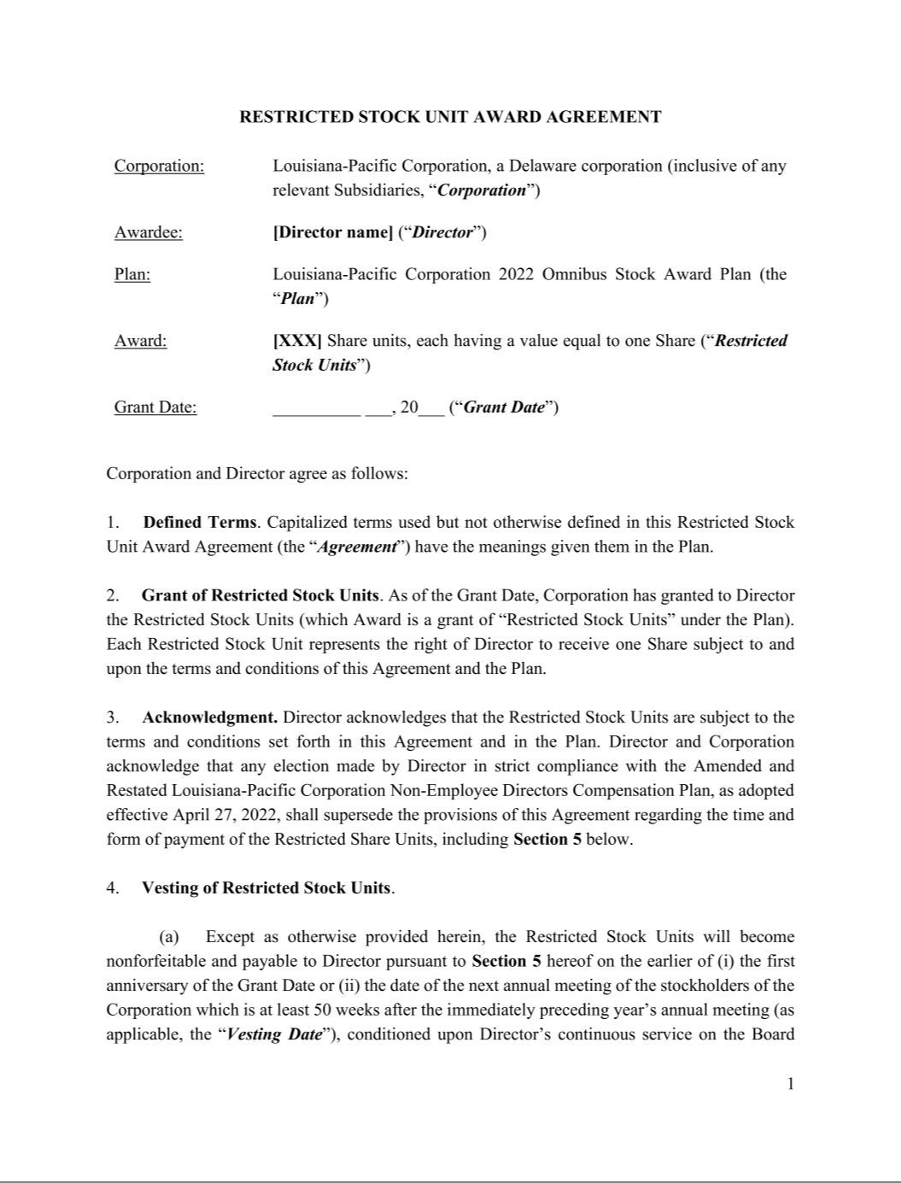

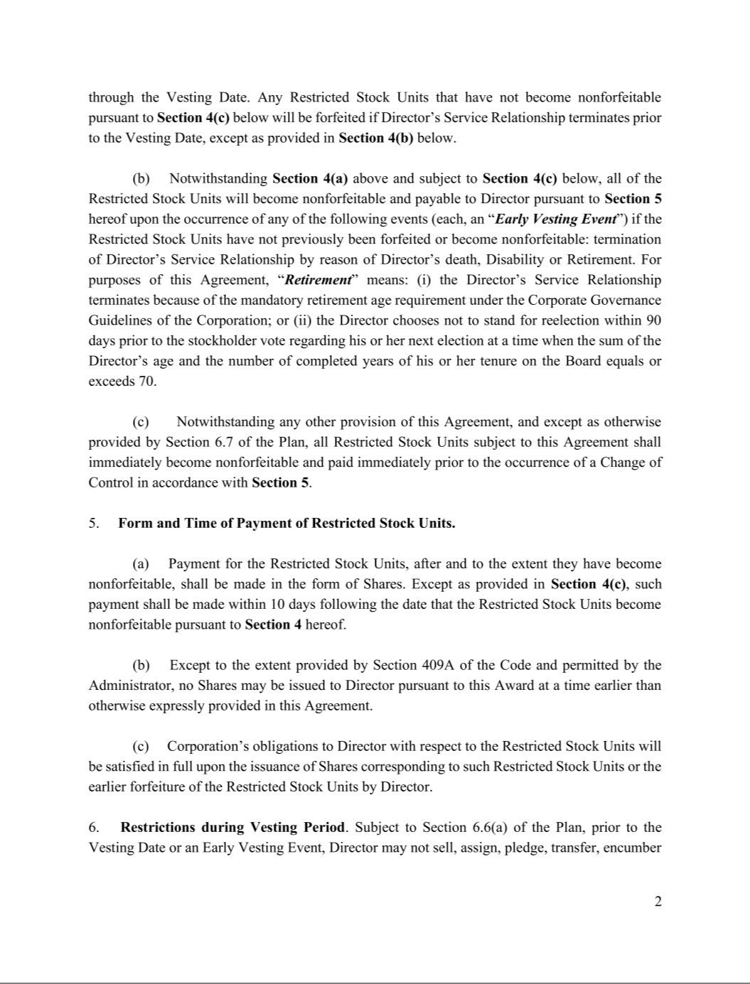

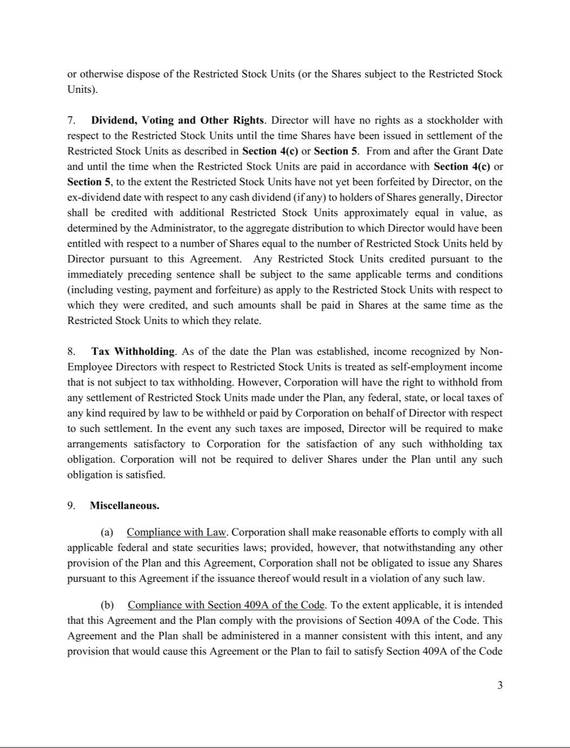

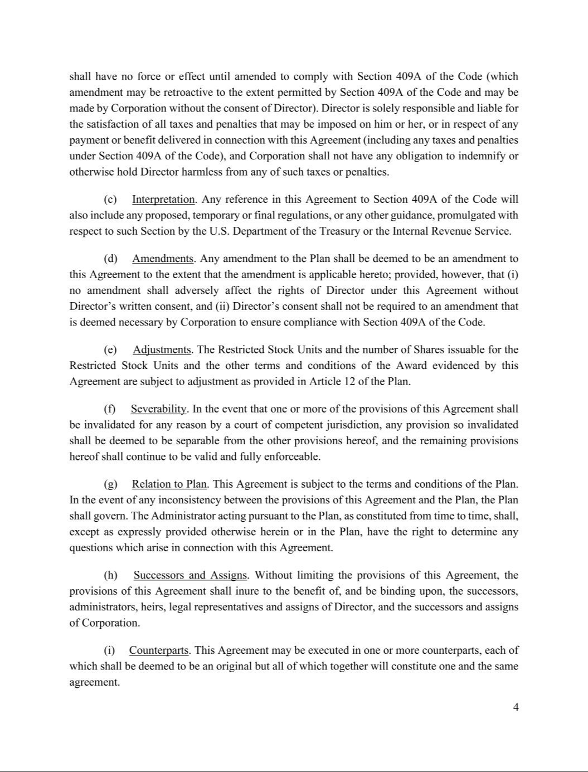

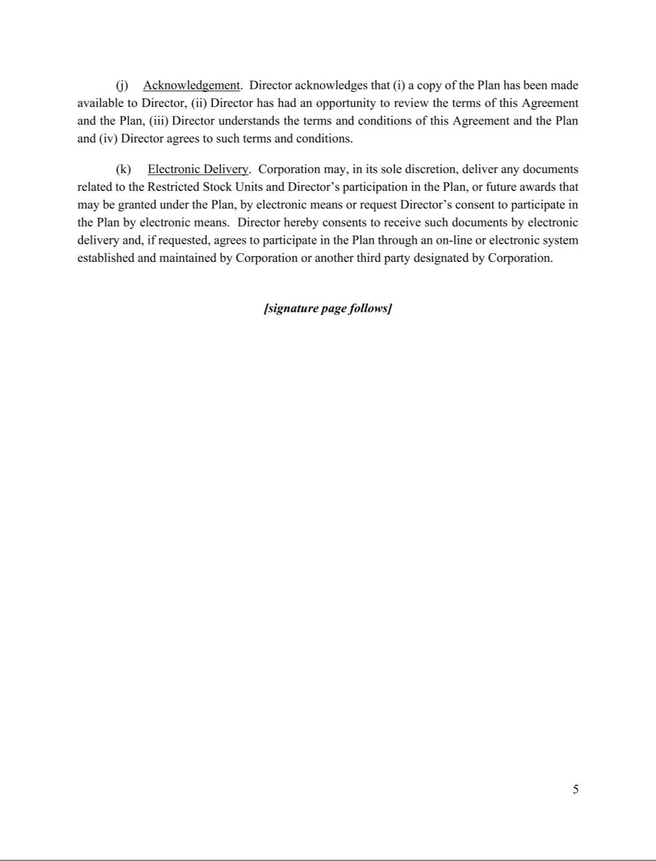

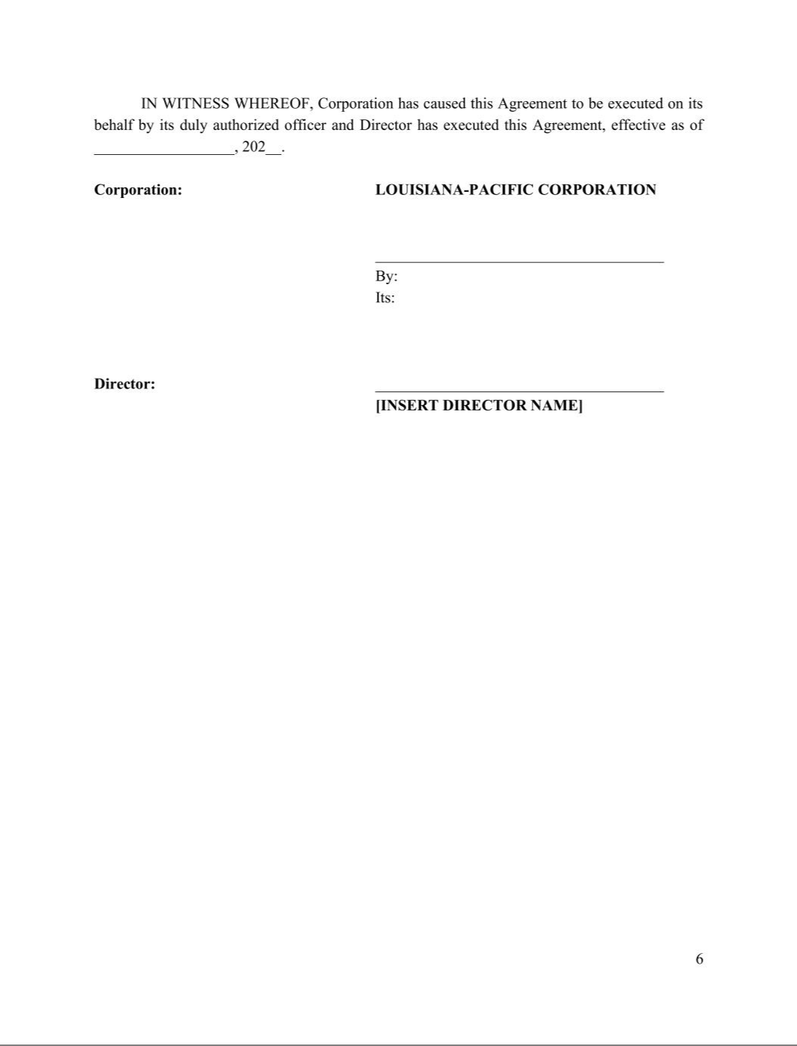

Exhibit 31.1

CERTIFICATIONS

I, W. Bradley Southern, certify that:

- I have reviewed this quarterly report on Form 10-Q of Louisiana-Pacific Corporation;

- Based on my knowledge, this report does not contain any untrue statement of a material fact or omit to state a material fact necessary to make the statements made, in light of the circumstances under which such statements were made, not misleading with respect to the period covered by this report;

- Based on my knowledge, the financial statements, and other financial information included in this report, fairly present in all material respects the financial condition, results of operations and cash flows of the registrant as of, and for, the periods presented in this report;

- The registrant’s other certifying officer and I are responsible for establishing and maintaining disclosure controls and procedures (as defined in Exchange Act Rules 13a-15(e) and 15d-15(e)) and internal control over financial reporting (as defined in Exchange Act Rules 13a-15(f) and 15d-15(f)) for the registrant and have:

- designed such disclosure controls and procedures, or caused such disclosure controls and procedures to be designed under our supervision, to ensure that material information relating to the registrant, including its consolidated subsidiaries, is made known to us by others within those entities, particularly during the period in which this report is being prepared;

- designed such internal control over financial reporting, or caused such internal control over financial reporting to be designed under our supervision, to provide reasonable assurance regarding the reliability of financial reporting and the preparation of financial statements for external purposes in accordance with generally accepted accounting principles;

- evaluated the effectiveness of the registrant’s disclosure controls and procedures and presented in this report our conclusions about the effectiveness of the disclosure controls and procedures, as of the end of the period covered by this report based on such evaluation; and

- disclosed in this report any change in the registrant's internal control over financial reporting that occurred during the registrant's most recent fiscal quarter (the registrant's fourth fiscal quarter in the case of an annual report) that has materially affected, or is reasonably likely to materially affect, the registrant's internal control over financial reporting; and

- The registrant’s other certifying officer and I have disclosed, based on our most recent evaluation of internal control over financial reporting, to the registrant’s auditors and the audit committee of the registrant’s board of directors (or persons performing the equivalent functions):

- all significant deficiencies and material weaknesses in the design or operation of internal control over financial reporting which are reasonably likely to adversely affect the registrant’s ability to record, process, summarize and report financial information; and

- any fraud, whether or not material, that involves management or other employees who have a significant role in the registrant’s internal control over financial reporting.

Date: August 6, 2025 | /s/ W. BRADLEY SOUTHERN
 | W. Bradley Southern
 | Chief Executive Officer

Exhibit 31.2

CERTIFICATIONS

I, Alan J.M. Haughie, certify that:

- I have reviewed this quarterly report on Form 10-Q of Louisiana-Pacific Corporation;

- Based on my knowledge, this report does not contain any untrue statement of a material fact or omit to state a material fact necessary to make the statements made, in light of the circumstances under which such statements were made, not misleading with respect to the period covered by this report;

- Based on my knowledge, the financial statements, and other financial information included in this report, fairly present in all material respects the financial condition, results of operations and cash flows of the registrant as of, and for, the periods presented in this report;

- The registrant’s other certifying officer and I are responsible for establishing and maintaining disclosure controls and procedures (as defined in Exchange Act Rules 13a-15(e) and 15d-15(e)) and internal control over financial reporting (as defined in Exchange Act Rules 13a-15(f) and 15d-15(f)) for the registrant and have:

- designed such disclosure controls and procedures, or caused such disclosure controls and procedures to be designed under our supervision, to ensure that material information relating to the registrant, including its consolidated subsidiaries, is made known to us by others within those entities, particularly during the period in which this report is being prepared;

- designed such internal control over financial reporting, or caused such internal control over financial reporting to be designed under our supervision, to provide reasonable assurance regarding the reliability of financial reporting and the preparation of financial statements for external purposes in accordance with generally accepted accounting principles;

- evaluated the effectiveness of the registrant’s disclosure controls and procedures and presented in this report our conclusions about the effectiveness of the disclosure controls and procedures, as of the end of the period covered by this report based on such evaluation; and

- disclosed in this report any change in the registrant's internal control over financial reporting that occurred during the registrant's most recent fiscal quarter (the registrant's fourth fiscal quarter in the case of an annual report) that has materially affected, or is reasonably likely to materially affect, the registrant's internal control over financial reporting; and

- The registrant’s other certifying officer and I have disclosed, based on our most recent evaluation of internal control over financial reporting, to the registrant’s auditors and the audit committee of the registrant’s board of directors (or persons performing the equivalent functions):

- all significant deficiencies and material weaknesses in the design or operation of internal control over financial reporting which are reasonably likely to adversely affect the registrant’s ability to record, process, summarize and report financial information; and

- any fraud, whether or not material, that involves management or other employees who have a significant role in the registrant’s internal control over financial reporting.

Date: August 6, 2025 | /s/ ALAN J.M. HAUGHIE
 | Alan J.M. Haughie
 | Executive Vice President and
 | Chief Financial Officer

Exhibit 32

Certifications of Chief Executive Officer and Chief Financial Officer Pursuant to 18 U.S.C. § 1350 as Adopted Pursuant to Section 906 of the Sarbanes-Oxley Act of 2002

Pursuant to 18 U.S.C. § 1350, as adopted pursuant to Section 906 of the Sarbanes-Oxley Act of 2002, in connection with the Quarterly Report on Form 10-Q of Louisiana-Pacific Corporation (the “Company”) for quarter ended June 30, 2025, as filed with the Securities and Exchange Commission on the date hereof (the “Report”), each of the undersigned officers of the Company certifies, that, to such officer’s knowledge:

- The Report fully complies with the requirements of Section 13(a) or 15(d) of the Securities Exchange Act of 1934, as amended; and

- The information contained in the Report fairly presents, in all material respects, the financial condition and results of operations of the Company as of the dates and for the periods expressed in the Report.

Date: August 6, 2025

/s/ W. BRADLEY SOUTHERN

Name: W. Bradley Southern
Title: Chief Executive Officer

/s/ ALAN J.M. HAUGHIE

Name: Alan J.M. Haughie

Title: Executive Vice President and Chief Financial Officer

A signed original of this written statement required by Section 906 has been provided to Louisiana-Pacific Corporation and will be retained by Louisiana-Pacific Corporation and furnished to the Securities and Exchange Commission or its staff upon request.

