UNITED STATES

SECURITIES AND EXCHANGE COMMISSION

Washington, D.C. 20549

_____________________________

FORM 10-K

- ANNUAL REPORT PURSUANT TO SECTION 13 OR 15(d) OF THE SECURITIES EXCHANGE ACT OF 1934:

For the Fiscal Year Ended December 31, 2021

Or

o TRANSITION REPORT PURSUANT TO SECTION 13 OR 15(d) OF THE SECURITIES EXCHANGE ACT OF 1934

For the transition period from to

Commission File Number 1-7107

LOUISIANA-PACIFIC CORPORATION

(Exact name of registrant as specified in its charter)

 |  | Delaware |  |  |  |  |  | 93-0609074
 | (State of Incorporation) |  |  |  |  |  |  |  | (I.R.S. Employer
 |  |  |  |  |  |  |  |  | Identification No.)
414 Union Street |  | Suite 2000
Nashville |  |  | TN | 37219 |  |  |  | (615) 986 - 5600
(Address of principal executive offices) |  |  |  |  |  |  |  |  | (Registrant’s telephone number
 |  |  |  |  |  |  |  |  | including area code)
 |  |  |  | Securities registered pursuant to Section 12(b) of the Act:
 | Title of Each Class |  |  | Trading Symbol |  |  |  |  | Name of Each Exchange on Which Registered
Common Stock, $1 par value |  |  |  |  | LPX |  |  |  | New York Stock Exchange
 |  |  |  | Securities registered pursuant to Section 12(g) of the Act: None
 |  |  |  | _____________________________ |  |  |  | ☐
Indicate by check mark if the registrant is a well-known seasoned issuer as defined in Rule 405 of the Securities Act. Yes ☒ |  |  |  |  |  |  | No
Indicate by check mark if the registrant is not required to file reports pursuant to Section 13 or Section 15(d) of the Act. Yes |  |  |  |  |  |  | ☐ | No ☒

Indicate by check mark whether the registrant (1) has filed all reports required to be filed by Section 13 or 15(d) of the Securities Exchange Act of 1934 during the preceding 12 months (or for such shorter period that the registrant was required to file such reports), and (2) has been subject to such filing requirements for the past 90 days. Yes ☒ No ☐

Indicate by check mark whether the registrant has submitted electronically every Interactive Data File required to be submitted pursuant to Rule 405 of Regulation S-T (§ 232.405 of this chapter) during the preceding 12 months (or for
such shorter period that the registrant was required to submit such files). Yes ☒ No ☐

Indicate by check mark whether the registrant is a large accelerated filer, an accelerated filer, a non-accelerated filer, a smaller reporting company, or an emerging growth company. See the definitions of “large accelerated filer,” “accelerated filer,” “smaller reporting company,” and “emerging growth company” in Rule 12b-2 of the Exchange Act.

Large accelerated filer | x | Accelerated filer | ☐
Non-accelerated filer | ☐ | Smaller reporting company | ☐
Non-accelerated filer | ☐ | Smaller reporting company | ☐
Emerging growth company | ☐

If an emerging growth company, indicate by check mark if the registrant has elected not to use the extended transition period for complying with any new or revised financial accounting standards provided pursuant to Section 13(a) of the Exchange Act. o

Indicate by check mark whether the registrant has filed a report on and attestation to its management’s assessment of the effectiveness of its internal control over financial reporting under Section 404(b) of the Sarbanes-Oxley Act (15 U.S.C. 7262(b)) by the registered public accounting firm that prepared or issued its audit report. ☒

Indicate by check mark whether the registrant is a shell company (as defined in Rule 12b-2 of the Exchange Act): Yes ☐ No ☒

State the aggregate market value of the voting and non-voting common equity held by non-affiliates computed by reference to the price at which the common equity was sold, or the average bid and asked price of such common equity, as of the last business day of the registrant’s most recently completed second fiscal quarter: $5,143,093,012.

Indicate the number of shares outstanding of each of the registrant’s classes of common stock as of the latest practicable date: 85,857,037 shares of Common Stock, $1 par value, outstanding as of February 17, 2022.

Documents Incorporated by Reference

Certain portions of the registrant's Definitive Proxy Statement for its 2022 Annual Meeting of Stockholders (which is expected to be filed with the Securities and Exchange Commission within 120 days after the end of the registrant's 2021 fiscal year) are incorporated by reference into Part III by this annual report on Form 10-K.

Except as otherwise specified and unless the context otherwise requires, references to “LP,” the “Company,” “we,” “us,” and “our” refer to Louisiana-Pacific Corporation and its subsidiaries.

CAUTIONARY STATEMENT REGARDING FORWARD-LOOKING STATEMENTS

Section 27A of the Securities Act of 1933, as amended, and Section 21E of the Securities Exchange Act of 1934, as amended (the Exchange Act), provide a “safe harbor” for forward-looking statements to encourage companies to provide prospective information about their businesses and other matters as long as those statements are identified as forward-looking and are accompanied by meaningful cautionary statements identifying important factors that could cause actual results to differ materially from those discussed in the statements. This annual report on Form 10-K contains, and other reports and documents we file with, or furnish to, the Securities and Exchange Commission (SEC) may contain forward-looking statements. These statements are based upon the beliefs and assumptions of, and on information available to, our management.

The following statements are or may constitute forward-looking statements: (1) statements preceded by, followed by or that include words like “may,” “will,” “could,” “should,” “believe,” “expect,” “anticipate,” “intend,” “plan,” “estimate,” “project,” “potential,” “continue,” “likely,” or “future” or the negative or other variations thereof and (2) other statements regarding matters that are not historical facts, including without limitation, plans for product development, forecasts of future costs and expenditures, possible outcomes of legal proceedings, capacity expansion, and other growth initiatives, and the adequacy of reserves for loss contingencies.

Factors that could cause actual results to differ materially from those expressed or implied by the forward-looking statements include, but are not limited to, the following:

- impacts from public health issues (including global pandemics, such as the ongoing COVID-19 pandemic) on the economy, demand for our products or our operations, including the actions and recommendations of governmental authorities to contain such public health issues;
- changes in governmental fiscal and monetary policies, including tariffs and levels of employment;

- changes in general economic conditions, including impacts from the ongoing COVID-19 pandemic;

- changes in the cost and availability of capital;

- changes in the level of home construction and repair and remodel activity;

- changes in competitive conditions and prices for our products;

- changes in the relationship between supply of and demand for building products;

- changes in the financial or business conditions of third-party wholesale distributors and dealers;

- changes in the relationship between supply of and demand for raw materials, including wood fiber and resins, used in manufacturing our products;

- changes in the cost and availability of energy, primarily natural gas, electricity, and diesel fuel;

- changes in the cost and availability of transportation;

- impact of manufacturing our products internationally;

- difficulties in the launch or production ramp-up of newly introduced products;

- unplanned interruptions to our manufacturing operations, such as explosions, fires, inclement weather, natural disasters, accidents, equipment failures, labor shortages or disruptions, transportation interruptions, supply interruptions, public health issues (including pandemics and quarantines), riots, civil insurrection or social unrest, looting, protests, strikes, and street demonstrations;
- changes in other significant operating expenses;

- changes in currency values and exchange rates between the U.S. dollar and other currencies, particularly the Canadian dollar, Brazilian real, and Chilean peso;

- changes in, and compliance with, general and industry-specific laws and regulations, including environmental and health and safety laws and regulations, the U.S. Foreign Corrupt Practices Act and anti-bribery laws, laws related to our international business operations, and changes in building codes and standards;
- changes in tax laws and interpretations thereof;

- changes in circumstances giving rise to environmental liabilities or expenditures;

- warranty costs exceeding our warranty reserves;

- challenge to or exploitation of our intellectual property or other proprietary information by others in the industry;

- changes in the funding requirements of our defined benefit pension plans;

1

- the resolution of existing and future product-related litigation, environmental proceedings and remediation efforts, and other legal or environmental proceedings or matters;

- the effect of covenants and events of default contained in our debt instruments;

- the amount and timing of any repurchases of our common stock and the payment of dividends on our common stock, which will depend on market and business conditions and other considerations; and
- acts of public authorities, war, civil unrest, natural disasters, fire, floods, earthquakes, inclement weather, and other matters beyond our control.

In addition to the foregoing and any risks and uncertainties specifically identified in the text surrounding forward-looking statements, any statements in the reports and other documents filed by us with the SEC that warn of risks or uncertainties associated with future results, events, or circumstances identify important factors that could cause actual results, events, and circumstances to differ materially from those reflected in the forward-looking statements.

The forward-looking statements that we make or that are made by others on our behalf are based on our knowledge of our business and our operating environment and assumptions that we believe to be or will believe to be reasonable when such forward-looking statements were or are made. As a consequence of the factors described above, the other risks, uncertainties, and factors we disclose below and in the reports and other documents filed by us with the SEC, other risks not known to us at this time, changes in facts, assumptions not being realized or other circumstances, our actual results may differ materially from those discussed in or implied or contemplated by our forward-looking statements. Consequently, this cautionary statement qualifies all forward-looking statements we make or that are made on our behalf, including those made herein and incorporated by reference herein. We cannot assure you that the results or developments expected or anticipated by us will be realized or, even if substantially realized, that those results or developments will result in the expected consequences for us or affect us, our business, our operations or our operating results in the manner or to the extent we expect. We caution readers not to place undue reliance on such forward-looking statements, which speak only as of their dates. We undertake no obligation to revise or update any of the forward-looking statements to reflect subsequent events or circumstances except to the extent required by applicable law.

ABOUT THIRD-PARTY INFORMATION

In this annual report on Form 10-K, we rely on and refer to information regarding industry data obtained from market research, publicly available information, industry publications, U.S. government sources, and other third parties. Although we believe the information is reliable, we cannot guarantee the accuracy or completeness of the information and have not independently verified it.

2

 |  |  |  |  |  |  |  |  |  |  |  |  |  |  | TABLE OF CONTENTS
 | PART I
 | Item 1 |  |  |  |  | BUSINESS |  |  |  |  |  |  |  |  |  |  |  |  |  |  |  |  |  |  |  |  | 4
 | Item 1A |  |  |  |  | RISK FACTORS |  |  |  |  |  |  |  |  |  |  |  |  |  |  |  |  |  |  |  |  | 13
 | Item 1B |  |  |  |  | UNRESOLVED STAFF COMMENTS |  |  |  |  |  |  |  |  |  |  |  |  |  |  |  |  |  |  |  |  | 22
 | Item 2 |  |  |  |  | PROPERTIES |  |  |  |  |  |  |  |  |  |  |  |  |  |  |  |  |  |  |  |  | 23
 | Item 3 |  |  |  |  | LEGAL PROCEEDINGS |  |  |  |  |  |  |  |  |  |  |  |  |  |  |  |  |  |  |  |  | 24
 | Item 4 |  |  |  |  | MINE SAFETY DISCLOSURES |  |  |  |  |  |  |  |  |  |  |  |  |  |  |  |  |  |  |  |  | 24
 | PART II
 | Item 5 |  |  |  |  | MARKET FOR REGISTRANT’S COMMON EQUITY, RELATED STOCKHOLDER MATTERS, AND ISSUER PURCHASES |  |  |  |  |  |  |  |  |  |  |  |  |  |  |  |  |  |  |  |  | 25
 |  |  |  |  |  | OF EQUITY SECURITIES |  |  |  |  |  |  |  |  |  |  |  |  |  |  |  |  |  |  |  |  | 25
 | Item 6 |  |  |  |  | RESERVED |  |  |  |  |  |  |  |  |  |  |  |  |  |  |  |  |  |  |  |  | 27
 | Item 7 |  |  |  |  | MANAGEMENT’S DISCUSSION AND ANALYSIS OF FINANCIAL CONDITION AND RESULTS OF OPERATIONS |  |  |  |  |  |  |  |  |  |  |  |  |  |  |  |  |  |  |  |  | 27
 | Item 7A |  |  |  |  | QUANTITATIVE AND QUALITATIVE DISCLOSURES ABOUT MARKET RISK |  |  |  |  |  |  |  |  |  |  |  |  |  |  |  |  |  |  |  |  | 41
 | Item 8 |  |  |  |  | FINANCIAL STATEMENTS AND SUPPLEMENTARY DATA |  |  |  |  |  |  |  |  |  |  |  |  |  |  |  |  |  |  |  |  | 42
 | Item 9 |  |  |  |  | CHANGES IN AND DISAGREEMENTS WITH ACCOUNTANTS ON ACCOUNTING AND FINANCIAL DISCLOSURE |  |  |  |  |  |  |  |  |  |  |  |  |  |  |  |  |  |  |  |  | 85
 | Item 9A |  |  |  |  | CONTROLS AND PROCEDURES |  |  |  |  |  |  |  |  |  |  |  |  |  |  |  |  |  |  |  |  | 85
 | Item 9B |  |  |  |  | OTHER INFORMATION |  |  |  |  |  |  |  |  |  |  |  |  |  |  |  |  |  |  |  |  | 87
 | Item 9C |  |  |  |  | DISCLOSURE REGARDING FOREIGN JURISDICTIONS THAT PREVENT INSPECTIONS |  |  |  |  |  |  |  |  |  |  |  |  |  |  |  |  |  |  |  |  | 87
 | PART III
 | Item 10* |  |  |  |  | DIRECTORS, EXECUTIVE OFFICERS AND CORPORATE GOVERNANCE |  |  |  |  |  |  |  |  |  |  |  |  |  |  |  |  |  |  |  |  | 88
 | Item 11* |  |  |  |  | EXECUTIVE COMPENSATION |  |  |  |  |  |  |  |  |  |  |  |  |  |  |  |  |  |  |  |  | 88
 | Item 12* |  |  |  |  | SECURITY OWNERSHIP OF CERTAIN BENEFICIAL OWNERS AND MANAGEMENT AND RELATED STOCKHOLDER |  |  |  |  |  |  |  |  |  |  |  |  |  |  |  |  |  |  |  |  | 88
 |  |  |  |  |  | MATTERS |  |  |  |  |  |  |  |  |  |  |  |  |  |  |  |  |  |  |  |  | 88
 | Item 13* |  |  |  |  | CERTAIN RELATIONSHIPS AND RELATED TRANSACTIONS, AND DIRECTOR INDEPENDENCE |  |  |  |  |  |  |  |  |  |  |  |  |  |  |  |  |  |  |  |  | 89
 | Item 14* |  |  |  |  | PRINCIPAL ACCOUNTANT FEES AND SERVICES |  |  |  |  |  |  |  |  |  |  |  |  |  |  |  |  |  |  |  |  | 89
 | PART IV
 | Item 15 |  |  |  |  | EXHIBITS AND FINANCIAL STATEMENT SCHEDULES |  |  |  |  |  |  |  |  |  |  |  |  |  |  |  |  |  |  |  |  | 90
 | Item 16 |  |  |  |  | FORM 10-K SUMMARY |  |  |  |  |  |  |  |  |  |  |  |  |  |  |  |  |  |  |  |  | 93

- All or a portion of the referenced section is incorporated by reference from our Definitive Proxy Statement for our 2022 Annual Meeting of the Stockholders (which is expected to be filed with the SEC within 120 days after the end of our 2021 fiscal year).

3

PART I

ITEM 1. Business

General

We are a leading provider of high-performance building solutions that meet the demands of builders, remodelers, and homeowners worldwide. We have leveraged our expertise serving the new home construction, repair and remodeling, and outdoor structures markets to become an industry leader known for innovation, quality, and reliability. Our customers are primarily homebuilding, retail, wholesale, and industrial businesses. Since our founding in 1972, LP has been Building a Better World™ by helping customers construct beautiful, durable homes. We are headquartered in Nashville, Tennessee, and as of December 31, 2021, we operated 25 plants across the U.S., Canada, Chile, and Brazil.

The table below summarizes the relative sizes of our business segments in 2021:
 | Segment |  |  | Net Sales |  | Percentage of 2021 Net Sales
 |  |  |  | (in millions) |  | Percentage of 2021 Net Sales
 | Siding |  | $ | 1,170 |  | 26 %
 | Oriented Strand Board (OSB) |  |  | 2,387 |  | 52 %
 | Engineered Wood Products (EWP) |  |  | 638 |  | 14 %
 | South America |  |  | 265 |  | 6 %
 | Other |  |  | 95 |  | 2 %
 | Intersegment |  |  | (3) |  | — %
 |  |  | $ | 4,553

Our Business Segments

Siding

We believe that we are the largest producer of engineered wood siding. Our Siding segment serves diverse end markets with a broad product offering, including LP® SmartSide® Trim & Siding, LP® SmartSide® ExpertFinish® Trim & Siding, LP BuilderSeries® Lap Siding, and LP® Outdoor Building Solutions® (collectively referred to as Siding Solutions). Our Siding Solutions products consist of a full line of engineered wood siding, trim, soffit, and fascia. These products offer superior protection against hail, wind, moisture, fungal decay, and termites compared to solid wood. These products are used in new home construction, repair and remodeling projects, and outdoor structures such as sheds.

We intend to continue growing Siding sales and increase the breadth of our Siding product offerings. To do so, we plan to increase the production capacity of these higher-margin, value-added products through the addition of new plants, additional conversion of existing OSB plants to Siding manufacturing plants, expansion of our capacity at existing Siding facilities, and expansion of our
pre-finished (primed and painted) offerings. We will also continue to drive product innovation by utilizing our technological expertise in wood composites, overlays, chemical treatments, and durable and beautiful paints to better address the needs of our customers.

Oriented Strand Board (OSB)

OSB is a structural building product made from wood strands, arranged in layers, and bonded with resin and wax. OSB serves many of the same uses as plywood, including roof decking, sidewall sheathing and floor underlayment,

4

but less expensive and more sustainable. Our OSB segment manufactures and distributes OSB structural panel products, including our innovative value-added OSB portfolio known as LP Structural Solutions (which includes LP® TechShield® Radiant Barrier, LP WeatherLogic® Air & Water Barrier, LP Legacy® Premium Sub-Flooring, LP® FlameBlock® Fire-Rated Sheathing, and LP® TopNotch® Sub-Flooring).

We intend to continue to grow sales of our Structural Solutions portfolio as a percentage of our total production and to aggressively manage cost through (i) the efficiency with which we operate our manufacturing facilities (measured in Overall Equipment Effectiveness, or OEE), (ii) the efficiency with which we convert sustainably harvested wood fiber into our products, and (iii) our ongoing work to optimize logistics and reduce other costs.

Engineered Wood Products (EWP)

Our EWP segment is comprised of LP® SolidStart® I-Joist (I-Joist), Laminated Veneer Lumber (LVL), and other related products. This segment also includes the sale of I-Joists produced by our joint venture with Resolute Forest Products, Inc., as well as plywood manufactured by our LVL operations in Golden, British Columbia. During 2021, we ceased Laminated Strand Lumber (LSL) production at our Houlton, Maine facility to begin the conversion of that facility to Siding Solutions production.

In North America, we are one of the top three producers (including our joint venture production) of I-Joists and LVL. We believe that our engineered I-Joists, which are used primarily in residential and commercial flooring and roofing systems and other structural applications, are stronger, lighter, straighter, and more sustainable than conventional lumber joists of similar dimensions. Our LVL is a high-grade, value-added structural product used in applications where extra strength and quality are required, such as headers and beams.

We continue to explore strategic alternatives with respect to the remaining EWP segment, including a possible sale in whole or in part, as previously announced.

South America

Our South American segment manufactures and distributes OSB structural panel and siding products in South America and certain export markets. This segment also distributes and sells related products to encourage the region’s transition to wood frame construction. This segment has manufacturing operations in two countries, Chile and Brazil, and operates sales offices in Chile, Brazil, Peru, Colombia, Argentina, and Paraguay. We believe that we are the leading producer of OSB and siding in South America, and we are positioned to capitalize on the growing demand for wood-based residential construction in South America.

Our Business Strategy

Grow Our Siding Business. We believe that our leadership position in treated engineered wood siding allows us to benefit from demand growth, particularly as sustainable engineered wood continues to displace alternative siding materials such as vinyl, fiber cement, and other materials. We have consistently grown our Siding segment above the underlying market growth rates, and this segment is less sensitive to new housing market cyclicality as over 50% of Siding Solutions demand comes from other markets, including sheds and repair and remodeling. We believe that long-term market trends and demographics suggest continued growth in demand for sustainable engineered wood siding in these markets, which we are well-positioned to meet.

During 2021, we announced a phased capacity expansion strategy for Siding Solutions. This expansion strategy includes the conversion of our OSB mill in Sagola, Michigan, to Siding Solutions production sometime after siding production begins at our Houlton, Maine mill. The conversion of these two facilities will add approximately 520 million square feet of Siding Solutions capacity and remove 670 million square feet of OSB capacity (on a 3/8” basis).

Generate Value-Added Sales Growth Through Customer Focus and Innovation. We believe that our products help customers address labor shortages because they are easy to work with and often combine multiple steps into a

5

single product system. Our marketing efforts drive awareness and a greater understanding of our products’ potential with builders, repair and remodel contractors, industrial manufacturers, and major home improvement retailers. Through our sales efforts we target customers by distribution channel and focus on providing them with a broad array of traditional and specialty building products coupled with quality service. Our strategically located facilities in the U.S., Canada, Chile, and Brazil allow us to be closer to our customers and more responsive to their changing needs. We prioritize high-quality service and continue to build on our reputation for on-time shipments. In addition, we continually seek to identify new specialty building solutions and markets where we can utilize our core competencies in the design, manufacturing, and marketing of building products.

Focus on Operating Efficiency, Cost Reduction, and Portfolio Optimization. We continue to improve the OEE of our manufacturing facilities. Our OEE programs have produced excellent returns and generated many best practices that have been applied across our manufacturing system. Given these initiatives and the strategic locations of many of our facilities, we believe that we are very competitive regarding average delivered cost.

As market conditions change, we will continue to adapt our product mix, selectively invest in new technologies that modernize our manufacturing facilities, and manage our capacity to best match customer demand. We believe that these strategies optimize our portfolio and margins and enhance the quality and consistency of our earnings.

Pursue Selected Strategic Transactions. We continuously evaluate strategic investments in assets, businesses, and technologies, as well as the performance of our businesses. We believe that our pursuit of these opportunities, if successful, could enable us to increase the size and scope of our businesses or joint ventures.

We continue to explore strategic alternatives with respect to the EWP segment, including a possible sale in whole or in part, as previously announced. We can give no assurance as to whether we will be able to identify any strategic alternatives that are likely to increase value to our stockholders.

Expand Internationally. We believe that our investments in South America will help us continue to satisfy the growing demand for wood-based residential construction in this region. Continued investments as a market leader in this region should allow us to capitalize on demand while diversifying our revenue mix and market cyclicality.

Our Market

Our sales and marketing efforts are primarily focused on traditional distribution, professional building products dealers, home centers, third-party wholesale buying groups, and end-users, particularly homeowners. The wholesale distribution channel includes a variety of specialized and broad-line wholesale distributors and dealers focused primarily on the supply of products for use by professional builders and contractors. The retail distribution channel includes large retail chains catering to the do-it-yourself (DIY) and repair and remodeling markets as well as smaller independent retailers.

Our Customers

We seek to maintain a broad customer base and a balanced approach to national distribution through both wholesale and retail channels. In 2021, our top ten customers accounted for approximately 43% of our sales. Our principal customers include the following:

- Wholesale distribution companies, which supply building materials to retailers on a regional, state, or local basis;

- Distributors, who provide building materials to smaller retailers, contractors, and others;

- Building materials professional dealers that specialize in sales to professional builders, remodeling firms, and trade contractors that are involved in residential home construction and light commercial building;

- Retail home centers that provide access to consumer markets with a broad selection of home improvement

6

materials and increasingly serve professional builders, DIY remodelers, and trade contractors; and

- Shed producers that design, construct, and distribute prefabricated residential and light commercial structures, including fully manufactured, modular, and panelized structures, for consumer and professional markets.

Our Competitors / Competition

The building products industry is highly competitive. We compete internationally with several thousand forest and building products firms, ranging from very large, fully integrated firms to smaller enterprises that may manufacture a few items. We also compete less directly with firms that manufacture substitutes for wood building products.

Our specialty products, including Siding Solutions, Structural Solutions, and EWP I-Joist and LVL, generally compete based on product features, benefits, quality, and availability. Our commodity OSB generally competes based on price, quality, and availability of products.

Our Manufacturing

We operate manufacturing facilities throughout North and South America. Our facilities utilize the best available manufacturing techniques based on the needs of our businesses, and we continuously work to improve efficiency and productivity, as measured by OEE. We currently operate 22 strategically located manufacturing and production facilities in the U.S. and Canada, two facilities in Chile, and one facility in Brazil. We also operate additional facilities through our joint ventures in North America.

Strategic Sourcing

We rely on various suppliers to furnish the raw materials and inputs used in the manufacturing of our products. To maximize our buying effectiveness in the marketplace, we have a central strategic sourcing group that consolidates purchases of certain materials and indirect items across business segments. The goal of the strategic sourcing group is to develop global strategies for a given component group, identify suppliers that meet our business requirements, and develop long-term relationships with these vendors. By developing these strategies and relationships, we seek to leverage our material needs to implement leading practices, reduce costs, improve process efficiency, improve operating performance. and ensure continuity of supply.

Raw Materials

Wood fiber is the primary raw material used in most of our operations, and the primary source of wood fiber is timber. The primary end-markets for timber harvested in North America are manufacturers who supply: (1) the housing market where it is used in the construction of new housing and the repair and remodeling of existing housing; (2) the pulp and paper market; (3) commercial and industrial markets; (4) export markets; and (5) emerging biomass energy production markets. The supply of timber is limited by the availability of and access to timberlands. The availability of timberlands, in turn, is limited by several factors, including policies governing forest management, alternate uses of land, and loss to urban or suburban real estate development. Because wood fiber is subject to commodity pricing, the cost of various types of timber that we purchase in the market has, at times, fluctuated greatly due to weather, governmental regulations, or economic and other industry conditions. However, our mills are generally located near large and diverse supplies of timber. We source all our wood fiber sustainably, as certified against Sustainable Forestry Initiative® (SFI®) and Programme for the Endorsement of Forest Certification (PEFC®) standards.

In addition to wood fiber, we use significant quantities of various resins in our manufacturing processes. Resin product costs are influenced by changes in the prices of raw materials used to produce resin, primarily petroleum products and energy, as well as competing demand for resin products. Currently, we purchase most of our resin from four major suppliers. However, there can be no assurance that pricing or availability of resins will not be impacted by competing demand or supply chain disruptions due to significant weather or other uncontrollable events.

7

While a significant portion of our energy requirements are met at our plants by the energy produced from the conversion of wood waste, we also purchase electricity and natural gas. Energy prices have experienced significant volatility in recent years, particularly in deregulated markets. We attempt to mitigate our exposure to energy price changes through the selective use of long-term supply agreements.

Seasonality

Our business is subject to seasonal variances, with demand for many of our products tending to be higher during the building season, which generally occurs in the second and third quarters in North America and the fourth and first quarters in South America. We do this in an effort to better balance our inventory levels with demand, manage the logistics of our product shipments, and allow our production facilities to run efficiently.

Government Regulation

Our operations are subject to the laws and regulations of the United States and multiple foreign jurisdictions. These regulations, which differ among jurisdictions, include those related to financial and other disclosures, accounting standards, corporate governance, intellectual property, tax, trade, antitrust, employment, immigration and travel regulations, privacy, and anti-corruption. Additional information concerning legal and regulatory matters is set forth under “Risk Factors – Legal and Regulatory Risk Factors” in Item 1A of this annual report on Form 10-K.

We are subject to income taxes in the United States and foreign jurisdictions. Our provision for income taxes and the effective tax rate could be affected by numerous factors, including changes in applicable tax laws, interpretations of applicable tax laws, the amount and composition of pre-tax income in jurisdictions with differing tax rates, and the valuation of deferred tax assets. Additional information concerning tax matters is set forth under “Risk Factors – Legal and Regulatory Risk Factors - Regulatory and statutory changes applicable to us or our customers, including changes in effective tax rates or tax law, could adversely affect our financial condition and results of operations” in Item 1A of this annual report on Form 10-K, and in Note 9 of the Notes to the Consolidated Financial Statements included in Item 8 of this annual report on Form 10-K.

Our operations are also subject to many environmental laws and regulations governing, among other things, the discharge of pollutants and other emissions on or into the land, water, and air, the disposal of hazardous substances or other contaminants, the remediation of contamination, and the restoration and reforestation of timberlands. In addition, certain environmental laws and regulations impose liability and responsibility on present and former owners, operators, or users of facilities and sites for contamination at such facilities and sites without regard to causation or knowledge of contamination. Compliance with environmental laws and regulations can significantly increase the costs of our operations. In some cases, plant closures can invoke more rigorous compliance requirements. Violations of environmental laws and regulations can subject us to additional costs and expenses, including defense costs and expenses and civil and criminal penalties. We cannot guarantee that the environmental laws and regulations to which we are subject will not become more stringent or be more stringently implemented or enforced in the future.

Changes in global or regional climate conditions and current or future governmental responses to such changes at the international, U.S. federal, and state levels, such as regulating and/or taxing the production of carbon dioxide and other “greenhouse gases” to facilitate the reduction of emissions into the atmosphere, and/or the imposition of taxes or other incentives to produce and use “cleaner” energy, may increase energy costs, limit harvest levels, and impact our operations or our planned or future growth. Because our manufacturing operations depend on significant amounts of energy and raw materials, these initiatives could have an adverse impact on our operations and profitability. Future legislation or regulatory activity in this area remains uncertain, as does the potential impact on our operations.

We are committed to complying with all applicable environmental laws and regulations and intend to devote significant management attention to such matters. In addition, we occasionally undertake construction projects for environmental control equipment or incur other environmental costs that extend an asset’s useful life, improve its

8

efficiency, and/or improve the property's marketability.

Additional information concerning environmental matters is set forth under Item 3, Legal Proceedings, and in Note 15 of the Notes to the Consolidated Financial Statements included in Item 8 of this annual report on Form 10-K.

Workforce and Employee Relations

Our employees are our most important asset, and they are integral to our ability to achieve our strategic objectives. The continued success and growth of our business depends, in large part, on our ability to attract, retain, and develop a diverse population of talented and high-performing employees at all levels. We have developed key recruitment and retention strategies, objectives, and measures that we focus on as part of the overall management of LP, which will continue to support our efforts to succeed in a competitive labor market. These strategies, objectives, and measures are the basis of our workforce management framework and are advanced through the following programs, policies, and initiatives:

Labor Relations: We are committed to working collaboratively with the unions that represent some of our employees. As of December 31, 2021, we employed approximately 4,800 team members, of which approximately 2,800, 1,200, and 800 were employed in the United States, Canada, and South America, respectively. Approximately 4,200 were employed at manufacturing facilities, and 1,600 team members were subject to collective bargaining agreements and/or national trade union agreements.

Health, Safety, and Wellness: We are committed to the health, safety, and wellness of our employees. Safety is a core principle and key-value at LP, and we safeguard our people, projects, and reputation by maintaining a safety culture that strives to eliminate workplace incidents, risks, and hazards. Our innovative safety and health processes are at the forefront of everything we do. We provide our employees, contractors, and guests with ongoing safety training to ensure that safety policies and procedures are effectively communicated and implemented. We also aim to start every meeting, every mill tour, and every morning at our manufacturing facilities with a message about safety. The success of our business is fundamentally connected to the safety and well-being of our people.

LP is committed to continual improvement of our health and safety performance. We establish internal, annual targets and seek continual safety performance improvements every year. One of the metrics that we carefully track is Total Incident Rate (TIR), a common industry measure of recordable incidents per 100 employees. We have established a targeted TIR of <1.0, which we believe represents industry-leading performance. We use this data to prioritize, manage, and carefully track safety performance at all our facilities and integrate sound safety practices to make a meaningful difference in every facet of our operations. To further enhance our commitment to safety, we have also implemented a Serious Injury and Fatality (SIF) prevention program and the tracking of Workplace Incident Reports (WIR). The SIF prevention program is a proactive approach to address the most significant exposures our employees face on the job. WIR tracking reflects the severity and frequency of incidents to monitor our safety performance. The SIF program and WIR tracking enhance hazard recognition and employee engagement and drive our teams to evaluate controls to ensure we are incorporating improved levels of protection whenever possible.

We have a Pandemic Response Team, which is responsible for implementing COVID-19 safety protocols and procedures to protect our employees and the communities in which we operate. We continue to monitor developments and update our practices in response to changes in the COVID-19 workplace safety and health standards established by OSHA, and any additional national or state standards in jurisdictions in which we operate. At this time, it is unclear, among other things, how such standards (including any federal or state vaccine mandates) may impact our workforce. For a detailed discussion of the impact of the COVID-19 pandemic on our business, see Item 1A, Risk Factors, of this annual report on Form 10-K.

Diversity, Equity, and Inclusion: We embrace the diversity of our team members, customers, stakeholders, and consumers, including their unique backgrounds, experiences, thoughts, and talents, and are committed to continued efforts to increase diversity and foster an inclusive workplace. Everyone at LP is valued and appreciated for their distinct contributions to the growth and sustainability of our business. We strive to cultivate a culture and vision that

9

supports and enhances our ability to recruit, develop, and retain diverse talent at every level.

Our Human Resources Department and our executive management team provide oversight of our policies, programs, and initiatives focusing on workforce diversity, equity, and inclusion, talent and development, and compensation and benefits, and it is our policy to fully comply with all laws (domestic and foreign) applicable to equal employment opportunity and discrimination in the workplace.

Talent and Development: Our talent strategy is focused on attracting the best talent and recognizing and rewarding their performance while continually developing, engaging, and retaining our employees. We focus on the team member experience, removing barriers to engagement, further modernizing the human relations process, and continually improving the equity and effectiveness of all talent practices.

Our talent development programs provide employees with the resources they need to help achieve their career goals, build management skills, and lead the Company.

Compensation and Benefits: We strive to provide competitive compensation and benefits programs to help meet the needs of our employees and to provide the proper incentives to attract, retain, and motivate them.

While subject to change, our current benefit programs may include, depending on country/region and employment position, stock awards granted pursuant to our stock award plans, awards granted under our annual cash incentive award plan, a 401(k) Plan, healthcare and insurance benefits, health savings and flexible spending accounts, paid time off, family medical leave, paid parental leave (maternity, paternity, adoption), employee emergency support fund, tuition assistance, and scholarship programs.

We also provide our employees and their families with access to a variety of innovative, flexible, and convenient health and wellness programs. These benefits provide protection and security so employees can have peace of mind concerning events that may impact their financial well-being. In addition, we offer employees the ability to customize benefit options to meet their needs and the needs of their families.

Available Information

We file annual reports on Form 10-K, quarterly reports on Form 10-Q, current reports on Form 8-K, proxy statements, and from time to time, other documents with the SEC. Our SEC filings are available to the public over the internet at the SEC’s website at http://www.sec.gov.

In addition, we will make available our annual reports on Form 10-K, quarterly reports on Form 10-Q, current reports on Form 8-K, and amendments to those reports filed or furnished pursuant to Section 13(a) or 15(d) of the Exchange Act through our internet website at http://www.lpcorp.com under the “Investor Relations” tab as soon as reasonably practicable after we electronically file such material with, or furnish it to, the SEC. Information contained on, or accessible through, our website is not a part of, and is not incorporated by reference into, this annual report on Form 10-K.

10

Segment and Price Trend Data

The following tables set forth for each of the last three years: (1) our sales volumes, (2) housing starts, and (3) OEE. We consider the following items to be key performance indicators because LP’s management uses these metrics to evaluate our business and trends, measure our performance, and make strategic decisions and believe that the key performance indicators presented provide additional perspective and insights when analyzing our core operating performance. These key performance indicators should not be considered superior to, as a substitute for, or as an alternative to, and should be considered in conjunction with, accounting principles generally accepted in the United States of America (U.S. GAAP) financial measures presented herein. These measures may not be comparable to similarly titled performance indicators used by other companies.

In addition, information concerning our: (1) net sales by business segment; (2) profit by business segment; (3) identifiable assets by segment; (4) depreciation and amortization by business segment;

- capital expenditures by business segment; and (6) geographic segment information, is included in Note 19 of the Notes to the Consolidated Financial Statements included in Item 8 of this annual report on Form 10-K.

Sales Volume Information Summary

 |  |  |  |  | Year Ended December 31, 2021
Sales Volume | Siding |  |  | OSB |  |  | EWP |  |  | South America |  |  | Total
Siding Solutions (MMSF) |  | 1,621 |  |  |  | — |  |  | — | 46 |  |  | 1,667 |  |  | 2021
OSB - Structural Solutions (MMSF) |  |  | — | 1,664 |  |  |  |  | — | 615 |  |  | 2,279 |  | Housing starts¹:
OSB - Commodity (MMSF) |  |  | — | 2,014 |  |  |  |  | — |  | — |  | 2,014 |  | Single-Family | 1,123
I-Joist (MMLF) |  |  | — |  |  | — | 124 |  |  |  | — |  | 124 |  | Multi-Family | 472
LVL (MCF) |  |  | — |  |  | — | 6,985 |  |  |  | — |  | 6,985 |  |  | 1,595
LSL (MCF) |  |  | — |  |  | — | 2,004 |  |  |  | — |  | 2,004
 |  |  |  |  | Year Ended December 31, 2020
Sales Volume | Siding |  |  | OSB |  |  | EWP |  |  | South America |  |  | Total
Siding Solutions (MMSF) |  | 1,393 |  |  |  | — |  |  | — | 36 |  |  | 1,429 |  |  | 2020
OSB - Structural Solutions (MMSF) |  |  | — | 1,565 |  |  |  |  | — | 688 |  |  | 2,253 |  | Housing starts¹:
OSB - Commodity (MMSF) |  |  | — | 1,978 |  |  |  |  | — |  | — |  | 1,978 |  | Single-Family | 991
I-Joist (MMLF) |  |  | — |  |  | — | 109 |  |  |  | — |  | 109 |  | Multi-Family | 389
LVL (MCF) |  |  | — |  |  | — | 6,957 |  |  |  | — |  | 6,957 |  |  | 1,380
LSL (MCF) |  |  | — |  |  | — | 2,711 |  |  |  | — |  | 2,711
 |  |  |  |  | Year Ended December 31, 2019
Sales Volume | Siding |  |  | OSB |  |  | EWP |  |  | South America |  |  | Total
Siding Solutions (MMSF) |  | 1,234 |  |  |  | — |  |  | — | 31 |  |  | 1,265 |  |  | 2019
OSB - Structural Solutions (MMSF) | 3 |  |  | 1,599 |  |  | 19 |  |  | 597 |  |  | 2,218 |  | Housing starts¹:
OSB - Commodity (MMSF) | 47 |  |  | 2,144 |  |  | 17 |  |  |  | — |  | 2,208 |  | Single-Family | 888
I-Joist (MMLF) |  |  | — |  |  | — | 98 |  |  |  | — |  | 98 |  | Multi-Family | 402
LVL (MCF) |  |  | — |  |  | — | 7,015 |  |  |  | — |  | 7,015 |  |  | 1,290
LSL (MCF) |  |  | — |  |  | — | 3,040 |  |  |  | — |  | 3,040

- Actual U.S. Housing starts data reported by U.S. Census Bureau is based upon information published through January 19, 2022.

11

We monitor housing starts, which is a leading external indicator of residential construction in the United States that correlates with the demand for many of our products. We believe that this is a useful measure for evaluating our results and that providing this measure should allow interested persons to more readily compare our sales volume for past and future periods to an external indicator of product demand. Other companies may present housing start data differently, and therefore, as presented by us, our housing start data may not be comparable to similarly titled indicators reported by other companies.

We monitor sales volumes for our products in our Siding, OSB, EWP, and South America segments, which we define as the number of units of our products sold within the applicable period. Evaluating sales volume by product type helps us identify and address changes in product demand, broad market factors that may affect our performance, and opportunities for future growth. It should be noted that other companies may present sales volumes differently, and therefore, as presented by us, sales volumes may not be comparable to similarly titled measures reported by other companies. We believe that sales volumes can be a useful measure for evaluating and understanding our business.

Overall Equipment Effectiveness Summary

Years Ended December 31,

 | 2021 |  |  | 2020 |  | 2019
Siding |  | 89 % |  | 89 % |  | 85 %
OSB |  | 83 % |  | 87 % |  | 86 %
EWP |  | 87 % |  | 89 % |  | 81 %
South America |  | 77 % |  | 73 % |  | 76 %

We measure OEE of each of our mills to track improvements in the utilization and productivity of our manufacturing assets. OEE is a composite metric that considers asset uptime (adjusted for capital project downtime and similar events), production rates, and finished product quality. It should be noted that other companies may present OEE differently, and therefore, as presented by us, OEE may not be comparable to similarly titled measures reported by other companies. We believe that when used in conjunction with other metrics, OEE can be a useful measure for evaluating our ability to generate profits, and that providing this measure should allow interested persons to monitor operational improvements.

12

ITEM 1A. Risk Factors

You should be aware that the occurrence of any of the events described in this Risk Factors section and elsewhere in

this annual report on Form 10-K or in any other of our filings with the SEC could have a material adverse effect on our business, financial position, results of operations and cash flows. In evaluating us, you should consider carefully,
among other things, the risks described below and the matters described in “Cautionary Statement Regarding Forward-Looking Statements.”

Business and Operational Risk Factors

Our business, financial condition, and results of operations have been, and may again be. adversely affected by global pandemics, including the ongoing COVID-19 pandemic. Our business, financial condition, and results of operations have been, and may again be, adversely affected if the COVID-19 pandemic interferes with the ability of our employees, suppliers, customers, distributors, financing sources, or others to conduct business or continues to negatively affect consumer confidence or the global economy.

The ongoing COVID-19 pandemic is a widespread health crisis that has affected large segments of the global economy, resulting in rapidly changing markets and economic activities. The pandemic and any preventative or protective actions that governments, our customers, our suppliers, or we may take, in addition to those already in place, with respect to COVID-19 may have a material adverse effect on our business or our supply of raw materials, production, distribution channels, and customers, including business shutdowns or disruptions for an indefinite period of time, reduced operations, labor shortages and disruptions (including concerns surrounding COVID-19 and related impacts from any expanded COVID-19 vaccination requirements), restrictions on manufacturing or shipping products or reduced consumer demand. Any additional financial impact cannot be estimated reasonably at this time but may materially affect our business, financial condition, or results of operations. The extent to which COVID-19 continues to affect our results will depend on future developments, including whether there are additional outbreaks, resurgences, variants, or related strains of the virus in locations where we operate, and the availability of, prevalence of access to, and rate of public acceptance of effective medical treatments and vaccines for COVID-19, all of which are highly uncertain and cannot be predicted.

We continue to monitor developments and update our practices in response to changes in the COVID-19 workplace safety and health standards established by OSHA, and any additional national or state standards in jurisdictions in which we operate. At this time, it is unclear, among other things, how such standards (including any potential future national or state vaccine mandates) may impact our workforce.

Additionally, the COVID-19 pandemic has resulted in significant, industry-wide supply chain disruptions. In particular, the pandemic has impacted our global supply chain network and resulted in, among other things, disruptions and delays in shipments of certain materials or components used in our products. We have, and will continue to, as needed, collaborate with our suppliers to utilize technology, better forecasting, flexibility in transportation, and other arrangements to mitigate these supply chain disruptions. However, despite our mitigation efforts, we may continue to experience challenges to our global supply chain network, including related to the cost and availability of raw materials and components due to shortages and resulting cost inflation. Any such, disruptions to our supply chain network may result in our inability to meet customer demand for our products or increase costs and could adversely impact our business and results of operations.

We are uncertain of the potential long-term impacts of the pandemic on our business, and the severity, duration, and timing of the business and economic impacts from the continuing, unprecedented public health effort to contain and combat the spread of COVID-19, which has previously included, and may in the future include, among other things, significant volatility in financial markets and a sharp decrease in the value of equity securities, including our common stock.

13

We mostly depend on third parties for transportation services and increases in costs and the availability of transportation could materially and adversely affect our business and operations. Our business depends on the transportation of many products, both domestically and internationally. We rely primarily on third parties for transportation of the products we manufacture and/or distribute as well as for delivery of our raw materials. In particular, a significant portion of the goods we manufacture and raw materials we use are transported by railroad or trucks, which are highly regulated. If any of our third-party transportation providers were to fail to deliver the goods we manufacture or distribute in a timely manner, including as a result of the impacts arising from the COVID-19 pandemic, we may be unable to sell those products at full value or at all. Similarly, if any of these providers were to fail to deliver raw materials to us in a timely manner, we may be unable to manufacture our products in response to customer demand. In addition, if any of these third parties were to cease operations or cease doing business with us, we may be unable to replace them at a reasonable cost. Any failure of a third-party transportation provider to deliver raw materials or finished products in a timely manner could harm our reputation, negatively affect our customer relationships and have a material adverse effect on our financial condition and results of operations. In addition, an increase in transportation rates and oil and/or fuel surcharges could materially and adversely affect our sales and profitability.

Our reliance on third-party wholesale distribution channels could impact our business. We offer our products directly and through a variety of third-party wholesale distributors and dealers. Adverse changes in the financial or business condition of these wholesale distributors and dealers or our customers, including as a result of the impacts arising from the COVID-19 pandemic, could subject us to losses and affect our ability to bring our products to market. One or more of our customers may experience financial difficulty, file for bankruptcy protection, or go out of business as a result of the COVID-19 pandemic's current and future effects, which could result in an increase in customer financial difficulties that affect us. The direct impact on us could include reduced revenues and write-offs of accounts receivable and negatively impact our operating cash flow. While we currently cannot estimate what those effects will be, if they are severe, the indirect impact could include impairments of intangible assets and reduced liquidity, among others. Any such adverse changes could have a material adverse effect on our business, financial position, liquidity, results of operations, and cash flows. Further, our ability to effectively manage inventory levels at wholesale distributor locations may be impaired under such arrangements, which could increase expenses associated with excess and obsolete inventory and negatively impact cash flows.

Unplanned events may interrupt our manufacturing operations, which may adversely affect our business. The manufacturing of our products is subject to unplanned events such as explosions, fires, inclement weather, natural disasters, accidents, equipment failures, labor disruptions, transportation interruptions, supply interruptions, public health issues (including pandemics and quarantines),

riots, civil insurrection or social unrest, looting, protests, strikes, and street demonstrations. Operational interruptions could significantly curtail the production capacity of a facility for a period of time. We have redundant capacity and capability to produce many of our products within our manufacturing platform to mitigate our business risk from such interruptions, but major or prolonged interruptions could compromise our ability to meet our customers' needs. Delayed delivery of our products to customers who require on-time delivery from us may cause customers to purchase alternative products at a higher cost, reschedule their own production, or incur other incremental costs. Customers may be able to pursue financial claims against us for their incremental costs, and we may incur costs to correct such problems in addition to any liability resulting from such claims. Interruptions may also harm our reputation among actual and potential customers, potentially resulting in a loss of business. To the extent these losses are not covered by insurance, our financial position, results of operations, and cash flows could be adversely affected by such events.

We may experience difficulties in the launch or production ramp-up of new products, which could adversely affect our business. As we ramp up manufacturing processes for newly introduced products, we may experience difficulties, including manufacturing disruptions, delays, or other complications, which could adversely impact our ability to serve our customers, our reputation, our costs of production, and, ultimately, our financial position, results of operations and cash flows.

Cybersecurity risks related to the technology used in our operations and other business processes, as well as security breaches of company, customer, employee, or vendor information, could adversely affect our business. We

14

rely on various information technology systems to capture, process, store, and report data and interact with customers, vendors, and employees. Despite careful security and controls design, implementation, updating, and internal and independent third-party assessments, our information technology systems, and those of our third-party providers, could become subject to security breaches, cyber-attacks, ransomware attacks, employee misconduct, computer viruses, misplaced or lost data, programming and/or human errors or other similar events. Network, system, and data breaches could result in misappropriation of sensitive data or operational disruptions, including interruption to systems availability and denial of access to and misuse of applications required by our customers to conduct business with us. In addition, hardware and operating system software and applications that we procure from third parties may contain defects in design or manufacture, including "bugs" and other problems that could unexpectedly interfere with the operation of the systems. Misuse of internal applications, theft of intellectual property, trade secrets, or other corporate assets, and inappropriate disclosure of confidential information could stem from such incidents. A breach in cybersecurity could result in manipulation and destruction of sensitive data, cause critical systems to malfunction, be damaged or shut down, and lead to disruption to our operations and production downtimes, potentially for lengthy periods of time. Theft of personal or other confidential data and sensitive proprietary information could also occur as a result of a breach in cybersecurity, exposing us to costs and liabilities associated with privacy and data security laws in the jurisdictions in which we operate. Furthermore, we face additional cybersecurity risks related to our employees in administrative functions continuing to work remotely as a result of the COVID-19 pandemic. While we have security measures in place that are designed to protect customer and other sensitive information and the integrity of our information technology systems and prevent data loss and other security breaches, our security measures or those of our third-party service providers may not be sufficiently broad in scope to protect all relevant information, may not function as planned, or could be breached as a result of third-party action, employee or vendor error, malfeasance, or otherwise. Because the techniques used to obtain unauthorized access, disable or degrade service, or sabotage systems change frequently or may be designed to remain dormant until a predetermined event and often are not recognized until launched against a target, we may be unable to anticipate these techniques or implement sufficient control measures to defend against these techniques. Once a security incident is identified, we may be unable to remediate or otherwise respond to such an incident in a timely manner. Additionally, a breach could expose us, our customers, our suppliers, and our employees to risks of misuse of such information. Such negative consequences of cyberattacks or security breaches could adversely affect our reputation, competitive position, business, or results of operations. The lost profits and increased costs related to cyber or other security threats or disruptions may not be fully insured against or indemnified by other means. A security failure could also impact our ability to operate our businesses effectively, adversely affect our reported financial results, impact our reputation, and expose us to potential liability or litigation. As a result, cybersecurity and the continued development and enhancement of our controls, processes, and practices remain a priority for us. We may be required to expend additional resources to continue to enhance our security measures to investigate and remediate any security vulnerabilities.

From time to time, we may implement new technology systems or replace and/or upgrade our current information technology systems. These upgrades or replacements may not improve our productivity to the levels anticipated and may subject us to inherent costs and risks associated with implementing, replacing, and updating these systems, including potential disruption of our internal control structure, substantial capital expenditures, demands on management time and other risks of delays or difficulties in transitioning to new systems or of integrating new systems into other existing systems. Our inability to prevent information technology system disruptions or to mitigate the impact of such disruptions could have an adverse effect on us.

Because our intellectual property and other proprietary information may become compromised, we are subject to the risk that competitors could copy our products or processes. Our success depends, in part, on the proprietary nature of our technology, including non-patentable intellectual property, such as our process technology. To the extent that a competitor can reproduce or otherwise capitalize on our technology, it may be difficult, expensive, or impossible for us to obtain adequate legal or equitable relief. Also, the laws of some foreign countries may not protect our intellectual property to the same extent as do the laws of the United States. In addition to patent protection of intellectual property rights, we consider elements of our product designs and processes to be proprietary and confidential, and/or trade secrets. To safeguard our confidential information, we rely on employee, consultant, and vendor nondisclosure agreements and contractual provisions and a system of internal and technical safeguards to protect our proprietary information. However, any of our registered or unregistered intellectual

15

property rights may be subject to challenge or possibly exploited by others in the industry, which could materially adversely affect our financial position, results of operations, cash flows, and competitive position.

We manufacture our products internationally and are exposed to risks associated with doing business globally. We manufacture our products in the United States, Canada, Chile, and Brazil and sell our products primarily in North and South America. Accordingly, we are subject to risks associated with potential disruption caused by changes in political, monetary, economic, and social environments, including civil and political unrest, terrorism, possible expropriation, local labor conditions (including labor disruptions or shortages), changes in laws, regulations, and policies of foreign governments and trade disputes with the United States (including tariffs), and compliance with U.S. laws affecting activities of U.S. companies abroad, including tax laws, economic sanctions and enforcement of contract and intellectual property rights.

Our international operations and sourcing of materials (including from Canada) could be harmed by a variety of factors, including:

- recessionary trends in international markets;

- legal and regulatory changes and the burdens and costs of our compliance with a variety of laws, including export controls, import and customs trade restrictions, tariffs, and regulations related to the COVID-19 pandemic;

- increases in transportation costs or transportation delays;

- work stoppages and labor strikes;

- fluctuations in exchange rates, particularly the value of the U.S. dollar relative to other currencies; and

- political unrest, terrorism and economic instability.

If any of these or other factors were to render the conduct of our business in a particular country undesirable or impractical, our business, financial condition, or results of operations could be materially adversely affected.

We are subject to physical, operational, transitional, and financial risks associated with climate change and global, regional, and local weather conditions, as well as by legal, regulatory, and market responses to climate change. There has been an increased focus, including from investors, the general public and U.S. and foreign governmental and nongovernmental authorities, regarding environmental, sustainability, and governance (ESG) matters, including with respect to climate change, greenhouse gas emissions, packaging and waste, sustainable supply chain practices, deforestation, and land, energy, and water use. This increased awareness with respect to ESG matters, including climate change, may result in more prescriptive reporting requirements with respect to ESG metrics, an expectation that such metrics will be voluntarily disclosed by companies such as ours, and increased pressure to make commitments, set targets, or establish goals, and take action to meet them. As the result of this increased focus and our commitment to ESG matters, we have voluntarily provided disclosure with respect to various ESG matters, including climate change.

The unpredictability and frequency of natural disasters such as hurricanes, earthquakes, hailstorms, wildfires, snow, ice storms, the spread of disease, and insect infestations could also affect the supply of raw materials or cause variations in their costs. In addition, global climate change may increase the frequency or intensity of extreme weather events, such as storms, floods, heat waves, and other events that could affect our facilities and demand for our products.

Other climate-related business risks that we face include risks related to the transition to a lower-carbon economy, including but not limited to increased transportation-related costs; increased regulations; and more stringent and/or complex environmental and other permitting requirements. To the extent that climate-related risks materialize, particularly if we are unprepared for them, we may incur unexpected costs, and our business, operations and financial results may be materially and adversely affected.

16

Industry Risk Factors

Our business primarily relies on North American new home construction and repair, which are impacted by risks associated with fluctuations in the housing market. Downward changes in the general economy, the housing market, or other business conditions could adversely affect our results of operations, cash flows, and financial condition. The housing market is sensitive to changes in economic conditions and other factors, such as the level of employment, access to labor, consumer confidence, consumer income, availability of financing, interest rate, and inflation levels, and growth of the gross domestic product.

Adverse changes in any of these conditions generally, or in any of the markets where we operate, could decrease demand for our products and could adversely impact our businesses by causing consumers to delay or decrease homeownership; making consumers more price-conscious, resulting in a shift in demand to smaller homes; making consumers more reluctant to make investments in their existing homes; or making it more challenging to secure loans for major renovations or new home construction. While we believe long-term housing market fundamentals remain positive, including low-interest rates and a relatively constrained supply of homes available for sale, we expect that overall economic conditions in the United States could be negatively impacted by the spread of COVID-19, as discussed above, though the magnitude and duration of any such impact are unknown and highly uncertain. If conditions in the overall housing market or in a specific market or submarket worsen in the future beyond our current expectations, such changes could have a material adverse effect on our financial position, results of operations, and cash flows. Additionally, higher interest rates, high levels of unemployment, restrictive lending practices, heightened regulation, and increased foreclosures could have a material adverse effect on our financial position, results of operations, and cash flows.

We have a high degree of product concentration in OSB. OSB accounted for about 57%, 47%, and 39% of our North American net sales in 2021, 2020, and 2019, respectively, and we expect OSB sales to continue to account for a substantial portion of our revenues and profits in the future. The concentration of our business in the OSB market further increases our sensitivity to commodity pricing and price volatility. Historical prices for our commodity products have been volatile, and we, like other participants in the building products industry, have limited influence over the timing and extent of price changes for our products. Commodity product pricing is significantly affected by the relationship between supply and demand in the building products industry. Product supply is influenced primarily by fluctuations in available manufacturing capacity. Demand is affected by the state of the economy in general and a variety of other factors, including the level of new residential construction activity and home repair and remodeling activity and changes in the availability and cost of mortgage financing. In this competitive environment, with so many variables for which we do not control, we cannot guarantee that pricing for our OSB products will not decline from current levels. The continued development of builder and consumer preference for our OSB products (commodity and Structural Solutions) over competitive products is critical to sustaining and expanding demand for our products. Therefore, a failure to maintain and increase builder and consumer acceptance of our OSB products could have a material adverse effect on our financial position, liquidity, results of operations, and cash flows.

Intense competition in the building products industry could prevent us from increasing or sustaining our net sales and profitability. The markets for our products are highly competitive. Our competitors range from very large, fully integrated forest and building products firms to smaller firms that may manufacture only one or a few types of products. Many of our competitors may have greater financial and other resources, greater product diversity, and better access to raw materials than we do, and certain of the mills operated by our competitors may be lower-cost producers than the mills operated by us. Increased competition in any of the markets in which we compete would likely cause pricing pressures in those markets. Any of these factors could have a material adverse effect on our financial position, results of operations, and cash flows.

Our results of operations may be adversely affected by potential shortages of raw materials and increases in raw material costs. The most significant raw material used in our operations is wood fiber. Wood fiber is subject to commodity pricing, which fluctuates based on market factors over which we have no control. In addition, the cost of various types of wood fiber that we purchase in the market has at times fluctuated greatly because of governmental, economic, or industry conditions and may be affected by increased demand resulting from initiatives to increase the

17

use of biomass materials in the production of heat, power, bio-based products, and biofuels. Wood fiber supply could also be influenced by natural events, such as forest fires, severe weather conditions, insect epidemics, and other natural disasters, which may increase wood fiber costs, restrict access to wood fiber, or force production curtailments.

In addition to wood fiber, we also use a significant quantity of various resins in our manufacturing processes. Resin product costs are influenced by changes in the prices or availability of raw materials used to produce resins, primarily petroleum products, as well as demand for and availability of resin products. The selling prices of our products have not always increased in response to raw material cost increases. We are unable to determine to what extent, if any, we will be able to pass any future raw material cost increases through to our customers through product price increases. Our inability to pass increased costs through to our customers could have a material adverse effect on our financial condition, results of operations, and cash flows. In addition, supply disruptions in resin may impact our ability to produce our products or may cause production costs to increase.

Provincial Crown forestlands, from which we obtain wood fiber, can also be subject to constitutionally protected Treaty, Aboriginal Title, or Aboriginal Rights of Indigenous peoples of Canada. Most lands in British Columbia and Quebec are not covered by Treaties or by resolved aboriginal land claims, and as a result, the claims of these Indigenous peoples relating to Crown forestlands are largely left unresolved. In areas where there are treaties, such as in Manitoba, where LP operates, provincial governments may be required to consult with relevant Indigenous Nations about forestry operations. Provincial governments are actively engaged in discussions with Indigenous Nations but negotiations progress slowly and can be subject to litigation. In addition, it can take time for a government to consult with Indigenous Nations, and this too can be subject to litigation. LP is actively engaged in developing relationships with Indigenous communities that have a direct interest in our operations and have been working to address potential risks or opportunities related to our forest management activities in Canada. Nonetheless, final or interim resolution of claims brought forward by Provincial Governments and Indigenous Nations may result in additional restrictions on wood supply which may increase operating costs and timber prices in Canada.

Legal and Regulatory Risk Factors

We are subject to significant environmental regulation and environmental compliance expenditures and liabilities. Our business is subject to many environmental laws and regulations, particularly with respect to discharges of pollutants and other emissions on or into the land, water, and air, the disposal and remediation of hazardous substances or other contaminants, and the restoration and reforestation of timberlands. Compliance with these laws and regulations is a significant factor in our business. We have incurred and expect to continue to incur significant expenditures to comply with applicable environmental laws and regulations. Moreover, changes to the environmental laws and regulations to which we are subject and the enactment of new environmental laws, regulations, or other requirements, including with respect to greenhouse gas emissions or climate change, may cause us to incur increased and unexpected compliance costs or impose restrictions on our ability to manufacture our products or operate our business. In addition, there has historically been a lack of consistent climate legislation, which has created and continues to create economic and regulatory uncertainty. Our failure to comply with applicable environmental laws and regulations and permit requirements could result in civil or criminal fines or penalties or enforcement actions, including regulatory or judicial orders enjoining or curtailing operations or requiring corrective measures, installation of pollution control equipment, or remedial actions, as well as reputational harm.

Some environmental laws and regulations impose liability and responsibility on present and former owners, operators, or users of facilities and sites for contamination at such facilities and sites, without regard to causation or knowledge of contamination. In addition, we occasionally evaluate various alternatives with respect to our facilities, including possible dispositions or closures. Investigations undertaken in connection with these activities may lead to discoveries of contamination that must be remediated, and closures of facilities may trigger compliance requirements that are not applicable to operating facilities. Consequently, we cannot guarantee that existing or future circumstances or developments with respect to contamination will not require significant expenditures by us.

18

We are subject to various environmental, product liability, and other legal proceedings, matters, and claims. The outcome of these proceedings, matters, and claims, and the magnitude of related costs and liabilities, are subject to uncertainties. We currently are, or from time to time in the future may be, involved in a number of environmental matters and legal proceedings, including legal proceedings involving antitrust, warranty or non-warranty product liability claims, negligence, and other claims, including claims for wrongful death, personal injury and property damage alleged to have arisen out of use by others of our or our predecessors’ products or the release by us or our predecessors of hazardous substances. The conduct of our business involves the use of hazardous substances and the generation of contaminants and pollutants. In addition, the end-users of many of our products are members of the general public. Environmental matters and other legal matters and proceedings, including class action settlements relating to certain of our products, have in the past caused and, in the future may cause, us to incur substantial costs. The actual or alleged existence of defects in any of our products could also subject us to significant product liability claims. We have established contingency reserves in our Consolidated Financial Statements with respect to the estimated costs of existing environmental matters and legal proceedings to the extent that our management has determined that such costs are both probable and reasonably estimable as to amount. However, such reserves are based upon various estimates and assumptions relating to future events and circumstances, all of which are subject to inherent uncertainties. We regularly monitor our estimated exposure to environmental and litigation loss contingencies and, as additional information becomes known, may change our estimates significantly. However, no estimate of the range of any such change can be made at this time. We may incur costs in respect of existing and future environmental matters and legal proceedings as to which no contingency reserves have been established. We cannot assure that we will have sufficient resources available to satisfy the related costs and expenses associated with these matters or proceedings. The incurring of costs in excess of our contingency reserves could have a material adverse effect on our business, financial condition, and results of operations.

Regulatory and statutory changes applicable to us or our customers, including changes in effective tax rates or tax law, could adversely affect our financial condition and results of operations. We, and many of our customers, are subject to various national, state and, local laws, rules, and regulations. Changes in any of these areas could result in additional compliance costs, seizures, confiscations, recall or monetary fines, any of which could prevent or inhibit the manufacture, distribution and sale of our products.

We are also subject to periodic examination of our income tax returns by the Internal Revenue Service and other tax authorities. We regularly assess the likelihood of adverse outcomes resulting from these examinations to determine the adequacy of our provision for income taxes. There can be no assurance that the outcomes from these examinations will not have a material adverse effect on our business, financial condition, and results of operations.

We are also exposed to changes in tax law, as well as any future regulations issued and changes in interpretations of tax laws, which can impact our current and future years' tax provisions. The effect of such tax law changes or regulations and interpretations, as well as any additional tax legislation in the U.S. or other jurisdictions in which we operate, could have a material adverse effect on our business, financial condition, and results of operations.

In addition, our products and markets are subject to extensive and complex local, state, federal, and foreign statutes, ordinances, rules, and regulations. These mandates, including building design and safety and construction standards and zoning requirements, affect the cost, selection, and quality requirements of building components, such as the structural panel and siding products that we manufacture and sell, and often provide broad discretion to governmental authorities as to the types and quality specifications of products used in new home construction and repair and remodeling projects. Compliance with these standards and changes in such statutes, ordinances, rules, and regulations may increase the costs of manufacturing our products or may reduce the demand for certain of our products in the affected geographical areas or product markets. Conversely, a decrease in product safety standards could reduce demand for our more modern products if less expensive alternatives that did not meet higher standards became available for use in that market. All or any of these changes could have a material adverse effect on our business, financial condition, and results of operations.

We are subject to the U.S. Foreign Corrupt Practices Act and other anti-corruption laws, as well as other international trade and regulatory laws governing our operations. If we fail to comply with these laws, we could be subject to civil or criminal penalties, other remedial measures, and legal expenses, which could adversely affect our

19

business, financial condition, and results of operations. Our operations are subject to anti-corruption laws, including the U.S. Foreign Corrupt Practices Act (FCPA) and other anti-corruption laws that apply in countries where we do business. The FCPA and these other laws generally prohibit us and our employees and intermediaries from bribing, being bribed or making, offering or authorizing other prohibited payments or gifts to government officials or other persons to obtain or retain business or gain some other business advantage. We conduct business in a number of jurisdictions that pose a high risk of potential FCPA or other anti-corruption law violations, and we participate in relationships with third parties whose actions could potentially subject us to liability under the FCPA or other anti-corruption laws. In addition, we cannot predict the nature, scope, or effect of future regulatory requirements to which our operations might be subject or the manner in which existing laws might be administered or interpreted.

We are also subject to other laws and regulations governing our international operations, including regulations administered by the U.S. Department of Commerce’s Bureau of Industry and Security, the U.S. Department of Treasury’s Office of Foreign Assets Control, and various non-U.S. government entities, including applicable export control regulations, economic sanctions on countries, entities and other persons, customs requirements, currency exchange regulations and transfer pricing regulations (collectively, Trade Control Laws).

We have and maintain a compliance program with policies, procedures, and employee training to help ensure compliance with the FCPA, other applicable anti-corruption laws, and Trade Control Laws. However, despite our compliance program, there is no assurance that we or our intermediaries will be completely effective in complying with all applicable anti-corruption laws, including the FCPA or other legal requirements or Trade Control Laws. If we are not in compliance with the FCPA and other anti-corruption laws or Trade Control Laws, we may be subject to criminal and civil penalties, disgorgement and other sanctions and remedial measures, and legal expenses, which could have an adverse impact on our business, financial condition, results of operations and liquidity.

Likewise, any investigation of any potential violations of the FCPA, other anti-corruption laws, or Trade Control Laws by the U.S. or foreign authorities could also have an adverse impact on our reputation, business, financial condition, and results of operations.

Financial Risk Factors

Warranty claims relating to our products and exceeding our warranty reserves could have a material adverse effect on our business. We have offered, and continue to offer, various warranties on our products. Although we maintain reserves for warranty-related claims and we have established and recorded product-related warranty reserves on our Consolidated Financial Statements, we cannot guarantee that warranty expense levels or the results of any warranty-related legal proceedings will not exceed our reserves. If our warranty reserves are significantly exceeded, the costs associated with such warranties could have a material adverse effect on our financial position, results of operations, and cash flows.

We have not independently verified the results of third-party research or confirmed assumptions or judgments upon which it may be based, and the forecasted and other forward-looking information contained therein is subject to inherent uncertainties. We have referred, and may in the future refer, in our annual reports, quarterly reports, and other documents that we file with the SEC, to historical, forecasted, and other forward-looking information published by sources such as Resource Information Systems, Inc. (RISI), Forest Economic Advisors, LLC (FEA), Random Lengths Publications, Inc. (Random Lengths), the U.S. Census Bureau, and the American Plywood Association that we believe to be reliable. However, we have not independently verified this information and, with respect to the forecasted and forward-looking information, have not independently confirmed the assumptions and judgments upon which it is based. Forecasted and other forward-looking information is necessarily based on assumptions regarding future occurrences, events, conditions, and circumstances and subjective judgments relating to various matters and is subject to inherent uncertainties. Actual results may differ materially from the results expressed or implied by, or based upon, such forecasted and forward-looking information.

Because we have operations outside the United States and report our earnings in U.S. dollars, unfavorable fluctuations in currency values and exchange rates could have a material adverse effect on our results of operations. Because our reporting currency is the U.S. dollar, our non-U.S. operations face the additional risk of fluctuating

20

currency values and exchange rates. Such operations may also face hard currency shortages and controls on currency exchange. Changes in the value of foreign currencies (principally Canadian dollars, Brazilian reals, and Chilean pesos) could have an adverse effect on our results of operations. We have, in the past, entered into foreign exchange contracts associated with certain of our indebtedness and may continue to enter into foreign exchange contracts associated with major equipment purchases to manage a portion of the foreign currency rate risk. We historically have not entered into currency rate hedges with respect to our exposure from operations, although we may do so in the future. There can be no assurance that fluctuation in foreign currencies and other foreign exchange risks will not have a material adverse effect on our financial position, results of operations, or cash flows.

Covenants and events of default in our debt instruments could limit our ability to undertake certain types of transactions and adversely affect our liquidity. Our Amended Credit Facility (as defined herein) and the indenture governing our 2029 Senior Notes contain a number of restrictive covenants that impose operating and financial restrictions on us and may limit our ability to engage in acts that may be in our long-term best interest, including, among others, restrictions on our ability to incur indebtedness, grant liens to secure indebtedness, engage in sale and leaseback transactions and merge or consolidate or sell all or substantially all of our assets.

In addition, restrictive covenants in our Amended Credit Facility require us to maintain specified financial ratios and satisfy other financial condition tests. Our ability to meet those financial ratios and tests can be affected by events beyond our control, and we may be unable to meet them.

A breach of the covenants or restrictions under our Amended Credit Facility or under the indenture governing our 2029 Senior Notes could result in an event of default under the applicable indebtedness. Such a default may allow the creditors to accelerate the related debt. A payment default or an acceleration following an event of default under our Amended Credit Facility or our indenture for our 2029 Senior Notes could trigger an event of default under the other indebtedness obligation, as well as any other debt to which a cross-acceleration or cross-default provision applies, which could result in the principal of and the accrued and unpaid interest on all such debt becoming due and payable. In addition, an event of default under our Amended Credit Facility could permit the lenders under our Amended Credit Facility to terminate all commitments to extend further credit under that facility. Furthermore, if we were unable to repay any amounts due and payable under our Amended Credit Facility, those lenders could proceed against the collateral granted to them to secure that indebtedness. In the event our lenders or noteholders accelerate the repayment of our borrowings, we and our subsidiaries may not have sufficient assets to repay that indebtedness.

As a result of these restrictions, we may be:

- limited in how we conduct our business and grow in accordance with our strategy;

- unable to raise additional debt or equity financing to operate during general economic or business downturns; or

- unable to compete effectively or to take advantage of new business opportunities.

In addition, our financial results, our level of indebtedness, and our credit ratings could adversely affect the availability and terms of any additional or replacement financing.

More detailed descriptions of our Amended Credit Facility and the indenture governing our 2029 Senior Notes are included in filings made by us with the SEC, along with the documents themselves, which provide the full text of these covenants.

Our defined benefit plan funding requirements or plan settlement expense could impact our financial results and cash flow. We have several pension plans in the U.S. and Canada, covering many of our employees. Benefit accruals under our defined benefit pension plan in the U.S. were frozen as of January 1, 2010, and benefit accruals under our defined benefit pension plan in Canada were frozen as of January 1, 2020. In November 2021 the Company initiated the termination of our U.S. defined benefit pension plan, with payment of all accrued benefits from plan assets expected by the end of 2022, which we expect to result in pension settlement expense in 2022. See Note 17 of the Notes to the Consolidated Financial Statement included in Item 8 of this annual report on Form 10-K. Significant changes in interest rates, decreases in the fair value of plan assets, and timing and amount of benefit payments could

21

affect the funded status of our plans and could increase future funding requirements of the plans. A significant increase in future funding requirements could have a negative impact on our financial position, results of operations, and cash flows. Our pension plans allow eligible retiring employees to receive lump-sum distributions of benefits earned. Lump-sum distributions of accrued benefits will also be available to the participants in the terminated U.S. pension plan. Under applicable accounting rules, if annual lump sum distributions exceed an actuarially determined threshold of the total of the annual service and interest costs, we would be required to recognize, in the current period of operations, a settlement expense of a portion of the unrecognized actuarial loss, which could have a negative impact on our results of operations.

General Risk Factors

In addition to the risks discussed above, we are subject to a variety of other risks as a publicly traded U.S. manufacturing company. As a publicly-traded U.S. manufacturing company, we are subject to a variety of other risks, each of which could adversely affect our financial position, results of operations or cash flows, or the price of our common stock. These risks include but are not limited to:

- the effects of global economic uncertainty or recession, including the impact of the COVID-19 pandemic and the responses of governmental authorities thereto;

- the ability to attract and retain key management and other personnel and develop effective succession plans;

- pursuing growth through acquisitions, including the ability to identify acceptable acquisition candidates, finance and consummate acquisitions on favorable terms, and successfully integrate acquired assets or businesses;

- compliance with a wide variety of health and safety laws and regulations and changes to such laws and regulations;

- the exertion of influence over us, individually or collectively, by a few entities with concentrated ownership of our stock;

- taxation by multiple jurisdictions and the impact of such taxation on the effective tax rate and the amount of taxes paid;

- changes in tax laws and regulations;

- new or modified legislation related to health care;

- compliance with Section 404 of the Sarbanes-Oxley Act of 2002, including the potential impact of compliance failures; and

- failure to meet the expectations of investors, including as a result of factors beyond the control of an individual company.

ITEM 1B. Unresolved Staff Comments

None.

22

ITEM 2. Properties

Information regarding our principal facilities and their production capacities is set forth in the following table. Information regarding current operating production capacities is based on annual typical operating rates and normal production mixes under current market conditions, considering known constraints such as log supply. Market conditions, fluctuations in log supply, environmental restrictions, and the nature of current orders may cause actual production rates and mixes to vary significantly from the production rates and mixes shown.

 | OSB⁵ |  |  | Siding⁴
 | OSB - 3/8” basis, million square feet |  |  | Siding - 3/8” basis, million square feet
 | Carthage, TX |  | 500 | Dawson Creek, British Columbia, Canada² |  |  |  | 300
 | Peace Valley, British Columbia, Canada¹ |  | 800 | Newberry, MI |  |  |  | 165
 | Hanceville, AL |  | 420 | Hayward, WI² |  |  |  | 475
 | Jasper, TX |  | 475 | Tomahawk, WI |  |  |  | 230
 | Maniwaki, Quebec, Canada |  | 650 | Two Harbors, MN |  |  |  | 220
 | Roxboro, NC |  | 525 | Swan Valley, Manitoba, Canada² |  |  |  | 350
 | Sagola, MI⁷ |  | 420 | Houlton, ME^{2,6} |  |  |  | 220
 | Clarke County, AL |  | 725
 |  | 8 facilities | 4,515 |  |  |  | 7 facilities | 1,960

 | EWP |  |  | South America
 | I-Joist. million lineal feet ³ |  |  | OSB / Siding - 3/8” basis, million square feet
 | Red Bluff, CA |  | 80 | Panguipulli, Chile |  |  |  | 300
 |  |  |  | Lautaro, Chile |  |  |  | 160
 | LVL , thousand cubic feet |  |  | Ponta Grossa, Brazil |  |  |  | 330
 | Golden, BC, Canada |  | 4,000 |  |  |  | 3 facilities | 790
 | Wilmington, NC |  | 4,600
 |  | 3 facilities | 8,600

- The Peace Valley facility restarted operations in the third quarter of 2021 after being curtailed in the third quarter of 2019.
- The Hayward, WI, Dawson Creek, British Columbia, Canada, Swan Valley, Manitoba, Canada, and Houlton, ME siding facilities can produce commodity OSB when market conditions warrant.

- In addition to the plants described, our 50/50 joint venture with Resolute Forest Products, Inc. owns and operates a plant in St. Prime, Quebec, Canada, and a plant in La Rouche, Quebec, Canada. The combined annual production capacity of these facilities is 140 million lineal feet. On February 14, 2022, we entered an agreement to sell our 50% equity interest in the operations at these plants.

⁴ In addition to the Siding plants listed, we own and operate three finishing facilities in Roaring River, NC, Granite City, IL, and Green Bay, WI, which support our Siding production. ⁵ In addition to the OSB plants listed, we own a facility in Watkins, MN, which supports our Structural Solutions portfolio.

⁶ We ceased production of LSL and OSB at our Houlton, ME facility to begin the conversion to siding production. Siding operations expected to begin production in early 2022. ⁷Our Sagola, MI facility will begin conversion sometime after siding production begins at Houlton.

23

ITEM 3. Legal Proceedings

ENVIRONMENTAL MATTERS

We are involved in a number of environmental proceedings and activities and may be wholly or partially responsible for known or unknown contamination existing at a number of other sites at which we have conducted operations or disposed of waste. Based on the information currently available, management believes that any fines, penalties, or other costs or losses resulting from these matters should not have a material adverse effect on our financial position, results of operations, cash flows, or liquidity.

OTHER PROCEEDINGS

We are party to other legal proceedings in the ordinary course of business. Based on the information currently available, we believe that the resolution of such proceedings should not have a material adverse effect on our financial position, results of operations, cash flows, or liquidity.

CONTINGENCY RESERVES

We maintain reserves for the estimated cost of the legal and environmental matters referred to above. However, as with any estimate, the uncertainty of predicting the outcomes of claims and litigation and environmental investigations and remediation efforts could cause actual costs to vary materially from current estimates. Due to various uncertainties, we cannot predict to what actual degree payments will exceed the recorded liabilities related to these matters. However, it is possible that, in either the near term or the longer term, revised estimates or actual payments will significantly exceed the recorded liabilities.

For information regarding our financial statement reserves for the estimated costs of the environmental and legal matters referred to above, see Note 15 of the Notes to the Consolidated Financial Statements included in Item 8 in this annual report on Form 10-K.

ITEM 4. Mine Safety Disclosures

N/A

24

PART II

ITEM 5. Market for Registrant’s Common Equity, Related Stockholder Matters and Issuer Purchases of Equity Securities

The common stock of LP is listed on the New York Stock Exchange with the ticker symbol “LPX.” As of February 17, 2022, there were approximately 3,871 holders of record of our common stock.

DIVIDEND POLICY

We paid quarterly cash dividends of $0.16 per share for the first and second quarters of 2021 and $0.18 per share for the third and fourth quarters of 2021. We paid quarterly cash dividends of $0.145 per share for each quarter of 2020. We will continue to review our ability to pay cash dividends on an ongoing basis, and the payment of dividends in the future is subject to the discretion of LP’s Board of Directors depending upon, among other factors, our financial condition, and other general market and business conditions, and legal and contractual restrictions on the payment of dividends, including compliance with the terms of our Amended Credit Facility.

ISSUER PURCHASES OF EQUITY SECURITIES

In February 2020, LP’s Board of Directors authorized the 2020 Share Repurchase Program under which LP was authorized to repurchase up to $200 million of shares of LP’s common stock. In November 2020, LP’s Board of Directors authorized the expansion of the 2020 Share Repurchase Program, under which LP was authorized to repurchase up to an additional $300 million of shares of LP’s common stock. The 2020 Share Repurchase Program was exhausted in May 2021. On May 4, 2021, LP's Board of Directors authorized the 2021 Share Repurchase Program under which LP was authorized to repurchase up to $1,000 million of shares of LP's common stock (the First 2021 Share Repurchase Program). On November 2, 2021, LP's Board of Directors authorized an additional share repurchase plan under which the Company may repurchase shares of its common stock totaling up to $500 million (the Second 2021 Share Repurchase Program). The First 2021 Share Repurchase Program was exhausted in December 2021. LP may initiate, discontinue, or resume purchases of its common stock under the Second 2021 Share Repurchase Program in the open market, in block, and privately negotiated transactions, including under Rule 10b5-1 plans, at times and in such amounts as management deems appropriate without prior notice, subject to market and business conditions, regulatory requirements, and other factors.

The following amount of our common stock was repurchased under this authorization during the quarter ended December 31, 2021:

 |  |  |  |  |  | Total Number of Shares |  |  | Approximate Dollar Value of Shares
 | Total Number of Shares |  |  | Average Price Paid Per |  | Purchased as Part of Publicly |  |  | Available for Repurchase Under the
Period | Total Number of Shares |  |  |  |  | Announced Purchase Plans or |  |  | Plans or Programs
Period | Purchased |  |  | Share |  | Programs¹ |  |  | (in millions) at period end
October 1, 2021 - October 31, 2021 | 2,124,635 | $ |  | 64.14 |  | 2,124,635 | $ |  | 177
November 1, 2021 - November 30, 2021 | 739,494 | $ |  | 63.49 |  | 739,494 | $ |  | 630
December 1, 2021 - December 31, 2021 | 1,755,806 | $ |  | 74.04 |  | 1,755,806 | $ |  | 500
Total for Fourth Quarter 2021 | 4,619,935 |  |  |  |  | 4,619,935

¹As of December 31, 2021, we have not repurchased any shares of our common stock under the Second 2021 Share Repurchase Program.

Additional repurchases of common stock may be made through open market, block and privately negotiated transactions, including SEC Rule 10b5-1 plans, at such times and in such amounts as management deems appropriate, subject to Board of Directors' authorization, market and business conditions, regulatory requirements,

25

and other factors.

PERFORMANCE GRAPH

The following graph compares the cumulative total return to investors, including dividends paid (assuming reinvestment of dividends) and appreciation or depreciation in stock price, from an investment in LP common stock for the period from December 31, 2016, through December 31, 2021, to the total cumulative return to investors from the Standard & Poor’s 500 Stock Index and Standard & Poor’s Building Products Index for the same period. Stockholders are cautioned that the graph shows the returns to investors as of the dates noted and may not be representative of the returns for any other past or future periods.
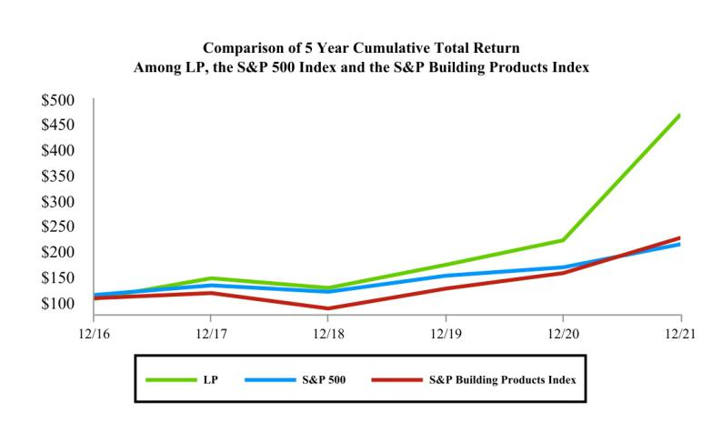

26

ITEM 6. (Reserved)

ITEM 7. Management’s Discussion and Analysis of Financial Condition and Results of Operations

This Management's Discussion and Analysis of Financial Condition and Results of Operations should be read in conjunction with our Consolidated Financial Statements and related Notes and other financial information appearing elsewhere in this annual report on Form 10-K, and with Part II, Item 7 (Management’s Discussion and Analysis of Financial Condition and Results of Operations) of our annual report on Form 10-K for our fiscal year ended December 31, 2020, filed with the SEC on February 18, 2021, which provides a discussion of our financial condition and results of operations for fiscal year 2020 compared to fiscal year 2019. The following discussion includes forward-looking statements that are based on the beliefs of our management, as well as assumptions made by, and information currently available to, our management.

OVERVIEW

General

We are a leading provider of high-performance building solutions that meet the demands of builders, remodelers, and homeowners worldwide. We have leveraged our expertise serving the new home construction, repair and remodeling, and outdoor structures markets to become an industry leader known for innovation, quality, and reliability. Our manufacturing facilities are located in the U.S., Canada, Chile, and Brazil.

To serve these markets, we operate in four segments: Siding, OSB, EWP, and South America.

Executive Summary

Total net sales for 2021 increased year-over-year by $1,765 million (or 63%) to $4,553 million, including Siding Solutions growth of $243 million (or 27%), $1,113 million from higher OSB prices, an EWP revenue increase of $249 million (or 64%) due to price increases in response to significantly higher raw material input costs, and an increase of $96 million (or 57%) in South America due to higher prices.

Net income attributed to LP increased year-over-year by $878 million (or 176%) to $1,377 million ($14.09 per diluted share) primarily due to the record OSB prices. Adjusted EBITDA (defined below) increased by $1,191 million (or 153%) over the prior year to $1,972 million. Adjusted EBITDA is a non-GAAP financial measure. Please see “—Non-GAAP Financial Measures” below for more information about our use of non-GAAP financial measures in this annual report on Form 10-K and the reconciliation of Adjusted EBITDA to Net income.

Demand for Building Products

Demand for our products correlates positively with new home construction and repair and remodeling activity in North America, which historically have been characterized by significant cyclicality. The U.S. Census Bureau reported on January 19, 2022, that 2021 actual single-housing starts were 13% higher than those in 2020. Actual multi-family housing starts in 2021 were about 21% higher than those in 2020. Repair and remodeling activity is difficult to reasonably measure, but many indications, including the substantial increase in LP’s retail sales, suggest that it grew significantly in 2021.

Although housing market demand has recently been very strong, future economic conditions in the United States and the demand for homes remain uncertain due to continuing COVID-19-related disruptions, government directives, actions and economic relief efforts related thereto, and the impact of these actions on the economy, employment levels, consumer confidence, and financial markets, among other things. Additionally, as a result of increased demand in the housing market and a strengthening economy in the United States, we have experienced increases in material prices, supply disruptions, and labor shortages, which will be a challenge for LP as we continue

27

to work to meet the demands of builders, remodelers, and homeowners worldwide. The potential effect of these factors on our future operational and financial performance is uncertain. As a result, our past performance may not be indicative of future results.

The chart below, which is based on data published by U.S. Census Bureau, provides a graphical summary of new housing starts for single and multi-family in the U.S., showing actual and rolling five- and ten-year averages for housing starts.
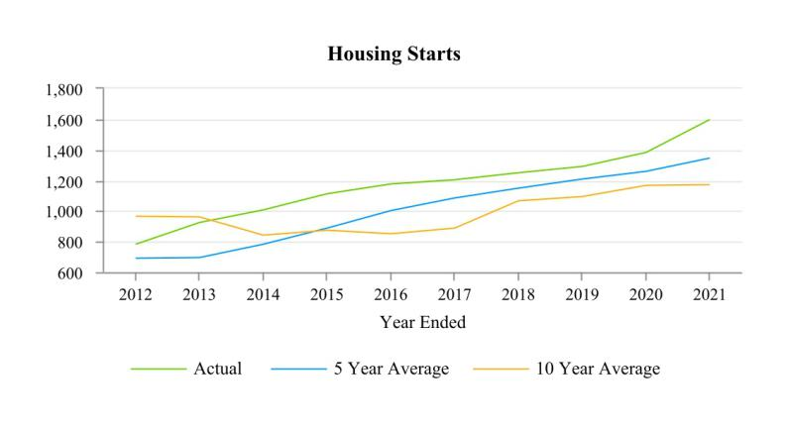

Supply and Demand for Siding

Siding Solutions is a specialty building material and is subject to competition from various siding technologies, including vinyl, stucco, wood, fiber cement, brick, and others. We believe we are the largest manufacturer in the engineered wood siding market. The overall siding market is estimated to be an overall $12 billion industry. We have consistently grown our Siding Solutions above the underlying market growth rates. Siding Solutions is generally less sensitive to new housing market cyclicality since roughly 50% of its demand comes from other markets, including sheds and repair and remodel. Our growth in this market depends upon the continued displacement of vinyl, wood, fiber cement, stucco, bricks, and other alternatives, our product innovation and our technological expertise in wood and wood composites to address the needs of our customers.

Supply and Demand for OSB

OSB is a commodity product, and it is subject to competition from manufacturers worldwide. Product supply is influenced primarily by fluctuations in available manufacturing capacity and imports. The ratio of overall OSB demand to capacity generally drives price. We experienced increased demand for commodity OSB during 2021; however, we cannot predict whether the prices of our OSB products will remain at current levels or increase or decrease in the future.

CRITICAL ACCOUNTING POLICIES AND SIGNIFICANT ESTIMATES

Management’s Discussion and Analysis of Financial Condition and Results of Operations are based upon our Consolidated Financial Statements, which have been prepared in accordance with U.S. GAAP. The preparation of these financial statements requires management to make informed estimates and judgments that affect the reported amounts of assets, liabilities, revenues and expenses, and related disclosure of contingent assets and liabilities. Our financial position and/or results of operations may be materially different when reported under different conditions or when using different assumptions in the application of such policies. In the event estimates or assumptions prove

28

to be different from actual amounts, adjustments are made in subsequent periods to reflect more current information. Our significant accounting policies are disclosed in the Consolidated Financial Statements and Item 8 of this annual report on Form 10-K. The following discussion addresses our most critical accounting policies, which are those that are both important to the portrayal of our financial condition and results of operations and that require significant judgment or use of complex estimates.

Long-lived Assets

Property, plant and equipment, and long-lived assets (including amortizable identifiable intangible assets) are tested for recoverability whenever events or changes in circumstances indicate that their carrying amount may not be recoverable, including but not limited to facility curtailments and asset abandonments. When such events occur, we group long-lived assets with other assets and liabilities at the lowest level for which identifiable cash flows exist. We compare the sum of the undiscounted cash flows expected to result from the use and eventual disposition of the asset or asset group to the carrying amount of a long-lived asset or asset group. The cash flows are based on our best estimate of future cash flows derived from the most recent business projections. The significant assumptions used to determine estimated cash flows are the cash inflows and outflows directly resulting from the use of those assets in operations, including sales volume, product pricing, support costs, and other costs to operate. We recognize an impairment loss if the amount of the asset’s carrying value exceeds the asset’s estimated fair value. Fair value is estimated primarily using discounted expected future cash flows on a market-participant basis. If we recognize an impairment loss, the adjusted carrying amount of the asset becomes its new cost basis. For a depreciable long-lived asset, the new cost basis is depreciated (amortized) over the remaining estimated useful life of that asset.

Our impairment loss calculations contain uncertainties because they require management to make assumptions and to apply judgment to estimate future cash flows and asset fair values. We have not made any material changes in our impairment loss assessment methodology in the periods presented. We do not believe a material change in the estimates or assumptions that we use to calculate long-lived asset impairments is likely. However, if actual results are not consistent with our estimates and assumptions used in estimating future cash flows and asset fair values, we may be exposed to losses that could be material.

Defined Benefit Pension Plans

We have a number of pension plans in the U.S. and Canada, covering many of our employees. Benefit accruals under our defined benefit pension plan in the U.S. were frozen as of January 1, 2010, and benefit accruals under our defined benefit pension plan in Canada were frozen as of January 1, 2020.

We are required to make assumptions that are used to calculate the related assets, liabilities, and expenses recorded in our Consolidated Financial Statements. Net actuarial gains and losses occur when actual experience differs from any of the assumptions used to value defined benefit pension plans or when assumptions change as they may each year. The primary factors contributing to actuarial gains and losses are changes in the discount rate and the differences between expected and actual returns on pension plan assets. This accounting method results in the potential for volatile and challenging to forecast gains and losses.

We record amounts relating to these defined benefit pension plans based on various actuarial assumptions, including discount rates, assumed rates of return, compensation increases, and life expectancy. We review our actuarial assumptions on an annual basis and make modifications to the assumptions based on current economic conditions and trends. The assumptions utilized in recording our obligations under our plans are based on our experience and on advice from our independent actuaries. However, differences in actual experience or changes in the assumptions may materially affect our financial condition or results of operations.

In November 2021, the Company initiated the termination of our frozen U.S. and Canadian defined benefit pension plans (the Plan), which would result in the full settlement of the Company's net pension benefit obligations. The distribution of Plan assets pursuant to the termination will not be made until the Plan termination satisfies all regulatory requirements, which is expected to be completed by the end of 2022. Plan participants will receive their full accrued benefits from Plan assets by electing either lump-sum distributions or annuity contracts with a

29

qualifying third-party annuity provider. The Plan termination is expected to result in pension settlement expense in 2022, which will be determined based on prevailing market conditions, the actual lump-sum distributions, and annuity purchase rates at the date of distribution. As a result, we are currently unable to reasonably estimate timing nor the final amount of such settlement charges. Upon settlement, we expect to recognize pre-tax pension settlement charges that will include a non-cash charge for the recognition of all pre-tax actuarial losses accumulated in Accumulated Other Comprehensive Loss ($101 million as of December 31, 2021) and (2) any cash contributions to settle the Plan’s obligations ($6 million net projected benefit obligation as of December 31, 2021). The actual amount of the settlement charges and any potential cash contribution will depend on various factors, including interest rates, Plan asset returns, and the lump-sum election rate.

As of December 31, 2021, we used a discount rate and long-term rate of return assumption of 2.6% and 5.3%, respectively, for our U.S. defined benefit pension plan. We used a discount rate and a long-term rate of return assumption of 2.6% and 2.3%, respectively, for our Canadian plans as of December 31, 2021.

- A 50-basis point change in our discount rate assumption would lead to an increase or decrease in our pension liability of approximately $13 million and would have a nominal impact on pension expenses.
- A 50-basis point change in the long-term rate of return on plan assets used in accounting for our pension plans would have a $1 million impact on pension expense.

It is not possible to forecast or predict whether there will be actuarial gains and losses in future periods, and if required, the magnitude of any such adjustment. These gains and losses are driven by differences in actual experience or changes in the assumptions that are beyond our control, such as changes in interest rates and the actual return on pension plan assets.

Customer Program Costs

Our businesses routinely incur customer program costs to obtain favorable product placement, promote sales of products, and maintain competitive pricing. Customer program costs and incentives, including rebates and promotion and volume allowances, are accounted for as a reduction in net sales at the time the program is initiated and/or the revenue is recognized. The costs include, but are not limited to, volume allowances and rebates, promotional allowances, and cooperative advertising programs. These costs are recorded at the later of the time of sale or the implementation of the program based on management’s best estimates.

Our estimates are based on historical and projected experience for each type of program or customer. Volume allowances are accrued based on our estimates of customer volume achievement and other factors incorporated into customer agreements, such as new products, merchandising support, and customer training.

Although we believe we can reasonably estimate customer volumes and support and the related customer payments at interim periods, it is possible that actual results could be different from previously estimated amounts. At the end of each year, a significant portion of the actual volume and support activity is known. Thus, we do not believe that a material change in the amounts recorded as customer program costs payable is likely. We had $45 million and $44 million accrued as customer rebates as of December 31, 2021, and 2020, respectively.

30

NON-GAAP FINANCIAL MEASURES

In evaluating our business, we utilize non-GAAP financial measures that fall within the meaning of SEC Regulation G and Regulation S-K Item 10(e), which we believe provide users of the financial information with additional meaningful comparison to prior reported results. Non-GAAP financial measures do not have standardized definitions and are not defined by U.S. GAAP. In this annual report on Form 10-K, we disclose income attributed to LP before interest expense, provision for income taxes, depreciation and amortization, and exclude stock-based compensation expense, loss on impairment attributed to LP, product-line discontinuance charges, other operating credits and charges, net, loss on early debt extinguishment, investment income, pension settlement charges, and other non-operating items as Adjusted EBITDA (Adjusted EBITDA), which is a non-GAAP financial measure. We have included Adjusted EBITDA in this report because we view it as an important supplemental measure of our performance and believe that it is frequently used by interested persons in the evaluation of companies that have different financing and capital structures and/or tax rates. We also disclose income attributed to LP, excluding loss on impairment attributed to LP, product-line discontinuance charges, interest expense outside of normal operations, other operating credits and charges, net, loss on early debt extinguishment, gain (loss) on acquisition, pension settlement charges, and adjusting for a normalized tax rate as Adjusted Income (Adjusted Income). We also disclose Adjusted Diluted EPS, calculated as Adjusted Income divided by diluted shares outstanding. We believe that Adjusted Diluted EPS and Adjusted Income are useful measures for evaluating our ability to generate earnings and that providing these measures should allow interested persons to more readily compare the earnings for past and future periods.

Adjusted EBITDA, Adjusted Income, and Adjusted Diluted EPS are not substitutes for the U.S. GAAP measures of net income and net income per diluted share or for any other U.S. GAAP measures of operating performance. It should be noted that other companies may present similarly titled measures differently, and therefore, as presented by us, these measures may not be comparable to similarly titled measures reported by other companies. Adjusted EBITDA, Adjusted Income, and Adjusted Diluted EPS have material limitations as performance measures because they exclude items that are actually incurred or experienced in connection with the operation of our business.

We have elected to change our definition of Adjusted EBITDA and Adjusted Income to exclude pension settlement costs incurred during the year ended December 31, 2021. Pension settlement costs relate to any acceleration of the unrecognized actuarial loss related to our frozen U.S. and Canadian defined benefit pension plans. We consider pension settlement charges not to be reflective of our ongoing operations and believe that presenting Adjusted EBITDA and Adjusted Income excluding pension settlement charges provides increased transparency as to the operating costs of our current business performance. We did not revise prior years’ Adjusted EBITDA or Adjusted Income amounts because there were no significant costs similar in nature to these items.

31

The following table presents significant items by operating segment and reconciles Net income to Adjusted EBITDA (dollar amounts in millions):

 | Year ended December 31, |  |  | 2021 |  |  | 2020 |  |  | 2019
 | Net income
 | Net income |  | $ | 1,373 |  | $ | 497 |  | $ | (10)
 | Add (deduct):
 | Loss from noncontrolling interest |  |  | 4 |  |  | 2 |  |  | 5
 | Net income attributed to LP |  |  | 1,377 |  |  | 499 |  |  | (5)
 | Provision for income taxes |  |  | 426 |  |  | 125 |  |  | (13)
 | Depreciation and amortization |  |  | 119 |  |  | 111 |  |  | 122
 | Stock-based compensation expense |  |  | 17 |  |  | 12 |  |  | 9
 | Loss on impairment attributed to LP |  |  | 5 |  |  | 15 |  |  | 92
 | Other operating credits and charges, net |  |  | (1) |  |  | (4) |  |  | 1
 | Product-line discontinuance charges |  |  | — |  |  | 8 |  |  | —
 | Pension settlement charges |  |  | 2 |  |  | — |  |  | —
 | Interest expense |  |  | 14 |  |  | 19 |  |  | 19
 | Investment income |  |  | (1) |  |  | (4) |  |  | (10)
 | Loss on early debt extinguishment |  |  | 11 |  |  | — |  |  | —
 | Other non-operating items |  |  | 4 |  |  | — |  |  | (6)
 | Adjusted EBITDA |  | $ | 1,972 |  | $ | 781 |  | $ | 209
 | Siding |  | $ | 289 |  | $ | 246 |  | $ | 169
 | OSB |  |  | 1,531 |  |  | 519 |  |  | 10
 | EWP |  |  | 95 |  |  | 23 |  |  | 26
 | South America |  |  | 113 |  |  | 42 |  |  | 34
 | Other |  |  | (20) |  |  | (19) |  |  | (3)
 | Corporate |  |  | (36) |  |  | (30) |  |  | (27)
 | Adjusted EBITDA |  | $ | 1,972 |  | $ | 781 |  | $ | 209

32

The following table provides the reconciliation of net income to Adjusted Income (dollar amounts in millions, except earnings per share):

 | Year ended December 31, |  |  | 2021 |  |  | 2020 |  |  | 2019
 | Net income |  | $ | 1,373 |  | $ | 497 |  | $ | (10)
 | Add (deduct):
 | Loss from noncontrolling interest |  |  | 4 |  |  | 2 |  |  | 5
 | Net income attributed to LP |  |  | 1,377 |  |  | 499 |  |  | (5)
 | Loss on impairment attributed to LP |  |  | 5 |  |  | 15 |  |  | 92
 | Other operating credits and charges, net |  |  | (1) |  |  | (4) |  |  | 1
 | Product-line discontinuance charges |  |  | — |  |  | 8 |  |  | —
 | Loss on early debt extinguishment |  |  | 11 |  |  | — |  |  | —
 | Pension settlement charges |  |  | 2 |  |  | — |  |  | —
 | Gain on acquisition |  |  | — |  |  | — |  |  | (14)
 | Reported tax provision |  |  | 426 |  |  | 125 |  |  | (13)
 | Normalized tax provision at 25% for 2021, 2020, and 2019 |  |  | (455) |  |  | (161) |  |  | (16)
 | Adjusted Income |  | $ | 1,365 |  | $ | 482 |  | $ | 45
 | Adjusted weighted average shares - diluted |  |  | 98 |  |  | 112 |  |  | 123
 | Diluted net income per share attributed to LP |  | $ | 14.09 |  | $ | 4.46 |  | $ | (0.04)
 | Adjusted Diluted EPS |  | $ | 13.97 |  | $ | 4.31 |  | $ | 0.37

OUR OPERATING RESULTS

Our results of operations for each of our segments are discussed below, as are results of operations for the “other” category, which comprises other products that are not individually significant. See Note 19 of the Notes to the Consolidated Financial Statements included in Item 8 of this annual report on Form 10-K for further information regarding our segments.

Siding

The Siding segment serves diverse end markets with a broad product offering of engineered wood siding, trim, and fascia, including LP® SmartSide® Trim & Siding, LP® SmartSide® ExpertFinish® Trim & Siding, LP BuilderSeries® Lap Siding, and LP® Outdoor Building Solutions® (collectively referred to as Siding Solutions).

Segment Net sales, Adjusted EBITDA, and Adjusted EBITDA margin for this segment were as follows:

 | Dollar amounts in millions |  |  |  |  |  |  |  | Increase (decrease)
 | Year Ended December 31, |  |  | 2021 |  |  | 2020 |  | 2021 - 2020
 | Net sales |  | $ | 1,170 |  | $ | 959 |  | 22 %
 | Adjusted EBITDA |  |  | 289 |  |  | 246 |  | 17 %
 | Adjusted EBITDA margin |  |  | 25 % |  |  | 26 %

33

Net sales in this segment by product line were as follows:

 | Dollar amounts in millions |  |  |  |  |  |  |  | Increase (decrease)
 | Year Ended December 31, |  |  | 2021 |  |  | 2020 |  | 2021 - 2020
 | Siding Solutions |  | $ | 1,158 |  | $ | 915 |  | 27 %
 | Other |  |  | 12 |  |  | 44 | (74) %
 | Total |  | $ | 1,170 |  | $ | 959

Percent changes in average net sales price and unit shipments were as follows:

 |  | 2021 versus 2020
 | Average |  |  |  | Unit
 | Selling Price |  |  |  | Shipments
Siding Solutions |  | 9 % |  |  | 16 %

Year Ended December 31, 2021, Compared to Year Ended December 31, 2020

For the full year, Siding net sales increased year-over-year by $211 million (or 22%), primarily due to a 27% increase in Siding Solutions revenue partially offset by the discontinuation of fiber (included in the Other product line) in 2020.

The increase in Adjusted EBITDA of $43 million reflects revenue growth offset by $66 million of raw material & freight cost inflation and $36 million of discretionary investments in support of future growth, including capacity expansions, equipment maintenance, and sales & marketing.

OSB

The OSB segment manufactures and distributes OSB structural panel products, including our value-added OSB portfolio known as LP Structural Solutions (which includes LP® TechShield® Radiant Barrier, LP WeatherLogic® Air & Water Barrier, LP Legacy® Premium Sub-Flooring, and LP® FlameBlock® Fire-Rated Sheathing) and LP® TopNotch® Sub-Flooring. OSB is manufactured using wood strands arranged in layers and bonded with resins. Significant cost inputs to produce OSB (including approximate breakdown percentages for 2021) were as follows: wood fiber (26%), resin and wax (20%), labor and burden (16%), utilities (six percent), and other manufacturing costs (32%).

Segment Net sales, Adjusted EBITDA, and Adjusted EBITDA margin for this segment were as follows:

 | Dollar amounts in millions |  |  |  |  |  |  |  | Increase (decrease)
 | Year Ended December 31, |  |  | 2021 |  |  | 2020 |  | 2021 - 2020
 | Net sales |  | $ | 2,387 |  | $ | 1,220 |  | 96 %
 | Adjusted EBITDA |  |  | 1,531 |  |  | 519 |  | 195 %
 | Adjusted EBITDA margin |  |  | 64 % |  |  | 43 %

34

Net sales in this segment by product line were as follows:

 | Dollar amounts in millions |  |  |  |  |  |  |  | Increase (decrease)
 | Year Ended December 31, |  |  | 2021 |  |  | 2020 |  | 2021 - 2020
 | OSB - Structural Solutions |  | $ | 1,152 |  | $ | 580 | 99 %
 | OSB - Commodity |  |  | 1,221 |  |  | 632 | 93 %
 | Other |  |  | 14 |  |  | 9 | 67 %
 | Total |  | $ | 2,387 |  | $ | 1,220

Percent changes in average net sales prices and unit shipments were as follows:

 |  | 2021 versus 2020
 | Average |  |  |  | Unit
 | Selling Price |  |  |  | Shipments
OSB - Structural Solutions |  | 87 % |  |  | 6 %
OSB - Commodity |  | 90 % |  |  | 2 %

Year Ended December 31, 2021, Compared to Year Ended December 31, 2020

OSB net sales increased year-over-year by $1,167 million (or 96%), largely due to $1,113 million in increased OSB prices. Structural Solutions sales volume, as a percentage of total OSB segment sales volume, was 45% in 2021 compared to 44% in 2020.

Adjusted EBITDA increased by $1,012 million, with price increases partially offset by $41 million of increased raw material costs and $38 million of maintenance and Peace Valley restart costs.

EWP

The EWP segment is comprised of LP® SolidStart® I-Joist (I-Joist), Laminated Veneer Lumber (LVL), and Laminated Strand Lumber (LSL) and other related products. This segment also includes the sales of I-Joist and LVL products produced by our joint venture and sales of plywood produced as an ancillary product of the LVL production process. During 2021, we ceased LSL production at our Houlton, Maine facility to begin the conversion of that facility to Siding Solutions production.

Segment Net sales, Adjusted EBITDA, and Adjusted EBITDA margin for this segment were as follows:

 | Dollar amounts in millions |  |  |  |  |  |  |  | Increase (decrease)
 | Year Ended December 31, |  |  | 2021 |  |  | 2020 |  | 2021 - 2020
 | Net Sales |  | $ | 638 |  | $ | 389 |  | 64 %
 | Adjusted EBITDA |  |  | 95 |  |  | 23 |  | 307 %
 | Adjusted EBITDA margin |  |  | 15 % |  |  | 6 %

35

Net sales in this segment by product line were as follows:

 | Dollar amounts in millions |  |  |  |  |  |  |  | Increase (decrease)
 | Year Ended December 31, |  |  | 2021 |  |  | 2020 |  | 2021 - 2020
 | I-Joist |  | $ | 309 |  | $ | 148 | 109 %
 | LVL |  |  | 194 |  |  | 141 | 38 %
 | LSL |  |  | 47 |  |  | 45 | 5 %
 | Other, including plywood and related products |  |  | 88 |  |  | 55 | 59 %
 | Total |  | $ | 638 |  | $ | 389

Percent changes in average net sales prices and unit shipments were as follows:

 |  | 2021 versus 2020
 | Average |  |  |  | Unit
 | Selling Price |  |  |  | Shipments
I-Joist |  | 83 % |  |  | 14 %
LVL |  | 38 % |  |  | — %
LSL |  | 41 % |  |  | (26)%

Year Ended December 31, 2021, Compared to Year Ended December 31, 2020

EWP net sales increased year-over-year by $249 million (or 64%) from 2020, predominantly due to price increases in response to significantly higher raw material costs. Resulting increases in Adjusted EBITDA reflect the net effect of these price and cost increases.

South America

Our South America segment manufactures and distributes OSB structural panel and siding products in South America and certain export markets. This segment has manufacturing operations in two countries, Chile and Brazil, and operates sales offices in Chile, Brazil, Peru, Columbia, Argentina, and Paraguay.

Segment Net sales, Adjusted EBITDA, and Adjusted EBITDA margin for this segment were as follows:

 | Dollar amounts in millions |  |  |  |  |  |  |  | Increase (decrease)
 | Year Ended December 31, |  |  | 2021 |  |  | 2020 |  | 2021 - 2020
 | Net sales |  | $ | 265 |  | $ | 169 |  | 57 %
 | Adjusted EBITDA |  |  | 113 |  |  | 42 |  | 170 %
 | Adjusted EBITDA margin |  |  | 43 % |  |  | 25 %
Net sales in this segment by product were as follows:

 | Dollar amounts in millions |  |  |  |  |  |  |  | Increase (decrease)
 | Year Ended December 31, |  |  | 2021 |  |  | 2020 |  | 2021 - 2020
 | OSB -Structural Solutions |  | $ | 227 |  | $ | 146 | 56 %
 | Siding |  |  | 33 |  |  | 20 | 65 %
 | Other |  |  | 5 |  |  | 3 | 96 %
 | Total |  | $ | 265 |  | $ | 169

36

Percent changes in average net sales prices and unit shipments for 2021 compared to 2020 were as follows:

 |  | 2021 versus 2020
 | Average |  |  |  | Unit
 | Selling Price |  |  |  | Shipments
OSB |  | 74 % |  |  | (11)%
Siding |  | 31 % |  |  | 26 %

Year Ended December 31, 2021, Compared to Year Ended December 31, 2020

South America net sales increased year-over-year by $96 million (or 57%) compared to 2020, predominantly due to higher OSB and siding prices. Increased Adjusted EBITDA reflects the effect of these price increases, partially offset by higher costs of imported raw material.

Other

Our other products segment includes our off-site framing operation Entekra Holdings, LLC (Entekra), remaining timber and timberlands, and other minor products, services, and closed operations, which do not qualify as discontinued operations.

Net sales increased year-over-year by $43 million (or 83%) to $95 million primarily due to the Entekra growth. Adjusted EBITDA was $(20) million for 2021 as compared to $(19) million in 2020.

GENERAL CORPORATE AND OTHER EXPENSE, NET

General corporate and other expenses primarily comprise corporate overhead unrelated to business activities such as wages and benefits, professional fees, insurance, and other expenses for corporate functions, including certain executive officers, public company activities, tax, internal audits, and other corporate functions.

General corporate and other expense, net, was $46 million in 2021 as compared to $37 million in 2020. The increase in 2021 as compared to 2020 was primarily due to increased costs associated with stock compensation and performance incentives.

LOSS ON IMPAIRMENTS

During 2021, we recognized $6 million of pre-tax impairment charges primarily due to a non-cash impairment charge of $5 million related to goodwill associated with our off-site construction operation Entekra.

During 2020, we recognized $16 million of pre-tax impairment charges. Included within these impairment charges was a $9 million charge related to our fiber-producing assets. These impairment charges reflect the accelerated conversion from fiber production to pre-finishing. Additionally, we recognized $2 million in non-cash impairment charges related to our divestiture of the East River facility and $5 million related to goodwill associated with Entekra.

OTHER OPERATING CREDITS AND CHARGES, NET

For a discussion of other operating credits and charges, net, see Note 13 of the Notes to the Consolidated Financial Statements included in Item 8 of this annual report on Form 10-K.

37

NON-OPERATING INCOME (EXPENSE)

For a discussion of non-operating income (expense), see Note 13 of the Notes to the Consolidated Financial Statements included in Item 8 of this annual report on Form 10-K.

INCOME TAXES

We recognized a tax provision of $426 million in 2021 compared to $125 million in 2020. For 2021, the primary differences between the U.S. statutory rate of 21% and the effective rate relate to state income tax. We paid $421 million and $70 million of income taxes net of refunds in 2021 and 2020, respectively.

LEGAL AND ENVIRONMENTAL MATTERS

For a discussion of legal and environmental matters involving us and the potential impact thereof on our financial position, results of operations, and cash flows, see Item 3 in this annual report on Form 10-K as well as Note 15 of the Notes to the Consolidated Financial Statements included in Item 8 of this annual report on Form 10-K.

LIQUIDITY AND CAPITAL RESOURCES

Overview

Our principal sources of liquidity are existing cash and investment balances, cash generated by our operations, and our ability to borrow under such credit facilities as we may have in effect from time to time. We assess our liquidity in terms of our ability to generate cash to fund our short- and long-term cash requirements. As such, we project our anticipated cash requirements as well as cash flows generated from operating activities to meet those needs. We anticipate long-term cash uses may also include strategic acquisitions. On a long-term basis, we will continue to rely on our credit facility for any long-term funding not provided by operating cash flows. We may also, from time to time, issue and sell equity, debt, or hybrid securities or engage in other capital market transactions.

Our principal uses of liquidity are paying the costs and expenses associated with our operations, servicing outstanding indebtedness, paying dividends, and making capital expenditures. We may also, from time to time, prepay or repurchase outstanding indebtedness or shares or acquire assets or businesses that are complementary to our operations. Any such repurchases may be commenced, suspended, discontinued, or resumed, and the method or methods of affecting any such repurchases may be changed at any time, or from time to time, without prior notice.

Operating Activities

During 2021, we generated $1,484 million of cash from operations as compared to $659 million in 2020. The improvement in cash provided by operations was primarily related to increases in OSB pricing and growth in Siding Solutions revenue. At December 31, 2021, and 2020, we had working capital of $181 million and $172 million, respectively.

Investing Activities

During 2021, net cash used for investing activities was $247 million as compared to $49 million in 2020. Capital expenditures for 2021 and 2020 were $254 million and $77 million, respectively.

This increase in capital expenditures was primarily related to Siding conversion expenditures and growth and maintenance capital.

During 2020, we received $15 million in cash related to the divestiture of our East River facility assets and brand rights of CanExel®. Additionally, we received $10 million related to the cash surrender value of the company-owned life insurance policy and $3 million related to the sale of our auction rate securities (ARS).

Capital expenditures in 2022 are expected to be in the range of $400 million to $430 million. We expect to fund our

38

short-term and long-term capital expenditures through cash on hand, cash generated from operations, and available borrowing under our Amended Credit Facility, as necessary.

Financing Activities

During 2021, net cash used in financing activities was $1,388 million as compared to $272 million in 2020. We used $300 million to repurchase shares of LP common stock under the 2020 Share Repurchase Program, which was exhausted in May 2021. We used $1,000 million to repurchase shares of LP common stock under the First 2021 Share Repurchase Program, which was exhausted in December 2021. Additionally, we used $66 million to pay quarterly cash dividends. On November 2, 2021, LP’s Board of Directors authorized the Second 2021 Share Repurchase Program, under which the Company may repurchase shares of its common stock totaling up to $500 million.

In March 2021, we issued $350 million aggregate principal amount of the 2029 Senior Notes. In March 2021, LP used the proceeds from the issuance of the 2029 Senior Notes and cash on hand to redeem all of the 2024 Senior Notes at a redemption price of 102.438% of the principal amount thereof plus accrued and unpaid interest to, but not including, the redemption date. In connection with financing activities, we paid $2 million in debt issuance costs related to the third amendment to our Amended Credit Facility and $13 million in redemption premiums and debt issuance costs related to the 2024 Senior Notes. The remaining financing activities relate to the repurchase of stock from employees in connection with income tax withholding requirements associated with our employee stock-based compensation plans.

During 2020, net cash used in financing activities was $272 million as compared to $717 million in 2019. We used $200 million to repurchase LP common stock under the 2020 Share Repurchase Program. Additionally, we used $65 million to pay quarterly cash dividends. In the first quarter of 2020, we borrowed $350 million under our Amended Credit Facility as a precautionary measure due to the COVID-19 pandemic, and we repaid the outstanding balance in the second quarter of 2020.

CREDIT FACILITIES

The Amended Credit Facility provides for a revolving credit facility in the principal amount of up to $550 million, with a $60 million sub-limit for letters of credit. The Amended Credit Facility, and all loans thereunder, become due on June 8, 2027. As of December 31, 2021, we had no amounts outstanding under the Amended Credit Facility.

The Amended Credit Facility contains various restrictive covenants and customary events of default, the occurrence of which could result in the acceleration of our obligation to repay the indebtedness outstanding thereunder. The Amended Credit Facility also contains financial covenants that require us and our consolidated subsidiaries to have, as of the end of each quarter, a capitalization ratio (i.e., funded debt less unrestricted cash to total capitalization) of no more than 57.5%. As of December 31, 2021, we were in compliance with all financial covenants under the Amended Credit Facility.

In March 2020, LP entered into the Letter of Credit Facility, which provides for the funding of letters of credit up to an aggregate outstanding amount of $20 million, which may be secured by certain cash collateral of LP. The Letter of Credit Facility includes an unused commitment fee, due quarterly, ranging from 0.50% to 1.875% of the daily available amount to be drawn on each letter of credit issued under the Letter of Credit Facility. The Letter of Credit Facility is subject to similar affirmative, negative, and financial covenants as those set forth in the Amended Credit Facility, including the capitalization ratio covenant. As of December 31, 2021, we were in compliance with all covenants under the Letter of Credit Facility.

OTHER LIQUIDITY MATTERS

2029 Senior Notes

In March 2021, we issued the 2029 Senior Notes in the aggregate principal amount of $350 million, which mature

39

on March 15, 2029. As of December 31, 2021, future interest payments associated with the 2029 Senior Notes totaled $95 million, with $13 million payable within 12 months of such date. For additional information regarding the 2029 Senior Notes, please see Note 11 of the Notes to the Consolidated Financial Statements included in Item 8 of this annual report on Form 10-K.

Contingency Reserves

Contingency reserves, which represent an estimate of future cash needs for various contingencies (principally, environmental reserves), totaled $25 million at December 31, 2021, of which $1 million is estimated to be payable within one year of such date. There is inherent uncertainty concerning the reliability and precision of such estimates, and as such, the amounts ultimately paid in resolving these contingencies could exceed the current reserves by a material amount.

Leases

We have lease arrangements for real estate, mobile equipment at our manufacturing facilities, rail cars to transport our products, and a fleet of vehicles. As of December 31, 2021, we had fixed lease payment obligations of $66 million, with $5 million payable within 12 months of such date.

Other Purchase Obligations

Our other purchase obligations primarily consist of obligations related to information technology infrastructure. As of December 31, 2021, we had other purchase obligations of $34 million, with $18 million payable within 12 months of such date.

Off-Balance Sheet Arrangements

As of December 31, 2021, we had standby letters of credit of $12 million outstanding related to collateral for environmental impact on owned properties, deposit for forestry license, and insurance collateral, including workers' compensation.

Potential Impairments

We continue to review several mills and investments for potential impairments. Management currently believes we have adequate support for the carrying value of each of these assets based upon the anticipated cash flows that result from our estimates of future demand, pricing, and production costs, assuming certain levels of planned capital expenditures. As of December 31, 2021, the fair values of LP's facilities were in excess of their carrying value, which supported the conclusion that no impairment is necessary for those facilities. However, if demand and pricing for our products fall to levels significantly below cycle average demand and pricing, or should we decide to invest capital in alternative projects, or should changes occur related to our wood supply for these locations, it is possible that future impairment charges will be required.

We also review from time to time possible dispositions of various assets in light of current and anticipated economic and industry conditions, our strategic plan, and other relevant factors. Because a determination to dispose of particular assets can require management to make assumptions regarding the transaction structure of the disposition and to estimate the net sales proceeds, which may be less than previous estimates of undiscounted future net cash flows, we may be required to record impairment charges in connection with decisions to dispose of assets.

PROSPECTIVE ACCOUNTING PRONOUNCEMENTS

For a discussion of prospective accounting pronouncements, see Note 2 of the Notes to the Consolidated Financial Statements included in Item 8 of this annual report on Form 10-K.

40

ITEM 7A. Quantitative and Qualitative Disclosures About Market Risk

Each of our international operations has transactional foreign currency exposures related to buying and selling in currencies other than the local currencies in which it operates. Exposures are related to the U.S. dollar relative to the Canadian dollar, Brazilian real, and the Chilean peso. We also have translation exposure resulting from translating the financial statements of foreign subsidiaries into U.S. dollars. Although we have in the past entered into foreign exchange contracts associated with certain of our indebtedness and may continue to enter into foreign exchange contracts associated with major equipment purchases to manage a portion of the foreign currency rate risk, we historically have not entered into currency rate hedges with respect to our exposure from operations, provided we may do so in the future.

Some of our products are sold as commodities, and therefore sales prices fluctuate daily based on market factors over which we have little or no control. The most significant commodity product we sell is OSB. Based upon an assumed North America annual production capacity in the OSB segment of 4.5 billion square feet (3/8” basis) or 3.9 billion square feet (7/16” basis), a $1 change in the annual average price per thousand square feet on 7/16” basis would change annual pre-tax profits by approximately $4 million.

We historically have not entered into material commodity futures and swaps, although we may do so in the future.

41

ITEM 8. Financial Statements and Supplementary Data

REPORT OF INDEPENDENT REGISTERED PUBLIC ACCOUNTING FIRM

To the Stockholders and the Board of Directors of Louisiana-Pacific Corporation

Opinion on the Financial Statements

We have audited the accompanying consolidated balance sheets of Louisiana-Pacific Corporation and subsidiaries (the "Company") as of December 31, 2021 and 2020, the related consolidated statements of income, comprehensive income, cash flows, and stockholders’ equity, for each of the three years in the period ended December 31, 2021, and the related notes (collectively referred to as the "financial statements"). In our opinion, the financial statements present fairly, in all material respects, the financial position of the Company as of December 31, 2021 and 2020, and the results of its operations and its cash flows for each of the three years in the period ended December 31, 2021, in conformity with accounting principles generally accepted in the United States of America.

We have also audited, in accordance with the standards of the Public Company Accounting Oversight Board (United States) (PCAOB), the Company's internal control over financial reporting as of December 31, 2021, based on criteria established in Internal Control — Integrated Framework (2013) issued by the Committee of Sponsoring Organizations of the Treadway Commission and our report dated February 22, 2022, expressed an unqualified opinion on the Company's internal control over financial reporting.

Basis for Opinion

These financial statements are the responsibility of the Company's management. Our responsibility is to express an opinion on the Company's financial statements based on our audits. We are a public accounting firm registered with the PCAOB and are required to be independent with respect to the Company in accordance with the U.S. federal securities laws and the applicable rules and regulations of the Securities and Exchange Commission and the PCAOB.

We conducted our audits in accordance with the standards of the PCAOB. Those standards require that we plan and perform the audit to obtain reasonable assurance about whether the financial statements are free of material misstatement, whether due to error or fraud. Our audits included performing procedures to assess the risks of material misstatement of the financial statements, whether due to error or fraud, and performing procedures that respond to those risks. Such procedures included examining, on a test basis, evidence regarding the amounts and disclosures in the financial statements. Our audits also included evaluating the accounting principles used and significant estimates made by management, as well as evaluating the overall presentation of the financial statements. We believe that our audits provide a reasonable basis for our opinion.

Critical Audit Matter

The critical audit matter communicated below is a matter arising from the current-period audit of the financial statements that was communicated or required to be communicated to the Finance & Audit Committee and that (1) relates to accounts or disclosures that are material to the financial statements and (2) involved our especially challenging, subjective, or complex judgments. The communication of critical audit matters does not alter in any way our opinion on the financial statements, taken as a whole, and we are not, by communicating the critical audit matter below, providing a separate opinion on the critical audit matter or on the accounts or disclosures to which it relates.

Retirement Plans and Post-Retirement Benefits— Refer to Notes 1 and 17 to the financial statements

Critical Audit Matter Description

The Company has a number of frozen defined benefit pension plans in the U.S. and Canada covering many of their employees. In November 2021, the Company initiated the termination of its U.S. and Canadian defined benefit pension plans (“Plans”). The Plans are expected to be settled at the end of 2022, subject to required regulatory approvals. Plan participants will have a choice of receiving their full accrued benefits by electing either lump sum

42

distributions or annuity contracts with a qualifying third-party annuity provider. Expenses and liabilities related to the defined benefit pension obligation are recorded based on various actuarial assumptions, including discount rate, assumed rates of return, and assumptions related to the rate of election by participants to receive lump sum payments or annuities upon the termination of the Plans in 2022.

We identified the Company’s actuarial assumptions used in valuing the defined benefit pension obligation as a critical audit matter given the requirement of management to make assumptions related to the selection of the discount rates, expected rate of return on plan assets, and the lump sum selection rate. Performing audit procedures to evaluate the reasonableness of these assumptions required a high degree of auditor judgement and increased extent of effort, which included the need to involve an actuarial specialist.

How the Critical Audit Matter Was Addressed in the Audit

Our audit procedures related to the Company’s actuarial assumptions for the defined benefit pension obligation included the following, among others:

- We tested the effectiveness of the internal controls over the valuation of the defined benefit pension obligation.

- With the assistance of our actuarial specialist, we evaluated the reasonableness of the discount rates, expected rate of return on plan assets, and the lump sum election rate by:

  - Evaluating the methodology utilized to select the discount rates, expected rate of return on assets, and lump sum election rate for conformity with applicable accounting guidance.

  - Testing the underlying source information.

  - Developing independent estimates using externally published information and comparing to the calculations based on management’s selected assumptions.

  - We compared the actuarial assumptions used by management to historical trends and evaluated the change in the defined benefit pension obligation from the prior year due to the change in service cost, interest cost, actuarial gains and losses, benefit payments and the impacts to the assumptions as a result of the announced plan termination.

/s/ Deloitte & Touche LLP

Nashville, Tennessee

February 22, 2022

We have served as the Company’s auditor since 1997.

43

Consolidated Statements of Income

Dollar amounts in millions, except per share

 |  |  |  |  | Year Ended December 31,
 | 2021 |  |  |  | 2020 |  |  | 2019
Net sales | $ | 4,553 |  | $ | 2,788 |  | $ | 2,310
Cost of sales |  | (2,482) |  |  | (1,920) |  |  | (2,007)
Gross profit |  | 2,070 |  |  | 867 |  |  | 303
Selling, general, and administrative expenses |  | (241) |  |  | (211) |  |  | (230)
Loss on impairments |  | (6) |  |  | (16) |  |  | (92)
Other operating credits and charges, net |  | 1 |  |  | (4) |  |  | (1)
Income from operations |  | 1,824 |  |  | 636 |  |  | (20)
Interest expense |  | (14) |  |  | (19) |  |  | (19)
Investment income |  | 1 |  |  | 4 |  |  | 10
Other non-operating items |  | (16) |  |  | — |  |  | 6
Income before income taxes |  | 1,795 |  |  | 621 |  |  | (23)
Provision for income taxes |  | (426) |  |  | (125) |  |  | 13
Equity in unconsolidated affiliate |  | 4 |  |  | 1 |  |  | —
Net income | $ | 1,373 |  | $ | 497 |  | $ | (10)
Net loss attributed to noncontrolling interest |  | 4 |  |  | 2 |  |  | 5
Net income attributed to LP | $ | 1,377 |  | $ | 499 |  | $ | (5)
Basic net income per share attributed to LP:
Net income per share - basic | $ | 14.19 |  | $ | 4.48 |  | $ | (0.04)
Diluted net income per share attributed to LP:
Net income per share - diluted | $ | 14.09 |  | $ | 4.46 |  | $ | (0.04)
Average shares of common stock used to compute net income per share:
Basic |  | 97 |  |  | 111 |  |  | 123
Diluted
Diluted |  | 98 |  |  | 112 |  |  | 123

See Notes to the Consolidated Financial Statements.

44

Net income

Other comprehensive income, net of tax

Foreign currency translation adjustments

Unrealized gains on securities, net of reversals

Changes in defined benefit pension plans Other

Consolidated Statements of Comprehensive Income

Dollar amounts in millions

Year Ended December 31,

2021 |  |  | 2020 |  |  |  | 2019
$ | 1,373 |  | $ | 497 |  | $ | (10)
 | (28) |  |  | (1) |  |  | (10)
 | — |  |  | (3) |  |  | (1)
 | 5 |  |  | 8 |  |  | 4
 | — |  |  | (2) |  |  | —

Other comprehensive income (loss), net of tax |  | (23) |  |  | 2 |  |  | (7)
Comprehensive income | $ | 1,350 |  | $ | 499 |  | $ | (17)
Comprehensive loss associated with noncontrolling interest |  | 4 |  |  | 2 |  |  | 5
Comprehensive income attributed to LP | $ | 1,354 |  | $ | 501 |  | $ | (12)

See Notes to the Consolidated Financial Statements.

45

Consolidated Balance Sheets

Dollar amounts in millions

 |  | December 31,
 |  | 2021 |  |  | 2020
ASSETS
Cash and cash equivalents | $ | 358 |  | $ | 535
Receivables, net of allowance for doubtful accounts of $2 million at December 31, 2021, and 2020, respectively |  | 191 |  |  | 184
Inventories |  | 323 |  |  | 259
Prepaid expenses and other current assets |  | 18 |  |  | 15
Total current assets |  | 890 |  |  | 993
Timber and timberlands |  | 84 |  |  | 52
Property, plant and equipment, net |  | 1,069 |  |  | 918
Operating lease assets |  | 52 |  |  | 40
Goodwill and other intangible assets |  | 39 |  |  | 46
Investments in and advances to affiliates |  | 21 |  |  | 11
Restricted cash |  | 13 |  |  | —
Other assets |  | 25 |  |  | 24
Deferred tax asset |  | 2 |  |  | 3
Total assets | $ | 2,194 |  | $ | 2,086
LIABILITIES AND STOCKHOLDERS’ EQUITY
Accounts payable and accrued liabilities | $ | 338 |  | $ | 268
Income taxes payable |  | 13 |  |  | 18
Total current liabilities |  | 351 |  |  | 286
Long-term debt |  | 346 |  |  | 348
Deferred income taxes |  | 86 |  |  | 78
Non-current operating lease liabilities |  | 44 |  |  | 32
Contingency reserves, excluding current portion |  | 24 |  |  | 13
Other long-term liabilities |  | 105 |  |  | 86
Total liabilities |  | 955 |  |  | 842
Redeemable noncontrolling interest |  | 4 |  |  | 10
Stockholders’ equity:
Preferred stock, $1 par value; 15,000,000 shares authorized, no shares issued |  | — |  |  | —
Common stock, $1 par value; 200,000,000 shares authorized; 102,415,883 shares issued and 85,636,154 shares issued and outstanding, respectively, as of
December 31, 2021; 123,547,974 shares issued and 106,240,030 shares issued and outstanding, respectively, as of December 31, 2020 |  | 102 |  |  | 124
Additional paid-in capital |  | 458 |  |  | 452
Retained earnings |  | 1,239 |  |  | 1,206
Treasury stock, 16,779,729 shares and 17,307,944 shares, at cost as of December 31, 2021, and 2020, respectively |  | (390) |  |  | (397)
Accumulated comprehensive loss |  | (174) |  |  | (151)
Total stockholders’ equity |  | 1,235 |  |  | 1,234
Total liabilities and stockholders’ equity | $ | 2,194 |  | $ | 2,086

See Notes to the Consolidated Financial Statements.

46

Consolidated Statements of Cash Flows

Dollar amounts in millions

 |  |  |  |  | Year Ended December 31,
 |  |  | 2021 |  |  |  |  | 2020 |  |  | 2019
 | CASH FLOWS FROM OPERATING ACTIVITIES
 | Net income |  | $ | 1,373 | $ |  |  | 497 |  | $ | (10)
 | Adjustments to net income:
 | Depreciation and amortization |  |  | 119 |  |  |  | 111 |  |  | 123
 | Loss on impairment |  |  | 6 |  |  |  | 16 |  |  | 92
 | Gain on acquisition |  |  | — |  |  |  | — |  |  | (14)
 | Loss on early debt extinguishment |  |  | 11 |  |  |  | — |  |  | —
 | Deferred taxes |  |  | 7 |  |  |  | 2 |  |  | 10
 | Other adjustments, net |  |  | 13 |  |  |  | 18 |  |  | 19
 | Changes in assets and liabilities (net of acquisitions):
 | Receivables |  |  | (14) |  |  |  | (53) |  |  | (21)
 | Inventories |  |  | (71) |  |  |  | (12) |  |  | 3
 | Prepaid expenses |  |  | — |  |  |  | (4) |  |  | (1)
 | Accounts payable and accrued liabilities |  |  | 46 |  |  |  | 30 |  |  | (4)
 | Income taxes payable, net of receivables |  |  | (5) |  |  |  | 54 |  |  | (37)
 | Net cash provided by continuing operating activities |  |  | 1,484 |  |  |  | 659 |  |  | 160
 | Net cash used in discontinued operating activities |  |  | — |  |  |  | — |  |  | (1)
 | Net cash provided by operating activities |  |  | 1,484 |  |  |  | 659 |  |  | 159
 | CASH FLOWS FROM INVESTING ACTIVITIES
 | Property, plant, and equipment additions |  |  | (254) |  |  |  | (77) |  |  | (163)
 | Acquisition of businesses, net of cash acquired |  |  | — |  |  |  | — |  |  | 30
 | Proceeds from business divestiture |  |  | — |  |  |  | 15 |  |  | —
 | Redemption of insurance cash surrender value |  |  | — |  |  |  | 10 |  |  | —
 | Investment in unconsolidated affiliates |  |  | — |  |  |  | — |  |  | (3)
 | Other investing activities, net |  |  | 5 |  |  |  | 3 |  |  | (1)
 | Net cash used in investing activities |  |  | (247) |  |  |  | (49) |  |  | (137)
 | CASH FLOWS FROM FINANCING ACTIVITIES
 | Repayment of long-term debt |  |  | (359) |  |  |  | (350) |  |  | (5)
 | Borrowing of long-term debt |  |  | 350 |  |  |  | 350 |  |  | —
 | Payment of cash dividends |  |  | (66) |  |  |  | (65) |  |  | (65)
 | Purchase of stock |  |  | (1,300) |  |  |  | (200) |  |  | (638)
 | Other financing activities, net |  |  | (13) |  |  |  | (7) |  |  | (9)
 | Net cash used in financing activities |  |  | (1,388) |  |  |  | (272) |  |  | (717)
 | Effect of exchange rate on cash, cash equivalents, and restricted cash |  |  | (14) |  |  |  | 2 |  |  | (2)
 | Net increase (decrease) in cash, cash equivalents, and restricted cash |  |  | (164) |  |  |  | 340 |  |  | (697)
 | Cash, cash equivalents, and restricted cash at the beginning of the year |  |  | 535 |  |  |  | 195 |  |  | 892
 | Cash, cash equivalents, and restricted cash at the end of the year |  | $ | 371 |  |  | $ | 535 |  | $ | 195
 | Supplemental cash flow information:
 | Cash paid for income taxes, net |  | $ | (421) | $ |  |  | (70) |  | $ | (20)
 | Tax authority deposit applied to income taxes |  | $ | — | $ |  |  | (32) |  | $ | —
 | Cash paid for interest, net |  | $ | (16) | $ |  |  | (18) |  | $ | (13)
 | Unpaid capital expenditures |  | $ | 46 | $ |  |  | 16 |  | $ | 15

See Notes to the Consolidated Financial Statements.

47

Consolidated Statements of Stockholders’ Equity

Dollar and share amounts in millions, except per share amounts

 | Common Stock |  |  |  |  | Treasury Stock |  |  |  | Additional |  |  |  |  |  |  | Accumulated |  |  | Total
 |  |  |  |  |  |  |  |  |  | Additional |  |  |  | Retained |  |  |  |  |  | Total
 | Shares |  | Amount |  |  | Shares |  | Amount |  | Paid-In |  |  |  |  |  |  | Comprehensive |  |  | Stockholders’
 | Shares |  | Amount |  |  | Shares |  |  |  | Capital |  |  |  | Earnings |  |  | Loss |  |  | Equity
Balance as of December 31, 2018 |  | 153 | $ | 153 |  | 16 | $ | (378) |  | $ | 458 |  | $ | 1,613 |  | $ | (146) |  | $ | 1,700
Net income attributed to LP |  | — |  | — |  | — |  | — |  |  | — |  |  | (5) |  |  | — |  |  | (5)
Cash dividends on common stock paid ($0.135 per share) |  | — |  | — |  | — |  | — |  |  | — |  |  | (65) |  |  | — |  |  | (65)
Issuance of shares under stock plans, net of taxes withheld |  | — |  | — |  | — |  | 10 |  |  | (13) |  |  | — |  |  | — |  |  | (3)
Purchase of stock |  | (23) |  | (23) |  | 2 |  | (38) |  |  | — |  |  | (577) |  |  | — |  |  | (638)
Compensation expense associated with stock-based |  | — |  | — |  | — |  | — |  |  | 9 |  |  | — |  |  | — |  |  | 9
compensation |  | — |  |  |  | — |  |  |  |  | 9 |  |  |  |  |  |  |  |  | 9
Other comprehensive loss |  | — |  | — |  | — |  | — |  |  | — |  |  | — |  |  | (7) |  |  | (7)
Balance as of December 31, 2019 |  | 130 |  | 130 |  | 18 |  | (406) |  |  | 454 |  |  | 966 |  |  | (153) |  |  | 991
Net income attributed to LP |  | — |  | — |  | — |  | — |  |  | — |  |  | 499 |  |  | — |  |  | 499
Cash dividends on common stock paid ($0.145 per share) |  | — |  | — |  | — |  | — |  |  | — |  |  | (65) |  |  | — |  |  | (65)
Issuance of shares under stock plans, net of taxes withheld |  | — |  | — |  | (1) |  | 9 |  |  | (12) |  |  | — |  |  | — |  |  | (3)
Purchase of stock |  | (6) |  | (6) |  | — |  | — |  |  | — |  |  | (194) |  |  | — |  |  | (200)
Compensation expense associated with stock-based |  | — |  | — |  | — |  | — |  |  | 12 |  |  | — |  |  | — |  |  | 12
compensation |  | — |  |  |  | — |  |  |  |  | 12 |  |  |  |  |  |  |  |  | 12
Noncontrolling interest redemption value adjustment |  | — |  | — |  | — |  | — |  |  | (2) |  |  | — |  |  | — |  |  | (2)
Other comprehensive loss |  | — |  | — |  | — |  | — |  |  | — |  |  | — |  |  | 2 |  |  | 2
Balance as of December 31, 2020 |  | 124 |  | 124 |  | 17 |  | (397) |  |  | 452 |  |  | 1,206 |  |  | (151) |  |  | 1,234
Net income attributed to LP |  | — |  | — |  | — |  | — |  |  | — |  |  | 1,377 |  |  | — |  |  | 1,377
Cash dividends on common stock paid ($0.16 per share for
the first and second quarters and $0.18 per share for the |  | — |  | — |  | — |  | — |  |  | — |  |  | (66) |  |  | — |  |  | (66)
third and fourth quarters) |  | — |  |  |  | — |  |  |  |  |  |  |  | (66) |  |  |  |  |  | (66)
Issuance of shares under stock plans, net of taxes withheld |  | — |  | — |  | — |  | 7 |  |  | (12) |  |  | — |  |  | — |  |  | (5)
Purchase of stock |  | (21) |  | (21) |  | — |  | — |  |  | — |  |  | (1,279) |  |  | — |  |  | (1,300)
Compensation expense associated with stock-based |  | — |  | — |  | — |  | — |  |  | 17 |  |  | — |  |  | — |  |  | 17
compensation |  | — |  |  |  | — |  |  |  |  | 17 |  |  |  |  |  |  |  |  | 17
Other comprehensive loss |  | — |  | — |  | — |  | — |  |  | — |  |  | — |  |  | (23) |  |  | (23)
Balance as of December 31, 2021 |  | 102 | $ | 102 |  | 17 | $ | (390) |  | $ | 458 |  | $ | 1,239 |  | $ | (174) |  | $ | 1,235

See Notes to the Consolidated Financial Statements.

48

 |  |  |  |  |  |  |  |  |  |  |  | INDEX TO THE NOTES TO THE CONSOLIDATED FINANCIAL STATEMENTS
Note: |  | Description |  |  |  |  |  |  |  |  |  |  |  |  |  |  |  |  |  |  |  | Page No.
Note 1 |  | Summary of Significant Accounting Policies |  |  |  |  |  |  |  |  |  |  |  |  |  |  |  |  |  |  |  |  |  | 50
Note 2 |  | Present and Prospective Accounting Pronouncements |  |  |  |  |  |  |  |  |  |  |  |  |  |  |  |  |  |  |  | 56
Note 3 |  | Revenue |  |  |  |  |  |  |  |  |  |  |  |  |  |  |  |  |  |  |  |  |  | 56
Note 4 |  | Earnings Per Share |  |  |  |  |  |  |  |  |  |  |  |  |  |  |  |  |  |  |  | 59
Note 5 |  | Goodwill and Other Intangible Assets |  |  |  |  |  |  |  |  |  |  |  |  |  |  |  |  |  |  |  | 59
Note 6 |  | Investments in and Advances to Affiliates |  |  |  |  |  |  |  |  |  |  |  |  |  |  |  |  |  |  |  |  |  | 60
Note 7 |  | Divestitures |  |  |  |  |  |  |  |  |  |  |  |  |  |  |  |  |  |  |  |  |  | 60
Note 8 |  | Redeemable Noncontrolling Interest |  |  |  |  |  |  |  |  |  |  |  |  |  |  |  |  |  |  |  |  |  | 61
Note 9 |  | Income Taxes |  |  |  |  |  |  |  |  |  |  |  |  |  |  |  |  |  |  |  |  |  | 61
Note 10 |  | Leases |  |  |  |  |  |  |  |  |  |  |  |  |  |  |  |  |  |  |  |  |  | 64
Note 11 |  | Long-Term Debt |  |  |  |  |  |  |  |  |  |  |  |  |  |  |  |  |  |  |  |  |  | 66
Note 12 |  | Stockholders' Equity |  |  |  |  |  |  |  |  |  |  |  |  |  |  |  |  |  |  |  |  |  | 68
Note 13 |  | Other Operating and Non-Operating Income (Expense) |  |  |  |  |  |  |  |  |  |  |  |  |  |  |  |  |  |  |  | 70
Note 14 |  | Impairment of Long-Lived Assets |  |  |  |  |  |  |  |  |  |  |  |  |  |  |  |  |  |  |  |  |  | 71
Note 15 |  | Commitments and Contingencies |  |  |  |  |  |  |  |  |  |  |  |  |  |  |  |  |  |  |  |  |  | 72
Note 16 |  | Product Warranties |  |  |  |  |  |  |  |  |  |  |  |  |  |  |  |  |  |  |  |  |  | 74
Note 17 |  | Retirement Plans and Post-Retirement Benefits |  |  |  |  |  |  |  |  |  |  |  |  |  |  |  |  |  |  |  | 74
Note 18 |  | Accumulated Comprehensive Income |  |  |  |  |  |  |  |  |  |  |  |  |  |  |  |  |  |  |  |  |  | 80
Note 19 |  | Segment Information |  |  |  |  |  |  |  |  |  |  |  |  |  |  |  |  |  |  |  |  |  | 81
Note 20 |  | Subsequent Event |  |  |  |  |  |  |  |  |  |  |  |  |  |  |  |  |  |  |  |  |  | 83

49

NOTES TO THE CONSOLIDATED FINANCIAL STATEMENTS

- SUMMARY OF SIGNIFICANT ACCOUNTING POLICIES Nature of Operations

Louisiana-Pacific Corporation and our subsidiaries are a leading provider of high-performance building solutions that meet the demands of builders, remodelers, and homeowners worldwide. Serving the new home construction, repair and remodeling, and outdoor structures markets, we have leveraged our expertise to become an industry leader known for innovation, quality, and reliability. The Company operates 25 plants across the U.S., Canada, Chile, and Brazil, through foreign subsidiaries, and operate facilities through joint ventures. The principal customers for our building solutions are retailers, wholesalers, and homebuilding and industrial businesses, in North America and South America, with limited sales to Asia, Australia, and Europe. References to "LP," the "Company," "we," "our," and "us" refer to Louisiana-Pacific Corporation and its consolidated subsidiaries as a whole.

See Note 19 below for further information regarding our products and segments.

Basis of Presentation

The accompanying Consolidated Financial Statements have been prepared in accordance with U.S. GAAP. The preparation of financial statements in conformity with U.S. GAAP requires management to make estimates and assumptions that affect the amounts reported in the Consolidated Financial Statements and accompanying notes. Actual results could differ from those estimates.

The Consolidated Financial Statements include the accounts of LP and our controlled subsidiaries. All intercompany transactions, profits, and balances have been eliminated. All dollar amounts are in millions except per share.

Cash and Cash Equivalents

Cash and cash equivalents include cash on hand and short-term investments of three months or less when purchased. These investments are stated at cost, which approximates market value.

Receivables

Receivables consisted of the following:

 |  | December 31,
 | 2021 |  |  |  | 2020
Trade receivables | $ | 172 |  | $ | 161
Income tax receivable |  | 1 |  |  | 2
Other receivables |  | 20 |  |  | 23
Allowance for doubtful accounts |  | (2) |  |  | (2)
 | $ | 191 |  | $ | 184

Trade receivables are primarily generated by sales of our products to our wholesale and retail customers. Other receivables at December 31, 2021 and 2020, primarily consisted of sales tax receivables, vendor rebates, a receivable associated with an affiliate, and other miscellaneous receivables.

50

Investments

Our long-term investments are classified as available-for-sale and are reported at estimated fair value. Unrealized gains and losses, net of tax, on these investments are reported as a component of accumulated comprehensive loss in stockholders’ equity until realized. Impairment losses are charged to income for other-than-temporary declines in fair value. Realized gains and losses (including impairments) are recorded as investment income. For purposes of computing realized gains and losses, the cost is identified on a specific identification basis.

Fair Value Measurements

Fair value is defined as the exchange price that would be received for an asset or paid to transfer a liability (an exit price) in the principal or most advantageous market for the asset or liability in an orderly transaction between market participants on the measurement date. The fair value hierarchy requires an entity to maximize the use of observable inputs and minimize the use of unobservable inputs when measuring fair value. We are required to classify these financial assets and liabilities into two groups: (1) recurring, measured on a periodic basis, and (2) non-recurring, measured on an as-needed basis.

There are three levels of inputs that may be used to measure fair value:

Level 1 Unadjusted quoted prices in active markets that are accessible at the measurement date for identical, unrestricted assets or liabilities.

Level 2 Quoted prices for similar assets or liabilities in active markets; quoted prices for identical or similar assets or liabilities in inactive markets; or valuations based on models where the significant inputs are observable or can be corroborated by observable market data.
Level 3 Valuations based on models where significant inputs are not observable. Unobservable inputs are used when little or no market data is available and reflect the Company’s own assumptions about the assumptions market participants would use.

The Company's financial instruments consist of cash and cash equivalents, short-term receivables, trade payables, debt instruments, and trading securities. Carrying amounts reported on the balance sheet for cash and cash equivalents, receivables, and accounts payable approximate fair value due to the short-term maturity of these instruments. See discussion on fair market values for long-term debt included within Note 11 below.

Trading securities consist of rabbi trust financial assets, which are recorded in other assets in our Consolidated Balance Sheets. The rabbi trust holds assets attributable to the elections of certain management employees to defer the receipt of a portion of their compensation. The assets of the rabbi trust are invested in mutual funds and are reported at fair value based on active market quotations, which represent Level 1 inputs.

Inventories

Inventories are valued at the lower of cost or net realizable value. Inventory costs include materials, labor, and operating overhead. The FIFO (first-in, first-out) or average cost methods are used to value our inventories as of December 31, 2021. Included in the inventory balance is a lower of cost or market adjustment of $7 million as of December 31, 2021, and $12 million as of December 31, 2020. Inventory consisted of the following:

 |  | December 31,
 | 2021 |  |  |  | 2020
Logs | $ | 59 |  | $ | 49
Other raw materials |  | 59 |  |  | 36
Semi-finished inventory |  | 38 |  |  | 28
Finished products |  | 168 |  |  | 146
Total | $ | 323 |  | $ | 259

51

Timber and Timberlands

Timber and timberlands are comprised of timber deeds and allocations of the purchase price to Canadian timber harvesting licenses. Timber deeds are transactions in which we purchase timber but not the underlying land. The cost of timber deeds is capitalized in timber and timberlands and charged to the cost of timber harvested as the volume is removed. Timber that has been severed but has not yet been delivered to a facility is included in timber and timberlands. As of December 31, 2021, and 2020, we had timber and timberlands of $53 million and $18 million, respectively.

Timber licenses have a life of twenty to twenty-five years. These licenses are amortized on a straight-line basis over the life of the facilities. As of December 31, 2021, and 2020, we had timber licenses of $31 million and $34 million, respectively. Certain Canadian timber harvesting licenses also include future requirements for reforestation. The fair value of the future estimated reforestation obligation is accrued and recognized in cost of sales based on the volume of timber harvested; fair value is determined by discounting the estimated future cash flows using a credit adjusted risk-free rate. Subsequent changes to the fair value resulting from the passage of time and revisions to fair value calculations are recognized in earnings as they occur.

Property, Plant, and Equipment

Property, plant, and equipment, including capitalized interest, are recorded at cost and consisted of the following:

 |  | December 31,
 |  | 2021 |  |  | 2020
Land, land improvements, and logging roads, net of road amortization | $ | 182 |  | $ | 172
Buildings |  | 352 |  |  | 356
Machinery and equipment |  | 2,050 |  |  | 1,971
Construction in progress |  | 202 |  |  | 63
 |  | 2,786 |  |  | 2,562
Accumulated depreciation |  | (1,717) |  |  | (1,644)
Property, plant, and equipment, net | $ | 1,069 |  | $ | 918

Depreciation is calculated on a straight-line basis over the estimated useful lives of the assets, which typically range from 10 to 20 years for buildings and land improvements, 3 to 15 years for equipment, and the shorter of the lease term or estimated useful lives for leasehold improvements.

Depreciation and amortization expense on property, plant, and equipment was included in our Consolidated Statements of Income as noted below:

 |  |  |  |  | Year Ended December 31,
 | 2021 |  |  |  | 2020 |  |  | 2019
Cost of sales | $ | 111 |  | $ | 103 |  | $ | 115
Selling, general and administrative expenses |  | 3 |  |  | 3 |  |  | 3
Total depreciation and amortization | $ | 114 |  | $ | 106 |  | $ | 118

Logging road construction costs are capitalized and included in land and land improvements. These costs are amortized as the timber volume adjacent to the road system is harvested.

Long-lived assets to be held and used (primarily property, plant, and equipment and timber and timberlands) are reviewed for impairment when events or changes in circumstances indicate that the carrying amount of the assets may not be recoverable. When impairment is indicated, the book values of the assets are written down to their estimated fair value as calculated by the expected discounted cash flow or estimated net sales price. See Note 14 below for a discussion of charges related to impairments of property, plant, and equipment.

52

Long-lived assets that are held for sale are written down to the estimated sales proceeds less cost to sell unless the estimated net proceeds exceed the carrying value.

Goodwill and Intangible Assets

Goodwill and indefinite-lived intangible assets are assessed annually for impairment during the fourth quarter or earlier upon the occurrence of certain events or substantive changes in circumstances.

Impairment is evaluated by applying a fair-value based test. Impairment losses would be recognized whenever the implied fair value of goodwill is less than its carrying value.

During each of the years ended December 31, 2021 and 2020, we recognized non-cash impairment charges of $5 million, associated with goodwill from the purchase of our off-site construction operation, Entekra. Our 2019 annual impairment assessment did not result in impairments of our goodwill or intangible assets. See Note 5 below for further discussion of goodwill and intangible assets.

Investments in Affiliates

We account for investments in affiliates when we do not have a controlling financial interest using the equity method under which LP’s share of earnings and losses of the affiliate is reflected in earnings, and dividends are credited against the investment in affiliate when declared.

Restricted Cash

Our restricted cash accounts generally secure outstanding letters of credit. The restricted cash balance at December 31, 2021 and 2020, was $13 million and $0 million, respectively.

Accounts Payable and Accrued Liabilities

Accounts payable and accrued liabilities were as follows:

 |  | December 31,
 | 2021 |  |  |  | 2020
Trade accounts payable | $ | 191 |  | $ | 125
Salaries and wages payable |  | 71 |  |  | 62
Accrued rebates |  | 45 |  |  | 44
Taxes other than income taxes |  | 12 |  |  | 15
Current portion of operating lease liabilities |  | 7 |  |  | 8
Current portion of contingency reserve |  | 1 |  |  | 1
Other accrued liabilities |  | 11 |  |  | 13
Total Accounts payable and accrued liabilities | $ | 338 |  | $ | 268

Other accrued liabilities at December 31, 2021, and 2020, primarily consisted of reforestation liabilities, accrued rent, accrued interest, worker compensation liabilities, warranty reserves, and other items. Additionally, included in trade accounts payable is $46 million and $16 million related to capital expenditures that had not yet been paid as of December 31, 2021 and 2020, respectively.

53

Other Long-Term Liabilities

Other long-term liabilities were as follows:

 |  | December 31,
 | 2021 |  |  |  | 2020
Pension benefit obligation | $ | 12 |  | $ | 17
Asset retirement obligations |  | 8 |  |  | 10
Uncertain tax positions |  | 9 |  |  | 9
Post-retirement obligations |  | 9 |  |  | 9
Warranty reserves |  | 6 |  |  | 6
Other |  | 61 |  |  | 35
Total Other long-term liabilities | $ | 105 |  | $ | 86

Other long-term liabilities at December 31, 2021 and 2020, consisted primarily of stumpage liability for harvested timber, reforestation liabilities, and other items.

Asset Retirement Obligations

We record the fair value of the legal and conditional obligations to retire and remove long-lived assets in the period in which the obligation is incurred. These obligations primarily consist of monitoring costs on closed landfills, timber reforestation obligations associated with our timber licenses in Canada, and site restoration costs. When the related liability is initially recorded, we capitalize the cost by increasing the carrying amount of the related long-lived asset. Over time, the liability is accreted to its settlement value, and the capitalized cost is depreciated over the useful life of the related asset. Upon settlement of the liability, we recognize a gain or loss for any difference between the settlement amount and the liability recorded. The activity in our asset retirement obligation liability for 2021 and 2020 is summarized in the following table.

 | Year Ended December 31,
 | 2021 |  |  | 2020
Beginning balance | $ | 10 |  | $ | 11
Accretion expense |  | 1 |  |  | 1
Adjusted to expense (cost of sales and other operating credits and charges, net) |  | (2) |  |  | (1)
Payments made |  | — |  |  | (1)
Ending balance | $ | 8 |  | $ | 10

Income Taxes

We account for income taxes under an asset and liability approach that requires the recognition of deferred tax assets and liabilities for the expected future tax consequences of events that have been recognized in our Consolidated Financial Statements or tax returns. In estimating future tax consequences, we generally consider all expected future events other than the enactment of changes in tax laws or rates. The effect on deferred tax assets and liabilities of a change in tax rates will be recognized as income or expense in the period that includes the enactment date. Additionally, deferred tax assets are reduced by a valuation allowance when it is more likely than not that some portion of the deferred tax assets will not be realized.

We recognize the effect of income tax positions only if those positions are more likely than not to be sustained. Recognized income tax positions are measured at the largest amount that is greater than 50% likely of being realized. Changes in recognition or measurement are reflected in the period in which the change in judgment occurs.

We classify interest related to income tax liabilities or uncertain tax positions as interest expense or interest income and, if applicable, penalties are recognized as a component of income tax expense.

54

We are subject to global intangible low-taxed income, an incremental tax on foreign income. We have made an accounting election to record this tax in the period the tax arises.

Redeemable Noncontrolling Interest

Redeemable noncontrolling interest in subsidiaries that is redeemable outside of our control is classified as mezzanine equity and measured at the greater of estimated redemption value at the end of each reporting period or the historical cost basis of the noncontrolling interest adjusted for cumulative earnings allocations. Net income attributed to noncontrolling interest is recorded in the Consolidated Statements of Income. Any adjustments to the redemption value of redeemable noncontrolling interest are recognized in either net income or through accumulated paid-in capital, depending on the nature of the underlying security (preferred or common units). See Note 8 below for a further discussion of redeemable noncontrolling interest.

Stock-Based Compensation

We have stock award plans covering certain key employees and directors, which provide for awards of restricted stock units, performance stock units, stock-settled stock appreciation rights (SSARS), and stock options. In addition, we offer an Employee Stock Purchase Plan (ESPP) to employees.

The fair value of our restricted stock and restricted stock units is the closing stock price of LP’s common stock the day preceding the grant date. The fair value of our performance stock units is estimated using the Monte Carlo simulation pricing model. The key assumptions used in this model include expected volatility, risk-free rate, and average and grant date stock prices. The estimate of expected volatility for performance units is based upon historical stock price volatility and the length of the performance period. The risk-free interest rate is based on zero-coupon U.S. Treasury bonds. The beginning average stock price equals the average closing value stock price over the defined period of trading days with the assumption that dividends distributed during the period were reinvested.

Foreign Currency Translation

The functional currency for our Canadian subsidiaries is the U.S. dollar. The books and records for these subsidiaries are maintained in the Canadian dollar. The financial statements of these foreign subsidiaries are remeasured into U.S. dollars using the historical exchange rate for property, plant, and equipment, timber and timberlands (related depreciation and amortization on both property, plant, and equipment and timber and timberlands), goodwill, and certain other non-monetary assets. We use the exchange rate at the balance sheet date for the remaining assets and liabilities, including deferred taxes. A weighted average exchange rate is used for each period for revenues and expenses. These transaction gains or losses are recorded in other non-operating items on the Consolidated Statements of Income.

The functional currencies of our Chilean, Brazilian, Argentinean, Columbian, and Peruvian subsidiaries are their respective local currencies, and therefore, their books and records are maintained in local currency. Translation adjustments, which are based upon the exchange rate at the balance sheet date for assets and liabilities and the weighted average rate for the income statement, are recorded in accumulated comprehensive loss in stockholders’ equity on the Consolidated Balance Sheets.

Advertising costs

Advertising costs of $24 million, $20 million, and $28 million in 2021, 2020, and 2019, respectively, are principally expensed as incurred and included as part of selling, general, and administrative expenses within our Consolidated Statements of Income. Advertising costs include product displays, media production costs, agency fees, sponsorships, and cooperating advertising.

Other Operating Credits and Charges, Net

We classify significant amounts unrelated to ongoing core operating activities as other operating credits and charges,

55

net in the Consolidated Statements of Income. Such items include, but are not limited to, restructuring charges (including severance charges), charges to establish and maintain litigation or environmental reserves, product reserves, gains or losses from settlements with governmental or other organizations, and gains (loss) on the sale or disposal of long-lived assets. Due to the nature of these items, amounts in the income statement can fluctuate from year to year. The determination of which items are considered significant and unrelated to core operations is based upon management’s judgment.

Retirement Benefits

We are required to use actuarial methods and assumptions in the valuation of defined benefit obligations and the determination of expense. Differences between actual and expected results or changes in the values of the obligations and plan assets are not recognized in earnings as they occur but, instead, systematically and gradually over subsequent periods. See Note 17 of the Notes to the Consolidated Financial Statements for further information.

Comprehensive Income

Comprehensive income consists of net income and other gains and losses affecting stockholders’ equity that are excluded from net income, including foreign currency translation adjustments, costs associated with pension or other post-retirement benefits that have not been recognized as components of net periodic benefit costs, and net unrealized gains or losses on securities and is presented in the accompanying Consolidated Statements of Comprehensive Income.

- PRESENT AND PROSPECTIVE ACCOUNTING PRONOUNCEMENTS Recently Adopted Accounting Policies

In December 2019, the FASB issued ASU No. 2019-12, Simplifying the Accounting for Income Taxes (Topic 740). This ASU simplifies the accounting for income taxes by, among other things, eliminating certain existing exceptions related to the general approach in ASC 740 relating to franchise taxes, reducing complexity in the interim-period accounting for year-to-date loss limitations and changes in tax laws, and clarifying the accounting for transactions outside of business combinations that result in a step-up in the tax basis of goodwill. The Company adopted ASU 2019-12 effective as of January 1, 2021. There was no impact on our Consolidated Financial Statements upon adoption.

3. REVENUE

The following table presents our reportable segment revenues, disaggregated by revenue source. We disaggregate revenue from contracts with customers into major product lines. We have determined that disaggregating revenue into these categories depicts how the nature, amount, timing, and uncertainty of revenue and cash flows are affected by economic factors.

As noted in the segment reporting information in Note 19 below, our reportable segments are: Siding, OSB, EWP, and South America.

56

 |  |  |  |  |  |  |  |  |  | Year Ended December 31, 2021
 | By Product type and family: |  |  |  |  | Siding |  |  | OSB |  |  |  | EWP |  |  |  | South America |  |  | Other |  |  | Inter-segment |  |  | Total
 | Value-add
 | Siding Solutions |  |  |  | $ | 1,158 |  | $ |  | — |  | $ | — |  | $ |  | 33 |  | $ | — |  | $ | — |  | $ | 1,191
 | OSB - Structural Solutions |  |  |  |  | — |  |  | 1,152 |  |  |  | — |  |  |  | 227 |  |  | — |  |  | — |  |  | 1,379
 | I-Joist |  |  |  |  | — |  |  |  | — |  |  | 309 |  |  |  | — |  |  | — |  |  | — |  |  | 309
 | LVL |  |  |  |  | — |  |  |  | — |  |  | 194 |  |  |  | — |  |  | — |  |  | — |  |  | 194
 | LSL |  |  |  |  | — |  |  |  | — |  |  | 47 |  |  |  | — |  |  | — |  |  | (3) |  |  | 44
 |  |  |  |  |  | 1,158 |  |  | 1,152 |  |  |  | 550 |  |  |  | 260 |  |  | — |  |  | (3) |  |  | 3,117
 | Commodity
 | OSB - Commodity |  |  |  |  | — |  |  | 1,221 |  |  |  | — |  |  |  | — |  |  | — |  |  | — |  |  | 1,221
 | Plywood |  |  |  |  | — |  |  |  | — |  |  | 48 |  |  |  | — |  |  | — |  |  | — |  |  | 48
 |  |  |  |  |  | — |  |  | 1,221 |  |  |  | 48 |  |  |  | — |  |  | — |  |  | — |  |  | 1,269
 | Other
 | Other products |  |  |  |  | 12 |  |  | 14 |  |  |  | 39 |  |  |  | 5 |  |  | 95 |  |  | — |  |  | 166
 |  |  |  |  | $ | 1,170 |  | $ | 2,387 |  |  | $ | 638 |  | $ |  | 265 |  | $ | 95 |  | $ | (3) |  | $ | 4,553
 |  |  |  |  |  |  |  |  |  | Year Ended December 31, 2020
 | By Product type and family: |  |  |  |  | Siding |  |  | OSB |  |  |  | EWP |  |  |  | South America |  |  | Other |  |  | Inter-segment |  |  | Total
 | Value-add
 | Siding Solutions |  |  |  | $ | 915 |  | $ |  | — |  | $ | — |  | $ |  | 20 |  | $ | — |  | $ | — |  | $ | 935
 | OSB - Structural Solutions |  |  |  |  | — |  |  | 580 |  |  |  | — |  |  |  | 146 |  |  | — |  |  | — |  |  | 726
 | I-Joist |  |  |  |  | — |  |  |  | — |  |  | 148 |  |  |  | — |  |  | — |  |  | — |  |  | 148
 | LVL |  |  |  |  | — |  |  |  | — |  |  | 141 |  |  |  | — |  |  | — |  |  | — |  |  | 141
 | LSL |  |  |  |  | — |  |  |  | — |  |  | 45 |  |  |  | — |  |  | — |  |  | — |  |  | 45
 |  |  |  |  |  | 915 |  |  | 580 |  |  |  | 334 |  |  |  | 166 |  |  | — |  |  | — |  |  | 1,995
 | Commodity
 | OSB - Commodity |  |  |  |  | — |  |  | 632 |  |  |  | — |  |  |  | — |  |  | — |  |  | (1) |  |  | 631
 | Plywood |  |  |  |  | — |  |  |  | — |  |  | 25 |  |  |  | — |  |  | — |  |  | — |  |  | 25
 |  |  |  |  |  | — |  |  | 632 |  |  |  | 25 |  |  |  | — |  |  | — |  |  | (1) |  |  | 656
 | Other
 | Other products |  |  |  |  | 44 |  |  | 9 |  |  |  | 30 |  |  |  | 3 |  |  | 52 |  |  | — |  |  | 137
 |  |  |  |  | $ | 959 |  | $ | 1,220 |  |  | $ | 389 |  | $ |  | 169 |  | $ | 52 |  | $ | (1) |  | $ | 2,788

57

 |  |  |  |  |  |  |  |  |  | Year Ended December 31, 2019
 | By Product type and family: |  |  |  |  | Siding |  |  | OSB |  |  |  | EWP |  |  |  | South America |  |  | Other |  |  | Inter-segment |  |  | Total
 | Value-add
 | Siding Solutions |  |  |  | $ | 797 |  | $ |  | — |  | $ | — |  | $ |  | 19 |  | $ | — |  | $ | — |  | $ | 816
 | OSB - Structural Solutions |  |  |  |  | 1 |  |  | 381 |  |  |  | 8 |  |  |  | 138 |  |  | — |  |  | — |  |  | 528
 | I-Joist |  |  |  |  | — |  |  |  | — |  |  | 137 |  |  |  | — |  |  | — |  |  | — |  |  | 137
 | LVL |  |  |  |  | — |  |  |  | — |  |  | 142 |  |  |  | — |  |  | — |  |  | — |  |  | 141
 | LSL |  |  |  |  | — |  |  |  | — |  |  | 50 |  |  |  | — |  |  | — |  |  | — |  |  | 50
 |  |  |  |  |  | 798 |  |  | 381 |  |  |  | 337 |  |  |  | 156 |  |  | — |  |  | — |  |  | 1,672
 | Commodity
 | OSB - Commodity |  |  |  |  | 9 |  |  | 387 |  |  |  | 3 |  |  |  | — |  |  | — |  |  | (5) |  |  | 394
 | Plywood |  |  |  |  | — |  |  |  | — |  |  | 25 |  |  |  | — |  |  | — |  |  | — |  |  | 25
 |  |  |  |  |  | 9 |  |  | 387 |  |  |  | 28 |  |  |  | — |  |  | — |  |  | (5) |  |  | 419
 | Other
 | Other products |  |  |  |  | 110 |  |  | 9 |  |  |  | 31 |  |  |  | 3 |  |  | 66 |  |  | — |  |  | 218
 |  |  |  |  | $ | 917 |  | $ | 777 |  |  | $ | 396 |  | $ |  | 159 |  | $ | 66 |  | $ | (5) |  | $ | 2,310

Revenue is recognized when obligations under the terms of a contract (i.e., purchase orders) with our customers are satisfied; generally, this occurs with the transfer of control of our products at a point in time. Revenue is measured as the amount of consideration we expect to receive in exchange for transferring goods. The shipping cost incurred by us to deliver products to our customers is recorded in cost of sales. The expected costs associated with our warranties continue to be recognized as an expense when the products are sold.

During 2021, 2020, and 2019, our top ten customers accounted for approximately 43%, 46%, and 42% of our sales, respectively, in the aggregate. No individual customer exceeded 10% of our sales in 2021, 2020, or 2019.

Our businesses routinely incur customer program costs to obtain favorable product placement, promote sales of products, and maintain competitive pricing. Customer program costs and incentives, including rebates and promotion and volume allowances, are accounted for as deductions from net sales at the time the program is initiated. These reductions from revenue are recorded at the time of sale or the implementation of the program based on management’s best estimates. Estimates are based on historical and projected experience for each type of program or customer. Volume allowances are accrued based on management’s estimation of customer volume achievement and other factors incorporated into customer agreements, such as new product purchases, store sell-through, and merchandising support. Management adjusts accruals when circumstances indicate (typically as a result of a change in volume expectations). As of December 31, 2021, and 2020, we accrued $45 million and $44 million, respectively, as customer rebates recorded in accounts payable and accrued liabilities on our Consolidated Balance Sheets.

We ship some of our products to customers' distribution centers on a consignment basis. We retain title to our products stored at the distribution centers. As our products are removed from the distribution centers by retailers and shipped to retailers’ stores, title passes from us to the retailers. At that time, we invoice the retailers and recognize revenue for these consignment transactions. We do not offer a right of return for products shipped to the retailers’ stores from the distribution centers. The amount of consignment inventory as of December 31, 2021 and 2020, was $2 million and $7 million, respectively.

58

- EARNINGS PER SHARE

Basic earnings per share are based on the weighted average number of shares of common stock outstanding. Diluted earnings per share are based upon the weighted average number of shares of common stock outstanding plus all potentially dilutive securities that were assumed to be converted into common shares at the beginning of the period under the treasury stock method. This method requires that the effect of potentially dilutive common stock equivalents (stock options, SSARs, restricted stock or units, and performance stock units) be excluded from the calculation of diluted earnings per share for the periods in which losses from continuing operations are reported because the effect is anti-dilutive.

The following table sets forth the computation of basic and diluted earnings per share:

 |  |  | Year Ended December 31,
Share amounts in millions | 2021 |  | 2020 |  | 2019
Denominator for basic earnings per share:
Weighted average common shares outstanding | 97 |  | 111 |  | 123
Effect of dilutive securities:
Dilutive effect of employee stock plans | 1 |  | 1 |  | —
Dilutive potential common shares | 98 |  | 112 |  | 123
Denominator for diluted earnings per share:
Adjusted weighted average shares | 98 |  | 112 |  | 123

For the year ended December 31, 2019, approximately 1 million of the outstanding restricted stock and shares of common stock issuable upon exercise of outstanding stock option awards have been excluded from the calculation of diluted earnings per share because the net loss for the year ended December 31, 2019, causes such securities to be anti-dilutive.

5. GOODWILL AND OTHER INTANGIBLE ASSETS

Changes in goodwill by segment for the years ended December 31, 2021 and 2020, are provided in the following table:

 | Siding |  |  | OSB |  | Other |  | Total
Balance at December 31, 2019 | $ | 4 | $ | 16 | $ | 10 | $ | 30
Impairment charges |  | — |  | — |  | (5) |  | (5)
Balance at December 31, 2020 |  | 4 |  | 16 |  | 5 |  | 25
Impairment charges |  | — |  | — |  | (5) |  | (5)
Balance at December 31, 2021 | $ | 4 | $ | 16 | $ | — $ |  | 19

Changes in other intangible assets for the years ended December 31, 2021 and 2020, are provided in the following table:

 | Timber Licenses¹ |  |  | Developed Technology |  | Trademark |  | Total Other Intangibles
Balance at December 31, 2019 | $ | 38 | $ | 20 | $ | 3 | $ | 61
Amortization |  | (4) |  | (1) |  | — |  | (5)
Balance at December 31, 2020 |  | 34 |  | 19 |  | 3 |  | 56
Amortization |  | (3) |  | (2) |  | — |  | (6)
Balance at December 31, 2021 | $ | 31 | $ | 17 | $ | 2 | $ | 50

¹Timber licenses are included in Timber and timberlands on the Consolidated Balance Sheets.

59

The Company’s goodwill is evaluated for impairment annually during the fourth quarter or more frequently if events indicate the carrying value of a reporting unit may not be recoverable. The Company’s annual goodwill impairment test performed considered the recent financial performance of the Company, including our off-site construction operation, Entekra. The 2021 impairment test for Entekra indicated carrying value exceeded the estimated fair value. The difference was recorded as a non-cash loss on impairment of $5 million for the year ended December 31, 2021, within loss on impairments in the Consolidated Statements of Income.

During 2020, we performed an interim evaluation of impairment on the goodwill associated with Entekra and recorded a non-cash loss on impairment of $5 million for the year ended December 31, 2020, within loss on impairments in the Consolidated Statements of Income. The annual impairment test for all other reporting units in 2021, 2020, and 2019 indicated that the estimated fair value exceeded carrying value, and therefore no impairment was recorded.

In performing the goodwill impairment test, we used an income approach to estimate the fair value of our reporting units. Determining fair value requires substantial judgment and the use of significant unobservable inputs, which are categorized as Level 3 fair value measurements. We applied a discounted cash flow model in which cash flows are projected using internal forecasts over future periods, plus a terminal value, and discounted to present value using a risk-adjusted rate of return. The cash flow forecasts included estimates of growth rates based on our current views of the long-term outlook of the reporting unit and may materially differ from actual results. The discount rate assumptions were based on an assessment of the risk inherent in the future cash flows of each reporting unit using industry, peer group, and company-specific information.

Included in the balance of timber licenses are values allocated to Canadian forest licenses whose initial value of $91 million is amortized over the estimated useful life of twenty to twenty-five years.

Amortization expense related to definite-lived intangible assets was $5 million for each of the years ended December 31, 2021, 2020, and 2019.

Amortization of the above intangible assets will be $5 million per year over the next five years.

6. INVESTMENTS IN AND ADVANCES TO AFFILIATES

At December 31, 2021, and 2020, we had an investment in a joint venture with Resolute Forest Products, Inc. to operate jointly owned I-Joist facilities in Quebec, Canada (Resolute-LP). Each partner owns 50% of the venture. We sell OSB web stock and LVL flanges to the Resolute-LP joint venture, both of which are used as raw materials for I-Joist manufacture. We purchase I-Joists manufactured by Resolute-LP for subsequent resale and distribution. We eliminate profits on these sales and purchases, to the extent the inventory has not been sold through to third parties, based on its 50% interest. For the years ended December 31, 2021, 2020, and 2019, we sold $58 million, $21 million, and $12 million, respectively, of OSB and LVL to Resolute-LP and purchased $170 million, $73 million, and $70 million, respectively, of I-Joists from Resolute-LP.

Included in our Consolidated Balance Sheets at December 31, 2021 and 2020, are $5 million and $7 million, respectively, in accounts receivable associated with Resolute-LP. For the years ended December 31, 2021, and 2020, we received $5 million and $4 million, respectively, in dividends from Resolute-LP. We classified the receipt of these cash dividends as cash flows from operations. Our cumulative equity in earnings from Resolute-LP exceeds the cumulative distributions received; therefore, the dividends were deemed to be a return on our investment and not a return of our investment.

We are the exclusive distributor of the I-Joists produced and sold by the joint venture, and it is considered an integral part of our operations. We classify the income from the joint venture as a reduction in cost of sales. LP recorded income from affiliates of $11 million in 2021, $4 million in 2020, and $11 million in 2019.

On February 14, 2022, we entered an agreement to sell our 50% equity interest in two joint ventures that produce I-joists to Resolute Forest Products Inc. for $50 million, subject to customary adjustments. The completion of the sale, subject to regulatory approvals and certain closing conditions, is expected to close in the first half of 2022.

60

7. DIVESTITURES

During the second quarter of 2020, we sold LP’s East River facility located in Nova Scotia, Canada (the East River facility), as well as the assets and brand rights for CanExel®, the fiber-based prefinished siding product manufactured at that facility, for a total purchase price of $17 million, $15 million of which was received in cash in connection with the closing and $2 million of which is payable under a promissory note due in three equal annual installments beginning in June 2021. The current portion is included in prepaid expenses and other current assets and the long-term portion is included in other assets within the Consolidated Balance Sheets. We recognized a gain on sale of $2 million for the year ended December 31, 2020, within other operating credits and charges, net in the Consolidated Statements of Income.

The total net carrying value of assets related to the East River facility and CanExel® at the date of sale was $14 million, consisting primarily of approximately $10 million and $5 million of inventories and property, plant, and equipment, net, respectively.

The Consolidated Statements of Income for the year ended December 31, 2020, include net sales of $14 million related to the divested East River facility and assets and brand rights for CanExel®.
The Consolidated Statements of Income for the year ended December 31, 2019, include net sales of $46 million related to the East River facility.

8. REDEEMABLE NONCONTROLLING INTEREST

Redeemable noncontrolling interest is interest in subsidiaries that is redeemable outside of our control, either for cash or other assets. These interests are classified as mezzanine equity and measured at the greater of estimated redemption value or carrying value at the end of each reporting period. Net loss attributed to noncontrolling interest is recorded in the Consolidated Statements of Income. Any adjustments to the redemption value of redeemable noncontrolling interest are recognized in either net income or through accumulated paid-in capital, depending on the nature of the underlying security (preferred or common units).

The components of redeemable noncontrolling interests are as follows:

Beginning balance

Adjustment to redemption value (through accumulated paid-in capital)

Net loss attributable to noncontrolling interest

Impairment charge attributed to noncontrolling interest

Ending balance

December 31,

 | 2021 |  |  | 2020
$ | 10 |  | $ | 10
 | (1) |  |  | 2
 | (3) |  |  | (1)
 | (1) |  |  | (1)
$ | 4 |  | $ | 10

- INCOME TAXES Income Tax Provision

The components of income from continuing operations before income taxes, including equity in unconsolidated affiliates, were as follows:

 |  |  |  |  | Year Ended December 31,
 | 2021 |  |  |  | 2020 |  |  | 2019
Domestic | $ | 1,632 |  | $ | 528 |  | $ | 18
Foreign |  | 167 |  |  | 93 |  |  | (41)
Total | $ | 1,799 |  | $ | 621 |  | $ | (23)

61

The following presents the components of our income tax provision (benefit) from continuing operations.

 |  |  |  |  | Year Ended December 31,
 | 2021 |  |  |  | 2020 |  |  | 2019
Current tax provision (benefit):
U.S. federal | $ | 314 |  | $ | 79 |  | $ | (5)
State and local |  | 62 |  |  | 17 |  |  | (1)
Foreign |  | 44 |  |  | 27 |  |  | (17)
Net current tax provision (benefit) |  | 420 |  |  | 123 |  |  | (23)
Deferred tax provision (benefit):
U.S. federal |  | 2 |  |  | (3) |  |  | 7
State and local |  | — |  |  | 8 |  |  | (1)
Foreign |  | 4 |  |  | (2) |  |  | 5
Net valuation allowance increase (decrease) |  | — |  |  | (1) |  |  | (1)
Net deferred tax provision |  | 6 |  |  | 2 |  |  | 10
Total income tax provision (benefit) | $ | 426 |  | $ | 125 |  | $ | (13)

We paid income taxes, net of refunds, of $421 million, $70 million, and $20 million during 2021, 2020, and 2019, respectively. Included in our Consolidated Balance Sheets at December 31, 2021 and 2020, is a net income tax payable of $12 million, and $15 million, respectively.

Deferred Taxes

The tax effects of significant temporary differences creating deferred tax assets and liabilities were as follows:

 |  | December 31,
 | 2021 |  |  |  | 2020
Accrued liabilities | $ | 20 |  | $ | 23
Pension and post-retirement benefits |  | 4 |  |  | 5
Stock-based compensation |  | 4 |  |  | 4
Benefit relating to capital loss, NOL carryforwards, and credit carryforwards |  | 7 |  |  | 9
Inventories |  | 8 |  |  | 7
Operating lease liabilities |  | 8 |  |  | 5
Other |  | 9 |  |  | 12
Total deferred tax assets |  | 60 |  |  | 65
Valuation allowance |  | (10) |  |  | (10)
Total deferred tax asset after valuation allowance |  | 50 |  |  | 55
Property, plant, and equipment |  | (112) |  |  | (109)
Timber and timberlands |  | (8) |  |  | (9)
Operating lease assets |  | (8) |  |  | (5)
Investment in Entekra |  | (6) |  |  | (7)
Total deferred tax liabilities |  | (134) |  |  | (130)
Net deferred tax liabilities |  | (84) |  |  | (75)
Balance sheet classification
Long-term deferred tax asset |  | 2 |  |  | 3
Long-term deferred tax liability |  | (86) |  |  | (78)
 | $ | (84) |  | $ | (75)

62

The benefit relating to capital loss and credit carryforwards included in the above table at December 31, 2021, consisted of:

 | Benefit Amount |  | Valuation Allowance |  | Expiration Beginning in
State credit carryforwards | $ | 1 | $ | — | 2034
Canadian capital loss carryforwards |  | 6 |  | (6) | No expiration
 | $ | 7 | $ | (6)

We periodically review the need for valuation allowances against deferred tax assets and recognize these deferred tax assets to the extent that their realization is more likely than not. As part of our review, we consider all positive and negative evidence, including earnings history, the future reversal of deferred tax liabilities, and the relevant expirations of carryforwards. We believe that the valuation allowances provided are appropriate. If future years’ earnings differ from the estimates used to establish these valuation allowances, or other objective positive or negative evidence arises, we may be required to record an adjustment to the valuation allowance resulting in an impact on tax provision (benefit) for that period.

As of December 31, 2021, certain of our foreign subsidiaries had accumulated undistributed earnings of approximately $184 million. These earnings have been, and are intended to be, indefinitely reinvested in our foreign operations, and we expect future U.S. cash generation to be sufficient to meet our future U.S. cash needs. As a result, no deferred taxes have been recorded with respect to the difference between the financial accounting value and the tax basis in these subsidiaries.

Since most of these earnings have previously been subject to the one-time U.S. transition tax on foreign earnings required by the 2017 Tax Cuts and Jobs Act, they are eligible to be repatriated without additional U.S. tax. Any additional taxes due with respect to such earnings, if repatriated to the U.S., would generally be limited to foreign withholding taxes, net of U.S. foreign tax credits, which we estimate could be up to $23 million.

Tax Rate Reconciliation

The following table summarizes the differences between the U.S. federal statutory tax rates and the total effective tax rates from continuing operations:

 |  |  |  |  |  | Year Ended December 31,
 | 2021 |  |  |  |  | 2020 |  |  |  | 2019
Income from continuing operations before income taxes, including equity in unconsolidated affiliates | $ | 1,799 |  |  | $ | 621 |  |  | $ | (23)
U.S. federal tax rate |  | 21 | % |  |  | 21 | % |  |  | 21 | %
State and local income taxes net of federal benefit |  | 3 |  |  |  | 3 |  |  |  | 11
Effect of foreign tax rates |  | 1 |  |  |  | 1 |  |  |  | 9
Effect of foreign exchange on functional currencies |  | — |  |  |  | — |  |  |  | (4)
Tax credits |  | — |  |  |  | (1) |  |  |  | 8
Noncontrolling interest |  | — |  |  |  | — |  |  |  | (4)
Stock-based compensation |  | — |  |  |  | — |  |  |  | 5
Capital gain tax rate differential |  | — |  |  |  | — |  |  |  | 5
Inflationary adjustment |  | — |  |  |  | — |  |  |  | 5
Valuation allowance |  | — |  |  |  | — |  |  |  | 8
Uncertain tax positions |  | — |  |  |  | (4) |  |  |  | (7)
Other, net |  | (1) |  |  |  | — |  |  |  | 1
Effective tax rate (%) |  | 24 % |  |  |  | 20 % |  |  |  | 58 %

We are subject to U.S. federal income tax as well as income taxes of multiple state jurisdictions. Our foreign subsidiaries are subject to income tax in Canada, Chile, Brazil, Peru, Colombia, Argentina, and Paraguay.

63

We generally remain subject to U.S. federal and state examinations for tax years 2018 and subsequent. In addition to the U.S., we have tax years that remain open and subject to examination by tax authorities in the following major tax jurisdictions: Brazil and Chile for tax years 2016 and subsequent, and Canada for tax years 2017 and subsequent. Our tax returns are currently under examination by tax authorities in Canada for years 2017 and 2018, and in Chile for years 2016 through 2018.

Uncertain Tax Positions

In accordance with the accounting for uncertain tax positions, the following is a tabular reconciliation of the total amount of unrecognized tax benefits at the beginning and end of the years presented:

 |  |  |  |  | December 31,
 | 2021 |  |  |  | 2020 |  |  | 2019
Beginning balance | $ | 11 |  | $ | 38 |  | $ | 41
Increases:
Tax positions taken in current year |  | 1 |  |  | 1 |  |  | 1
Tax positions taken in prior years |  | — |  |  | 1 |  |  | —
Decreases:
Settlements during the year |  | — |  |  | — |  |  | (4)
Lapse of statute in current year |  | (3) |  |  | (29) |  |  | —
Ending balance | $ | 9 |  | $ | 11 |  | $ | 38

Included in the above balances at December 31, 2021, is $9 million of tax benefits that, if recognized, would affect our effective tax rate. We accrued and paid no interest during 2021and 2020.

10. LEASES

Our lease portfolio consists primarily of real estate, mobile equipment at our manufacturing facilities, rail cars to transport our products, and a fleet of vehicles. We determine if an arrangement is a lease at contract inception. A lease exists when a contract conveys to the customer the right to control the use of identified property, plant, or equipment for a period of time in exchange for consideration.

As most of our leases do not provide an implicit rate, we used our incremental borrowing rate based on the information available at the commencement date in determining the present value of lease payments. The lease term for all of our leases includes the non-cancellable period of the lease plus any additional periods covered by either an option to extend (or not to terminate) the lease that we are reasonably certain to exercise, or an option to extend (or not to terminate) the lease controlled by the lessor.

As of December 31, 2021, our weighted average discount rate was four percent, and our weighted average remaining lease term was twelve years for operating leases.

64

Our operating leases are included in our Consolidated Balance Sheets and Consolidated Statement of Incomes as follows:

 |  |  | Classification |  |  | December 31,
 | Consolidated Balance Sheet |  |  |  |  | 2021 |  |  | 2020
 | Assets:
 | Operating lease assets |  | Operating lease assets |  | $ | 52 |  | $ | 40
 | Total lease assets |  |  |  | $ | 52 |  | $ | 40
 | Liabilities:
 | Current
 | Operating |  | Accounts payable and accrued liabilities |  | $ | 7 |  | $ | 8
 | Non-current
 | Operating |  | Non-current operating lease liabilities |  |  | 44 |  |  | 32
 | Total lease liabilities |  |  |  | $ | 51 |  | $ | 40

For the years ended December 31, 2021, and 2020, we incurred operating lease expenses of $11 million and $12 million, respectively, included within costs of sales and selling, general and administrative expenses. We made cash payments of $8 million and $9 million during the years ended December 31, 2021, and 2020, respectively, related to our operating leases.

We obtained the right to use (ROU) assets in exchange for new operating lease liabilities of $18 million and $4 million for the years ended December 31, 2021, and 2020, respectively. We did not enter into any financing leases during 2021 or 2020.

The following table sets forth the minimum lease payments that are expected to be made in each of the years indicated.

 |  | Operating Leases
2022 | $ | 5
2023 |  | 7
2024 |  | 6
2025 |  | 5
2026 |  | 5
2027 and thereafter |  | 39
Total lease payments |  | 66
Less: Interest |  | (15)
Present value of lease liabilities | $ | 51

65

11. LONG-TERM DEBT

 |  |  |  |  |  |  | December 31, 2021 |  |  |  |  |  |  |  |  | December 31, 2020
 | Interest Rate |  |  | Principal |  |  | Unamortized Debt |  |  | Total |  |  | Principal |  | Unamortized Debt Costs |  |  |  | Total
 |  |  |  |  |  |  | Costs |  |  |  |  |  |  |  |  |  |  |  | Total
Debentures:
Senior unsecured notes, maturing 2029, interest rates fixed | 3.625 % |  | $ | 350 |  | $ | (4) |  | $ | 346 |  | $ | — |  | $ | — |  | $ | —
Senior unsecured notes, maturing 2024, interest rates fixed | 4.875 % |  |  | — |  |  | — |  |  | — |  |  | 350 |  |  | (2) |  |  | 348
Amended Credit Facility, maturing 2023 to 2024, interest rates | varies |  |  | — |  |  | — |  |  | — |  |  | — |  |  | — |  |  | —
variable |  |  |  |  |  |  |  |  |  |  |  |  |  |  |  |  |  |  | —
Other financing:
Financing leases |  |  |  | — |  |  | — |  |  | — |  |  | 1 |  |  | — |  |  | 1
Total |  |  |  | 350 |  |  | (4) |  |  | 346 |  |  | 351 |  |  | (2) |  |  | 348
Less: current portion |  |  |  | — |  |  | — |  |  | — |  |  | — |  |  | — |  |  | —
Long-term portion |  |  | $ | 350 |  | $ | (4) |  | $ | 346 |  | $ | 351 |  | $ | (2) |  | $ | 348

Senior Notes

In March 2021, we issued $350 million of the 3.625% Senior Notes due in 2029 (2029 Senior Notes). We may redeem the 2029 Senior Notes, in whole or in part, prior to March 15, 2024, at a redemption price equal to 100% of the principal amount thereof plus a “make-whole” premium set forth in the indenture governing our 2029 Senior Notes, plus accrued and unpaid interest, if any, to, but not including, the date of redemption. On or after March 15, 2024, we may, at our option on one or more occasions, redeem all or any portion of these notes at the redemption prices set forth in the indenture governing the 2029 Senior Notes, plus accrued and unpaid interest, if any, to, but not including, the date of redemption. The indenture governing the 2029 Senior Notes contains certain covenants that, among other things, limit our ability to grant liens to secure indebtedness, engage in sale and leaseback transactions and merge or consolidate or sell all or substantially all of our assets. If we are subject to a "change of control," as defined in the indenture, we are required to offer to repurchase the 2029 Senior Notes at a purchase price equal to 101% of the principal amount thereof plus accrued and unpaid interest, if any, thereon to, but not including, the date of purchase. The indenture governing the 2029 Senior Notes contains customary events of default, including failure to make required payments on the 2029 Senior Notes, failure to comply with certain agreements or covenants contained in the indenture, failure to pay or acceleration of certain other indebtedness and certain events of bankruptcy and insolvency. An event of default in the indenture allows either the indenture trustee or the holders of at least 25% in aggregate principal amount of the then-outstanding 2029 Senior Notes to accelerate, or in certain cases, automatically causes the acceleration of, the amounts due under the 2029 Senior Notes.

In September 2016, we issued $350 million aggregate principal amount of the Senior Notes due 2024 (2024 Senior Notes). In March 2021, we used the proceeds from the issuance of the 2029 Senior Notes and cash on hand to redeem all of the 2024 Senior Notes at a redemption price of 102.438% of the principal amount thereof plus accrued and unpaid interest to, but not including, the redemption date. In connection with this redemption, we recorded an early debt extinguishment charge of $11 million, recorded within Other non-operating items on the Condensed Consolidated Statements of Income, which included $9 million of redemption premium and $2 million of unamortized debt costs associated with these notes.

Deferred debt costs are amortized over the life of the related debt using a straight-line basis which approximates the effective interest method. If the debt is retired early, the related unamortized deferred financing costs are written off in the period the debt is retired to Other non-operating items. During the year ended December 31, 2021, $2 million were written off in association with the 2024 Senior Notes extinguishment, and we paid $4 million in debt issuance costs that will be deferred and amortized over the life of the 2029 Senior Notes.

66

Credit Facility

In June 2021 and August 2021, LP entered into third and fourth amendments to its revolving credit facility, dated as of June 27, 2019 (Credit Facility), with American AgCredit, PCA, as administrative agent, and CoBank, ACB, as letter of credit issuer (as amended, the Amended Credit Facility). The Amended Credit Facility provides a revolving credit facility in the principal amount of up to $550 million, with a $60 million sub-limit for letters of credit. The revolving facility, pursuant to the Amended Credit Facility, terminates, and all loans made thereunder become due, in June 2027. LP has granted a security interest in substantially all of its U.S. personal property to secure the Amended Credit Facility, and certain of LP’s existing and future wholly-owned domestic subsidiaries may guarantee its obligations under the Amended Credit Facility and, subject to certain limited exceptions, provide security through a security interest in substantially all the personal property of these subsidiaries. The Amended Credit Facility provides a release of security interest after obtaining an Investment Grade rating from any one of Moody's, S&P, or Fitch.

There were no outstanding amounts borrowed under the Amended Credit Facility as of December 31, 2021.

Revolving borrowings under the Amended Credit Facility accrue interest, at our option, at either (a) a “base rate” plus a margin of 0.500% to 1.500% or (b) LIBOR plus a margin of 1.500% to 2.500%. The Amended Credit Facility also includes an unused commitment fee, due quarterly, ranging from 0.200% to 0.425%. The applicable margins and fees within these ranges are based on our ratio of consolidated EBITDA to cash interest charges. The “base rate” is the highest of (i) the Federal funds rate plus 0.5%, (ii) the U.S. prime rate, and (iii) one-month LIBOR plus 1.0%.

The Amended Credit Facility contains various restrictive covenants and customary events of default, the occurrence of which could result in the acceleration of our obligation to repay the indebtedness outstanding thereunder. The Amended Credit Facility also contains financial covenants that require us and our consolidated subsidiaries to have, as of the end of each quarter, a capitalization ratio (i.e., funded debt less unrestricted cash to total capitalization) of no more than 57.5%.

In March 2020, LP entered into a letter of credit facility agreement (Letter of Credit Facility) with Bank of America, N.A., which provides for the funding of letters of credit up to an aggregate outstanding amount of $20 million, which may be secured by certain cash collateral of LP. The Letter of Credit Facility includes a letter of credit fee, due quarterly, ranging from 0.50% to 1.875% of the daily available amount to be drawn on each letter of credit issued under the Letter of Credit Facility. The Letter of Credit Facility is subject to similar affirmative, negative, and financial covenants as those set forth in the Amended Credit Facility, including capitalization ratio covenants.

As of December 31, 2021, we were in compliance with all financial covenants under the 2029 Senior Notes, the Amended Credit Facility and the Letter of Credit Facility.

Deferred debt costs are amortized over the life of the related debt using a straight-line basis, which approximates the effective interest method. Included in such amortized amounts are deferred debt costs associated with our Amended Credit Facility, which are recorded within Other assets on our Condensed Consolidated Balance Sheets. We amortized deferred debt costs of $2 million for each of the years ended December 31, 2021, 2020, and 2019.

The weighted average interest rate for all long-term debt at December 31, 2021 and 2020, was approximately 3.6% and 4.9%, respectively. Required repayment of principal for long-term debt is as follows:

67

Years ending December 31,
2022 | $ | —
2023 |  | —
2024 |  | —
2025 |  | —
2026 |  | —
2027 and after |  | 350
Total | $ | 350

We estimated the 2029 Senior Notes to have a fair value of $358 million at December 31, 2021, based upon market quotations. We estimated the 2024 Senior Notes to have a fair value of $360 million at December 31, 2020, based upon market quotations. Fair values were based on trading activity among the Company’s lenders and the average bid and ask price as determined using published rates (Level 1 in the U.S. GAAP fair value hierarchy).

12. STOCKHOLDERS' EQUITY

Preferred Stock

We are authorized to issue up to 15,000,000 shares of preferred stock at $1.00 par value. At December 31, 2021, no shares of preferred stock have been issued.

Stock Award Plan

We have a stock-based compensation plan under which stock options, SSARs, restricted stock, restricted stock units, and performance stock units are granted. At December 31, 2021, approximately three million shares were available under the current plan for these awards.

 |  |  | Year ended December 31,
 | 2021 |  |  |  |  | 2020 |  |  | 2019
Total stock-based compensation expense (costs of sales, selling, general and administrative, and other operating credits and charges, net) | $ | 17 | $ |  |  | 12 |  | $ | 9
Income tax benefit related to stock-based compensation | $ | 3 | $ |  |  | 2 |  | $ | 1
Impact on cash flow due to taxes paid related to net share settlement of equity awards | $ | (7) | $ |  |  | (5) |  | $ | (5)

We recognize the compensation costs on a straight-line basis over the requisite service period of the award, which is generally the vesting term of three years.

SSARs

Prior to January 1, 2018, we granted SSARs to key employees. On exercise, we generally issue these shares from treasury. The SSARs are granted at market price at the date of grant. SSARs become exercisable over three years and expire ten years after the date of grant. All outstanding SSARs were vested as of December 31, 2021.

Restricted Stock Units and Performance Stock Units

We grant time-vested restricted stock units and performance stock units (PSUs) to certain key employees and directors under our stock award plan. Generally, time-vested restricted stock units granted prior to January 1, 2020, are subject to cliff-vesting for a period of three years from the date of grant for employees and one year for non-employee directors. Those awards granted after January 1, 2020, vest ratably over the three-year vesting period for employees and vest in full on the first anniversary of the grant date for non-employee directors. Certain of these awards are eligible to receive dividend equivalent shares. The grant date fair value of these awards approximates market value of the shares. PSUs vest based upon the attainment of certain performance and market metrics over a three-year cumulative performance period. For awards based upon the achievement of the performance goals, the awards are earned ratably from 0% to 200%. If the performance goals are met at the end of the performance period,

68

the award is adjusted to reflect LP's three-year total shareholder return (TSR) performance relative to a capital market peer group. This TSR modifier can increase or decrease the award by 20%, although the TSR modifier cannot cause the award to exceed the maximum of 200%.

Summary of Stock Awards Outstanding

The following table summarizes stock awards as of December 31, 2021, as well as activity during the last year.

 | Stock Options / SSARS |  |  |  |  | Restricted Stock Units and Performance Stock Units
 |  |  | Weighted |  |  |  |  | Weighted Average Grant
 | Number of Awards |  | Average |  |  | Number of Awards
 | Number of Awards |  | Exercise Price |  |  | Number of Awards |  |  | Date Fair Value
Outstanding at December 31, 2020 | 387,541 |  | $ | 15.56 | 1,228,330 |  |  | $ | 27.42
Granted | — |  |  | — | 538,287 |  |  |  | 47.57
Exercised | (148,212) |  |  | 13.36 |  | — |  |  | —
Vested | — |  |  | — | (429,590) |  |  |  | 27.97
Forfeited/cancelled | — |  |  | — |  | (249,033) |  |  | 32.51
Outstanding at December 31, 2021 | 239,329 |  | $ | 16.93 | 1,087,994 |  |  | $ | 36.39
Vested and expected to vest at December 31, 2021⁽¹⁾ | 239,329 |  | $ | 16.93 |  | — |  | $ | 36.39
Exercisable at December 31, 2021
Exercisable at December 31, 2021 | 239,329 |  | $ | 16.93 |  | — |  |  | —
Unrecognized compensation costs (in millions) |  |  | $ | — |  |  |  | $ | 27
To be recognized over weighted-average period of years |  |  |  | 0 |  |  |  |  | 0.8

_______________
- Expected to vest based upon historical forfeiture rate.

In July 2021, LP modified the performance vesting criteria of approximately 149,000 PSU awards granted in 2020. The modification was considered a Type III modification under Accounting for Share-Based Payments (ASC 718), in which the original awards were canceled, and the modified awards were considered granted on the modification date. Post-modification stock-based compensation expense related to these awards will be recognized over the remaining service period using modification date fair values of between $56.35 and $64.12 and the number of awards expected to vest.

The aggregate intrinsic value of the stock options and SSARs is the total pre-tax intrinsic value (the difference between our closing stock price on the last trading day of 2021 and the exercise price, multiplied by the number of in-the-money options and SSARs) that would have been received by the holders had all holders exercised their awards on December 31, 2021. This amount changes based on the market value of our stock, as reported by the New York Stock Exchange. The intrinsic value of SSARs exercised in the years ended December 31, 2021, 2020, and 2019 was $8 million, $8 million, and $13 million, respectively.

The total fair value of awards vested during the years ended December 31, 2021, 2020, and 2019, was $20 million, $13 million, and $11 million, respectively.

Share Repurchases

On February 6, 2020, we announced that our Board of Directors authorized a share repurchase program (2020 Share Repurchase Program) under which LP may repurchase up to $200 million of shares of LP’s common stock, and on November 4, 2020, we announced that our Board of Directors expanded the 2020 Share Repurchase Program by authorizing repurchases of an additional $300 million of our common stock.

On May 4, 2021, our Board of Directors authorized an additional share repurchase program (First 2021 Share Repurchase Program) under which we may repurchase up to $1 billion of shares of our common stock. On

69

November 2, 2021, our Board of Directors authorized an additional share repurchase plan under which we may repurchase up to $500 million shares of our common stock (Second 2021 Share Repurchase Program).

We repurchased approximately 21 million shares of our common stock at an average price of $61.52 per share through market purchases during 2021, with a remaining capacity of $500 million under the Second 2021 Share Repurchase Program as of December 31, 2021.

Employee Stock Purchase Plan

Our employee stock purchase plan (ESPP) provides our participating employees an opportunity to obtain shares of our common stock at a discount (through payroll deductions over six-month periods). At December 31, 2021, two million shares of common stock were reserved for issuance under the ESPP provisions.

- OTHER OPERATING AND NON-OPERATING INCOME (EXPENSE) Other operating credits and charges, net

The major components of other operating credits and charges, net in the Consolidated Statements of Income for the years ended December 31 are reflected in the table below and described in the paragraphs following the table:

 |  |  |  | Year Ended December 31,
 | 2021 |  |  |  | 2020 |  |  | 2019
Reorganization and facility curtailment charges | $ | (1) |  | $ | (5) |  | $ | (12)
Insurance recoveries |  | 3 |  |  | — |  |  | —
Canadian wage subsidies |  | — |  |  | 9 |  |  | —
Product-line discontinuance charges |  | — |  |  | (8) |  |  | —
Environment costs, net of insurance recoveries |  | (4) |  |  | (3) |  |  | 9
Adjustment to product-related warranty reserves |  | — |  |  | — |  |  | 4
Other |  | 2 |  |  | 3 |  |  | (2)
 | $ | 1 |  | $ | (4) |  | $ | (1)

During 2021, we recognized a charge of $4 million related to additional estimated environmental costs associated with a non-operating site. We incurred severance and other charges of $1 million related to certain reorganizations. Additionally, we received $3 million in insurance recoveries related to business interruption claims for weather-related downtime sustained in the prior year.

During 2020, we recognized a charge of $3 million related to additional estimated environmental costs to be paid by a third party associated with a non-operating site. We also incurred severance and other charges of $5 million related to certain reorganizations, and we recorded a charge of $8 million related to the discontinuance of our fiber product (primarily related to fiber inventory adjustments to net realizable values). Additionally, we received $9 million of Canadian wage subsidies during 2020.

During 2019, we recognized a $4 million gain related to the reduction of product-related warranty reserves associated with CanExel® products, and we received $9 million related to insurance recoveries on property damage. We also recognized $12 million of severance and other charges related to certain reorganizations.

70

Non-operating income (expense)

Non-operating income (expense) is comprised of the following components:

 |  |  |  |  | Year Ended December 31,
 | 2021 |  |  |  | 2020 |  |  | 2019
Interest expense | $ | (15) |  | $ | (17) |  | $ | (18)
Amortization of debt charges |  | (2) |  |  | (2) |  |  | (2)
Capitalized interest |  | 3 |  |  | — |  |  | 1
Interest expense, net of capitalized interest |  | (14) |  |  | (19) |  |  | (19)
Interest income |  | 1 |  |  | 2 |  |  | 9
Gain on sale of auction rate securities |  | — |  |  | 3 |  |  | —
SERP market adjustments |  | — |  |  | (1) |  |  | 1
Investment income |  | 1 |  |  | 4 |  |  | 10
Net periodic pension cost, excluding service cost |  | (1) |  |  | (1) |  |  | (3)
Foreign currency gains (losses) |  | (3) |  |  | 1 |  |  | (5)
Loss on early debt extinguishment |  | (11) |  |  | — |  |  | —
Pension settlement charges |  | (2) |  |  | — |  |  | —
Gain on acquisition of controlling interest |  | — |  |  | — |  |  | 14
Other non-operating items | $ | (16) |  | $ | — |  | $ | 6

Interest expense was $15 million, $17 million, and $18 million for the years ended December 31, 2021, 2020, and 2019, respectively.

During 2021, we recorded an early debt extinguishment charge of $11 million, which included $9 million of redemption premium and $2 million of unamortized debt costs associated with the early redemption of the 2024 Senior Notes. Additionally, we recognized $2 million of pension settlement expense related to a portion of the unrecognized actuarial loss.

During 2020, we sold our auction rate securities (ARS) and recognized a $3 million gain on available-for-sale securities.

During 2019, we obtained a controlling interest in Entekra. Entekra's results of operations have been fully consolidated, and we established a redeemable noncontrolling interest related to the minority holders. Due to the pre-existing ownership interest in Entekra, this acquisition was accounted for as a step acquisition in accordance with ASC 805, Business Combinations. We recognized a gain of $14 million, recorded within Other non-operating items on our Consolidated Statements of Income in connection with this transaction to record our ownership interest in Entekra at fair value on the acquisition date.

14. IMPAIRMENT OF LONG-LIVED ASSETS

We review the carrying values of our long-lived assets for potential impairments and believe we have adequate support for the carrying value of our long-lived assets. As of December 31, 2021, the fair values of LP's facilities were in excess of their carrying value, which supported the conclusion that no impairment is necessary for those facilities. However, if demand and pricing for our products fall to levels significantly below cycle average demand and pricing, or should we decide to invest capital in alternative projects, or should changes occur related to our wood supply for our mills, it is possible that future impairment charges will be required.

We also review from time to time potential dispositions of various assets, considering current and anticipated economic and industry conditions, our strategic plan, and other relevant factors. Because a determination to dispose of particular assets can require management to make assumptions regarding the transaction structure of the disposition and to estimate the net sales proceeds, which may be less than previous estimates of undiscounted future

71

net cash flows, we may be required to record impairment charges in connection with decisions to dispose of assets.

During 2020, we recorded $9 million in pre-tax impairment charges primarily related to our fiber-producing assets at a Siding facility. These impairment charges reflect the announced accelerated conversion of this facility from fiber production to pre-finishing in February 2020.

During 2019, we recorded an impairment of long-lived assets of $92 million related to non-operating and operating long-lived assets. Included within these impairment charges are $47 million related to non-operating assets located at Val-d’Or and St Michel, Quebec, Canada; Cook, Minnesota; and Silsbee, Texas; $39 million related to an EWP facility producing LSL and OSB, and $5 million related to a Siding facility that was held for sale. These impairment charges reflect changes to the anticipated usage of these facilities driven by market changes and improved operating efficiencies across our remaining facilities.

15. COMMITMENTS AND CONTINGENCIES

We maintain reserves for various contingent liabilities as follows:

 |  | December 31,
 | 2021 |  |  |  | 2020
Environmental reserves | $ | 25 |  | $ | 14
Other reserves |  | — |  |  | —
Total contingencies |  | 25 |  |  | 14
Current portion* |  | (1) |  |  | (1)
Long-term portion | $ | 24 |  | $ | 13

*The current portion of the contingency reserve is included in Accounts payable and accrued liabilities on our Consolidated Balance Sheets.

Estimates of our loss contingencies are based on various assumptions and judgments. Due to the numerous uncertainties and variables associated with these assumptions and judgments, both the precision and reliability of the resulting estimates of the related contingencies are subject to substantial uncertainties. We regularly monitor our estimated exposure to contingencies and, as additional information becomes known, may change our estimates significantly. While no estimate of the range of any such change can be made at this time, the amount that we may ultimately pay in connection with these matters could materially exceed, in either the near term or the longer term, the amounts accrued to date. Our estimates of our loss contingencies do not reflect potential future recoveries from insurance carriers except to the extent that recovery may, from time to time, be deemed probable as a result of an insurer’s agreement to payment terms.

Environmental Matters

We maintain a reserve for undiscounted estimated environmental loss contingencies. This reserve is primarily for estimated future costs of remediation of hazardous or toxic substances at numerous sites currently or previously owned by the Company. Our estimates of our environmental loss contingencies are based on various assumptions and judgments, the specific nature of which varies considering the particular facts and circumstances surrounding each environmental loss contingency. These estimates typically reflect assumptions and judgments as to the probable nature, magnitude, and timing of the required investigation, remediation and/or monitoring activities and the probable cost of these activities, and in some cases reflect assumptions and judgments as to the obligation or willingness and ability of third parties to bear a proportionate or allocated share of the cost of these activities. Due to the numerous uncertainties and variables associated with these assumptions and judgments, and the effects of changes in governmental regulation and environmental technologies, both the precision and reliability of the resulting estimates of the related contingencies are subject to substantial uncertainties. We regularly monitor our estimated exposure to environmental loss contingencies and, as additional information becomes known, may change our estimates significantly.

72

The activity in our reserve for estimated environmental loss contingency reserves is summarized in the following table.

 |  | Year Ended December 31,
 | 2021 |  |  |  | 2020
Beginning balance | $ | 13 |  | $ | 10
Adjustments to expense during the year (other operating credits charges, net and cost of sales) |  | 7 |  |  | 2
Adjustments to amounts to be paid by a third party |  | 6 |  |  | 2
Payments made |  | (1) |  |  | (1)
Ending balance | $ | 25 |  | $ | 13

During 2021 and 2020, we adjusted our reserves at several sites to reflect current estimates of remediation costs and environmental settlements.

Other Proceedings

We and our subsidiaries are parties to legal proceedings in the ordinary course of business. Based on the information currently available, management believes that the resolution of such proceedings should not have a material adverse effect on our financial position, results of operations, cash flows, or liquidity.

Self-Insurance

We are primarily self-insured for workers’ compensation and employee health care liability costs. Self-insurance liabilities for workers’ compensation are determined based upon a valuation performed by an actuarial firm. The estimate of future workers’ compensation liabilities incorporates loss development and an estimate associated with incurred but not yet reported claims. These claims are discounted. Self-insurance liabilities for employee health costs are determined actuarially based upon claims filed and estimated claims incurred but not yet reported. These claims are not discounted.

Indemnities and Guarantees

We are a party to contracts in which we agree to indemnify third parties for certain liabilities that arise out of or relate to the subject matter of the contract. In some cases, this indemnity extends to related liabilities arising out of the negligence of the indemnified parties, but usually excludes any liabilities caused by gross negligence or willful misconduct of the indemnified parties. We cannot estimate the potential amount of future payments under these agreements until events arise that would trigger the liability.

Additionally, in connection with certain sales of assets and divestitures of businesses, we have agreed to indemnify the buyer and related parties for certain losses or liabilities incurred by the buyer or such related parties with respect to (1) the representations and warranties made to the buyer by us in connection with the sales and (2) liabilities related to the pre-closing operations of the assets sold. Indemnities related to pre-closing operations generally include environmental liabilities, tax liabilities, and other liabilities not assumed by the buyer.

Indemnities related to the pre-closing operations of sold assets typically do not represent added liabilities for us, but simply serve to protect the buyer from potential liability associated with the obligations that existed (known and unknown) at the time of the sale. We record accruals for those pre-closing obligations that are considered probable and estimable. We have not accrued any additional amounts as a result of the indemnity agreements summarized below, as we believe the fair value of the guarantees is not material.

- In connection with various sales of our timberlands, we have agreed to indemnify various buyers with respect to losses resulting from breaches of limited representations and warranties contained in these agreements. These indemnities generally are capped at a maximum potential liability and have an unspecified duration.

73

- In connection with the sale by LP Canada Pulp Ltd (LPCP) of its pulp mill in Chetwynd, BC, Canada, to Tembec, Ltd in October 2002, LCLP provided an indemnity of unspecified duration for liabilities arising out of pre-closing operations. These indemnities, which do not extend to environmental liabilities, are capped at CAD$15 million in the aggregate.
- In connection with the mill exchange by LP Canada of its non-operating OSB mill in Chambord, Quebec, to Norbord in November 2016, we provided an indemnity for liabilities arising out of pre-closing operations. These indemnities are capped at CAD$5 million in aggregate.

We also have various other indemnities that are individually and in the aggregate immaterial.

We record a liability related to specific indemnification when future payment is probable and the amount is estimable.

16. PRODUCT WARRANTIES

We offer warranties on the sale of most of our products and record an accrual for estimated future claims. Such accruals are based upon historical experience and management’s estimate of the level of future claims. The activity in warranty reserves is summarized in the following table.

 |  | Year Ended December 31,
 | 2021 |  |  |  | 2020
Beginning balance | $ | 8 |  | $ | 8
Accrued to expense during the year |  | 1 |  |  | 2
Payments made |  | (2) |  |  | (2)
Total warranty reserves |  | 7 |  |  | 8
Current portion of warranty reserves |  | (2) |  |  | (2)
Long-term portion of warranty reserves | $ | 6 |  | $ | 6

The current portion of the warranty reserve is included in Accounts payable and accrued liabilities, and the long-term portion is included in Other long-term liabilities on our Consolidated Balance Sheets.

We believe that the warranty reserve balances at December 31, 2021, are adequate to cover future warranty payments. However, it is possible that additional charges may be required.

17. RETIREMENT PLANS AND POST-RETIREMENT BENEFITS

We sponsor various defined benefit pension plans and defined contribution retirement plans that provide retirement benefits to substantially all of our employees. Most regularly scheduled employees are eligible to participate in the defined contribution retirement plans except those covered by a collective bargaining agreement unless the collective bargaining agreement explicitly allows for participation in our plans. We contribute to a multiemployer plan for certain employees covered by collective bargaining agreements. Participation in the defined benefit pension plans is limited to active and retired employees that were eligible prior to the plans being frozen. We also provide other post-retirement benefits consisting primarily of healthcare benefits to certain retirees who meet age and service requirements.

Defined Benefit Pension Plans

Pension benefits are earned generally based upon years of service and compensation during active employment. Contributions to the defined benefit pension plans are based on actuarial calculations of amounts to cover current service costs and amortization of prior service costs over periods ranging up to 20 years. We contribute additional funds as necessary to maintain desired funding levels.

74

Benefit accruals under our most significant plan, which account for approximately 80% of the assets and 82% of the benefit obligations in the tables below, had been credited at the rate of three percent of eligible compensation with an interest credit based upon the 30-year U.S. Treasury rate. The Company discontinued providing contribution credits effective January 1, 2010, to its U.S. plans. The remaining defined benefit pension plans in Canada used a variety of benefit formulas, and we discontinued providing contribution credits effective January 1, 2020.

In November 2021, the Company initiated the termination of our frozen U.S. and Canadian defined benefit pension plans (the Plan), which would result in the full settlement of the Company's Plan obligations. The distribution of Plan assets pursuant to the termination will not be made until the Plan termination satisfies all regulatory requirements, which is expected to occur by the end of 2022. Plan participants will receive their full accrued benefits from Plan assets by electing either lump-sum distributions or annuity contracts with a qualifying third-party annuity provider. The Plan termination is expected to result in pension settlement expense in 2022, which will be determined based on prevailing market conditions, the actual lump-sum distributions, and annuity purchase rates at the date of distribution. As a result, we are currently unable to reasonably estimate the timing or final amount of such settlement charges. Upon settlement, we expect to recognize pre-tax pension settlement charges that will include a non-cash charge for the recognition of all pre-tax actuarial losses accumulated in Accumulated Other Comprehensive Loss ($101 million as of December 31, 2021) and (2) any cash contributions to settle the Plan’s obligations ($6 million net projected benefit obligation as of December 31, 2021). The actual amount of the settlement charges and any potential cash contribution will depend on various factors, including interest rates, Plan asset returns, and the lump-sum election rate.

The projected benefit obligation is the actuarial present value of benefits attributable to employee service rendered to date, including the effects of estimated salary increases. The following table details information regarding our pension plans at December 31, 2021 and 2020:

 | 2021 |  |  |  | 2020
Change in benefit obligation:
Beginning of year balance | $ | 319 |  | $ | 312
Service cost |  | 1 |  |  | 1
Interest cost |  | 7 |  |  | 9
Actuarial (gains) losses, net |  | (8) |  |  | 17
Foreign exchange rate changes |  | 1 |  |  | 1
Benefits paid |  | (19) |  |  | (21)
End of year balance | $ | 301 |  | $ | 319
Change in assets (fair value):
Beginning of year balance | $ | 310 |  | $ | 294
Actual return on plan assets |  | 5 |  |  | 35
Employer contribution |  | — |  |  | —
Foreign exchange rate changes |  | 1 |  |  | 2
Benefits paid |  | (19) |  |  | (21)
End of year balance | $ | 296 |  | $ | 310
Plan assets less than benefit obligations | $ | (6) |  | $ | (10)
Amounts included in the balance sheet:
Non-current pension assets, included in “Other assets” | $ | 6 |  | $ | 7
Current pension liabilities, included in “Accounts payable and accrued liabilities” |  | — |  |  | —
Non-current pension liabilities, included in “Other long-term liabilities” |  | (12) |  |  | (17)
Net amount recognized | $ | (6) |  | $ | (10)
Amounts in accumulated other comprehensive income:
Net actuarial loss | $ | (95) |  | $ | (101)
Prior service costs |  | (6) |  |  | (8)
Total pre-tax amounts in accumulated other comprehensive income | $ | (101) |  | $ | (109)

The 2021 actuarial gains of $8 million were primarily related to the impact of plan termination assumptions on the

75

discount rate. The 2020 actuarial losses of $17 million were largely the result of the actual return on assets exceeding the expected asset return offset by the increase in liability due to a decrease in the discount rate used to measure the obligations under the pension plans.

The changes recognized in other comprehensive loss were as follows:

 |  |  |  |  | Year Ended December 31,
 | 2021 |  |  |  | 2020 |  |  | 2019
Net actuarial gain (loss) and prior service (cost) arising during the period, net of tax | $ | (1) |  | $ | 3 |  | $ | —
Amortization of actuarial loss, prior service cost and settlements, net of tax |  | 6 |  |  | 5 |  |  | 4
Total amounts recognized in other comprehensive income | $ | 5 |  | $ | 8 |  | $ | 4

Weighted-average assumptions used to calculate our benefit obligations at December 31, 2021 and 2020:

 | 2021 |  |  | 2020
Discount rate:
U.S. |  | 2.6 % |  | 2.3 %
Canada |  | 2.6 % |  | 2.3 %
Rate of compensation increase:
U.S. |  | NA |  | NA
Canada |  | NA |  | NA

Benefit obligations by plan category are as follows:

 |  |  |  | 2021
 | U.S. |  |  | Canada |  |  |  | Total
Fair value of plan assets | $ | 237 |  | $ | 59 |  | $ | 296
Benefit obligation |  | 247 |  |  | 54 |  |  | 301
Funded Status | $ | (11) |  | $ | 5 |  | $ | (6)

 |  |  |  | 2020
 | U.S. |  |  | Canada |  |  |  | Total
Fair value of plan assets | $ | 246 |  | $ | 64 |  | $ | 310
Benefit obligation |  | 262 |  |  | 58 |  |  | 319
Funded Status | $ | (16) |  | $ | 6 |  | $ | (10)

The benefits expected to be paid from the benefit plans, which reflect expected future service, are as follows:

Year
2022 | $ | 76
2023 |  | 19
2024 |  | 16
2025 |  | 16
2026 |  | 16
2027– 2031 |  | 72

These estimated benefit payments are based upon assumptions about future events, including planned termination and expected settlements in 2022. Actual benefit payments may vary significantly from these estimates.

76

The following table sets forth the net periodic pension cost for our defined benefit pension plans. The components of our net periodic pension costs consisted of the following:

 |  |  |  |  | Year Ended December 31,
 | 2021 |  |  |  | 2020 |  |  | 2019
Service cost | $ | 1 |  | $ | 1 |  | $ | 3
Other components of net periodic pension cost:
Interest cost |  | 7 |  |  | 9 |  |  | 12
Expected return on plan assets |  | (13) |  |  | (14) |  |  | (14)
Amortization of prior service cost and net transition asset |  | 1 |  |  | 1 |  |  | 1
Amortization of net actuarial loss |  | 6 |  |  | 6 |  |  | 5
Net periodic pension cost before loss due to settlement |  | 2 |  |  | 2 |  |  | 6
Loss due to settlement |  | 2 |  |  | — |  |  | —
Total net periodic pension cost | $ | 4 |  | $ | 2 |  | $ | 6
Net periodic pension cost included in cost of sales | $ | — |  | $ | — |  | $ | 2
Net periodic pension cost included in selling, general, and administrative expenses |  | 1 |  |  | 1 |  |  | 1
Net periodic pension cost included in other non-operating items |  | 3 |  |  | 1 |  |  | 3
 | $ | 4 |  | $ | 2 |  | $ | 6

Weighted average assumptions used to calculate our net periodic pension costs for the years ended December 31, 2021, 2020, and 2019:

 | 2021 |  |  | 2020 |  | 2019
Discount rate:
U.S. |  | 2.3 % |  | 3.1 % |  | 4.2 %
Canada |  | 2.3 % |  | 3.0 % |  | 3.8 %
Expected return on plan assets:
U.S. |  | 5.3 % |  | 5.8 % |  | 5.8 %
Canada |  | 2.3 % |  | 3.2 % |  | 3.4 %
Rate of compensation increase:
U.S. |  | NA |  | NA |  | NA
Canada |  | NA |  | 3.5 % |  | 3.5 %

The expected long-term rate of return on plan assets reflects the weighted average expected long-term rates of return for the broad categories of investments currently held in the plans (adjusted for expected changes), based on historical rates of return for each broad category, as well as factors that may constrain or enhance returns in the broad categories in the future. The expected long-term rate of return on plan assets is adjusted when there are fundamental changes in expected returns in one or more broad asset categories and when the weighted average mix of assets in the plans changes significantly.

77

Asset allocation targets are established based upon the long-term returns and volatility characteristics of the investment classes and recognize the benefits of diversification and the profits of the plans’ liabilities. The actual and target allocations at the measurement dates are as follows:
 | Target |  |  |  | Actual
 | Target |  |  | Allocation
 | Allocation
2021* |  |  |  | 2021 |  |  |  | 2020
Asset category
U.S. Plans
Equity securities |  | — % |  | — % |  |  |  | 41 %
Debt securities |  | 76 % |  | 76 | % |  |  | 38 %
Multi-Strategy Funds |  | — % |  | — % |  |  |  | 20 %
Cash and cash equivalents |  | 24 % |  | 24 | % |  |  | 1 %
Total Allocation for U.S. Plans |  | 100 % |  | 100 | % |  |  | 100 %
Non-U.S. Plans
Debt securities |  | 54 % |  | 22 | % |  |  | 40 %
Multi-Strategy Funds |  | — % |  | 59 | % |  |  | 60 %
Cash and cash equivalents |  | 46 % |  | 19 % |  |  |  | — %
Total Allocation for Non-U.S. Plans |  | 100 % |  | 100 | % |  |  | 100 %

*Target allocation relates to the Company's Plan as of December 31, 2021. During fiscal 2021, the investment policy for the Company's Plan was updated to establish modified asset allocation targets. The updated investment objective is intended to reduce risk assets in favor of fixed-income investments as a result of the planned termination and expected settlement of the Plan in fiscal 2022.

Our investment policies for the defined benefit pension plans provide target asset allocations by broad categories of investment and ranges of acceptable allocations. These policies are set by an administrative committee with the goal of maximizing long-term investment returns within acceptable levels of volatility and risk. Our U.S. plans include hedge funds and real return investment strategies to increase returns and reduce volatility. Our plans do not currently invest directly in derivative securities, although such investments may be considered in the future to increase returns and/or reduce volatility. To the extent the expected return on plan assets varies from the actual return, an actuarial gain or loss results.

78

The fair value of our pension plan assets and fair value asset categories and the level of inputs as defined in Note 1 at December 31, 2021, and 2020, are as follows:

 |  |  |  |  |  |  |  | December 31, 2021
 |  |  |  |  | Quoted Prices in Active |  |  | Significant |  |  | Significant
 |  |  |  |  | Markets for Identical |  |  | Observable |  |  | Unobservable
Asset Category |  | Total |  |  | Assets |  |  | Inputs |  |  | Inputs |  |  | Net Asset Value
Asset Category |  |  |  |  | (Level 1) |  |  | (Level 2) |  |  | (Level 3) |  |  | Net Asset Value
Fixed-income investment funds:
Domestic bond funds |  | 180 |  |  | — |  |  | 180 |  |  | — |  |  | —
International bond funds |  | 47 |  |  | — |  |  | 13 |  |  | — |  |  | 34
Multi-strategy funds |  | — |  |  | — |  |  | — |  |  | — |  |  | —
Cash and cash equivalents |  | 68 |  |  | 58 |  |  | 11 |  |  | — |  |  | —
Total | $ | 296 |  | $ | 58 |  | $ | 204 |  | $ | — |  | $ | 34
 |  |  |  |  |  |  |  | December 31, 2020
 |  |  |  |  | Quoted Prices in Active |  |  | Significant |  |  | Significant
 |  |  |  |  | Markets for Identical |  |  | Observable |  |  | Unobservable
Asset Category |  | Total |  |  | Assets |  |  | Inputs |  |  | Inputs |  |  | Net Asset Value
Asset Category |  |  |  |  | (Level 1) |  |  | (Level 2) |  |  | (Level 3) |  |  | Net Asset Value
Equity investment funds:
Domestic stock funds | $ | 56 |  | $ | 56 |  | $ | — |  | $ | — |  | $ | —
International stock funds |  | 46 |  |  | 46 |  |  | — |  |  | — |  |  | —
Fixed-income investment funds
Domestic bond funds |  | 94 |  |  | 17 |  |  | — |  |  | — |  |  | 77
International bond funds |  | 64 |  |  | — |  |  | 26 |  |  | — |  |  | 38
Multi-strategy funds |  | 48 |  |  | 48 |  |  | — |  |  | — |  |  | —
Cash and cash equivalents |  | 2 |  |  | — |  |  | 2 |  |  | — |  |  | —
Total | $ | 310 |  | $ | 167 |  | $ | 28 |  | $ | — |  | $ | 115

Defined Contribution Plans

We also sponsor defined contribution plans in the U.S. and Canada. In the U.S., these plans are primarily 401(k) plans for hourly and salaried employees that allow for pre-tax employee deferrals and a Company match of up to five percent of an employee’s eligible wages (subject to certain limits). Under the profit-sharing feature of these plans, we may elect to contribute a discretionary amount as a percentage of eligible wages. Included in the assets of the 401(k) and profit-sharing plans are one million shares of LP common stock that represented approximately nine percent of the total market value of plan assets at December 31, 2021.

In Canada, we sponsor both defined contribution plans and Registered Retirement Savings Plans for hourly and salaried employees that allow for employee tax deferrals. We provide a base contribution of three percent of eligible earnings and match 50% of an employee’s deferrals up to a maximum of three percent of each employee’s eligible earnings (subject to certain limits).

Expenses related to the U.S. and Canadian defined contribution plans and the Registered Retirement Savings Plans, including the profit-sharing feature, were $22 million, $16 million, and $10 million in 2021, 2020, and 2019, respectively.

79

Other Benefit Plans

We have several plans that provide post-retirement benefits other than pensions, primarily for salaried employees in the U.S. and certain groups of Canadian employees. The obligation at December 31, 2021 and 2020, for these post-retirement benefits was $10 million for each period. The net expense related to these plans was not significant in 2021 or 2020.

In 2004, we adopted the Louisiana-Pacific Corporation 2004 Executive Deferred Compensation Plan (the Deferred Compensation Plan). Pursuant to the Deferred Compensation Plan, participants are eligible to defer up to 90% of their base salary and annual cash incentives that exceed the limitation as set forth by the I.R.S. and receive a five percent match on their contributions. Each Deferred Compensation Plan participant is fully vested in all employee deferred compensation and earnings credited associated with employee contributions. Employer contributions and associated earnings vest over periods not exceeding five years. The liability under the Deferred Compensation Plan amounted to $2 million at December 31, 2021, and 2020, respectively, and is included in Other long-term liabilities on our Consolidated Balance Sheets.

18. ACCUMULATED OTHER COMPREHENSIVE INCOME

Accumulated other comprehensive income includes cumulative translation adjustments, unrealized gains (losses) on certain financial instruments, and pension and post-retirement adjustments. Other comprehensive income activity, net of tax, is provided in the following table:

 | Pension |  |  | Translation |  |  | Other |  |  |  | Total
 | Pension |  |  | Adjustments |  |  | Other |  |  |  | Total
Balance at December 31, 2018 | $ | (93) |  | $ | (57) |  | $ | 4 |  | $ | (146)
Reclassified to income statement, net of taxes¹ |  | 4 |  |  | — |  |  | (1) |  |  | 3
Translation adjustments |  | — |  |  | (10) |  |  | — |  |  | (10)
Balance at December 31, 2019 |  | (89) |  |  | (67) |  |  | 3 |  |  | (153)
Other comprehensive income before reclassifications, net of taxes |  | 3 |  |  | — |  |  | (2) |  |  | 1
Reclassified to income statement, net of taxes¹ |  | 5 |  |  | — |  |  | (3) |  |  | 2
Translation adjustments |  | — |  |  | (1) |  |  | — |  |  | (1)
Balance at December 31, 2020 |  | (81) |  |  | (68) |  |  | (2) |  |  | (151)
Reclassified to income statement, net of taxes¹ |  | 5 |  |  | — |  |  | — |  |  | 5
Translation adjustments |  | — |  |  | (28) |  |  | — |  |  | (28)
Balance at December 31, 2021 | $ | (76) |  | $ | (96) |  | $ | (1) |  | $ | (174)
1 Amounts of actuarial loss and prior service cost are components of net periodic benefit cost. See Note 17 above for additional details.

Foreign currency translation adjustments exclude income tax expense (benefit) given that these adjustments arise out of the translation of assets into the reporting currency that is separate from the taxable income and is deemed to be reinvested for an indefinite period of time. The pension amounts reclassified from accumulated other comprehensive income included an income tax provision of $2 million, $2 million, and $1 million in 2021, 2020, and 2019, respectively.

80

19. SEGMENT INFORMATION

We operate in four segments: Siding, OSB, EWP, and South America. Our business units have been aggregated into these four segments based upon the similarity of economic characteristics, customers, and distribution methods. Our results of operations are summarized below for each of these segments separately as well as for the “other” category, which comprises other products that are not individually significant.

- The Siding segment serves diverse end markets with a broad product offering of engineered wood siding, trim, and fascia, including LP® SmartSide® Trim & Siding, LP® SmartSide® ExpertFinish® Trim & Siding, LP BuilderSeries® Lap Siding, and LP® Outdoor Building Solutions® (collectively referred to as Siding Solutions).

- The OSB segment manufactures and distributes OSB structural panel products, including our value-added OSB portfolio known as LP Structural Solutions (which includes LP® TechShield® Radiant Barrier, LP WeatherLogic® Air & Water Barrier, LP Legacy® Premium Sub-Flooring, and LP® FlameBlock® Fire-Rated Sheathing) and LP® TopNotch® Sub-Flooring.

- The EWP segment consists of LP SolidStart I-Joist (I-Joist), Laminated Veneer Lumber (LVL), Laminated Strand Lumber (LSL), and other related products. This segment also includes the sales of I-Joist and LVL products produced by our joint venture and sales of plywood produced as an ancillary product of the LVL production process. During 2021, we ceased Laminated Strand Lumber (LSL) production at our Houlton, Maine facility to begin the conversion of that facility to Siding Solutions production.

- Our South America segment manufactures and distributes OSB structural panel and siding products in South America and certain export markets. This segment has manufacturing operations in two countries, Chile and Brazil, and operates sales offices in Chile, Brazil, Peru, Columbia, Argentina, and Paraguay.

We evaluate the performance of our business segments based on net sales and Adjusted EBITDA. Accordingly, our chief operating decision maker evaluates performance and allocates resources based primarily on net sales and Adjusted EBITDA for our business segments. Adjusted EBITDA is a non-GAAP financial measure and is defined as income attributed to LP before interest expense, provision for income taxes, depreciation and amortization, and exclude stock-based compensation expense, loss on impairment attributed to LP, product-line discontinuance charges, other operating credits and charges, net, loss on early debt extinguishment, investment income, pension settlement charges, and other non-operating items.

Information about our product segments is as follows:

 |  |  |  |  | Year Ended December 31,
 | 2021 |  |  |  | 2020 |  |  | 2019
NET SALES BY BUSINESS SEGMENT
Siding | $ | 1,170 |  | $ | 959 |  | $ | 917
OSB |  | 2,387 |  |  | 1,220 |  |  | 777
EWP |  | 638 |  |  | 389 |  |  | 396
South America |  | 265 |  |  | 169 |  |  | 159
Other |  | 95 |  |  | 52 |  |  | 66
Intersegment Sales |  | (3) |  |  | (1) |  |  | (5)
Total sales | $ | 4,553 |  | $ | 2,788 |  | $ | 2,310

81

PROFIT BY SEGMENT
Net income | $ | 1,373 |  | $ | 497 |  | $ | (10)
Add (deduct):
Loss from noncontrolling interest |  | 4 |  |  | 2 |  |  | 5
Income from operations attributed to LP |  | 1,377 |  |  | 499 |  |  | (5)
Provision for income taxes |  | 426 |  |  | 125 |  |  | (13)
Depreciation and amortization |  | 119 |  |  | 111 |  |  | 122
Stock-based compensation expense |  | 17 |  |  | 12 |  |  | 9
Loss on impairment attributed to LP |  | 5 |  |  | 15 |  |  | 92
Other operating credits and charges, net |  | (1) |  |  | (4) |  |  | 1
Product-line discontinuance charges |  | — |  |  | 8 |  |  | —
Pension settlement charges |  | 2 |  |  | — |  |  | —
Interest expense |  | 14 |  |  | 19 |  |  | 19
Investment income |  | (1) |  |  | (4) |  |  | (10)
Loss on early debt extinguishment |  | 11 |  |  | — |  |  | —
Other non-operating items |  | 4 |  |  | — |  |  | (6)
Adjusted EBITDA | $ | 1,972 |  | $ | 781 |  | $ | 209
Siding
Siding | $ | 289 |  | $ | 246 |  | $ | 169
OSB |  | 1,531 |  |  | 519 |  |  | 10
EWP |  | 95 |  |  | 23 |  |  | 26
South America |  | 113 |  |  | 42 |  |  | 34
Other |  | (20) |  |  | (19) |  |  | (3)
Corporate |  | (36) |  |  | (30) |  |  | (27)
Adjusted EBITDA | $ | 1,972 |  | $ | 781 |  | $ | 209
 |  |  |  |  | Year Ended December 31,
 | 2021 |  |  |  | 2020 |  |  | 2019
Depreciation and Amortization
Siding | $ | 34 |  | $ | 32 |  | $ | 36
OSB |  | 69 |  |  | 65 |  |  | 59
EWP |  | 5 |  |  | 4 |  |  | 16
South America |  | 8 |  |  | 7 |  |  | 9
Other |  | 4 |  |  | 3 |  |  | 3
Non-segment related |  | — |  |  | — |  |  | —
Total depreciation and amortization | $ | 119 |  | $ | 111 |  | $ | 123
Capital Expenditures
Siding | $ | 177 |  | $ | 34 |  | $ | 86
OSB |  | 47 |  |  | 25 |  |  | 46
EWP |  | 5 |  |  | 6 |  |  | 6
South America |  | 20 |  |  | 7 |  |  | 7
Other |  | 2 |  |  | 4 |  |  | 14
Non-segment related |  | 4 |  |  | 1 |  |  | 4
Total capital expenditures | $ | 254 |  | $ | 77 |  | $ | 163

82

Information concerning identifiable assets by segment is as follows:

 |  | December 31,
 | 2021 |  |  |  | 2020
Identifiable Assets
Siding | $ | 705 |  | $ | 521
OSB |  | 521 |  |  | 511
EWP |  | 121 |  |  | 81
South America |  | 118 |  |  | 106
Other |  | 86 |  |  | 90
Non-segment related |  | 643 |  |  | 778
Total assets | $ | 2,194 |  | $ | 2,086

Non-segment related assets include cash and cash equivalents, short-term and long-term investments, corporate assets, and other items.

Information concerning our geographic segments is as follows:

 |  |  |  |  | Year Ended December 31,
 |  | 2021 |  |  | 2020 |  |  | 2019
GEOGRAPHIC LOCATIONS
Total Sales—Point of origin
U.S. | $ | 3,848 |  | $ | 2,425 |  | $ | 1,968
Canada |  | 915 |  |  | 643 |  |  | 653
South America |  | 291 |  |  | 185 |  |  | 178
Intercompany sales |  | (501) |  |  | (465) |  |  | (489)
Total Sales | $ | 4,553 |  | $ | 2,788 |  | $ | 2,310
Operating profit (loss)
U.S. | $ | 1,709 |  | $ | 608 |  | $ | 95
Canada |  | 61 |  |  | 50 |  |  | (17)
South America |  | 106 |  |  | 35 |  |  | 25
Other operating credits and charges, net and loss on impairments of assets |  | (5) |  |  | (20) |  |  | (93)
General corporate expense, loss on early debt extinguishment, other income (expense) and interest, net |  | (72) |  |  | (52) |  |  | (33)
 |  | 1,799 |  |  | 621 |  |  | (23)
Provision for income taxes |  | (426) |  |  | (125) |  |  | 13
Income from continuing operations | $ | 1,373 |  | $ | 497 |  | $ | (10)
Loss attributed to noncontrolling interest |  | 4 |  |  | 2 |  |  | 5
Income from continuing operations attributed to LP | $ | 1,377 |  | $ | 499 |  | $ | (5)
IDENTIFIABLE TANGIBLE LONG LIVED ASSETS
U.S. | $ | 419 |  | $ | 533 |  | $ | 570
Canada |  | 683 |  |  | 367 |  |  | 390
South America |  | 75 |  |  | 77 |  |  | 74
Total assets | $ | 1,177 |  | $ | 977 |  | $ | 1,034

83

20. SUBSEQUENT EVENT

On February 14, 2022, we entered an agreement to sell our 50% equity interest in two joint ventures that produce I-joists to Resolute Forest Products Inc. for $50 million, subject to customary adjustments. The joint ventures are comprised of Resolute-LP Engineered Wood Larouche Inc. in Larouche, Quebec, and Resolute-LP Engineered Wood St-Prime Limited Partnership in Saint-Prime, Quebec. We will enter into separate agreements with Resolute Forest Products to continue to serve as the exclusive distributor of the engineered wood products manufactured at the two operations. The completion of the sale, subject to regulatory approvals and certain closing conditions, is expected to close in the first half of 2022.

84

ITEM 9. Changes in and Disagreements with Accountants on Accounting and Financial Disclosure None.

ITEM 9A. Controls and Procedures

Evaluation of Disclosure Controls and Procedures

As of December 31, 2021, our Chief Executive Officer and Chief Financial Officer carried out, with the participation of the Company’s Disclosure Practices Committee and the Company’s management, a review and evaluation of the effectiveness of our disclosure controls and procedures, as defined in Rule 13a-15(e) promulgated under the Exchange Act. Based upon this evaluation, the Chief Executive Officer and Chief Financial Officer have concluded that, as of December 31, 2021, our disclosure controls and procedures were effective.

Changes in Internal Control over Financial Reporting

There were no changes in our internal control over financial reporting that occurred during our most recently completed fiscal quarter that have materially affected or are reasonably likely to materially affect our internal control over financial reporting.

Management’s Report on Internal Control Over Financial Reporting

Our management is responsible for establishing and maintaining adequate internal control over financial reporting, as defined in Rule 13a-15(f) promulgated under the Exchange Act. Our management conducted an assessment of the effectiveness of our internal control over financial reporting, as of the end of the period covered by this report, based on the framework established by the Committee of Sponsoring Organizations of the Treadway Commission in Internal Control-Integrated Framework (2013). Based on this assessment, our management has concluded that, as of December 31, 2021, the Company’s internal control over financial reporting was effective. Our independent registered public accounting firm, Deloitte & Touche LLP, has audited our internal control over financial reporting as of the end of the period covered by this report, as stated in their report included herein.

85

REPORT OF INDEPENDENT REGISTERED PUBLIC ACCOUNTING FIRM

To the Stockholders and the Board of Directors of Louisiana-Pacific Corporation

Opinion on Internal Control over Financial Reporting

We have audited the internal control over financial reporting of Louisiana-Pacific Corporation and subsidiaries (the “Company”) as of December 31, 2021, based on criteria established in Internal Control - Integrated Framework (2013) issued by the Committee of Sponsoring Organizations of the Treadway Commission (COSO). In our opinion, the Company maintained, in all material respects, effective internal control over financial reporting as of December 31, 2021, based on criteria established in Internal Control - Integrated Framework (2013) issued by COSO.

We have also audited, in accordance with the standards of the Public Company Accounting Oversight Board (United States) (PCAOB) the consolidated financial statements as of and for the year ended December 31, 2021, of the Company and our report dated February 22, 2022, expressed an unqualified opinion on those financial statements.

Basis for Opinion

The Company’s management is responsible for maintaining effective internal control over financial reporting and for its assessment of the effectiveness of internal control over financial reporting, included in the accompanying Management’s Report on Internal Control over Financial Reporting . Our responsibility is to express an opinion on the Company’s internal control over financial reporting based on our audit. We are a public accounting firm registered with the PCAOB and are required to be independent with respect to the Company in accordance with the U.S. federal securities laws and the applicable rules and regulations of the Securities and Exchange Commission and the PCAOB.

We conducted our audit in accordance with the standards of the PCAOB. Those standards require that we plan and perform the audit to obtain reasonable assurance about whether effective internal control over financial reporting was maintained in all material respects. Our audit included obtaining an understanding of internal control over financial reporting, assessing the risk that a material weakness exists, testing and evaluating the design and operating effectiveness of internal control based on the assessed risk, and performing such other procedures as we considered necessary in the circumstances. We believe that our audit provides a reasonable basis for our opinion.

Definition and Limitations of Internal Control over Financial Reporting

A company’s internal control over financial reporting is a process designed to provide reasonable assurance regarding the reliability of financial reporting and the preparation of financial statements for external purposes in accordance with generally accepted accounting principles. A company’s internal control over financial reporting includes those policies and procedures that (1) pertain to the maintenance of records that, in reasonable detail, accurately and fairly reflect the transactions and dispositions of the assets of the company; (2) provide reasonable assurance that transactions are recorded as necessary to permit preparation of financial statements in accordance with generally accepted accounting principles, and that receipts and expenditures of the company are being made only in accordance with authorizations of management and directors of the company; and (3) provide reasonable assurance regarding prevention or timely detection of unauthorized acquisition, use, or disposition of the company’s assets that could have a material effect on the financial statements.

Because of its inherent limitations, internal control over financial reporting may not prevent or detect misstatements. Also, projections of any evaluation of effectiveness to future periods are subject to the risk that controls may become inadequate because of changes in conditions, or that the degree of compliance with the policies or procedures may deteriorate.

/s/ Deloitte & Touche LLP

Nashville, Tennessee

February 22, 2022

86

ITEM 9B. Other Information

None.

ITEM 9C. Disclosure Regarding Foreign Jurisdictions that Prevent Inspections

Not applicable.

87

PART III

ITEM 10. Directors, Executive Officers and Corporate Governance

Directors

Information regarding our directors is incorporated herein by reference to the material included under the caption “Proposal 1: Election of Directors” in our Definitive Proxy Statement for our 2022 Annual Meeting of Stockholders (which we expect to file with the SEC within 120 days after the end of our 2021 fiscal year) (2022 Proxy Statement).

Executive Officers

Information regarding our executive officers is incorporated herein by reference to the material included under the caption “Executive Officers” in our 2022 Proxy Statement.

Delinquent Section 16(a) Reports

Information regarding compliance with Section 16(a) of the Exchange Act is incorporated herein by reference to the material included under the caption “Delinquent Section 16(a) Reports” in our 2022 Proxy Statement.

Audit Committee

Information regarding our Finance and Audit Committee is incorporated herein by reference to the material included under the captions “Board and Committee Meetings” and “Finance and Audit Committee” in our 2022 Proxy Statement.

Corporate Governance

We have adopted a Code of Business Conduct and Ethics and a Financial Leadership Code of Ethics applicable to our principal executive officer, principal financial officer, and principal accounting officer. Each of these documents, as well as the charters of the Governance and Corporate Responsibility Committee, Finance and Audit Committee, Compensation Committee and Executive Committee are available on our website at www.lpcorp.com on the “Investor Relations” tab under the caption “Corporate Governance.”

A description of any substantive amendment or waiver of our Financial Leadership Code of Ethics or our Code of Business Conduct applicable to our principal executive officer, our principal financial officer or our principal accounting officer or controller, or persons performing similar functions, will be disclosed on our website at http://www.lpcorp.com under the “Investor Relations” tab, in the Corporate Governance section. Any such description will be located on our website for a period of 12 months following the amendment or waiver.

The information provided on our website is not a part of this annual report on Form 10-K and therefore is not incorporated herein by reference.

ITEM 11. Executive Compensation

Information regarding executive compensation is incorporated herein by reference to the material under the captions “Compensation of Executive Officers” and “Director’ Compensation” in our 2022 Proxy Statement. Information regarding our Compensation Committee is incorporated herein by reference to the material under the captions “Compensation Committee Interlocks and Insider Participation” and “Compensation Committee Report” in our 2022 Proxy Statement.

88

ITEM 12. Security Ownership of Certain Beneficial Owners and Management and Related Stockholder Matters

Information regarding security ownership of certain beneficial owners and management and securities authorized for issuance under our existing equity compensation plans and arrangements is incorporated herein by reference to the material under the captions “Holders of Common Stock” and “Equity Compensation Plan Information” in the 2022 Proxy Statement.

ITEM 13. Certain Relationships and Related Transactions, and Director Independence

There are no transactions of the type required to be disclosed by Item 404(a) of Regulation S-K. Information regarding transactions with related persons and director independence is incorporated herein by reference to the material under the captions “Nominees for Director,” “Continuing Directors,” “Principles of Corporate Governance,” and “Related Person Transactions” in the 2022 Proxy Statement.

ITEM 14. Principal Accountant Fees and Services

Information regarding fees and services provided by our principal accountant and the LP Finance Audit Committee’s pre-approval policies and procedures relating thereto is incorporated herein by reference to the material under the caption “Pre-Approval of Audit and Permissible Non-Audit Services of Independent Registered Public Accounting Firm” in the 2022 Proxy Statement. The charter for the Finance and Audit Committee is disclosed on our website at www.lpcorp.com. The information provided on our website is not a part of this annual report on Form 10-K and therefore is not incorporated herein by reference.

89

PART IV

ITEM 15. Exhibits, Financial Statement Schedules

A. Financial Statements and Financial Statement Schedules

The following financial statements of LP are included in this annual report on Form 10-K:

Consolidated Balance Sheets—December 31, 2021, and 2020.

Consolidated Statements of Income—years ended December 31, 2021, 2020, and 2019.

Consolidated Statements of Comprehensive Income—years ended December 31, 2021, 2020 and 2019.

Consolidated Statements of Cash Flows—years ended December 31, 2021, 2020, 2019.

Consolidated Statements of Stockholders’ Equity—years ended December 31, 2021, 2020 and 2019.

Notes to the Consolidated Financial Statements.

Report of Independent Registered Public Accounting Firm. (PCAOB ID No. 34)

Interim Financial Results (unaudited).

No other financial statement schedules are required to be filed.

B. Exhibits

The exhibits filed or furnished, as applicable, as part of this annual report on Form 10-K or incorporated by reference herein are listed below. Each management contract or compensatory plan or arrangement is identified by an asterisk (*).

Each prior LP filing, which contains an exhibit incorporated by reference herein, is filed under SEC File No. 001-07107.

Exhibit
Number |  | Exhibit
 | 3.1 |  | Restated Certificate of Incorporation of LP. Incorporated herein by reference to Exhibit 3.1 to LP’s Annual Report on Form 10-K for the year ended December 31, 2007.
3.2 |  |  | Amended Certificate of Designation of Series A Junior Participating Cumulative Preferred Stock. Incorporated herein by reference to Exhibit 3.3 to LP’s Quarterly Report on
 |  |  | Form 10-Q for the quarter ended June 30, 2009.
3.3 |  |  | Bylaws of LP. Incorporated herein by reference to Exhibit 3.1 to LP’s Current Report on Form 8-K, filed on August 4, 2015.
4.1 |  |  | Indenture, dated as of March 11, 2021, between LP and The Bank of New York Mellon Trust Company, N.A., as trustee. Incorporated herein by reference to Exhibit 4.1 to
 |  |  | LP's Current Report on Form 8-K, filed on March 11, 2021.
4.2 |  |  | Description of Securities. Incorporated by reference to Exhibit 4.2 to LP's Annual Report on Form 10-K for the year ended December 31, 2020.
10.1 |  |  | First Amended and Restated Credit Agreement, dated as of June 27, 2019, among Louisiana-Pacific Corporation, as borrower, certain subsidiaries of the borrower from time
 |  |  | to time party thereto, as guarantors, American AgCredit, PCA, as administrative agent and sole lead arranger, CoBank, ACB, as L/C Issuer and lenders party thereto.
 |  |  | Incorporated herein by reference to Exhibit 10.1 to LP’s Current Report on Form 8-K, filed on June 28, 2019.
10.2 |  |  | Amended and Restated Security Agreement, dated as of June 27, 2019, among Louisiana-Pacific Corporation and American AgCredit, PCA. Incorporated herein by reference
 |  |  | to Exhibit 10.2 to LP’s Current Report on Form 8-K, filed on June 28, 2019.

90

10.3 | First Amendment to Amended and Restated Credit Agreement, dated May 1, 2020, among the Company, as borrower, American AgCredit PCA, as administrative agent,
 | CoBank, ACB, as letter of credit issuer and lenders and voting participants party thereto. Incorporated by reference to Exhibit 10.1 to LP’s Current Report on Form 8-K, filed
 | on May 5, 2020.
10.4 | Second Amendment to Amended and Restated Credit Agreement, dated May 27, 2020, among the Company, as borrower, American AgCredit PCA, as administrative agent,
 | CoBank, ACB, as letter of credit issuer and lenders and voting participants party thereto. Incorporated by reference to Exhibit 10.1 to LP’s Current Report on Form 8-K filed
 | on May 29, 2020.
10.5 | Negative Consent (February 2021), dated February 2, 2021, from American AgCredit, PCA, as administrative agent, to the lenders party to that certain First Amended and
 | Restated Credit Agreement, dated as of June 27, 2019, among Louisiana-Pacific Corporation, as borrower, certain subsidiaries of the borrower from time to time party
 | thereto, as guarantors, American AgCredit PCA, as administrative agent and sole lead arranger, CoBank, ACB, as L/C Issuer and lenders party thereto. Incorporated herein by
 | reference to Exhibit 10.1 to LP’s Quarterly Report on Form 10-Q for the quarter ended March 31, 2021. *
10.6 | Third Amendment to Amended and Restated Credit Agreement, dated June 8, 2021, among the Company, as borrower, American AgCredit PCA, as administrative agent,
 | CoBank, ACB, as letter of credit issuer and lenders and voting participants party thereto. Incorporated herein by reference to Exhibit 10.1 to LP’s Current Report on Form 8-
 | K, filed on June 8, 2021.
10.7 | Fourth Amendment to Amended and Restated Credit Agreement, dated August 6, 2021, among the Company, as borrower, American AgCredit PCA, as administrative agent,
 | CoBank, ACB, as letter of credit issuer and lenders and voting participants party thereto. Incorporated herein by reference to Exhibit 10.1 to LP’s Current Report on Form 8-
 | K, filed on August 6, 2021.
10.8 | 1992 Non-Employee Director Stock Option Plan (Amended and Restated as of May 8, 2009). Incorporated herein by reference to Exhibit 10.10 to LP’s Quarterly Report on
 | Form 10-Q for the quarter ended June 30, 2009. *
10.9 | Amended and Restated 1997 Incentive Stock Award Plan. Incorporated herein by reference to Appendix A to LP’s Definitive Proxy Statement on Schedule 14A, filed on
 | March 23, 2009. *
10.10 | Annual Cash Incentive Award Plan, Amended and Restated as of February 12, 2009. Incorporated herein by reference to Appendix B to LP’s Definitive Proxy Statement on
 | Schedule 14A, filed on March 23, 2009. *
10.11 | 2004 Executive Deferred Compensation Plan, Amended and Restated, Effective January 1, 2009. Incorporated herein by reference to Exhibit 10.13 to LP's Quarterly Report
 | on Form 10-Q for the quarter ended June 30, 2011. *
10.12 | 2008 Supplemental Executive Retirement Plan, Amended and Restated, Effective January 1, 2008. Incorporated herein by reference to Exhibit 10.14 to LP's Quarterly Report
 | on Form 10-Q for the quarter ended June 30, 2011. *
10.13 | 2013 Omnibus Stock Award Plan, Effective May 3, 2013. Incorporated herein by reference to Annex A to LP’s Definitive Proxy Statement on Schedule 14A, filed on March
 | 20, 2013. *
10.14 | Amendment No 1 to Louisiana-Pacific Corporation 2013 Omnibus Stock Award Plan. Incorporated herein by reference to Exhibit 10.26 LP's Annual Report on Form 10-K
 | for the year ended December 31, 2017.*
10.15 | Form of Stock Appreciation Rights Award Agreement under the 2013 Omnibus Stock Award Plan. Incorporated by reference to Exhibit 10.19 to LP's Annual Report on Form
 | 10-K for the year ended December 31, 2015.*
10.16 | Form of Stock Appreciation Rights Award Agreement with certain retirement provisions under the 2013 Omnibus Stock Award Plan. Incorporated herein by reference to
 | Exhibit 10.25 to LP's Annual Report on Form 10-K for the year ended December 31, 2016.

91

10.17 | Form of Restricted Stock Unit Award Agreement for directors under the 2013 Omnibus Stock Award Plan. Incorporated herein by reference to Exhibit 10.29 to LP's
 | Quarterly Report on Form 10-Q for the quarter ended March 31, 2017.*
10.18 | Form of Change of Control Employment Agreement. Incorporated herein by reference to Exhibit 10.26 to LP’s Current Report on Form 8-K, filed on March 4, 2015.
10.19 | Form of Restricted Stock Unit Award agreement for directors under the 2013 Omnibus Stock Award Plan. Incorporated herein by reference to Exhibit 10.2 to LP's Quarterly
 | Report filed on Form 10-Q for the quarter ended September 30, 2018.
10.20 | Form of Performance Stock Unit Award Agreement under the 2013 Omnibus Stock Award Plan. Incorporated herein by reference to Exhibit 10.30 to LP's Annual Report on
 | Form 10-K for the year ended December 31, 2018.
10.21 | Louisiana-Pacific Corporation 2019 Employee Stock Purchase Plan. Incorporated herein by reference to Annex A to LP's Definitive Proxy Statement on Schedule 14A, filed
 | on March 26, 2019.*
10.22 | Form of Severance Agreement between Louisiana-Pacific Corporation and Chief Executive Officer. Incorporated herein by reference to Exhibit 10.1 to LP's Current Report
 | on Form 8-K, filed on May 14, 2019.*
10.23 | Form of Severance Agreement between Louisiana-Pacific Corporation and Certain Officers other than Chief Executive Officer. Incorporated herein by reference to Exhibit
 | 10.2 to LP's Current Report on Form 8-K, filed on May 14, 2019.*
10.24 | Form of Performance Shares Award Agreement under the 2013 Omnibus Stock Award Plan. Incorporated herein by reference to Exhibit 10.3 to LP's Current Report on Form
 | 8-K, filed on May 14, 2019.*
10.25 | Form of Restricted Stock Unit Award Agreement under the 2013 Omnibus Stock Award Plan. Incorporated herein by reference to Exhibit 10.4 to LP's Current Report on
 | Form 8-K, filed on May 14, 2019.*
10.26 | Form of Restricted Stock Unit Award Agreement with retirement provisions under the 2013 Omnibus Stock Award Plan. Incorporated herein by reference to Exhibit 10.5 to
 | LP's Current Report on Form 8-K, filed on May 14, 2019.*
10.27 | Form of Restricted Stock Unit Award Agreement under the 2013 Omnibus Stock Award Plan with retirement provisions. Incorporated herein by reference to Exhibit 10.2 to
 | LP's Quarterly Report on Form 10-Q for the quarter ended September 30, 2019.*
10.28 | Form of Restricted Stock Unit Award Agreement under the 2013 Omnibus Stock Award Plan. Incorporated herein by reference to Exhibit 10.3 to LP's Quarterly Report on
 | Form 10-Q for the quarter ended September 30, 2019.*
10.29 | Form of 2020 Performance Shares Award Agreement under the 2013 Omnibus Stock Award Plan. Incorporated by reference to Exhibit 10.1 to LP’s Quarterly Report on
 | Form 10-Q for the quarter ended March 31, 2020.*
10.30 | Amended and Restated LP Non-Employee Directors Compensation Plan. Incorporated by reference to LP’s Quarterly Report on Form 10-Q for the quarter ended June 30,
 | 2020.*
10.31 | Form of Restricted Stock Unit Award Agreement under the 2013 Omnibus Stock Award Plan with retirement provisions.
10.32 | Form of Restricted Stock Unit Award Agreement under the 2013 Omnibus Stock Award Plan.
10.33 | Form of 2022 Performance Shares Award Agreement under the 2013 Omnibus Stock Award Plan.

- List of LP’s subsidiaries.

- Consent of Deloitte & Touche LLP.

92

31.1 | Certification of Chief Executive Officer pursuant to Rule 13a-14(a) under the Securities Exchange Act of 1934.
31.2 | Certification of Chief Financial Officer pursuant to Rule 13a-14(a) under the Securities Exchange Act of 1934.

- Certifications pursuant to §906 of the Sarbanes-Oxley Act of 2002.

101.INS | XBRL Instance Document.*
101.SCH | XBRL Taxonomy Extension Schema Document.*
101.CAL | XBRL Taxonomy Extension Calculation Linkbase Document.*
101.LAB | XBRL Taxonomy Extension Label Linkbase Document.*
101.PRE | XBRL Taxonomy Extension Presentation Linkbase Document.*
101.DEF | XBRL Taxonomy Extension Definition Linkbase Document.*
104 | Cover Page Interactive Data File (embedded with Inline XBRL document and contained in Exhibit 101).*

ITEM 16. Form 10-K Summary

None.

93

SIGNATURES

Pursuant to the requirements of Section 13 or 15(d) of the Securities Exchange Act of 1934, Louisiana-Pacific Corporation, a Delaware corporation (the “registrant”), has duly caused this annual report on Form 10-K to be signed on its behalf by the undersigned, thereunto duly authorized.

Date: | February 22, 2022 | LOUISIANA-PACIFIC CORPORATION
 |  | (Registrant)
 |  | /s/ ALAN J.M. HAUGHIE
 |  | Alan J.M. Haughie
 |  | Executive Vice President and
 |  | Chief Financial Officer

Pursuant to the requirements of the Securities Exchange Act of 1934, this annual report on Form 10-K has been signed below by the following persons on behalf of the registrant and in the capacities and on the dates indicated.

94

Date Signature and Title

February 22, 2022 | /s/ W. BRADLEY SOUTHERN
 | W. Bradley Southern
 | Chairman of the Board Chief Executive Officer
 | (Principal Executive Officer)

February 22, 2022 | /s/ ALAN J.M. HAUGHIE
 | Alan J.M. Haughie
 | Executive Vice President and Chief Financial Officer
 | (Principal Financial Officer)

February 22, 2022 | /s/ DEREK N. DOYLE
 | Derek N. Doyle
 | Vice President, Controller and Chief Accounting Officer
 | (Principal Accounting Officer)

February 22, 2022 |  | /s/ | JOSE A. BAYARDO
 |  |  | Jose A. Bayardo
 |  |  | Director
February 22, 2022 | /s/ |  | TRACY EMBREE
 |  |  | Tracy Embree
 |  |  | Director
February 22, 2022 | /s/ | LIZANNE C. GOTTUNG
 |  |  | Lizanne C. Gottung
 |  |  | Director
February 22, 2022 | /s/ F. NICHOLAS GRASBERGER III
 | F. NICHOLAS GRASBERGER III
 |  |  | Director
February 22, 2022 | /s/ | OZEY K. HORTON, Jr.
 |  |  | Ozey K. Horton
 |  |  | Director
February 22, 2022 | /s/ STEPHEN E. MACADAM
 |  |  | Stephen E. Macadam
 |  |  | Director
February 22, 2022 | /s/ | DUSTAN E. MCCOY
 |  |  | Dustan E. McCoy
 |  |  | Director

95

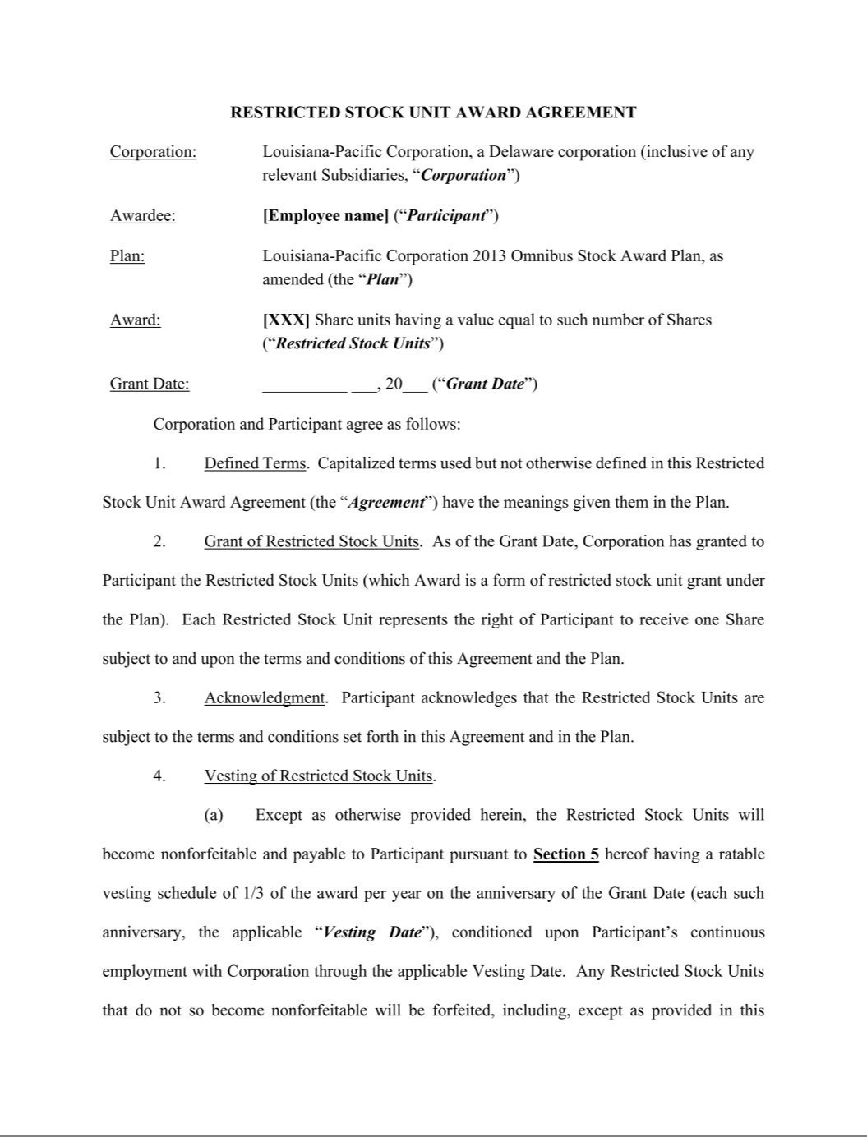

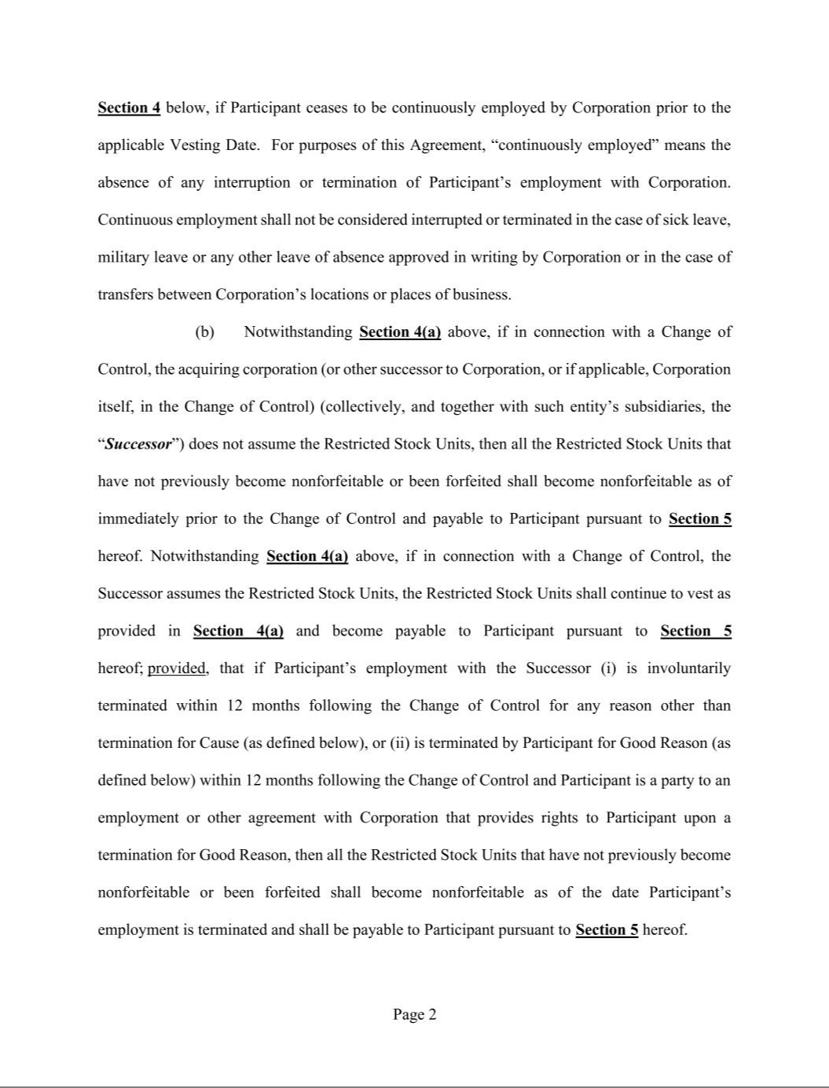

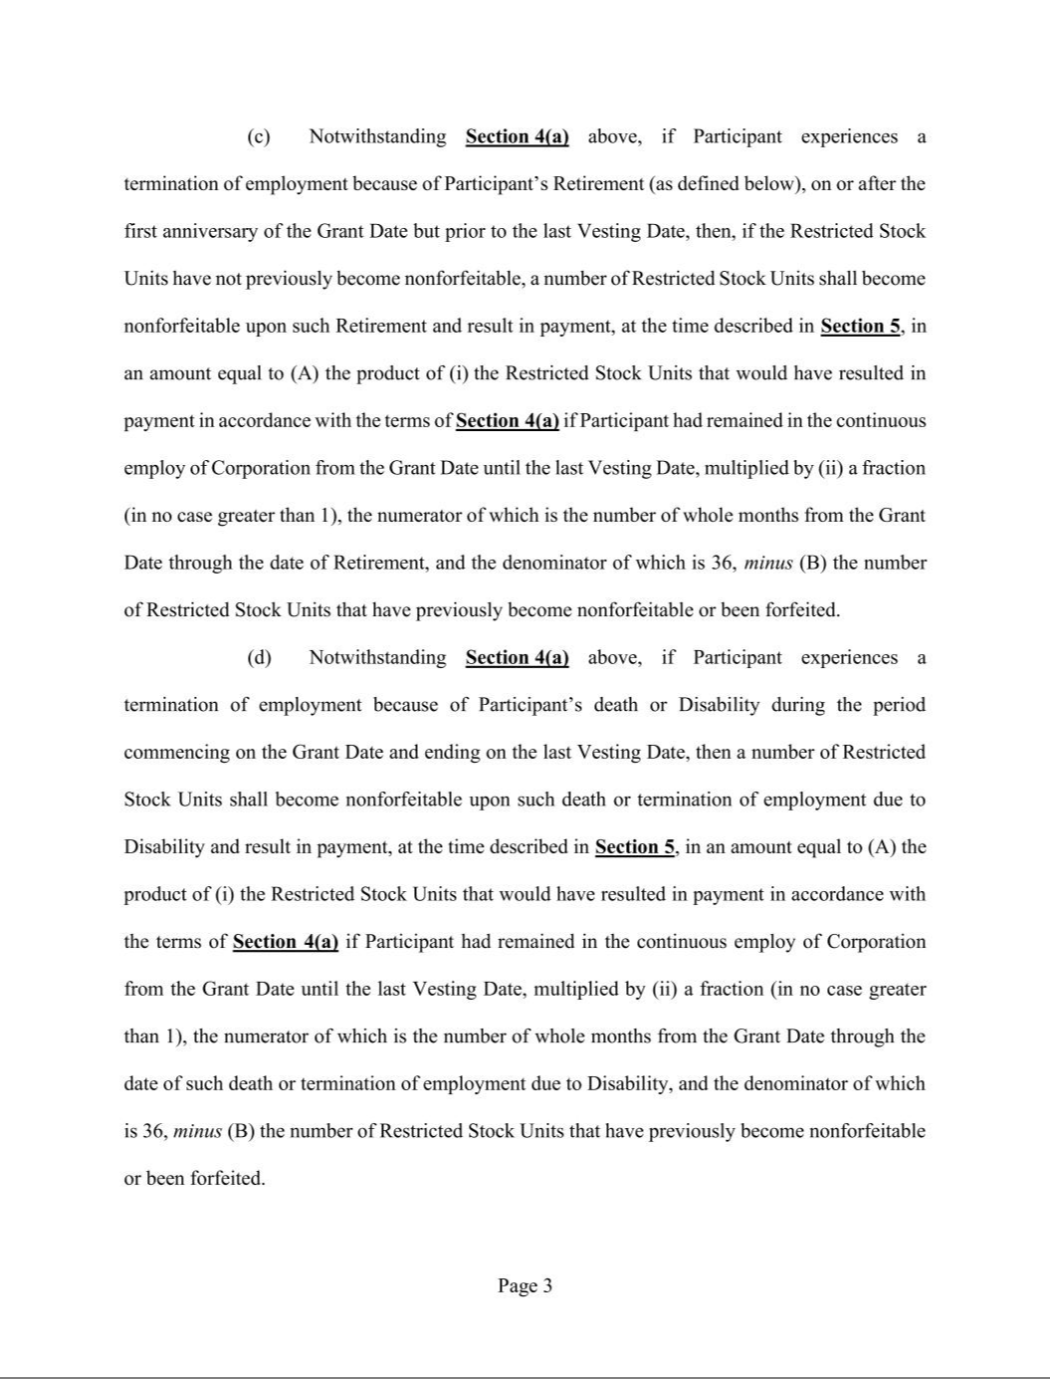

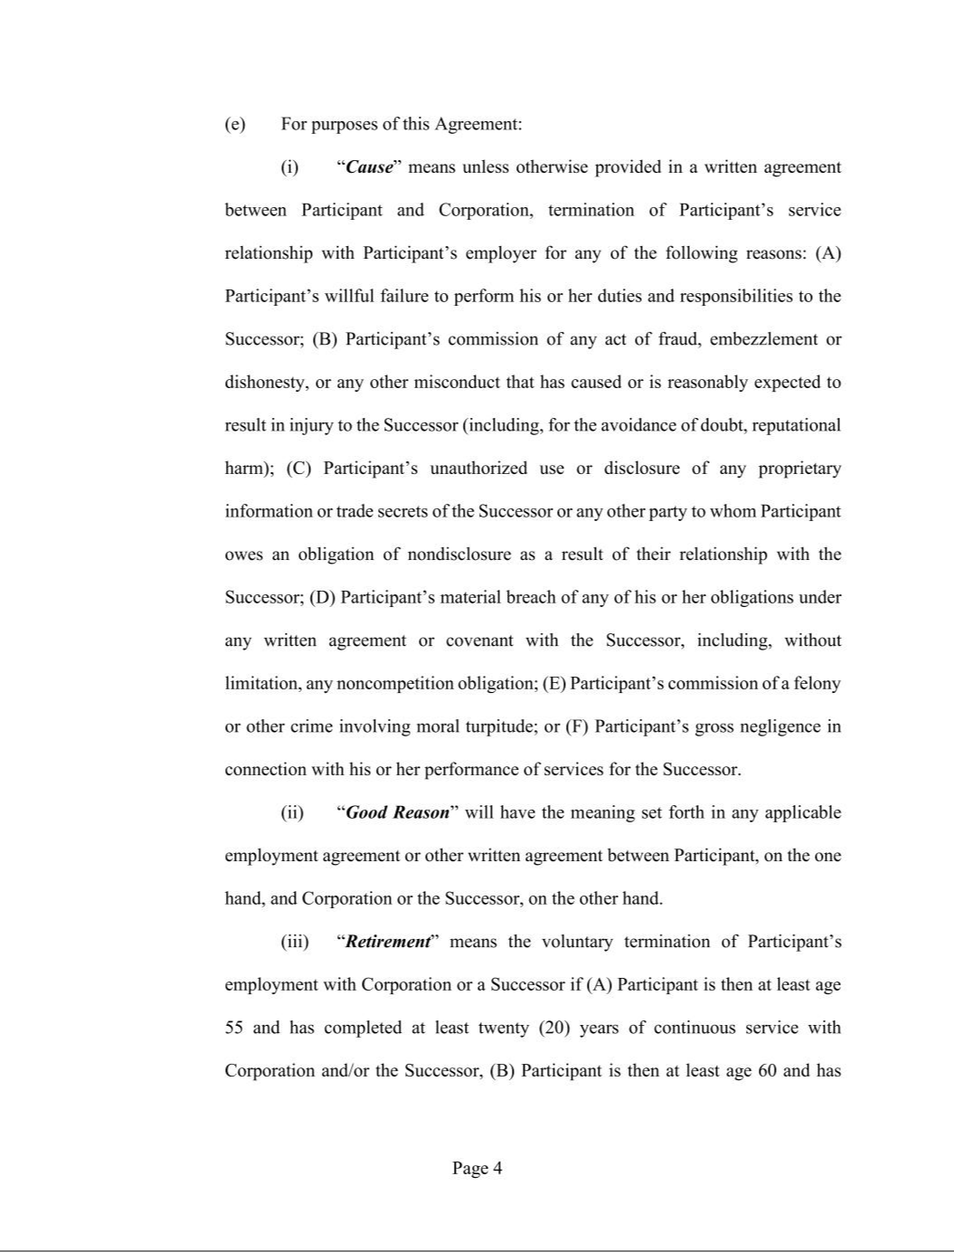

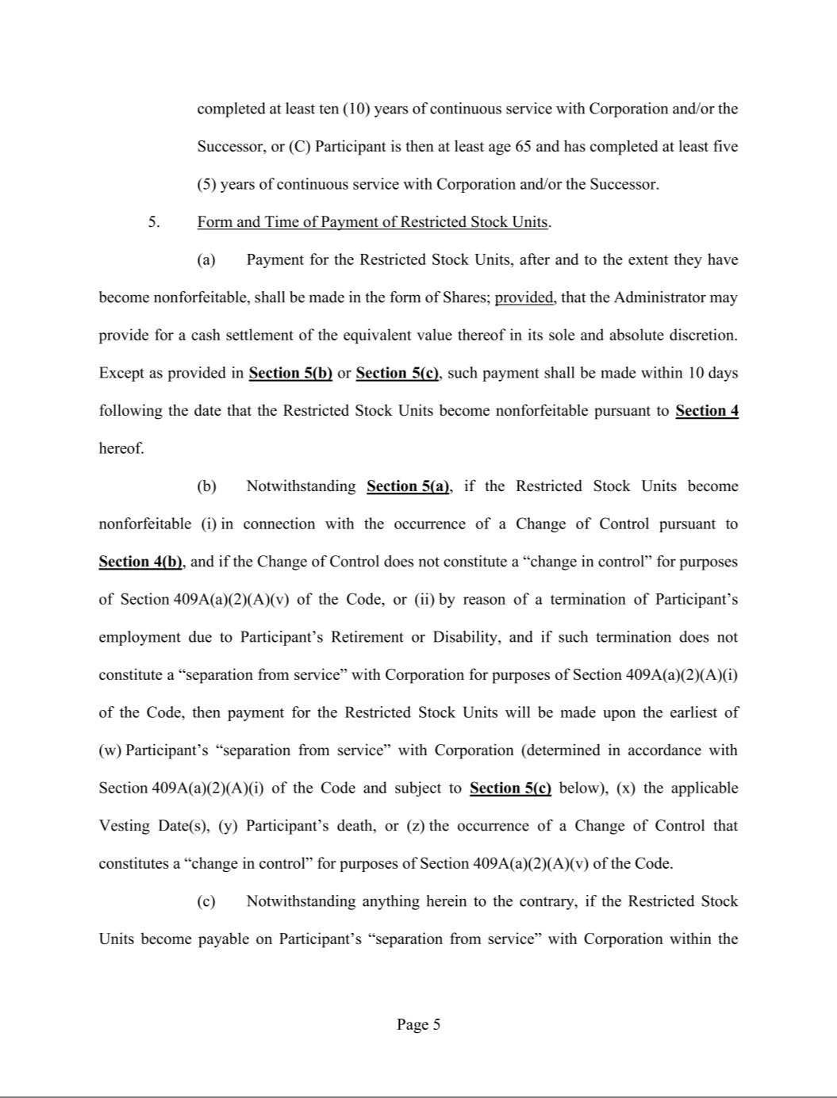

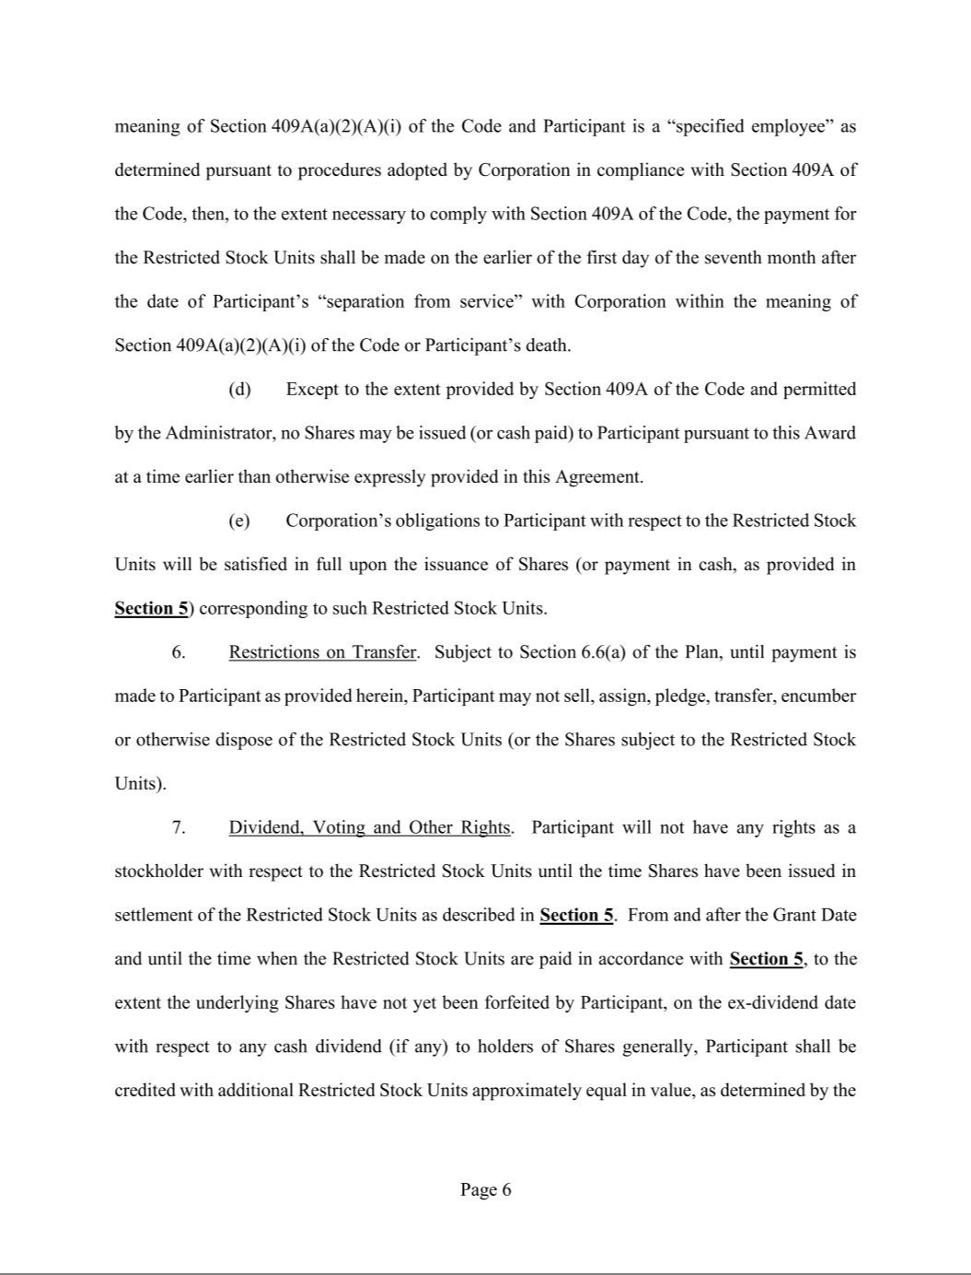

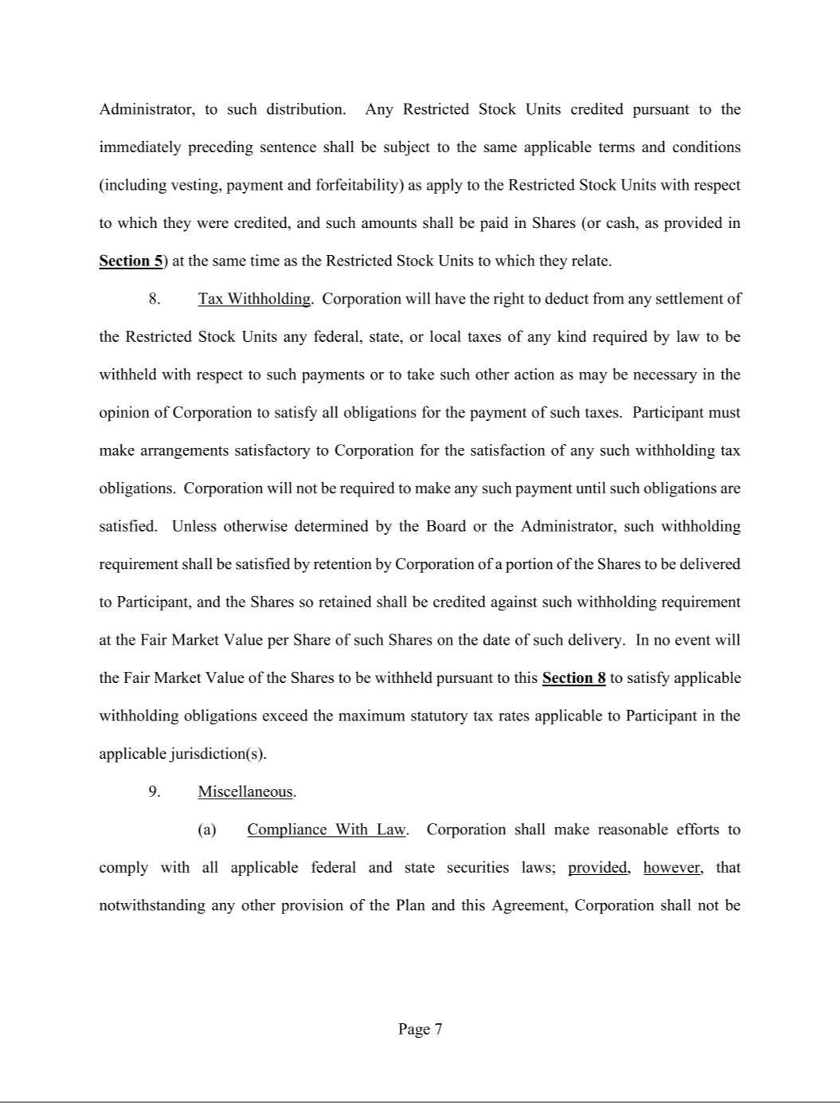

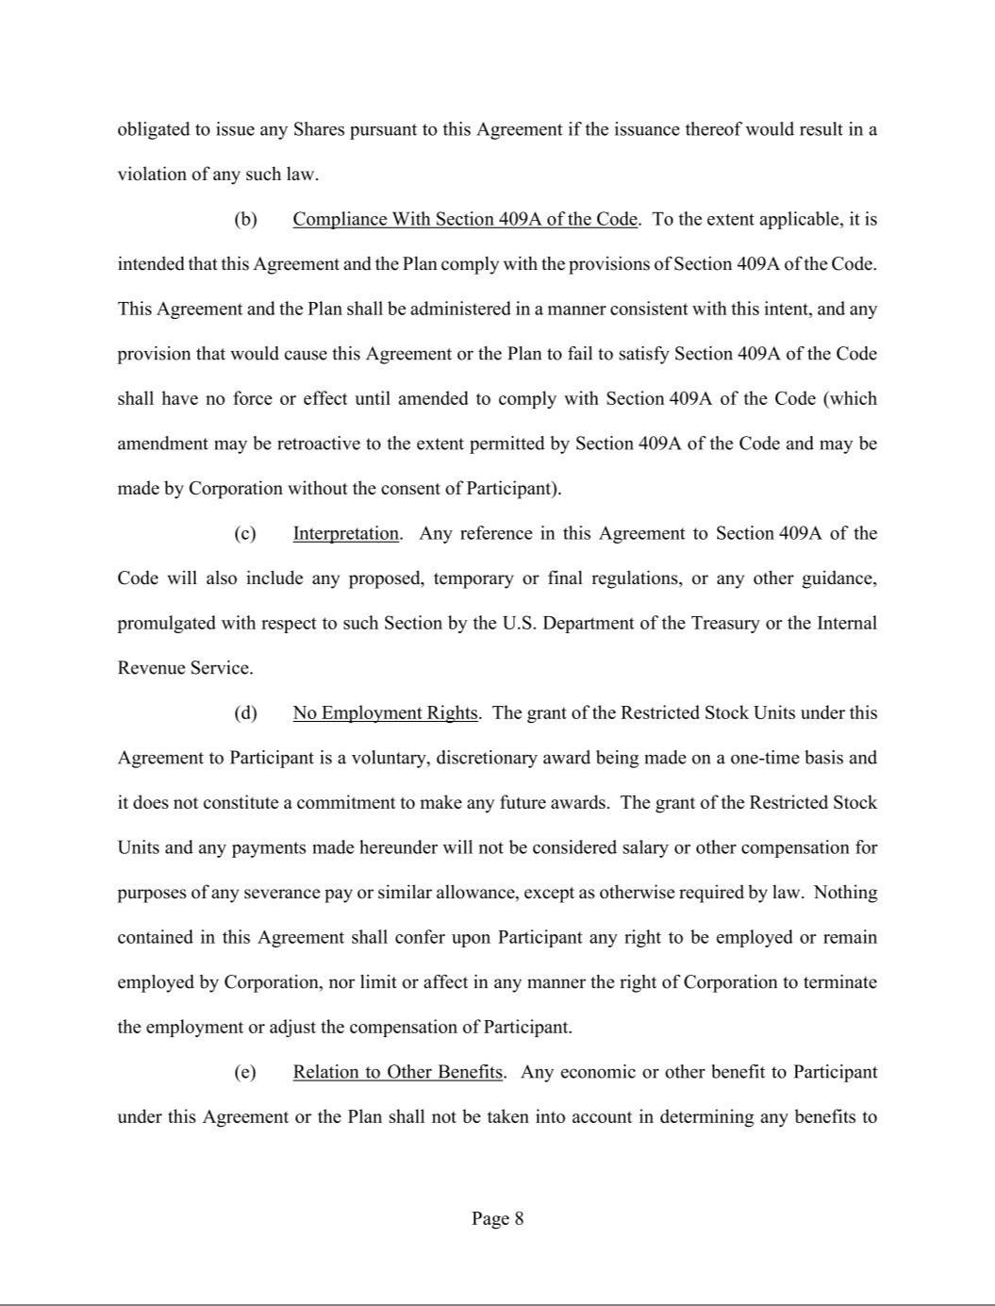

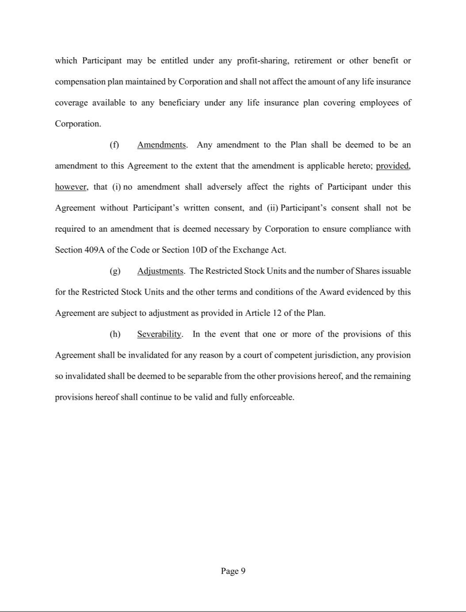

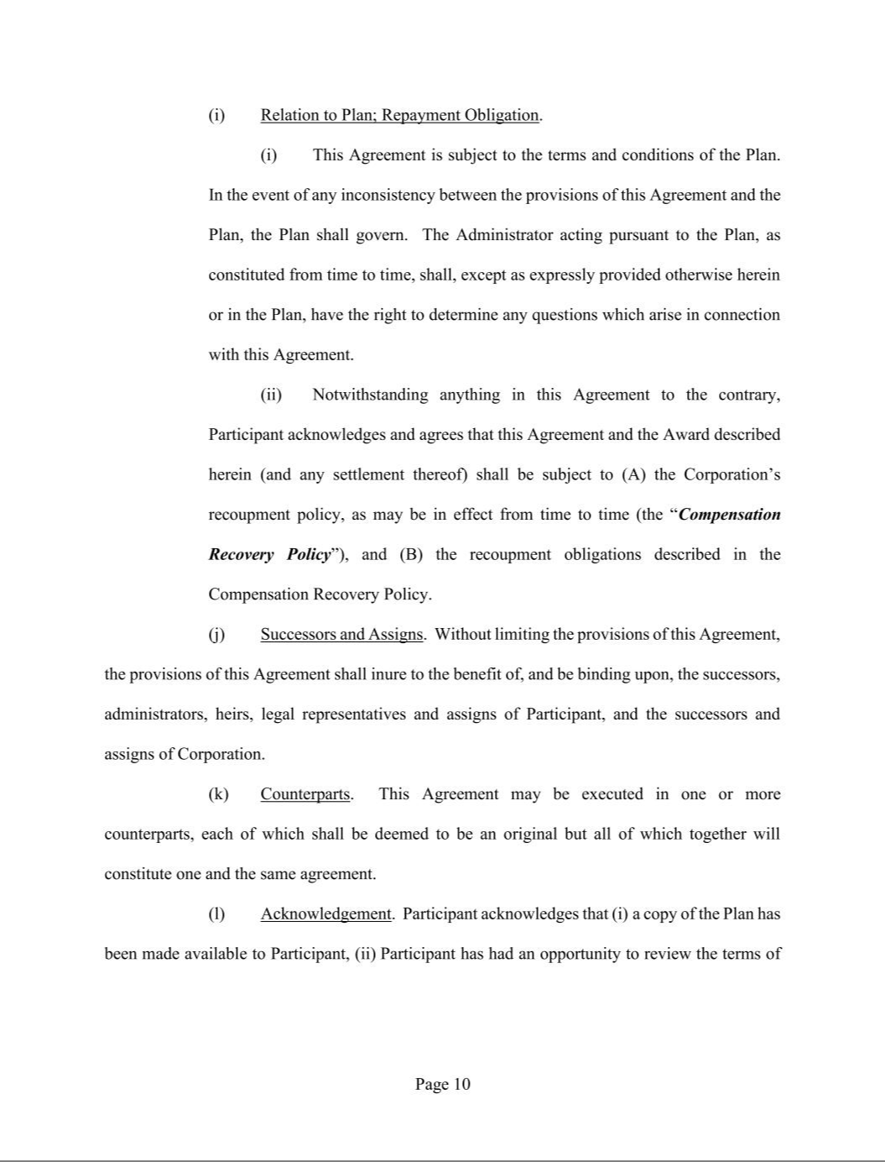

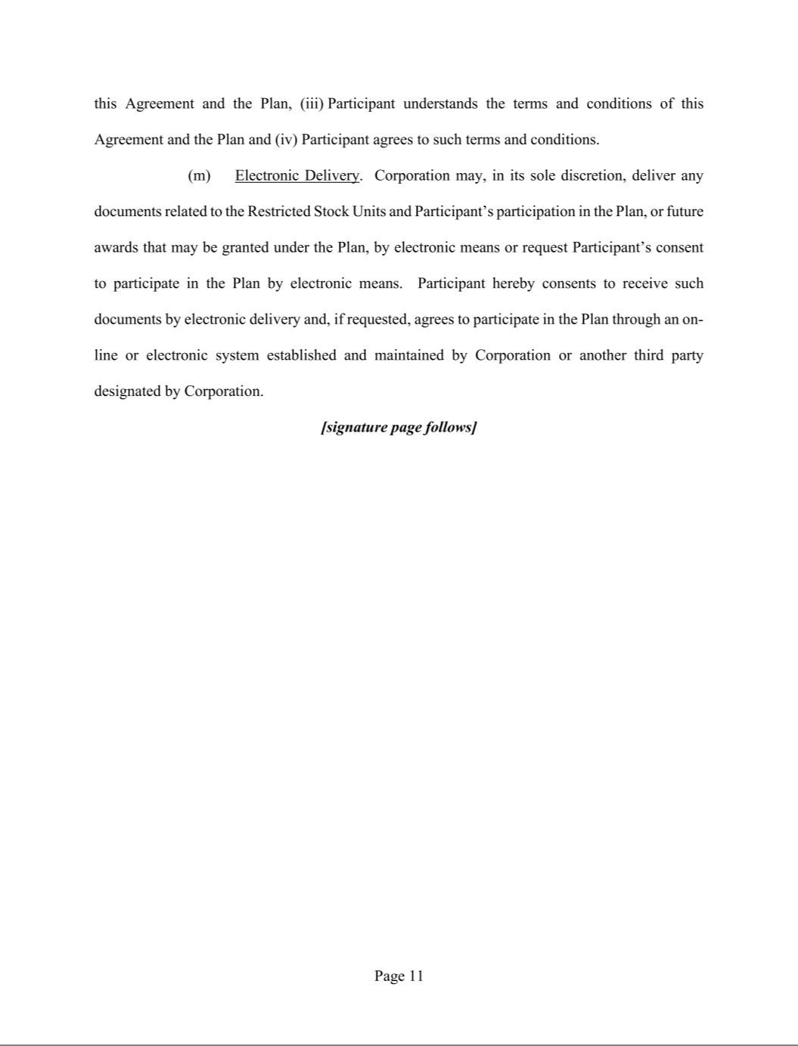

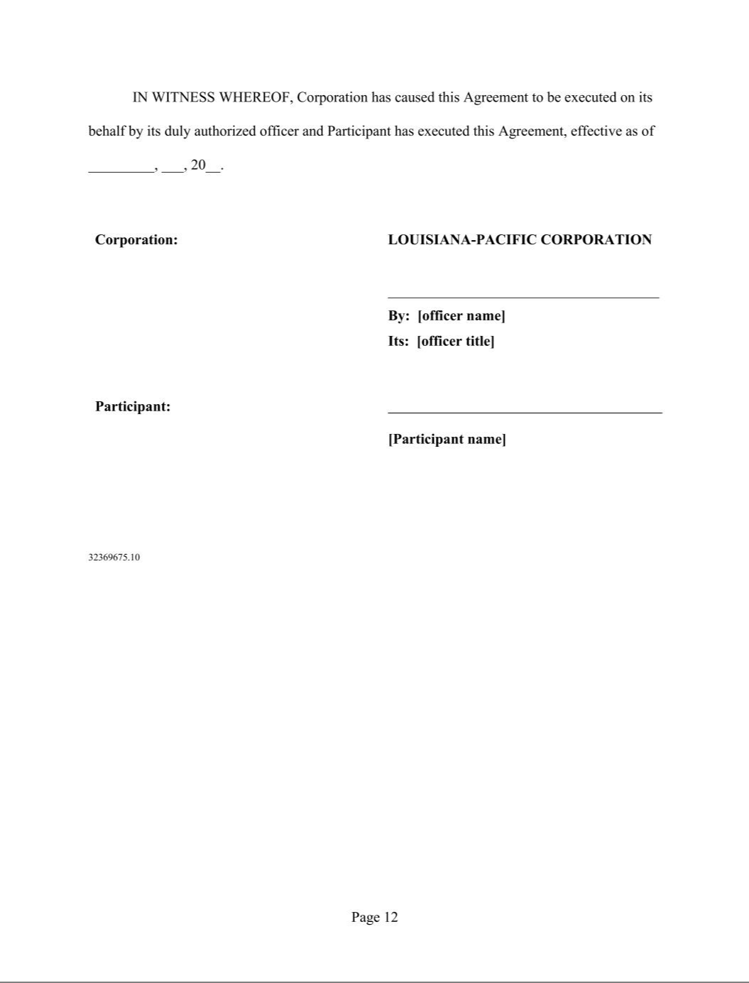

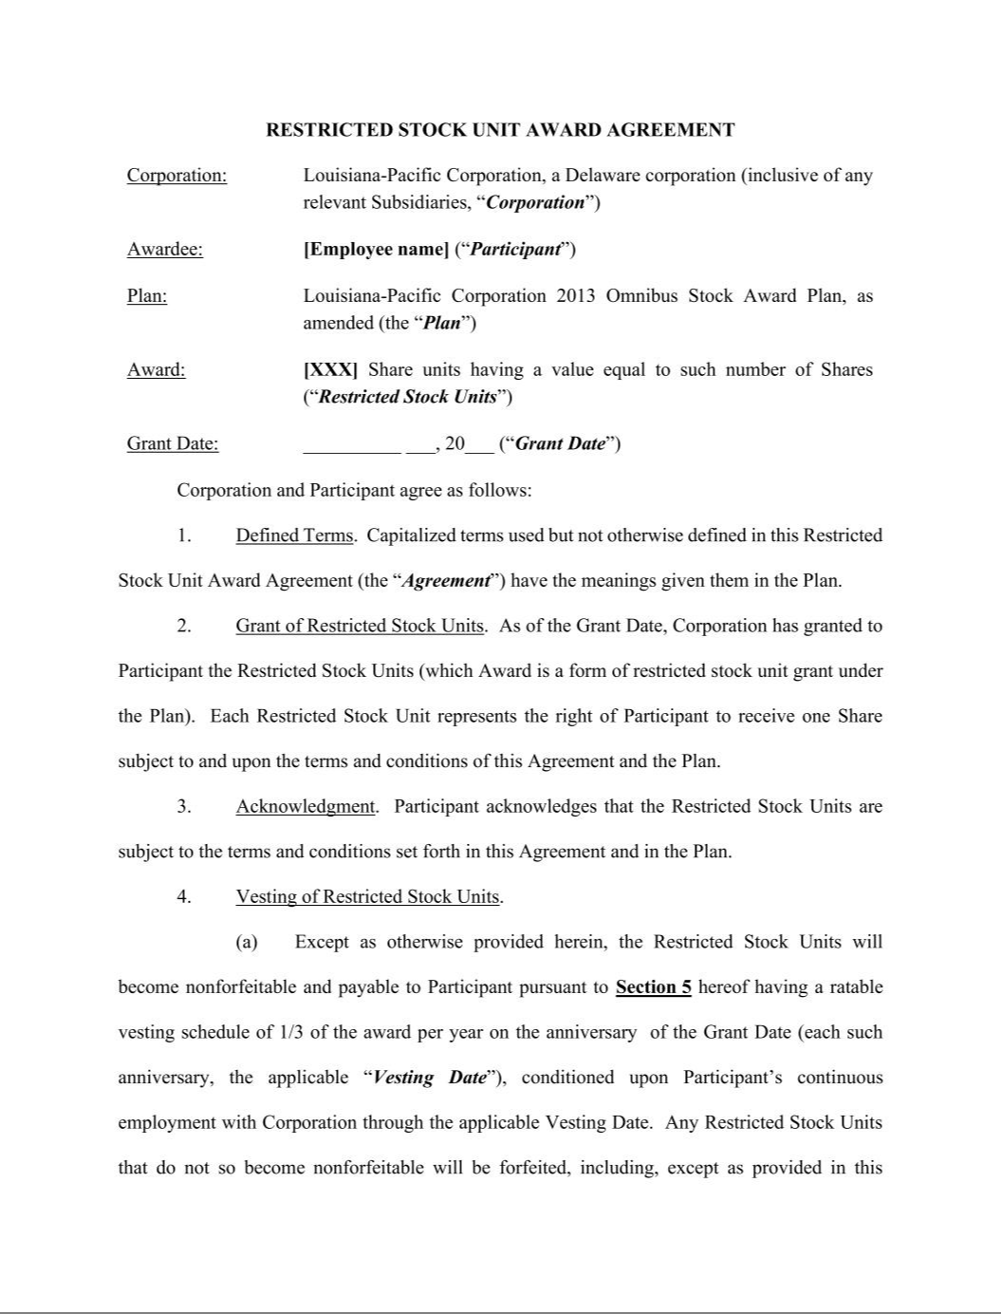

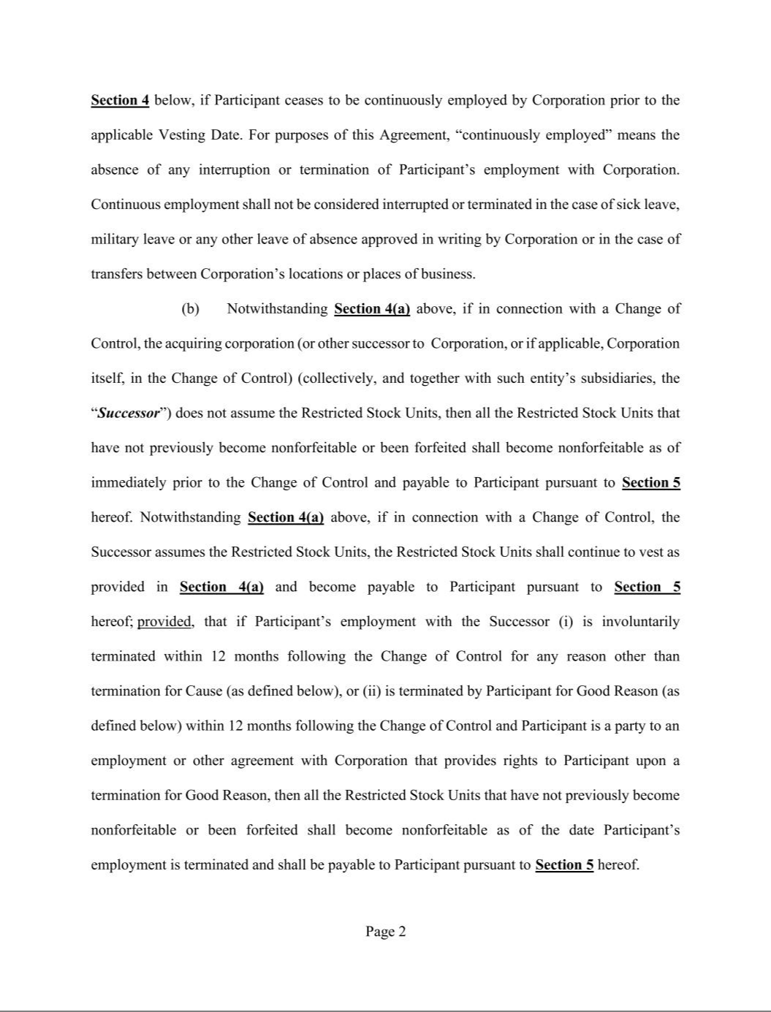

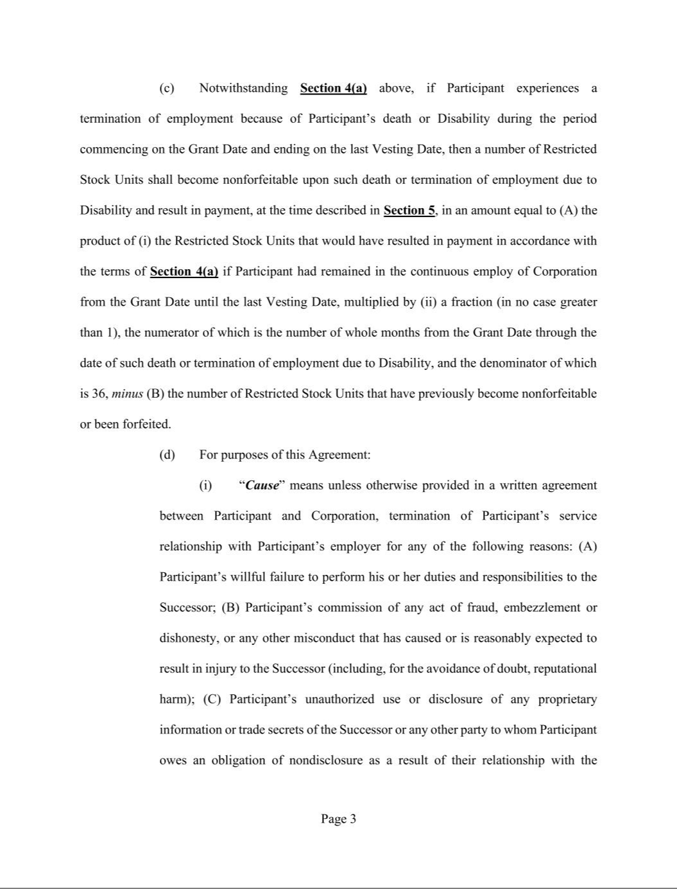

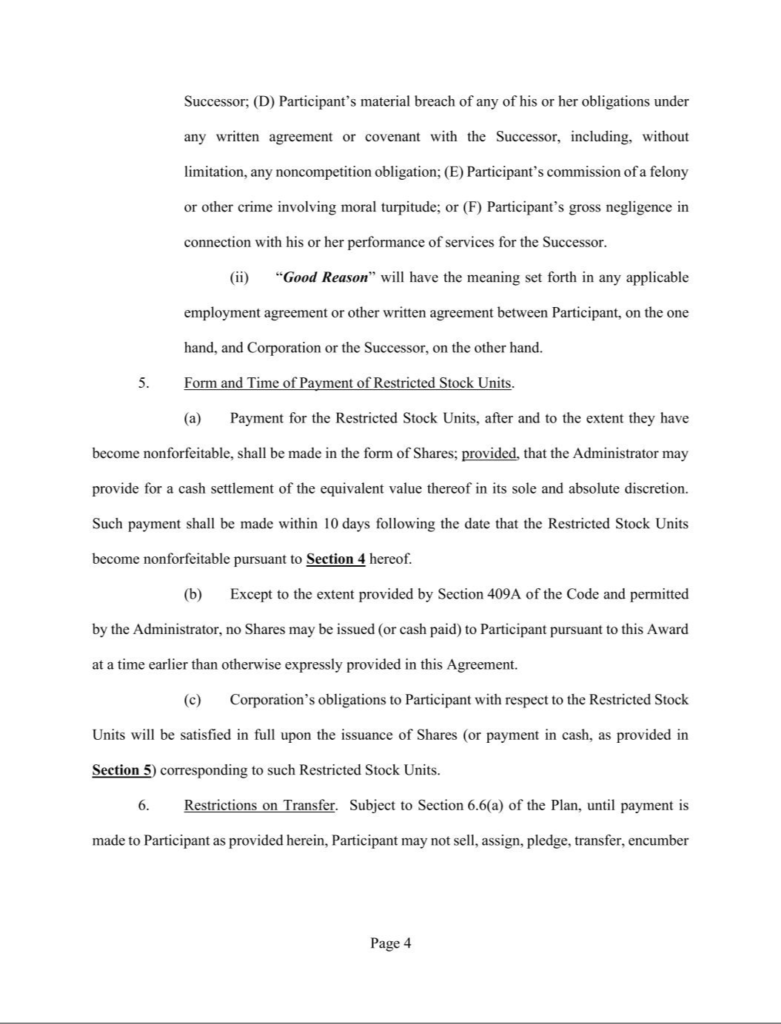

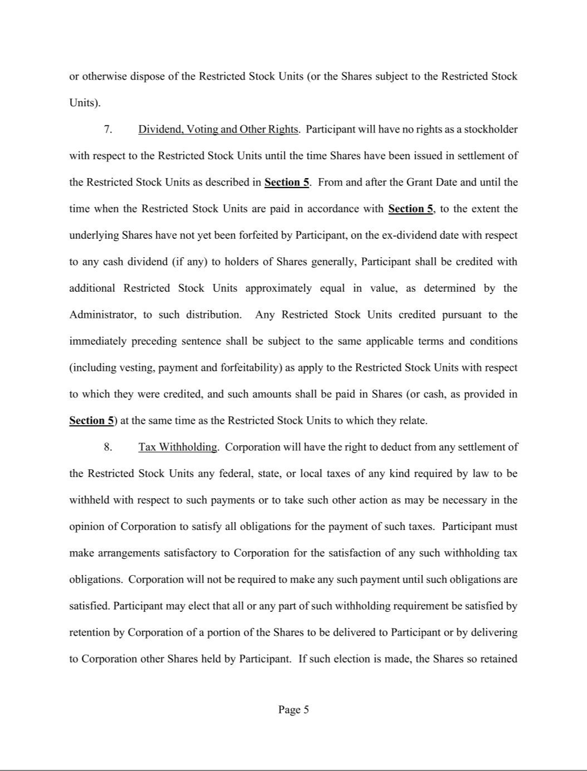

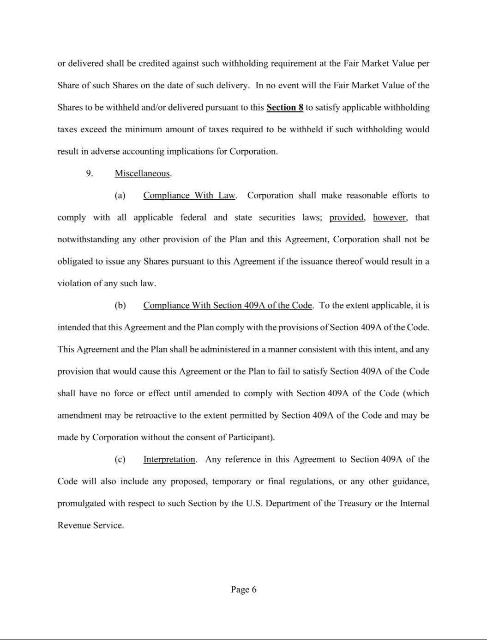

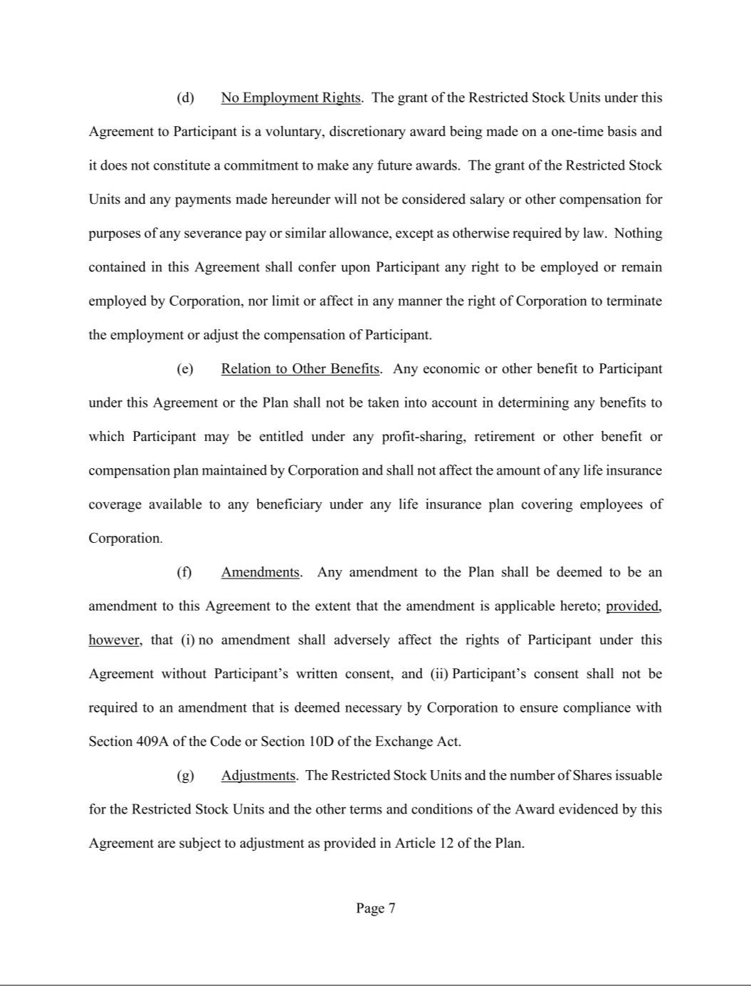

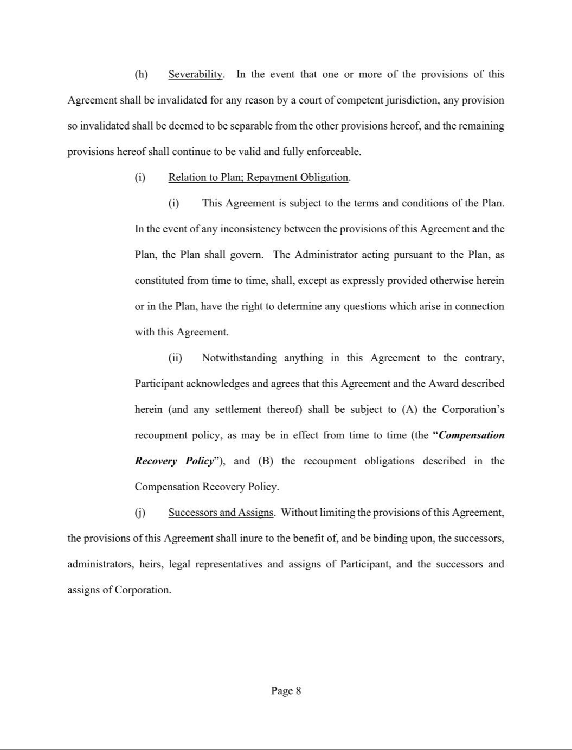

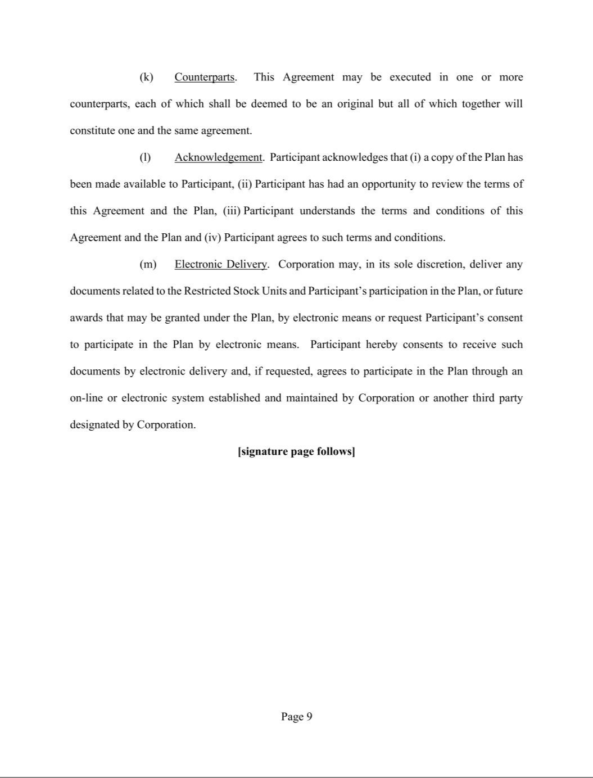

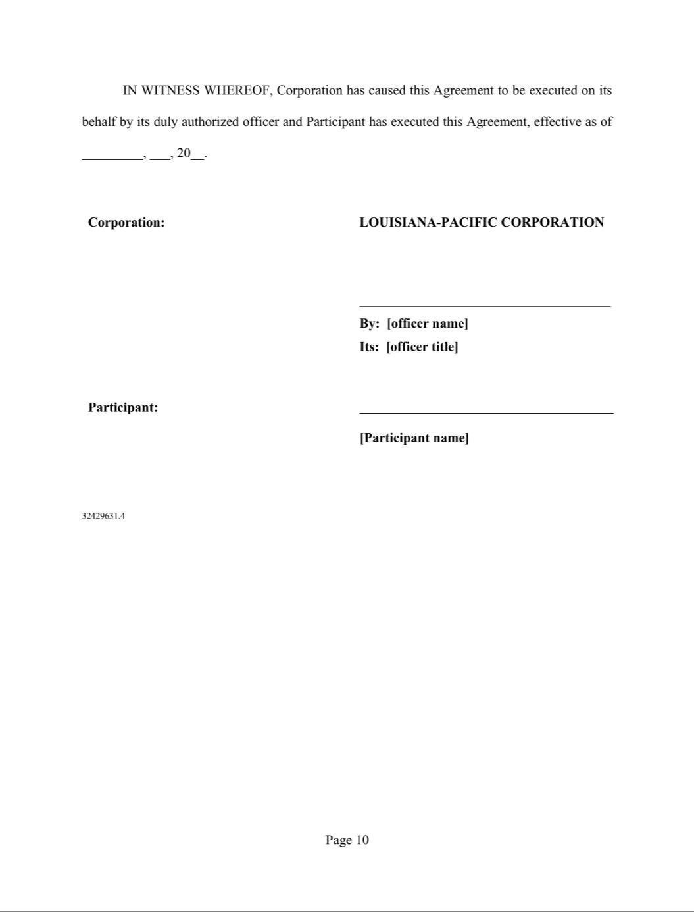

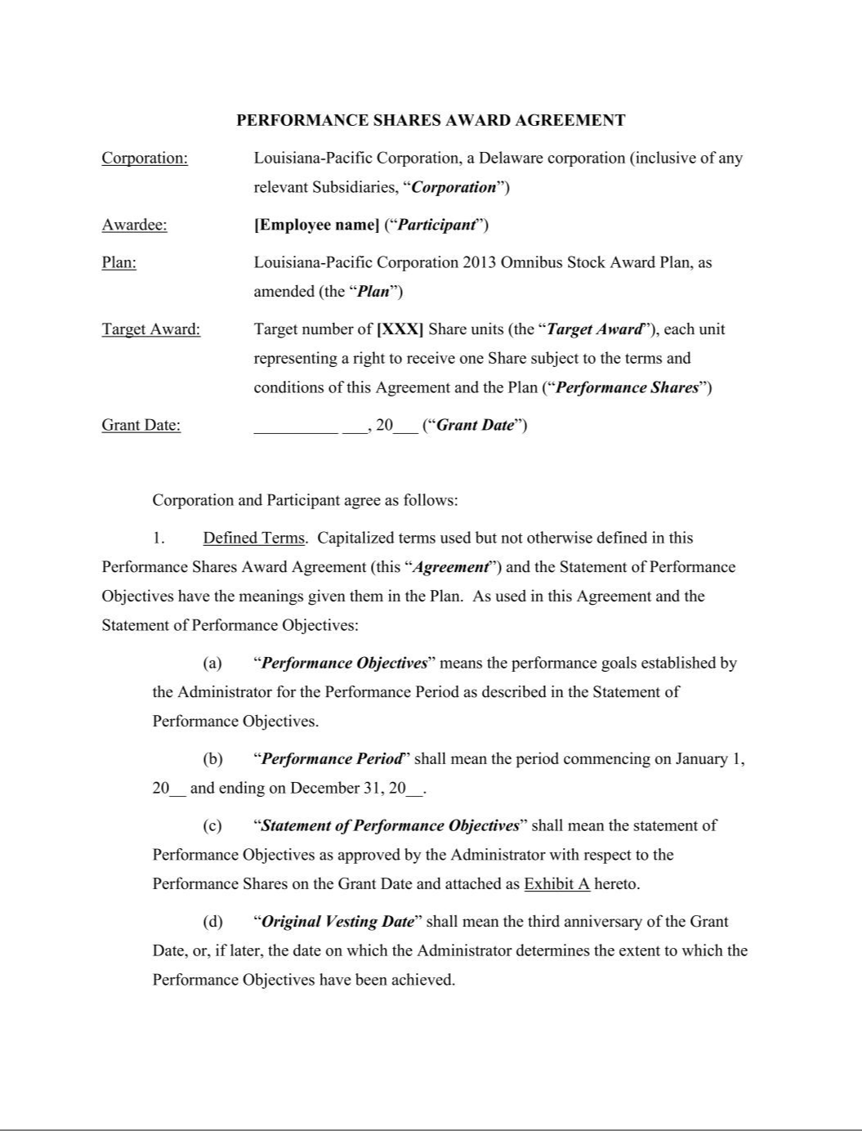

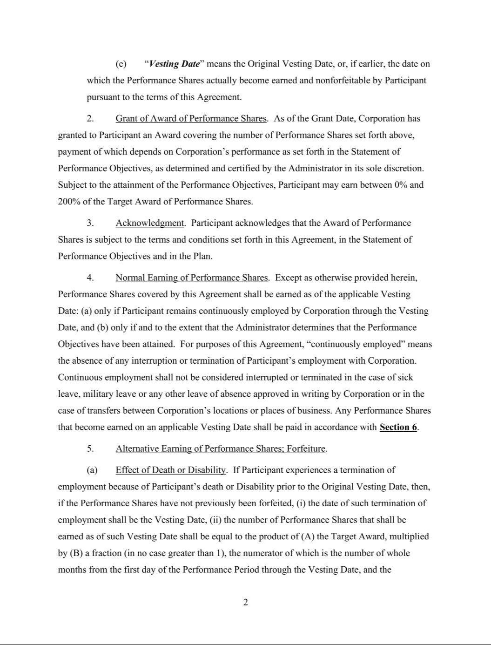

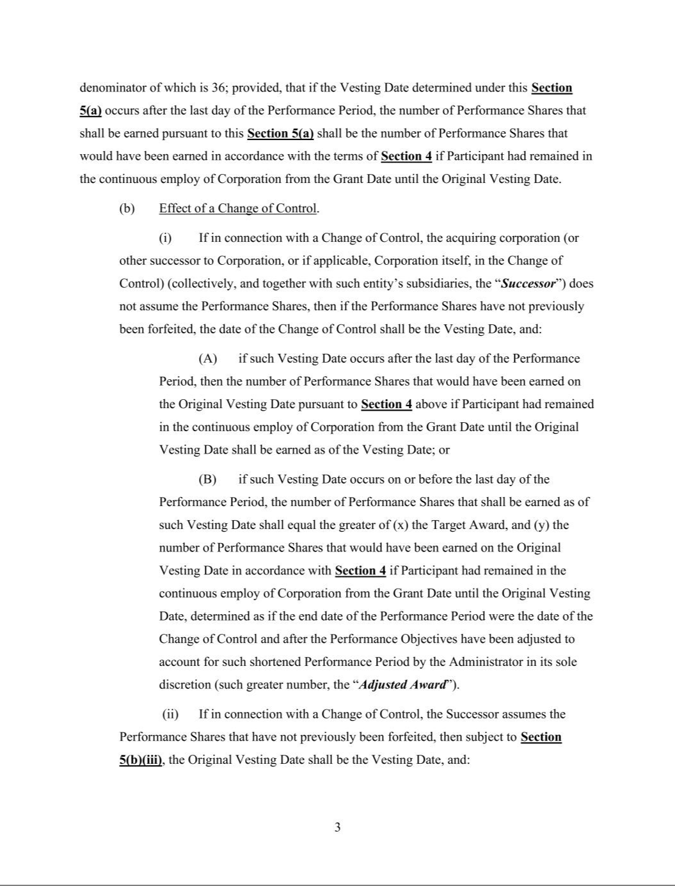

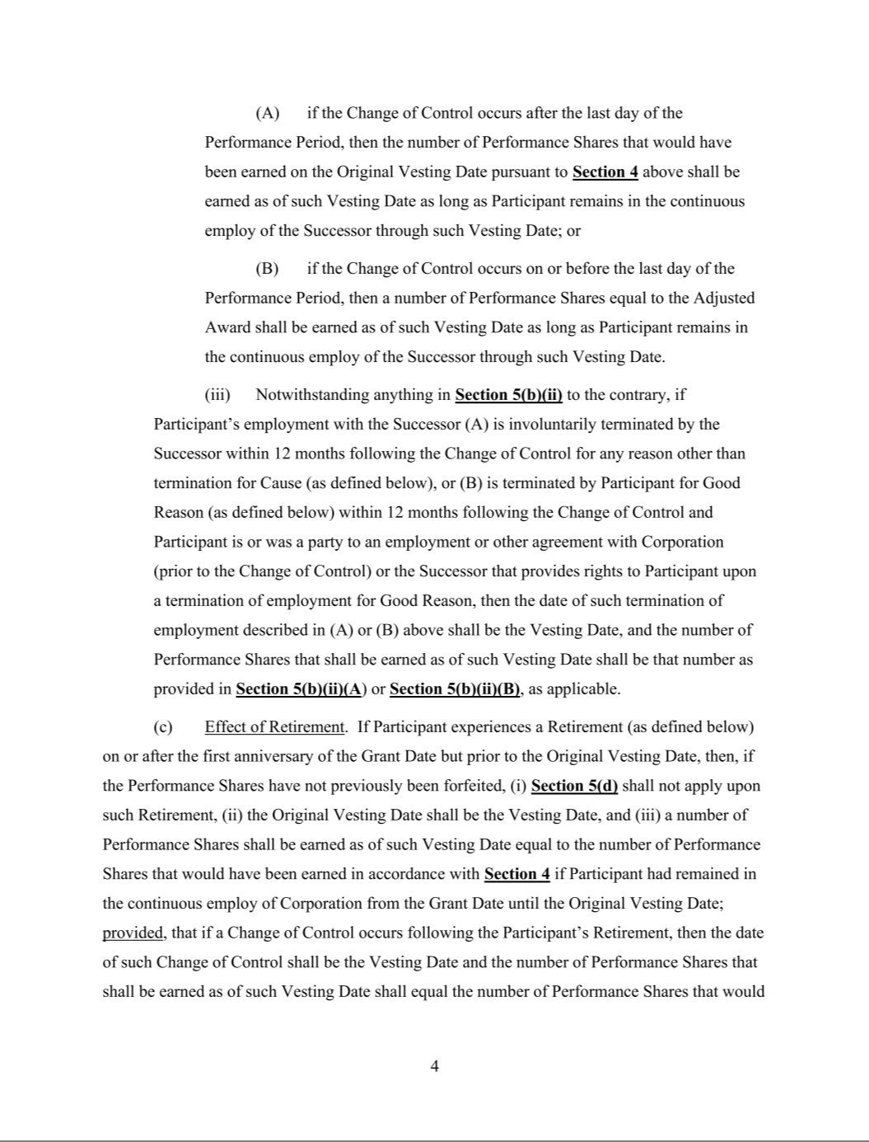

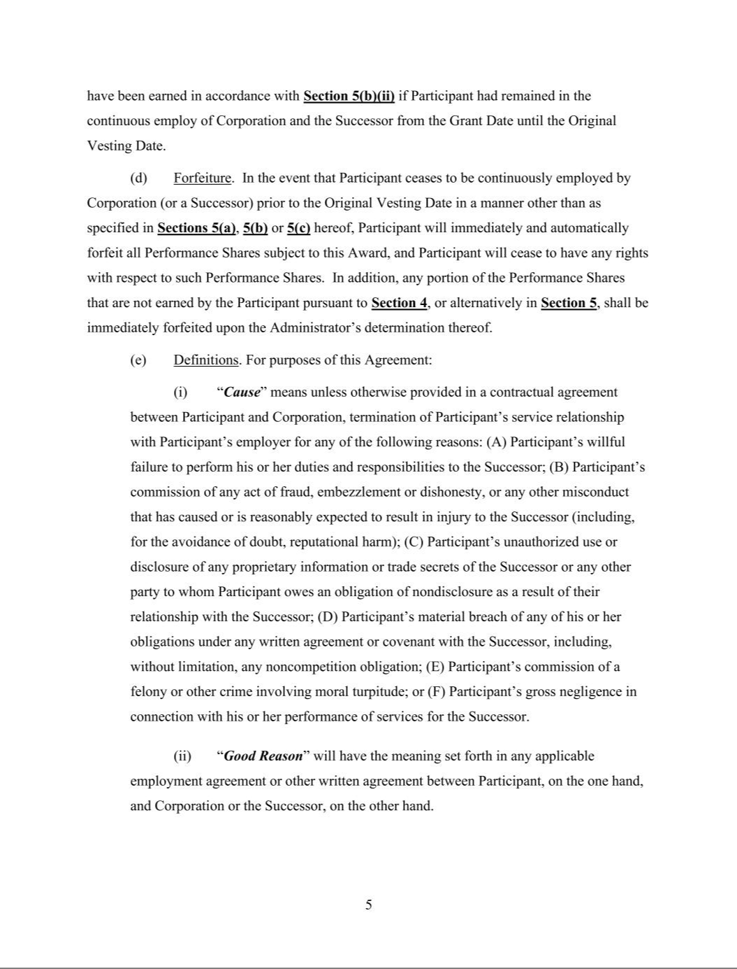

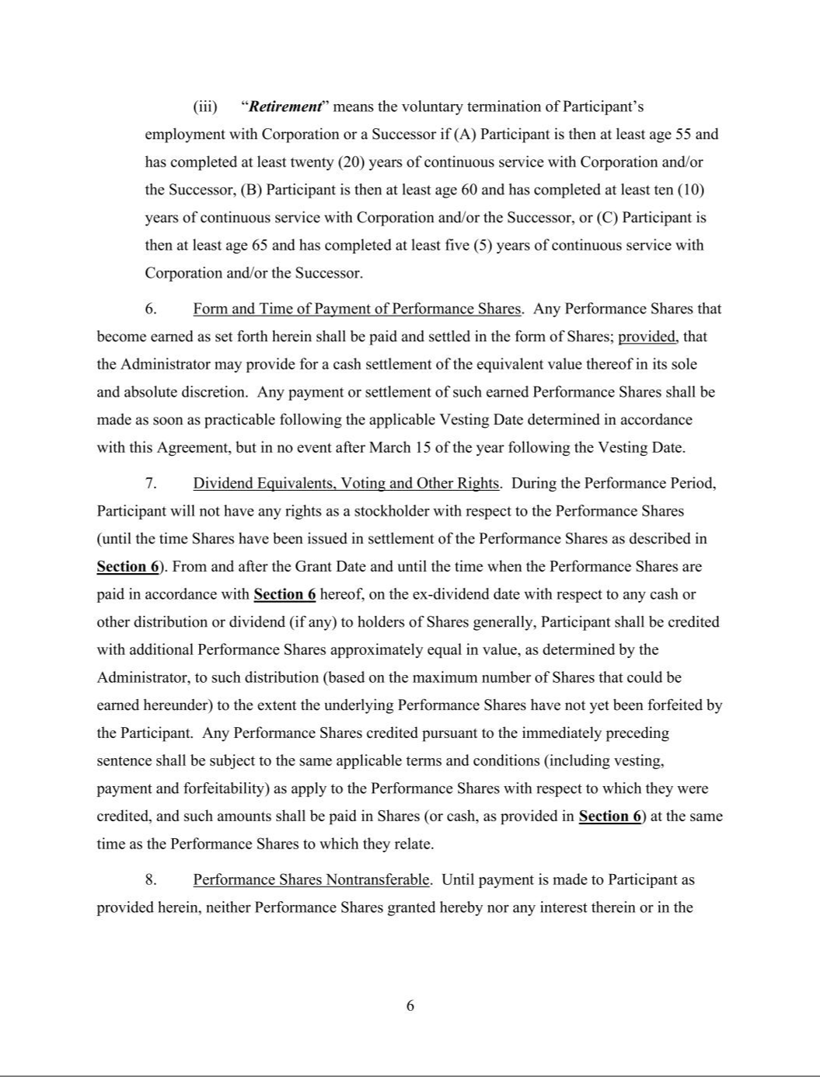

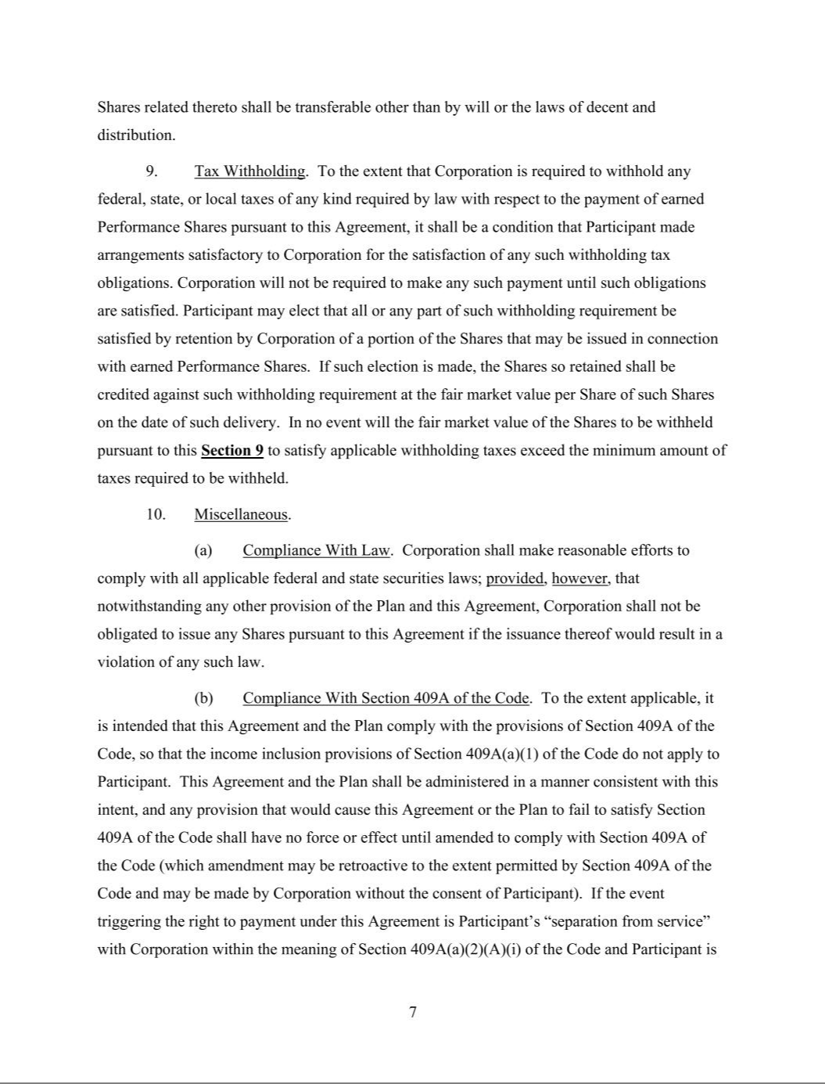

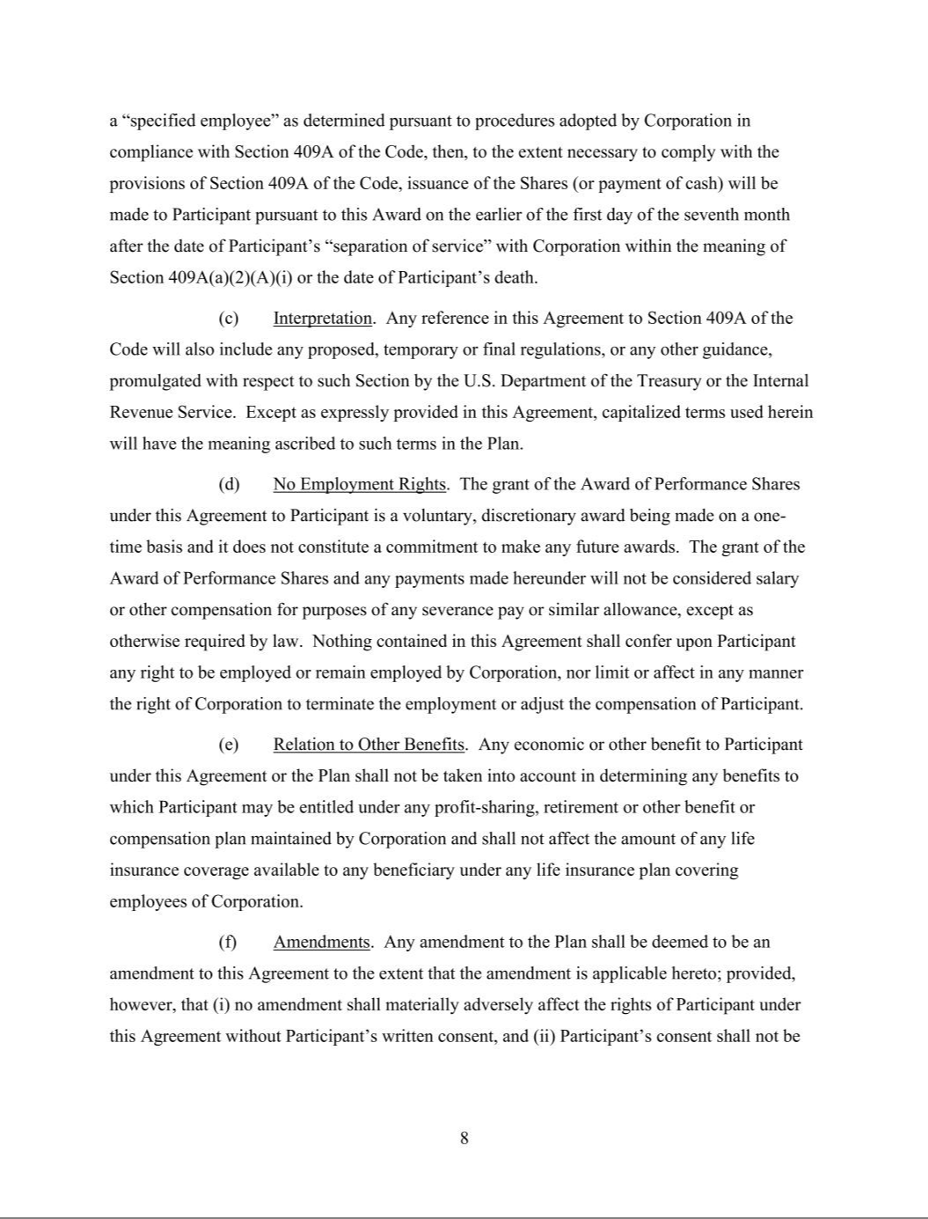

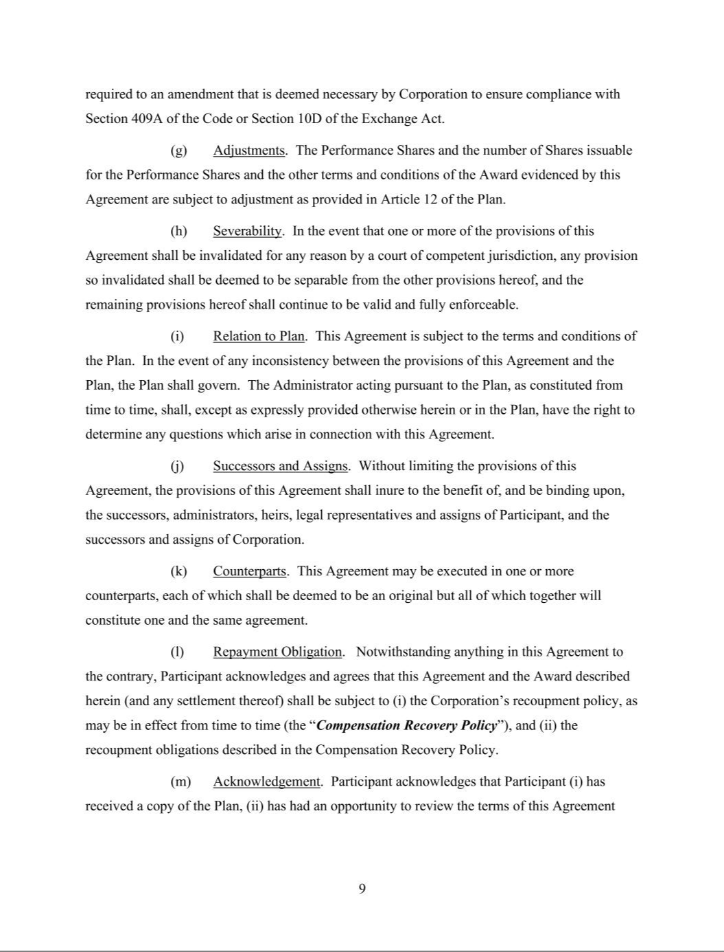

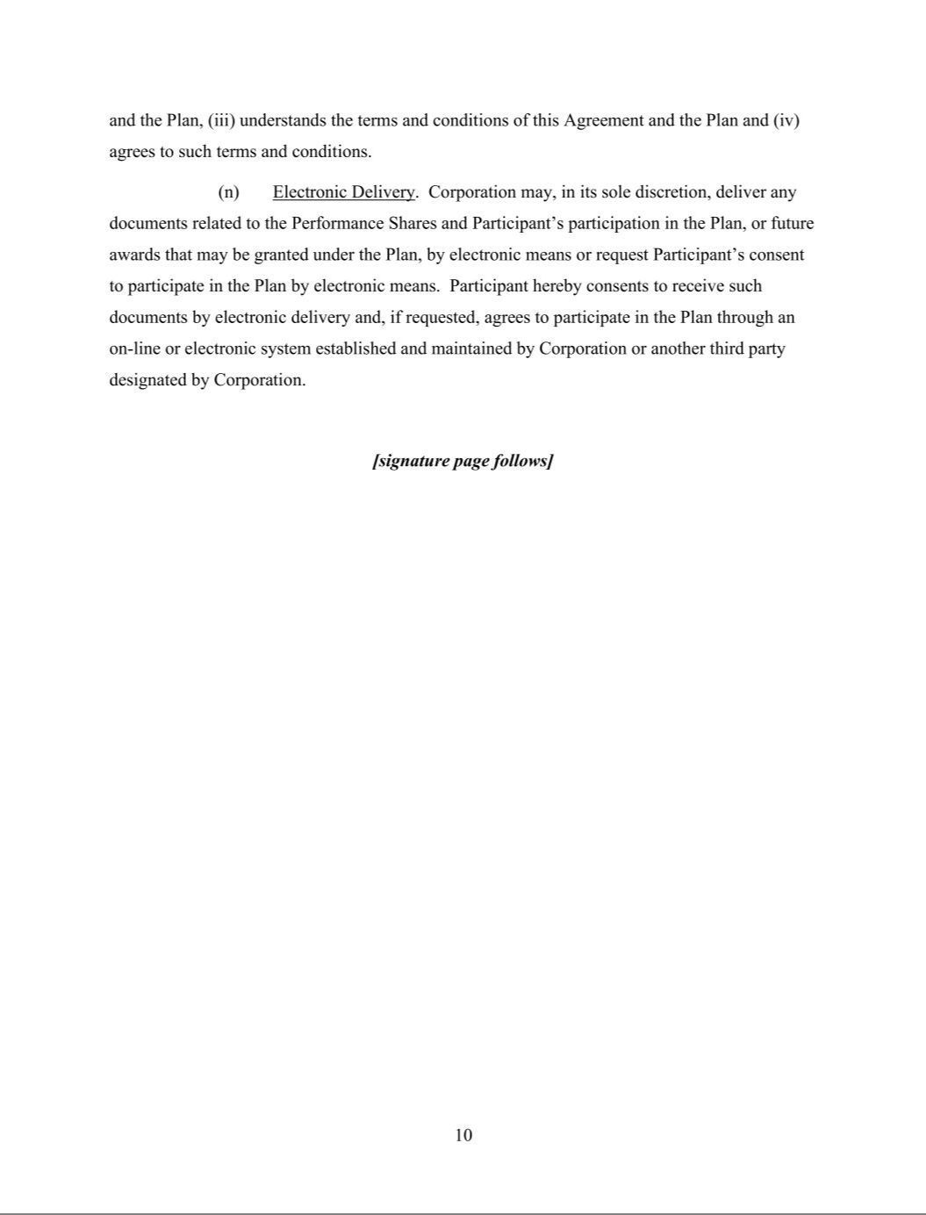

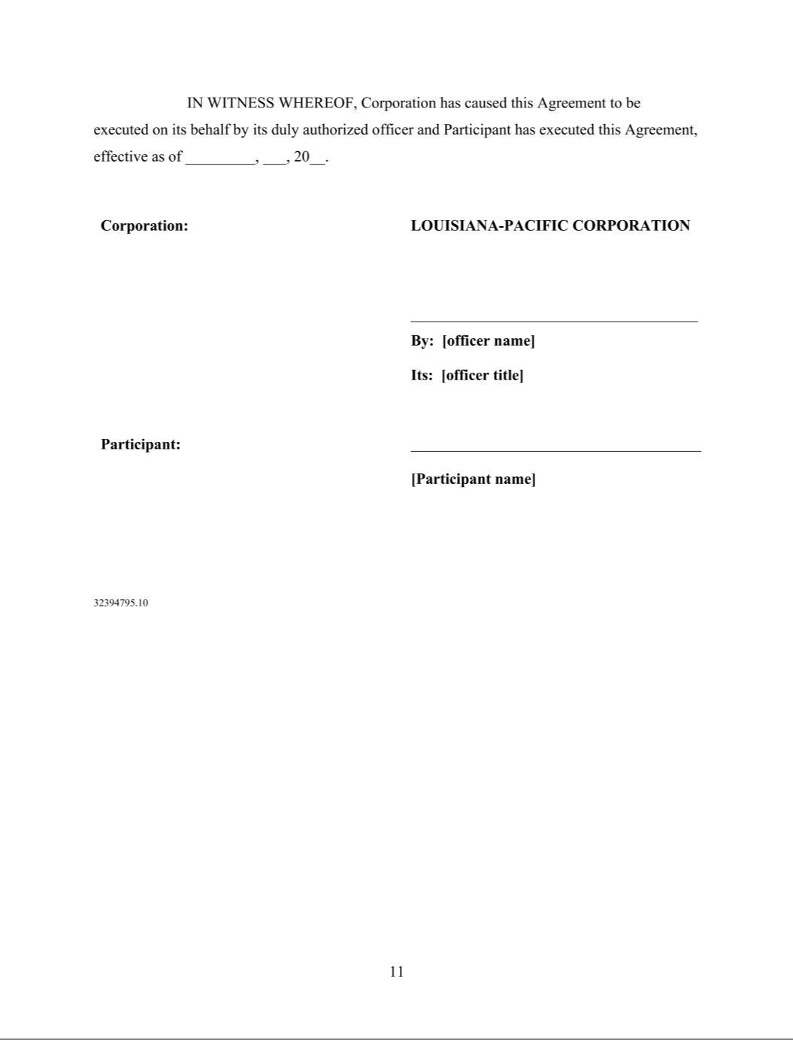

Exhibit 21

Domestic Subsidiaries
Ketchikan Pulp Company
Entekra Holdings, LLC
Entekra, LLC

Entekra Truss, LLC

Foreign Subsidiaries

Louisiana-Pacific Canada Holdings Ltd.
Louisiana-Pacific Canada Ltd.
Resolute-LP EW Prime Ltd. Partnership
Resolute-LP EW Laruche Inc.
Slocan-LP OSB Corp.
Louisiana-Pacific South America S.A.
Louisiana-Pacific Mexico
LP Brasil OSB Industria E. Comercio S.A.
Louisiana-Pacific Chile S.A.
Louisiana-Pacific del Perú S.A.C.
Louisiana-Pacific Argentina S.R.L.
Louisiana-Pacific Colombia S.A.S.
Louisiana-Pacific Paraguay S.A.
Entekra Ltd

Exhibit 23

CONSENT OF INDEPENDENT REGISTERED PUBLIC ACCOUNTING FIRM

We consent to the incorporation by reference in Registration Statement Nos. 333-228608, 333-159737, 333-156144, 333-153080, 333-118269, 333-118245, 333-88076, 333-53715, 333-87775, 333-87803, 333-188447, 333-110243, and 333-49106 on Form S-8 of our reports dated February 22, 2022, relating to the consolidated financial statements of Louisiana-Pacific Corporation and subsidiaries (the “Company”), and the effectiveness of the Company’s internal control over financial reporting, appearing in this Annual Report on Form 10-K of Louisiana-Pacific Corporation for the year ended December 31, 2021.

/s/ Deloitte & Touche LLP

Nashville, Tennessee

February 22, 2022

Exhibit 31.1

CERTIFICATIONS

I, W. Bradley Southern, certify that:

- I have reviewed this annual report on Form 10-K of Louisiana-Pacific Corporation;

- Based on my knowledge, this report does not contain any untrue statement of a material fact or omit to state a material fact necessary to make the statements made, in light of the circumstances under which such statements were made, not misleading with respect to the period covered by this report;

- Based on my knowledge, the financial statements, and other financial information included in this report, fairly present in all material respects the financial condition, results of operations and cash flows of the registrant as of, and for, the periods presented in this report;

- The registrant’s other certifying officer and I are responsible for establishing and maintaining disclosure controls and procedures (as defined in Exchange Act Rules 13a-15(e) and 15d-15(e)) and internal control over financial reporting (as defined in Exchange Act Rules 13a-15(f) and 15d-15(f)) for the registrant and have:

  - designed such disclosure controls and procedures, or caused such disclosure controls and procedures to be designed under our supervision, to ensure that material information relating to the registrant, including its consolidated subsidiaries, is made known to us by others within those entities, particularly during the period in which this report is being prepared;

  - designed such internal control over financial reporting, or caused such internal control over financial reporting to be designed under our supervision, to provide reasonable assurance regarding the reliability of financial reporting and the preparation of financial statements for external purposes in accordance with generally accepted accounting principles;

  - evaluated the effectiveness of the registrant’s disclosure controls and procedures and presented in this report our conclusions about the effectiveness of the disclosure controls and procedures, as of the end of the period covered by this report based on such evaluation; and

  - disclosed in this report any change in the registrant’s internal control over financial reporting that occurred during the registrant’s most recent fiscal quarter that has materially affected, or is reasonably likely to materially affect, the registrant’s internal control over financial reporting; and

- The registrant’s other certifying officer and I have disclosed, based on our most recent evaluation of internal control over financial reporting, to the registrant’s auditors and the audit committee of the registrant’s board of directors (or persons performing the equivalent function):

  - all significant deficiencies and material weaknesses in the design or operation of internal control over financial reporting which are reasonably likely to adversely affect the registrant’s ability to record, process, summarize and report financial information; and

  - any fraud, whether or not material, that involves management or other employees who have a significant role in the registrant’s internal control over financial reporting.

Date: February 22, 2022 /S/ W. BRADLEY SOUTHERN
W. Bradley Southern
Chief Executive Officer

Exhibit 31.2

CERTIFICATIONS

I, Alan J.M. Haughie, certify that:

- I have reviewed this annual report on Form 10-K of Louisiana-Pacific Corporation;

- Based on my knowledge, this report does not contain any untrue statement of a material fact or omit to state a material fact necessary to make the statements made, in light of the circumstances under which such statements were made, not misleading with respect to the period covered by this report;

- Based on my knowledge, the financial statements, and other financial information included in this report, fairly present in all material respects the financial condition, results of operations and cash flows of the registrant as of, and for, the periods presented in this report;

- The registrant’s other certifying officer and I are responsible for establishing and maintaining disclosure controls and procedures (as defined in Exchange Act Rules 13a-15(e) and 15d-15(e)) and internal control over financial reporting (as defined in Exchange Act Rules 13a-15(f) and 15d-15(f)) for the registrant and have:

- designed such disclosure controls and procedures, or caused such disclosure controls and procedures to be designed under our supervision, to ensure that material information relating to the registrant, including its consolidated subsidiaries, is made known to us by others within those entities, particularly during the period in which this report is being prepared;

- designed such internal control over financial reporting, or caused such internal control over financial reporting to be designed under our supervision, to provide reasonable assurance regarding the reliability of financial reporting and the preparation of financial statements for external purposes in accordance with generally accepted accounting principles;

- evaluated the effectiveness of the registrant’s disclosure controls and procedures and presented in this report our conclusions about the effectiveness of the disclosure controls and procedures, as of the end of the period covered by this report based on such evaluation; and

- disclosed in this report any change in the registrant's internal control over financial reporting that occurred during the registrant's most recent fiscal quarter that has materially affected, or is reasonably likely to materially affect, the registrant's internal control over financial reporting; and

- The registrant’s other certifying officer and I have disclosed, based on our most recent evaluation of internal control over financial reporting, to the registrant’s auditors and the audit committee of the registrant’s board of directors (or persons performing the equivalent function):

- all significant deficiencies and material weaknesses in the design or operation of internal control over financial reporting which are reasonably likely to adversely affect the registrant’s ability to record, process, summarize and report financial information; and

- any fraud, whether or not material, that involves management or other employees who have a significant role in the registrant’s internal control over financial reporting.

Date: February 22, 2022 | /s/ ALAN J.M. HAUGHIE
 | Alan J.M. Haughie
 | Executive Vice President and Chief Financial Officer

Exhibit 32

LOUISIANA-PACIFIC CORPORATION

411 Union Street, Suite 2000

Nashville, TN 37219-1700

(615)986-5600

February 22, 2022

Securities and Exchange Commission

Judiciary Plaza

450 Fifth Street, N.W.

Washington, D.C. 20549

Re: Certification Pursuant to § 906 of the Sarbanes-Oxley Act of 2002

Ladies and Gentlemen:

Pursuant to 18 U.S.C. § 1350, as adopted pursuant to § 906 of the Sarbanes-Oxley Act of 2002, in connection with the filing of the annual report on Form 10-K of Louisiana-Pacific Corporation (the “Company”) for the fiscal year ended December 31, 2021, as filed with the Securities and Exchange Commission on the date hereof (the “Report”), each of the undersigned officers of the Company certifies, that, to such officer’s knowledge:

- The Report fully complies with the requirements of Section 13(a) or 15(d) of the Securities Exchange Act of 1934; and

- The information contained in the Report fairly presents, in all material respects, the financial condition and results of operations of the Company as of the dates and for the periods expressed in the Report.

/s/ W. BRADLEY SOUTHERN
Name: W. Bradley Southern
Title: Chief Executive Officer

/s/ ALAN J.M. HAUGHIE
Name: Alan J.M. Haughie
Title: Executive Vice President and Chief Financial Officer

A signed original of this written statement required by Section 906 has been provided to Louisiana-Pacific Corporation and will be retained by Louisiana-Pacific Corporation and furnished to the Securities and Exchange Commission or its staff upon request.

