United States
SECURITIES AND EXCHANGE COMMISSION
Washington, D.C. 20549
__________________________________
FORM 8-K
__________________________________
CURRENT REPORT
Pursuant to Section 13 OR 15(d) of the
Securities Exchange Act of 1934
Date of Report (Date of earliest event reported): September 1, 2026
__________________________________
LOUISIANA-PACIFIC CORPORATION
(Exact name of registrant as specified in its charter)
__________________________________

Delaware |  |  |  |  |  | 1-7107 |  |  |  |  |  | 93-0609074
(State or other jurisdiction of  incorporation or organization) |  |  |  |  |  | Commission  File Number |  |  |  |  |  | (IRS Employer  Identification No.)
1610 West End Ave, Suite 200, Nashville, TN 37203
(Address of principal executive offices) (Zip Code)
Registrant’s telephone number, including area code: (615) 986 - 5600
__________________________________

Check the appropriate box below if the Form 8-K filing is intended to simultaneously satisfy the filing obligation of the registrant under any of the following provisions (see General Instruction A.2. below):

☐ Written communications pursuant to Rule 425 under the Securities Act (17 CFR 230.425)

☐ Soliciting material pursuant to Rule 14a-12 under the Exchange Act (17 CFR 240.14a-12)

☐ Pre-commencement communications pursuant to Rule 14d-2(b) under the Exchange Act (17 CFR 240.14d-2(b))

☐ Pre-commencement communications pursuant to Rule 13e-4(c) under the Exchange Act (17 CFR 240.13e-4(c))

Securities registered pursuant to Section 12(b) of the Act:
Title of each class |  |  | Trading Symbol |  |  | Name of each exchange on which registered
Common Stock, $1 par value |  |  | LPX |  |  | New York Stock Exchange

Indicate by check mark whether the registrant is an emerging growth company as defined in Rule 405 of the Securities Act of 1933 (§230.405 of this chapter) or Rule 12b-2 of the Securities Exchange Act of 1934 (§240.12b-2 of this chapter).
Emerging growth company ☐

If an emerging growth company, indicate by check mark if the registrant has elected not to use the extended transition period for complying with any new or revised financial accounting standards provided pursuant to Section 13(a) of the Exchange Act. [ ]

Item 7.01 Regulation FD Disclosure

On September 1, 2026, Louisiana-Pacific Corporation (“LP”) issued a press release announcing that it will indefinitely curtail OSB production at its Jasper facility in Jasper, TX. A copy of the press release is attached hereto as Exhibit 99.1 and is incorporated herein by reference. LP expects to incur approximately $4 million to $6 million of severance and other one-time costs related to the curtailment in 2026. This amount is an estimate and is subject to change as LP implements the curtailment.

The information contained in this Item 7.01, including Exhibit 99.1, shall not be deemed “filed” for any purpose, including for the purposes of Section 18 of the Securities Exchange Act of 1934 or otherwise subject to the liabilities of that Section, nor shall such information be deemed incorporated by reference into any filing under the Securities Act of 1933, regardless of any general incorporation language in such filings.

Forward-Looking Statements
This Current Report on Form 8-K contains forward-looking statements concerning LP's future results and performance within the meaning of the Private Securities Litigation Reform Act of 1995. These statements are based on the beliefs and assumptions of, and information currently available to our management. The assumptions underlying these forward-looking statements are themselves forward-looking statements. Forward-looking statements can be identified by words such as “may,” “will,” “could,” “should,” “believe,” “expect,” “anticipate,” “assume,” “intend,” “plan,” “seek,” “estimate,” “project,” “target,” “potential,” “continue,” “likely,” or “future,” as well as similar expressions, or the negative or other variations thereof. Forward-looking statements include other statements regarding matters that are not historical facts, including statements regarding the anticipated mill closure and related matters. The actual results may differ materially from those anticipated in the forward-looking statements as a result of numerous factors, many of which are beyond LP’s control, including the risks and uncertainties disclosed in LP’s reports filed from time to time with the SEC, including its most recent Annual Report on Form 10-K, Quarterly Reports on Form 10-Q and Current Reports on Form 8-K, available at www.sec.gov. Except as required by law, LP does not intend to update any forward-looking statement contained in this Current Report on Form 8-K to reflect new information, subsequent events, or circumstances arising after the date hereof.

Item 9.01 Financial Statements and Exhibits
(d) Exhibits.
Exhibit  Number |  |  | Description
99.1 |  |  | Press release issued by LP on September 1, 2026
104 |  |  | Cover Page Interactive Data File (embedded within Inline XBRL document)

SIGNATURE
Pursuant to the requirements of the Securities Exchange Act of 1934, the registrant has duly caused this report to be signed on its behalf by the undersigned hereunto duly authorized.
 |  |  | LOUISIANA-PACIFIC CORPORATION
 |  |  | By: |  |  | /s/ Leslie E. Davis
 |  |  |  |  |  | Leslie E. Davis
 |  |  |  |  |  | Vice President, Controller and Chief Accounting Officer
Date: September 1, 2026
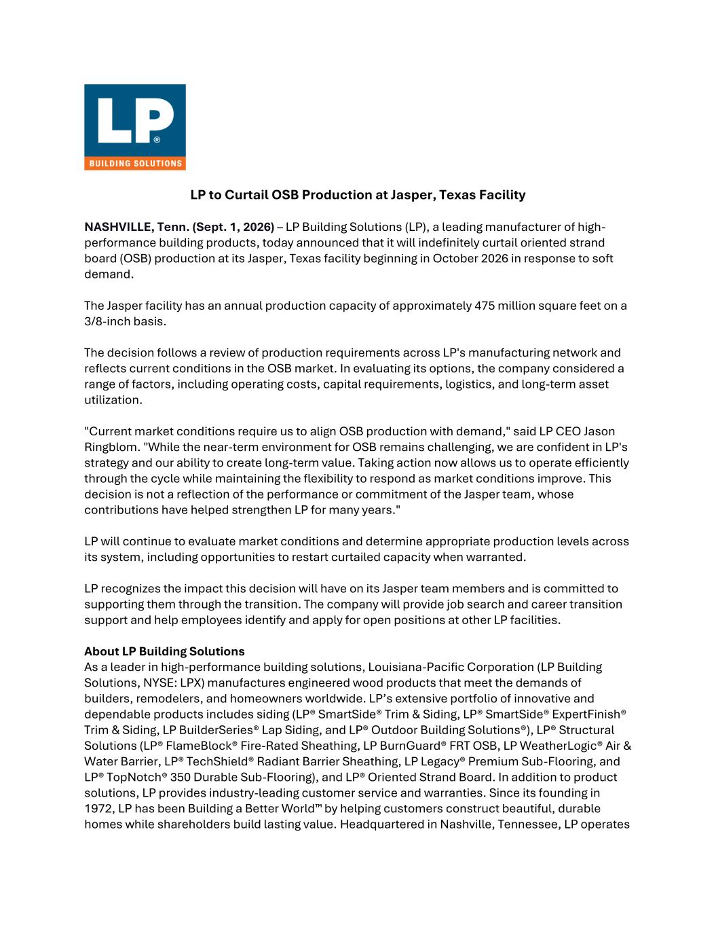

LP to Curtail OSB Production at Jasper, Texas Facility NASHVILLE, Tenn. (Sept. 1, 2026) – LP Building Solutions (LP), a leading manufacturer of high- performance building products, today announced that it will indefinitely curtail oriented strand board (OSB) production at its Jasper, Texas facility beginning in October 2026 in response to soft demand. The Jasper facility has an annual production capacity of approximately 475 million square feet on a 3/8-inch basis. The decision follows a review of production requirements across LP's manufacturing network and reflects current conditions in the OSB market. In evaluating its options, the company considered a range of factors, including operating costs, capital requirements, logistics, and long-term asset utilization. "Current market conditions require us to align OSB production with demand," said LP CEO Jason Ringblom. "While the near-term environment for OSB remains challenging, we are confident in LP's strategy and our ability to create long-term value. Taking action now allows us to operate efficiently through the cycle while maintaining the flexibility to respond as market conditions improve. This decision is not a reflection of the performance or commitment of the Jasper team, whose contributions have helped strengthen LP for many years." LP will continue to evaluate market conditions and determine appropriate production levels across its system, including opportunities to restart curtailed capacity when warranted. LP recognizes the impact this decision will have on its Jasper team members and is committed to supporting them through the transition. The company will provide job search and career transition support and help employees identify and apply for open positions at other LP facilities. About LP Building Solutions As a leader in high-performance building solutions, Louisiana-Pacific Corporation (LP Building Solutions, NYSE: LPX) manufactures engineered wood products that meet the demands of builders, remodelers, and homeowners worldwide. LP’s extensive portfolio of innovative and dependable products includes siding (LP® SmartSide® Trim & Siding, LP® SmartSide® ExpertFinish® Trim & Siding, LP BuilderSeries® Lap Siding, and LP® Outdoor Building Solutions®), LP® Structural Solutions (LP® FlameBlock® Fire-Rated Sheathing, LP BurnGuard® FRT OSB, LP WeatherLogic® Air & Water Barrier, LP® TechShield® Radiant Barrier Sheathing, LP Legacy® Premium Sub-Flooring, and LP® TopNotch® 350 Durable Sub-Flooring), and LP® Oriented Strand Board. In addition to product solutions, LP provides industry-leading customer service and warranties. Since its founding in 1972, LP has been Building a Better World™ by helping customers construct beautiful, durable homes while shareholders build lasting value. Headquartered in Nashville, Tennessee, LP operates

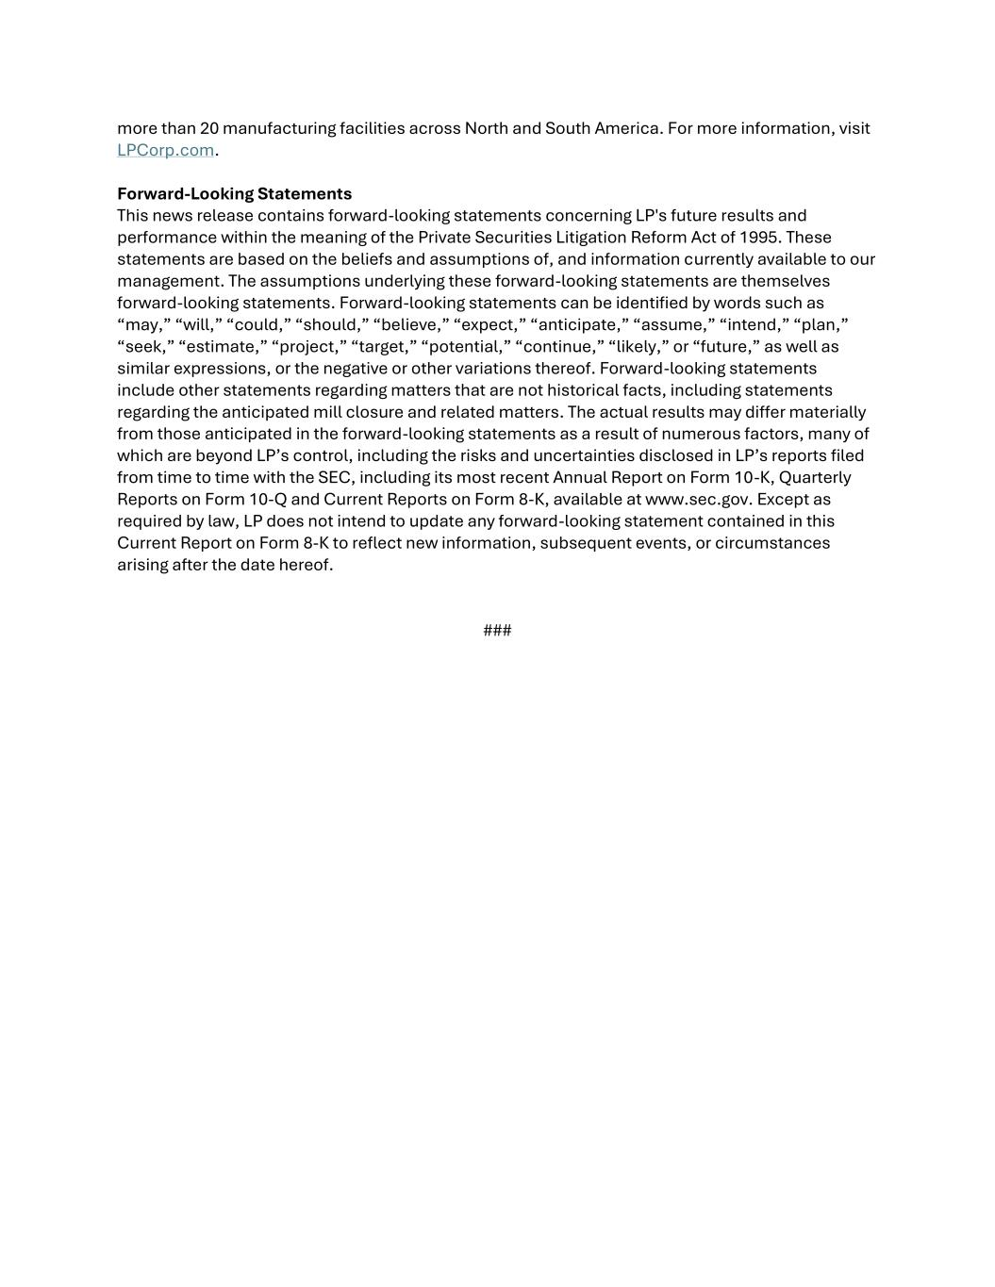
more than 20 manufacturing facilities across North and South America. For more information, visit LPCorp.com. Forward-Looking Statements This news release contains forward-looking statements concerning LP's future results and performance within the meaning of the Private Securities Litigation Reform Act of 1995. These statements are based on the beliefs and assumptions of, and information currently available to our management. The assumptions underlying these forward-looking statements are themselves forward-looking statements. Forward-looking statements can be identified by words such as “may,” “will,” “could,” “should,” “believe,” “expect,” “anticipate,” “assume,” “intend,” “plan,” “seek,” “estimate,” “project,” “target,” “potential,” “continue,” “likely,” or “future,” as well as similar expressions, or the negative or other variations thereof. Forward-looking statements include other statements regarding matters that are not historical facts, including statements regarding the anticipated mill closure and related matters. The actual results may differ materially from those anticipated in the forward-looking statements as a result of numerous factors, many of which are beyond LP’s control, including the risks and uncertainties disclosed in LP’s reports filed from time to time with the SEC, including its most recent Annual Report on Form 10-K, Quarterly Reports on Form 10-Q and Current Reports on Form 8-K, available at www.sec.gov. Except as required by law, LP does not intend to update any forward-looking statement contained in this Current Report on Form 8-K to reflect new information, subsequent events, or circumstances arising after the date hereof. ###

